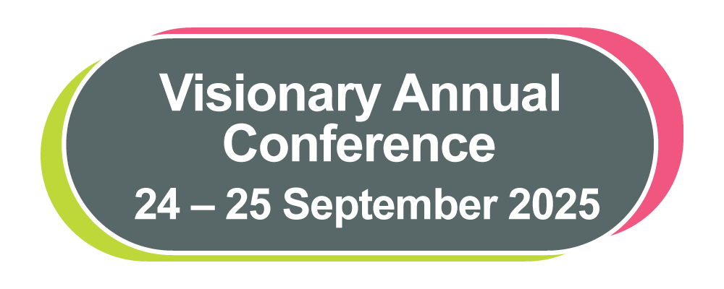

**Visionary Annual Conference**

**Delegate Pack**

**24 – 25 September 2025**

Contents

Contents 2

Welcome 4

Programme 5

Tuesday 23 September 2025 5

Wednesday 24 September 2025 5

Thursday 26 September 2025 6

Join us on BlueSky and LinkedIn 7

Meet the Panellists 7

Finding Your Way Around the Conference 15

NaviLens 16

Prayer Room and Quiet Spaces 17

Morning Walk with MyVision Oxfordshire 17

Thomas Pocklington Trust 18

Conference Sponsors and Funders 20

Member 20

National Partners 21

Corporate Sponsors and Funders 26

Acknowledgements 30

Exhibition 2025 31

Exhibitors 31

Location of Exhibitors 38

Visionary Annual Awards Dinner 39

Workshops 41

**Workshop Overview – Day One** 41

**Workshop Overview – Day Two** 42

Session One: Wednesday 24 September, 13:30 to 14:45 43

Session Two: Wednesday 24September, 15:15 to 16:30 49

Session Three: Thursday 25September, 10:30 to 11:45 56

Session Four: Thursday 25September, 12:15 to 13:30 62

Visionary Conference Team 67

Assistive Listening System (ALS) 72

Quick Guide to using NaviLens 73

General Evacuation Plan 76

Emergency Evacuation Routes 79

Conference Aston have installed new Assistive Listening Systems in some areas of the venue. If you would like to access these during the conference, please download the Sennheiser MobileConnect App prior to arrival and follow the instructions on page 72.

Welcome

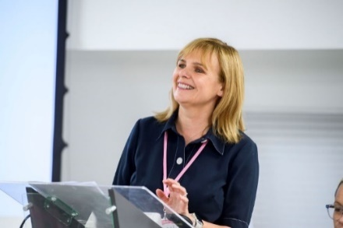  
Fiona Sandford, CEO, Visionary, speaking during her opening address at Visionary's Annual Conference in 2023. Fiona is smiling wearing a blue blouse.

**Hello Everyone – and welcome to our 2025 Conference!**

Whether you’re back for more or stepping into your very first Visionary conference, we are really pleased to have you with us. Get ready for a couple of days full of interesting conversations, thoughtful sessions and the chance to share ideas and experiences with just the right amount of caffeine and cake to keep us going!

This year’s programme reflects what *you* told us matters most. We’ve shaped the sessions around your priorities and the real challenges and opportunities facing your organisations. Expect practical workshops, honest discussions and tools you can take away and use immediately. There’s also a great exhibition area and, of course, plenty of time to catch up with old friends and make new connections.

We’re particularly pleased to welcome a range of speakers and panellists who bring experience, insight and fresh thinking – find out more about these wonderful people in this delegate pack. And, yes, we've once again gone digital – all your conference info is here and also at: https://www.visionary.org.uk/visionary-annual-conference-2025/

None of this would be possible without the continued support of our amazing members, partners, funders and sponsors. Thank you for being part of this brilliant community and helping to make it all happen.

Last but never least – a huge thank you to the Visionary team (tiny but mighty, as always!) who’ve worked so hard to bring this all together. It’s been a real team effort from start to finish.

So – deep breath, big smiles and let’s enjoy what we hope will be a really valuable couple of days. See you out there!

Warmest wishes, Fiona, CEO, Visionary

### Programme

We look forward to welcoming you to Conference Aston. Conference registration is open at the times listed below. Here you will receive a personalised programme detailing your selected workshops and where to find them. Please ensure you attend the sessions you have registered for, as we have arranged all the venue logistics based on everyone’s selections. Please check-in to your accommodation at the main hotel reception.

#### Tuesday 23 September 2025

16:00 to 18:00 Registration Open

16:00 to 16:45 Venue Familiarisation Tour (30 minute tour) – meet at the Visionary Registration Desk.

#### Wednesday 24 September 2025

**08:30 – 10:30 Registration opens with Exhibition and Networking**

09:00 – 09:30 Venue Familiarisation Tour – meet at the Visionary Registration Desk

10:30 – 12:00 Opening Address and Panel Discussion: Excellence in Inclusion

**12:00 – 13:30 Lunch, Networking and Exhibition**

13:30 – 14:45 Workshop Session 1

**14:45 – 15:15 Break and Exhibition**

15:15 – 16:30 Workshop Session 2

17:00 Exhibition closes

19:00 – 19:30 Reception Drinks

**19:30 onwards Visionary Annual Awards Dinner**

#### Thursday 26 September 2025

08:20 – 09:00 Registration

09:00 – 10:10 Welcome and Panel Discussion: Balancing Innovation and Responsibility: AI, Social Media, and Ethical Communications.

**10:10 – 10:30 Break**

10:30 – 11:45 Workshop Session 3

**11:45 – 12:15 Break**

12:15 – 13:30 Workshop Session 4

13:35 – 13:45 Closing Remarks

**13:45 – 15:00 Lunch in the Courtyard Restaurant**

**Depart at your leisure. Please don’t forget to come and say goodbye to the Visionary team!**

Join us on BlueSky and LinkedIn

We are delighted you are joining us at the Visionary Annual Conference 2025.

Please join the discussion on LinkedIn **@Visionary_UK** andBlueSky

We hope you enjoy your time at the conference and we want to hear all about your conference experience! Tell us about the workshops which grabbed your attention; the highlights of your day; the interesting people you met and anything else about your time with us.

Meet the Panellists

We are so excited about the opening addresses planned for this year's conference.

The conference will open on Wednesday 24September with an excellent panel session: **Excellence in Inclusion**, hosted by Eleanor Southwood, Director of Impact and External Affairs. Eleanor will be joined by Darren Harris, Dual Paralympian and Adversity Alchemist, Jo Milne, Founder of Cure Usher Syndrome and Robbie Crow, Strategic Disability Lead, BBC.

On Thursday 25 September we will start the day with a panel discussion: **Balancing Innovation and Responsibility: AI, Social Media, and Ethical Communications.** Sarah Kidner, Head of Communications and External Affairs will be joined by Amit Kalley, Founder of For Working Parents, Char Speedy, Director of Communications and Influencing at Guide Dogs UK, Helen Donkin, Head of Marketing at Henshaws and Sarah Watson, Head of Innovation at The National Lottery Community Fund.

**Darren Harris, Adversity Alchemist**



Darren wearing his navy England tracksuit and holding a gold cap with the three lions crest, and the words England and Great Britain blind squad, 100 caps.

Darren Harris, dual Paralympian, Adversity Alchemist and multi-award winning speaker, trainer and coach, gives leaders and teams the psychological tools to better prepare for and respond to challenges.  
His list of achievements and accolades include:  
• England’s highest capped male footballer, with 157 appearances.  
• 10 × World and European medallist.  
• Spoken to over ½ million delegates in 7 countries, since 2013.  
• Delivered 300+ programmes for corporate, educational and charitable organisations.  
• Fellow of the Professional Speaking Association (FPSA), a designation held by less than 12 percent of professional speakers.  
• Co-author of Amazon bestseller **Transforming Your Life.**  
• Recipient of an Honorary Doctorate for Outstanding Public Service.  
• Magical mathematician, pocket psychologist, and moonlight musician.

**Eleanor Southwood MBE, Director of Impact and External Affairs, Fight for Sight**



Eleanor is smiling and is wearing a black top with a yellow necklace with overlapping discs.

Ellie will be your host for the panel discussion.  Ellie joined Fight for Sight in 2023 following a career spanning the public, private and non-profit sectors. For ten years, until May 2024, she was an elected Councillor in a large London Borough. For 8 of those years, she held various roles on the Council’s Cabinet, with responsibilities including environmental services, jobs and economy, and housing, where she oversaw the building of the first council homes in decades. She is passionate about good quality, equitable local services.

Ellie is a former chair of the Royal National Institute of Blind People (RNIB) where she led the organisation through a statutory review by the Charity Commission, financial transformation and significant modernisation. She currently chairs Habinteg Housing Association, which specialises in accessible and adaptable homes across England.

Ellie’s early career included several public policy and consultancy roles, including in organisational change, campaigning and public service transformation.

**Jo Milne, Jo Milne, Campaigner & Founder, Cure Usher Syndrome**

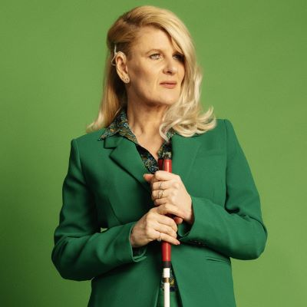

Jo is standing holding her red and white striped mobility cane. Jo is wearing a green trouser suit and has blonde mid length hair.

Jo is a passionate advocate for people living with **Usher syndrome** – the genetic condition causing both hearing and sight loss that she lives with. In 2014 she underwent a cochlear implant operation which gave her the ability to hear for the first time. Her story was picked up by the world’s media and the clip of her implants being switched on was viewed by more than 12 million people.

She has dedicated her life to raising awareness and supporting those living with Usher syndrome and their families, accelerating research through the charity she founded, **Cure Usher Syndrome**.

As a life-long campaigner fighting for meaningful change, Jo continues to empower her audiences with her own personal journey of resilience, determination, and commitment to provide a voice for all those touched by inequality and injustice.

**Libby Clegg, Paralympian**



Libby wearing her Great Britain tracksuit kissing her gold medal.

Libby Clegg is one of Britain’s most successful visually impaired athletes. After being diagnosed with Stargardt’s Macular Dystrophy at the age of 9, Libby got involved with her local athletics club. After watching the Paralympic Games in 2004 Libby was inspired to fulfil a dream that she never thought possible.  Libby has experienced many challenges on and off the track and has had an extremely successful career in athletics, over several years.  Libby has competed in four Paralympic Games, winning silver medals at Beijing, London and Tokyo.  In 2016, at the Rio Paralympics Libby won double gold and became a world record holder!  Libby retired from athletics in 2021.

**Robbie Crow, Strategic Disability Lead, BBC**



Robbie, a white male with short hair, stands in the foreground with a blurry office-type scene in the background. Robbie is smiling slightly at the camera and wearing a maroon jumper with a white collar peeking through. Only his head and shoulders are in view.

Recently recognised as one of the three most influential disabled people in the UK, Robbie is the BBC’s Strategic Disability Lead. He is responsible for disability inclusion across its entire current and potential workforce.

Before joining the BBC, Robbie worked in policy at the Scottish Government and chaired its disabled staff network. Robbie has held roles in the public and voluntary sectors and in the NHS. He previously led a national children’s charity as Chair for 6 years.

As a life-long disabled person, and multi-award winning disability inclusion expert, he’s a passionate advocate of the Social Model of Disability. You can follow Robbie on LinkedIn: https://www.linkedin.com/in/robbiecrow/

**And opening day 2 of the conference, we welcome..**

**Amit Kalley, Founder, For Working Parents**



Amit, a turban wearing Sikh man, standing in front of trees.

Amit is the founder of [For Working Parents](https://eur03.safelinks.protection.outlook.com/?url=https%3A%2F%2Furldefense.proofpoint.com%2Fv2%2Furl%3Fu%3Dhttp-3A__www.forworkingparents.com_%26d%3DDwMGaQ%26c%3DeuGZstcaTDllvimEN8b7jXrwqOf-v5A_CdpgnVfiiMM%26r%3D2Grta9UoGyvgvJjJmCKSi0_9eID1nAl0E_xLjhvReNw%26m%3D8lJEpu9i_6YIVnSwHcCN5Gq6MVdRLzsCGZwcR2LHgl0gbFLIxAhl5-WqfkPLSARc%26s%3DltzODMdXcIsbcXkBSoYHwrZkCegFp2KPzSYR3OzYTHs%26e%3D&data=05%7C02%7Camy.pearman%40visionary.org.uk%7Ce87c99486ec246b7c15408dda4d994a5%7C65395a073d564877b61bf53aafe53564%7C0%7C0%7C638847976734980043%7CUnknown%7CTWFpbGZsb3d8eyJFbXB0eU1hcGkiOnRydWUsIlYiOiIwLjAuMDAwMCIsIlAiOiJXaW4zMiIsIkFOIjoiTWFpbCIsIldUIjoyfQ%3D%3D%7C0%7C%7C%7C&sdata=4YAhp0YT3XMz24R5AwG8PHvj%2BfXTdnNRlVgC9AELDUU%3D&reserved=0), a company that helps organisations become more inclusive for their working parents and employees. A former Deputy Headteacher, Amit uses his experience and his training as an ICF Coach to create an environment in the workplace that is more empathetic and human and where parents and carers can thrive both at work and at home.

Amit focuses particularly on the digital world and helping parents decode online language, manage screentime, understand social media dangers, and keep their children safe online through building positive relationships and asking the right questions.

Amit’s LinkedIn profile and Instagram page provide regular digital advice and guidance organisations from around the world requesting copies of it to share with their communities.

Amit also speaks publicly about his own personal story, having lost his mother to ovarian cancer, becoming a parent to a daughter born with three holes in her heart, and being diagnosed with ADHD as an adult.

Facebook/Instagram/TikTok: @forworkingparents

LinkedIn: @AmitSinghKalley

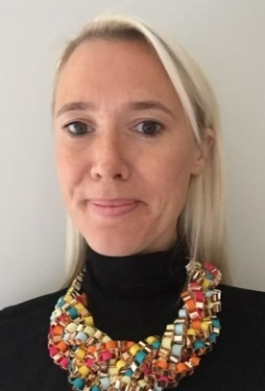**Char Speedy, Director of Communications and Influencing, Guide Dogs UK**

A head and shoulders image of Charlotte, who has long blond hair, pushed back behind her shoulders. Charlotte is wearing a black top with a colourful beaded necklace.

Char has worked in PR and comms roles in both agency and in-house environments, specialising in consumer and purpose-led campaigns. She has worked on high-profile campaigns for Honda Racing F1, Save the Children, UNHCR and Virgin Media.

She led the comms team at Dogs Trust for eight years before joining Guide Dogs in 2020 where she directs external, internal and influencing communications with a focus on showcasing the charity’s broader services beyond their iconic dogs through impactful media and partnership work.

Outside of work when not running after three children, she can be found running by the Thames – very slowly despite her name!

**Helen Donkin, Head of Marketing, Henshaws**



Head and shoulders portrait of Helen Donkin, a woman with long wavy brown hair and fair skin, looking directly at the camera with a gentle smile. She is wearing a dark blouse with a pink floral pattern. The background is a flat, bright magenta colour

Helen is Head of Marketing at Henshaws, a charity supporting people living with sight loss and a range of other disabilities. With over a decade of experience in the charity sector, she brings a unique perspective shaped by roles in fundraising, marketing, and events, including running the world’s largest crime writing festival.

Now studying for a master’s as an AI Data Specialist, Helen combines academic knowledge with frontline experience to explore how AI can be applied ethically within the sector. At Henshaws, she champions a ‘human-in-the-loop’ approach to AI, using tools to improve efficiency while protecting authenticity and accessibility. With a passion for making AI practical, inclusive, and responsible, Helen encourages open dialogue, ethical education, and the careful application of new technologies across charity communications and wider use cases.

**Sarah Kidner, Head of Communications and External Affairs, Fight for Sight**

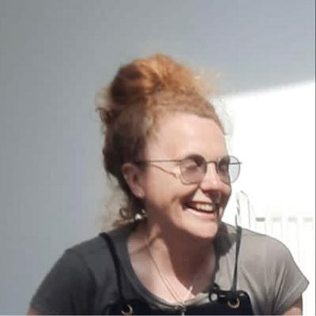

Sarah has red hair and is wearing earrings, glasses and a grey T-shirt. She is laughing.

For over 25 years Sarah has worked as a magazine editor, writer, and head of content. Sarah’s experience spans the commercial, charity, and not-for-profit sectors, including AbilityNet, British Heart Foundation and Which?.  In her first role at PC Pro, 30-years ago, Sarah wrote ‘futures’ articles about the potential and pitfalls of AI and articles about robotics.

Sarah leads the comms and external engagement teams at Fight for Sight and joins us at the conference to host the panel discussion on Thursday 25 September.

**Sarah Watson, Head of Innovation, The National Lottery Community Fund**

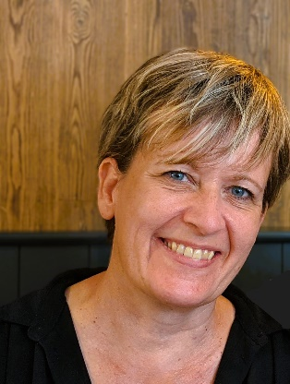

Sarah has short blonde hair and is smiling in front of a wooden panel background.

Sarah Watson is Head of Innovation at The National Lottery Community Fund, working in a small Innovation Unit that supports the Fund to deliver its strategy. The Unit approaches all its work through the Curb Cut effect, working with historically underserved communities and those most in need. Focusing on the strategy’s missions and commitments through an equity lens, the Unit is delivering on a range of projects with internal and external partners, including the development of AI. Working collaboratively, the Unit has supported the development of internal AI Principles and Policies and is experimenting with small proof of concepts to support grant-making and works across the sector to share learning and collaborate, including through an annual AI Funders Festival.

Finding Your Way Around the Conference

At registration you will receive a list of your workshop selections and the meeting room for each session. To assist with accessing the different workshops, lunch and refreshments, a tactile map will be located at the Visionary Registration Desk. These maps will be there for the duration of the event.

We have arranged for the team at Conference Aston to conduct familiarisation tours of the venue, to assist with navigation around the public spaces and finding workshop rooms. If you would like to join the familiarisation tour, please meet at the Visionary registration desk at the following times:

* Tuesday 23September at 16:00
* Wednesday 24September at 09:00

We are grateful to Blind Ambition for sponsoring the audio version and, as ever, huge thanks to the team at Galloways for preparing the delegate pack recording. Thank you all so much for your support.

We have worked with RNIB – Business Services to create a range of accessible event information. These include eBraille, large print and PDF versions of our delegate pack. To find out more please visit: [rnib.org.uk/business](https://www.rnib.org.uk/professionals/business-professionals/). Thank you to the team for the support and advice throughout the preparation of this delegate pack.

A detailed description of the exhibition layout is included in this delegate pack along with detailed description of the emergency evacuation routes. Please take time to read this information ahead of the conference.

NaviLens

We are pleased to be offering information via the NaviLens navigation app again this year. We will use their generic packages in the public areas of Conference Aston along with personalised codes to assist with networking.

**What is NaviLens?**

NaviLens uses a specially designed QR code that can be read from very short and long distances depending on the size of the code. Each code generated is unique, containing audio and visual text to assist with your navigation around the venue. To benefit from NaviLens during the conference please download the NaviLens App from Google Play or the Apple App Store.

**How will NaviLens be used during the conference?**

Each delegate name badge will feature a unique code. Once you have downloaded the app you will be able to scan your name badge and name badges of other delegates. NaviLens will read the person’s name, organisation and tell you how far away from you they are. You should also be able to scan a group of people and NaviLens will read everyone’s name and place them in terms of distance from you.

We will also feature NaviLens during lunch. Each table will feature a different code to assist with networking. In addition, each conference, meeting room and corridor used by Visionary will also have a NaviLens code on the door and at the front of the room. You will be able to scan the code to make sure you are joining the correct workshop. We will also place a NaviLens code on each table for dinner, so you will be able to find your table with ease.

A quick guide to using NaviLens is included at the end of the delegate pack.

Prayer Room and Quiet Spaces

During your time at Conference Aston, you are invited to visit the Martin-Luther King Multi-Faith Centre. You are very welcome to use this space for prayer, reflection, or quiet time away from the main conference. The Martin-Luther King Multi-Faith Centre is a short walk from the main entrance of Conference Aston. Please ask at the hotel reception for directions. There are male and female Islamic prayer rooms in both the main university building and the Students’ Union building. Please contact the hotel reception for opening times. For more information, please visit the Chaplaincy website: <https://www.aston.ac.uk/current-students/health-and-wellbeing/chaplaincy>

Torch Trust invites you to join them on Thursday 25September at 8am in Room 123 to take a few moments for prayer and reflection. All are welcome, any faith or none at all, as we share this time from a Christian perspective.

Morning Walk with MyVision Oxfordshire

Mark, Andy, Nathan and Joanne from MyVision Oxfordshire have kindly offered to lead a morning walk on Thursday 25 September. They will meet at the main hotel reception and depart Conference Aston at 7.50am, returning by 8.50am for the morning panel session.

If you would like to join them, please speak directly with Andy or Mark for details about the meeting time, location and route. This is a lovely opportunity for those who would like to start the day with some fresh air and exercise before our morning session begins. As the walk is organised by the MyVision Oxfordshire team, please liaise with them about joining the walk – let the Visionary team know if you would like an introduction.

Thomas Pocklington Trust

We would like to share special thanks to Thomas Pocklington Trust.

On behalf of the Visionary team, trustees, and our entire network we are hugely grateful for the ongoing support Visionary receives from Thomas Pocklington Trust.  Their support enables us to be responsive to the needs of our members, partners and in turn enhance the support available to blind and partially sighted people in local communities across the UK.

**About Thomas Pocklington Trust**

**Who We Are**

Thomas Pocklington Trust strives for equality of blind and partially sighted people in every aspect of society. We are a charitable organisation with a dedicated staff – over half of us are blind or partially sighted – and over 200 volunteers who have lived experience of sight loss. Our mission is to support blind and partially sighted people to bring about equity and inclusion in every aspect of society.

**What We Do**

Our work is focused on championing the needs and aspirations of blind and partially sighted people, fully recognising the depth and complexity of the challenges faced. We address these challenges not only within our local communities across the country through direct action by members of our Sight Loss Councils, but also at the heart of our national government and policy structures. We are a leader in providing direct grants that target systemic change and improvements for blind and partially sighted people.

Our mission is to support blind and partially sighted people to bring about equity and inclusion in society and in their own lives. We achieve this by focusing on significant life milestones for blind and partially sighted people, including ensuring that they are able to thrive in education, fostering positive employment opportunities and promoting overall health and wellbeing, with timely health interventions when needed.

In addition to addressing equality in life opportunities, our strategy is designed to support blind and partially sighted people at every stage of their journey through the education system, further training or employment and their chosen careers.

**How we do it**

We aim to:

* Provide information, resources and advice guidance to students in or entering education, and the professionals/parents/carers who support them. Reduce unemployment rates among blind and partially sighted people of working age, encouraging more employers to create accessible workplaces and generating employment opportunities for blind and partially sighted people.
* Ensure unrestricted access to all healthcare services for blind and partially sighted people, thereby removing barriers that limit their overall health, fitness and wellbeing.
* Campaign against injustices faced by blind and partially sighted people while actively promoting the creation of more inclusive, accessible and equitable communities and society at large. Find out more about Thomas Pocklington Trust campaigns here: https://www.pocklington.org.uk/access-inclusion-and-equality/

We support blind and partially sighted people to lead the lives they want to by:

* Providing information, advice, guidance and resources to students in or entering secondary school, college or university, along with their families, carers and the professionals who support them.
* Supporting people looking to start, restart or progress their careers.
* Encouraging engagement and volunteering, continually expanding our network of Sight Loss Councils across the UK.

Web: <https://www.pocklington.org.uk/>



Thomas Pocklington Trust logo

Conference Sponsors and Funders

Thank you to our fabulous sponsors and funders, for their support for making this year’s conference happen – we’re incredibly grateful for your support. We are delighted to share more information from our members, partners, funders, and corporate sponsors with you.

#### Member

**Sight Scotland and Sight Scotland Veterans**



Sight Scotland / Sight Scotland Veterans logo

Sight Scotland is Scotland’s largest sight loss charity. Our diverse services span all ages and stages of sight loss and visual impairment. It also includes the Royal Blind School in Edinburgh and specialist learning services across Scotland, residential care for children and adults, community services, and research funding into sight loss conditions. We also run the Scottish Braille Press which provides supported employment. Half of the employees of the Scottish Braille Press are disabled people, including people with visual impairment. Our community services are reaching out to support even more people with sight loss in Scotland, as well as their relatives and carers.

Sight Scotland Veterans provides support to armed forces veterans in Scotland, including those who served National Service and who are affected by sight loss, regardless of the cause. The charity helps veterans with sight loss regain confidence, restore their independence and make new connections.  Together, our charities are determined that no one should face sight loss alone.

Visit: [www.sightscotland.org.uk](https://sightscotland.org.uk/)

#### National Partners

**Blind Ambition**

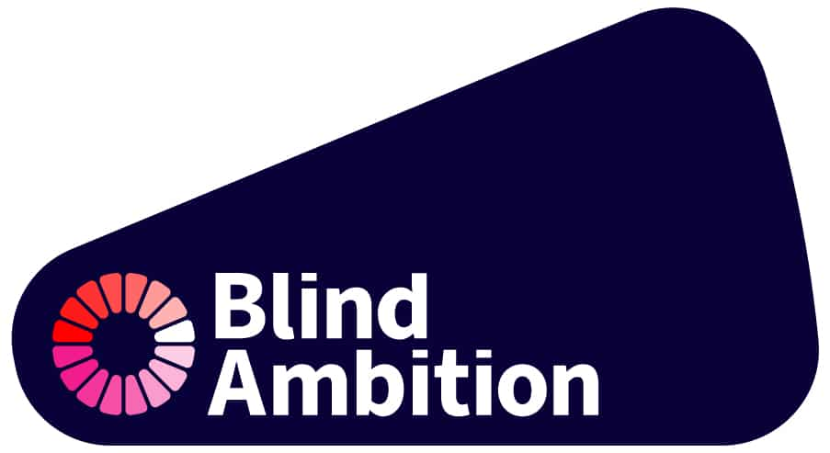

Blind Ambition logo

Blind Ambition (888) Ltd is an internationally award-winning disability inclusion consultancy led by Seema Flower, a blind entrepreneur and passionate advocate for accessibility and employment equality. We work across sectors—legal, financial, healthcare, transport and construction—delivering visual awareness training, inclusive recruitment consultancy, and audits of policy, practice and physical environments.

We’re proud to have worked with organisations such as LinkedIn, Lloyds Bank, Microsoft and NHS Trusts to help them build accessible and inclusive workplaces.

This year, we’ve launched a new accessible recruitment platform for blind and partially sighted jobseekers:

[www.blindambition.co.uk/recruitment](https://www.blindambition.co.uk/recruitment/)

With 75% of blind and partially sighted people unemployed, our new jobs board aims to connect inclusive employers with talented candidates, and to raise the bar for accessibility in recruitment.

We warmly invite you to publish your vacancies on our platform and be part of the movement to close the disability employment gap.

At Blind Ambition, we believe inclusion is more than a policy—it’s a promise to do better, every day.

**Fight for Sight**

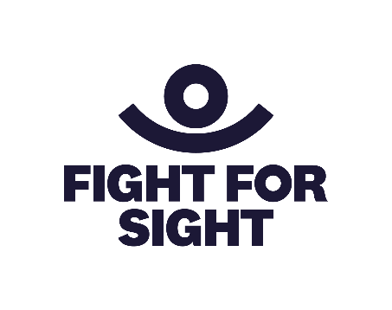

Fight for Sight logo

Imagine being told that you, or someone you love, is losing their sight. In that moment, two profound questions demand urgent answers.

* Can this be stopped?
* How will I live my life?

Currently, research into preventing and treating sight loss is chronically underfunded, receiving a mere 1.3% of publicly funded health research grants. People who are blind or vision impaired are three times more likely to experience loneliness and isolation than the general population.

We find and fund the brilliant minds and bright ideas that put change in sight. Our researchers are at the forefront, making breakthroughs and discoveries that will help us better understand, prevent, diagnose and treat eye disease. The partnerships we build and initiatives we support are changing life for blind and vision impaired people.

We are Fight for Sight and we won’t stop until we:**Save Sight. Change Lives.**

Visit:  [www.fightforsight.org.uk](https://eur03.safelinks.protection.outlook.com/?url=https%3A%2F%2Fwww.fightforsight.org.uk%2F&data=05%7C02%7Camy.pearman%40visionary.org.uk%7C0a409503062f4d9f9fe308dda9ce628c%7C65395a073d564877b61bf53aafe53564%7C0%7C0%7C638853426338014800%7CUnknown%7CTWFpbGZsb3d8eyJFbXB0eU1hcGkiOnRydWUsIlYiOiIwLjAuMDAwMCIsIlAiOiJXaW4zMiIsIkFOIjoiTWFpbCIsIldUIjoyfQ%3D%3D%7C0%7C%7C%7C&sdata=OBd04oIaUid5ze1HMw0M14NBFghyABgre0wCoKBndMw%3D&reserved=0)

**Glaucoma UK**

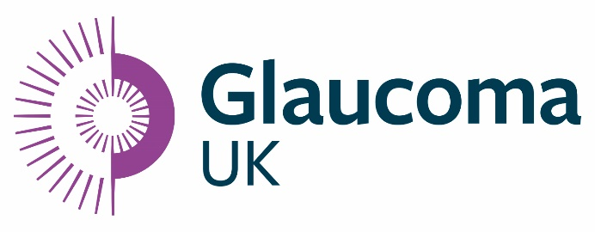

Glaucoma UK logo

At Glaucoma UK we are dedicated to ending preventable sight loss caused by glaucoma, because no-one should lose their sight to a disease that is preventable and treatable.

As a membership charity, we ensure people living with glaucoma have a voice in how and where their care and treatment are delivered.

We provide a host of support services to help people at all stages of their glaucoma journey, including:

* a dedicated helpline
* online webinars
* digital and face-to-face support groups
* information leaflets and booklets
* a website full of information and advice about the disease.

We also provide training and an annual conference for glaucoma care professionals.

Beyond support services, we fund research to advance our knowledge and understanding of the causes of glaucoma, and to improve prevention, early detection, diagnosis and treatment of the disease and allied conditions.

Through our annual grants programme, we empower UK based researchers to drive innovation and improve outcomes for people with glaucoma, now and into the future.

Visit: [www.glaucoma.uk](https://eur03.safelinks.protection.outlook.com/?url=https%3A%2F%2Fglaucoma.uk%2F&data=05%7C02%7Camy.pearman%40visionary.org.uk%7Ca738ed6b00874953d39d08dda803d15a%7C65395a073d564877b61bf53aafe53564%7C0%7C0%7C638851456557455340%7CUnknown%7CTWFpbGZsb3d8eyJFbXB0eU1hcGkiOnRydWUsIlYiOiIwLjAuMDAwMCIsIlAiOiJXaW4zMiIsIkFOIjoiTWFpbCIsIldUIjoyfQ%3D%3D%7C0%7C%7C%7C&sdata=JNv3cAba7wXjCkz21RbUNDFAy0borPPr8SRlQ1IkIOk%3D&reserved=0)

**Guide Dogs UK**

[Guide Dogs UK logo in navy blue.  A paw print to the left and Guide Dogs text to the right.
](http://www.guidedogs.org.uk)

Guide Dogs logo

Guide Dogs is here to help people with sight loss live the life they choose. Our aim is to level the playing field and create a world where people with a vision impairment can do what they want, when they want.

We understand that living with sight loss is different for everyone and our services reflect that. From the very first enquiry, our experts talk and listen to people’s needs and aspirations and offer advice and provide support. Beyond our iconic guide dogs, we provide a wide range of services for adults, children and young people, as well as providing sighted guide training to help make the world more inclusive for people with sight loss.

In these fast-changing times, we’re also exploring the opportunities that technology brings, including tech-driven navigation. Reflecting this, we’re delighted to sponsor the Develop and Share Award which recognises innovation and collaboration across the sector.

Visit:  [www.guidedogs.org.uk](https://eur03.safelinks.protection.outlook.com/?url=https%3A%2F%2Fwww.guidedogs.org.uk%2F&data=05%7C02%7Camy.pearman%40visionary.org.uk%7Cdd4bb46044cb442ce3e708dda80f74d3%7C65395a073d564877b61bf53aafe53564%7C0%7C0%7C638851506547467575%7CUnknown%7CTWFpbGZsb3d8eyJFbXB0eU1hcGkiOnRydWUsIlYiOiIwLjAuMDAwMCIsIlAiOiJXaW4zMiIsIkFOIjoiTWFpbCIsIldUIjoyfQ%3D%3D%7C0%7C%7C%7C&sdata=pYjiCYNKxTRNJgWCW8HgDZ2MuQqA1O5a8N3aY0XzFJ8%3D&reserved=0)

**Macular Society**

[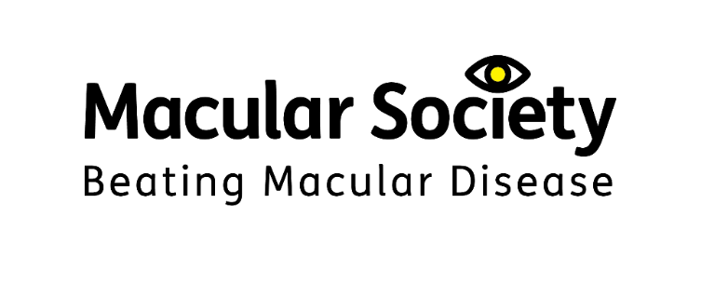](http://www.macularsociety.org.uk)

Macular Society logo – Beating macular disease

Macular disease is the biggest cause of sight loss in the UK, with around 300 people diagnosed every day. The Macular Society is determined to beat the fear and isolation of macular disease with world-class research, and the best advice and support.

The Society works in close collaboration with local and regional sight loss organisations, and the members of Visionary, to support people affected by this devastating condition and to beat macular disease, for good. The conference is a great opportunity to share experiences and learn from each other, in order to continue to improve the lives of those living with sight loss.

Visit: [www.macularsociety.org](https://www.macularsociety.org/)

**RNIB (Royal National Institute of Blind People)**

[](http://www.rnib.org.uk)  
RNIB logo – See differently

The Royal National Institute of Blind People (RNIB), is one of the UK’s leading sight loss charities. We offer practical and emotional support to blind and partially sighted people, their families and carers. We raise awareness of the experiences of blind and partially sighted people and campaign for change to make our society more accessible for all. We want to change our world so there are no barriers to people with sight loss.

RNIB is delighted to sponsor and support the Visionary Annual Conference. We wish to build stronger more productive relationships at a local level and are seeking to engage with local sight loss charities to provide more opportunities for blind and partially sighted people and improve equity of access.  If you are interested in having a discussion, please do not hesitate to email Carolyn Chamberlain: Carolyn.Chamberlain@rnib.org.uk

Visit:  [www.rnib.org.uk](https://www.rnib.org.uk/)

**RNIB – Business Services**



RNIB Business Services logo

The Royal National Institute of Blind People (RNIB) is the largest sight loss charity in the UK. At RNIB, we are passionate about accessibility and usability. This includes supporting local societies and charities to use our services and ensure blind and partially sighted people have the information they need in their required reading format.

We are pleased to be supporting this year’s Visionary conference by providing the conference information in a range of accessible formats including large print and braille.

Our expert consultants have valuable lived experience and want to ensure businesses websites, apps, products and services not only comply with current legislation, but are accessible and usable to all users. Through web audits, user testing, training, accessible design and consultancy, we aim to help businesses maximise the value of their products and services through a tailored approach.

We also offer transcriptions services for charities and business, visit our website for more information about Audio transcription, braille, easy read and large print transcription | RNIB: <https://enterprises.rnib.org.uk/our-services/document-transcription/>

To find out more about all of our services, please visit: https://enterprises.rnib.org.uk/

#### Corporate Sponsors and Funders

**Associated Optical**



Associated Optical logo – Partner of Eschenbach

Since 1983 Associated Optical, Eschenbach’s UK partner, has sought to provide eye-care professionals with innovative magnification devices to further enhance their patient care. Working closely with all of our key manufacturers and our education team, our aim is to inspire our customers to further improve people’s lives using patient-centred optical solutions.

Our key brands include Eschenbach Optik for Optical and Digital magnification, Ocutech Bioptics & LiveEyewear for Cocoons FitOvers and Filters.

Web: <https://www.associatedoptical.com/>

Russell Cooke



Russell-Cooke logo

We are delighted to sponsor the Visionary Annual Conference and to be delivering a workshop for 2025 delegates. We’re also very pleased to continue our ongoing support for Visionary members through the Member and Partner Benefits, please email Raquel for more information: [raquel.garrido-soriano@visionary.org.uk](mailto:raquel.garrido-soriano@visionary.org.uk)

Russell-Cooke’s charity and not-for-profit team is one of the country’s leading charity law practices. We are a team of lawyers who work exclusively with charities and other not-for-profit organisations. We have substantial breadth and depth within the team, with lawyers who specialise in a wide range of areas, including governance, operational and commercial matters, employment, property, intellectual property, safeguarding and data protection.

Many members of the team are charity trustees. The team is supported by other specialist lawyers throughout the firm where required. Russell-Cooke is one of the country’s top 100 law firms and has over 200 lawyers and other legal professionals based across three offices in London.

Web: <https://www.russell-cooke.co.uk/>

**Specsavers**

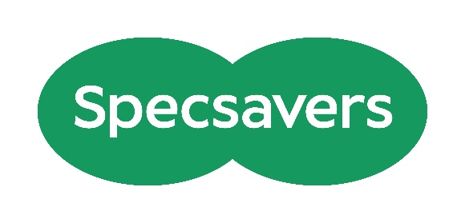

Specsavers logo

As the leading provider of optometry services for NHS Primary Care and the largest provider of community audiology services, Specsavers changes lives through better sight and hearing. Each practice is owned and run by experts who care for communities throughout the UK. There are currently more than 2,815 optics, audiology, domiciliary and ophthalmology businesses with more than 45,000 dedicated colleagues worldwide, and this year we have cared for more than 48 million people.

For more information visit [www.specsavers.co.uk](https://eur03.safelinks.protection.outlook.com/?url=http%3A%2F%2Fwww.specsavers.co.uk%2F&data=05%7C02%7Camy.pearman%40visionary.org.uk%7C43f50f4b945b43bbe6d608ddc45c0b42%7C65395a073d564877b61bf53aafe53564%7C0%7C0%7C638882621801468892%7CUnknown%7CTWFpbGZsb3d8eyJFbXB0eU1hcGkiOnRydWUsIlYiOiIwLjAuMDAwMCIsIlAiOiJXaW4zMiIsIkFOIjoiTWFpbCIsIldUIjoyfQ%3D%3D%7C0%7C%7C%7C&sdata=1SXhY8y4CQcOCIzhGw6qNXr59qxf8Do0eF9ZKZAIYBc%3D&reserved=0)

**The Powell Family Foundation**

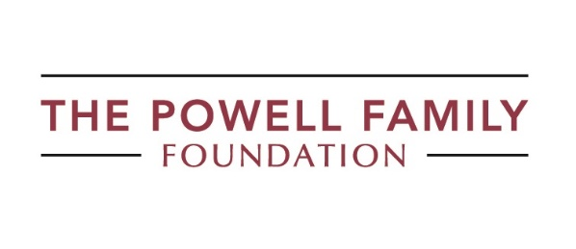

The Powell Family Foundation logo

We provide grants to individuals and charities, with the aim of creating opportunities for children and young people with a vision impairment to reach their full potential.

To learn more about us or apply for a grant please visit The Powell Family Foundation website: https://tpff.org.uk/

**Utility Aid**



Utility Aid logo

Utility Aid is the UK’s largest energy broker for the voluntary sector, working with over 4,000 organisations and counting. We are passionate about reducing energy costs, so that you have more money to spend on your services. As well as helping to secure new contracts at the best possible cost, we can also retrieve any money you have been overcharged on your energy bills. Through our invoice validation service, we have recovered over £8m for our charity customers to date.

**Our Services**

* **Energy Switching** – We only work with trustworthy suppliers to ensure you get the best possible service.
* **Account Management –**Our friendly Account Management Team provides quality aftercare advice and support. All queries are allocated to a dedicated member of the team who takes full ownership from start to finish.
* **Invoice Validation –**Our team of skilled analysts conducts thorough checks on invoices to ensure you are billed correctly and there are no overcharges. We automatically investigate any issues and liaise with suppliers to get mistakes rectified.
* **Net Zero & Carbon Reporting –**Our Net Zero services aim to help organisations reduce consumption in a financially feasible manner. We work with organisations to identify the budgets necessary and promote a methodology based on circular investment

Visit: [www.utility-aid.co.uk](https://www.utility-aid.co.uk/)

Acknowledgements

In addition to our sponsors, we are supported by many amazing organizations that help make this event possible. Thank you all for sharing your expertise this year in helping to create a varied programme for the Visionary Annual Conference 2025.

* Alison Oliver Consulting
* Beacon Centre for the Blind
* Berkshire Vision
* Empathyce
* EYECAN
* Good Innovation
* Guide Dogs UK
* Henshaws
* Kent Association for the Blind
* Merton Vision
* MoorVision
* MyVision Oxfordshire
* Outlookers
* Royal Society for Blind Children
* Royal Wolverhampton and Walsall Healthcare
* S3TAX
* Sense Ability Matters
* Sheffield Royal Society for the Blind
* Sight Advice South Lakes
* Sight Concern Bedfordshire
* Sight Cymru
* Sight for Surrey
* Sight Scotland and Sight Scotland Veterans
* Sight Support West of England
* The Braillists Foundation
* Thomas Pocklington Trust
* Vision Support
* Wales Council of the Blind
* Wakefield District Sight Aid

Your generosity in time and expertise is hugely appreciated. On behalf of all conference delegates – Thank you!

Exhibition 2025

Welcome to our annual exhibition!

This guide provides all the essential information about this year's event, taking place on Wednesday, 24September 2025, from 8:30am to 5:00pm. We are delighted to welcome new and regular conference exhibitors this year. Below you will find details about each of the organisations joining us this year. Please make sure you visit them and say hi!

#### Exhibitors

**Associated Optical**

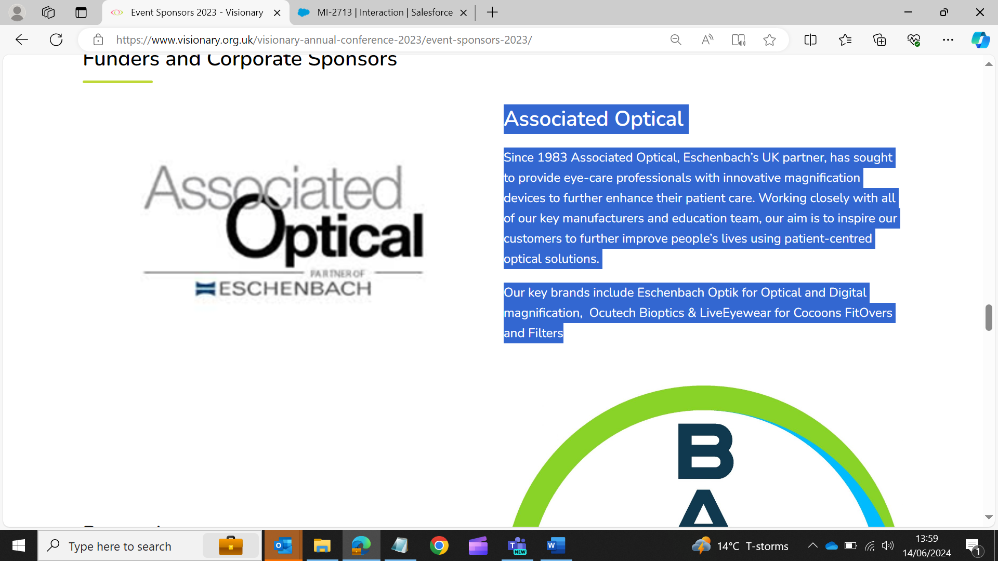

Association Optical logo – Partner of Eschenbach

Since 1983 Associated Optical, Eschenbach’s UK partner, has sought to provide eye-care professionals with innovative magnification devices to further enhance their patient care. Working closely with all of our key manufacturers and education team, our aim is to inspire our customers to further improve people’s lives using patient-centred optical solutions.

Our key brands include Eschenbach Optik for Optical and Digital magnification, Ocutech Bioptics & LiveEyewear for Cocoons FitOvers and Filters.

Web: <https://www.associatedoptical.com/>

**Blind Ambition**



Blind Ambition logo

Blind Ambition is an internationally award-winning disability inclusion consultancy led by Seema Flower, a blind entrepreneur and passionate advocate for accessibility and employment equality. We work across sectors—legal, financial, healthcare, transport and construction—delivering visual awareness training, inclusive recruitment consultancy, and audits of policy, practice and physical environments. We’re proud to have worked with organisations such as LinkedIn, Lloyds Bank, Microsoft and NHS Trusts to help them build accessible and inclusive workplaces. This year, we’ve launched a new accessible recruitment platform for blind and partially sighted jobseekers: www.blindambition.co.uk/recruitment With 75% of blind and partially sighted people unemployed, our new jobs board aims to connect inclusive employers with talented candidates, and to raise the bar for accessibility in recruitment. We warmly invite you to publish your vacancies on our platform and be part of the movement to close the disability employment gap. At Blind Ambition, we believe inclusion is more than a policy—it’s a promise to do better, every day.

Web: https://www.blindambition.co.uk

**Dizions Limited**

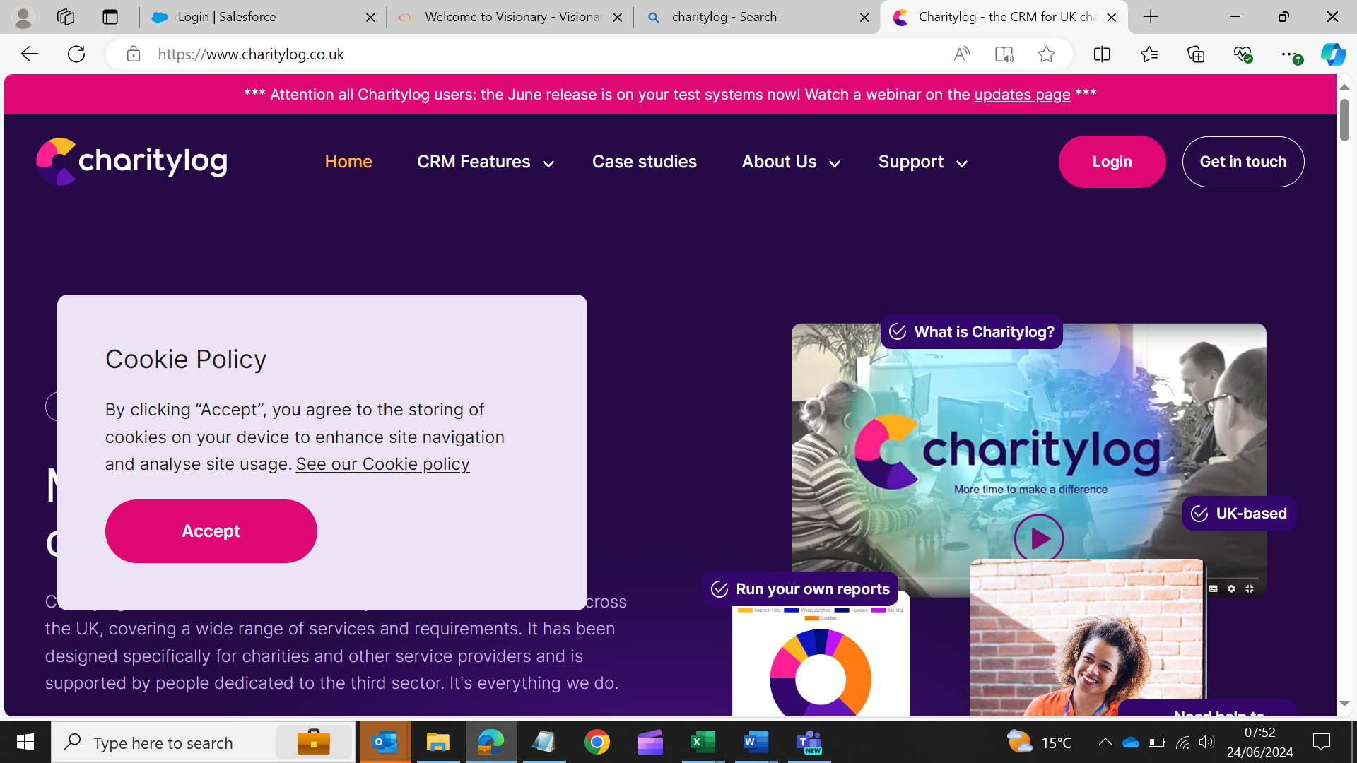

Charitylog logo

Charitylog is a cloud based CRM system used by over 900 charities. Typically, these charities provide services to clients and have to report to funders and commissioners, demonstrating impact and outcomes. It will help you manage the personal information you collect and support your organisation in meeting GDPR compliance. Whether your work is mainly 1:1 case work or group activities, in the office or in homes, Charitylog can provide the tools for recording activity and outcomes, as well as reporting.

Web: <https://www.charitylog.co.uk/>

**Fight for Sight**



Fight for Sight logo

Imagine being told that you, or someone you love, is losing their sight. In that moment, two profound questions demand urgent answers.

* Can this be stopped?
* How will I live my life?

The merger of Fight for Sight and Vision Foundation and our subsequent rebranding mean we are uniquely placed to answer both questions positively.

As Fight for Sight, we find and fund the brilliant minds and bright ideas that put change in sight. Our researchers are at the forefront, making breakthroughs and discoveries that will help us to better understand, prevent, diagnose and treat eye disease. The partnerships we build and initiatives we support are changing lives for blind and vision-impaired people.

We are Fight for Sight: we won’t stop until we: Save Sight. Change Lives.

Please come to our exhibition stand to discover more about our journey to date and our ambitious plans for the future.

Web: [www.fightforsight.org.uk](https://eur03.safelinks.protection.outlook.com/?url=https%3A%2F%2Flinkscan.io%2Fscan%2Fux%2FaHR0cDovL3d3dy5maWdodGZvcnNpZ2h0Lm9yZy51ay8%3D%2FF2F28C8CC1E2046C0DCDFC2828067D62BBF2BEFF06DC570F384C60B613F1A424%3Fc%3D1%26i%3D1%26docs%3D1&data=05%7C02%7Camy.pearman%40visionary.org.uk%7C3709c64185d04fcd27ad08dcb843f5ef%7C65395a073d564877b61bf53aafe53564%7C0%7C0%7C638587849259646915%7CUnknown%7CTWFpbGZsb3d8eyJWIjoiMC4wLjAwMDAiLCJQIjoiV2luMzIiLCJBTiI6Ik1haWwiLCJXVCI6Mn0%3D%7C0%7C%7C%7C&sdata=p%2BlnUtp3S5eIdsk5TSsIFSVJfPfNBqzSno3IY6ejF9M%3D&reserved=0)

**ITS VIP**

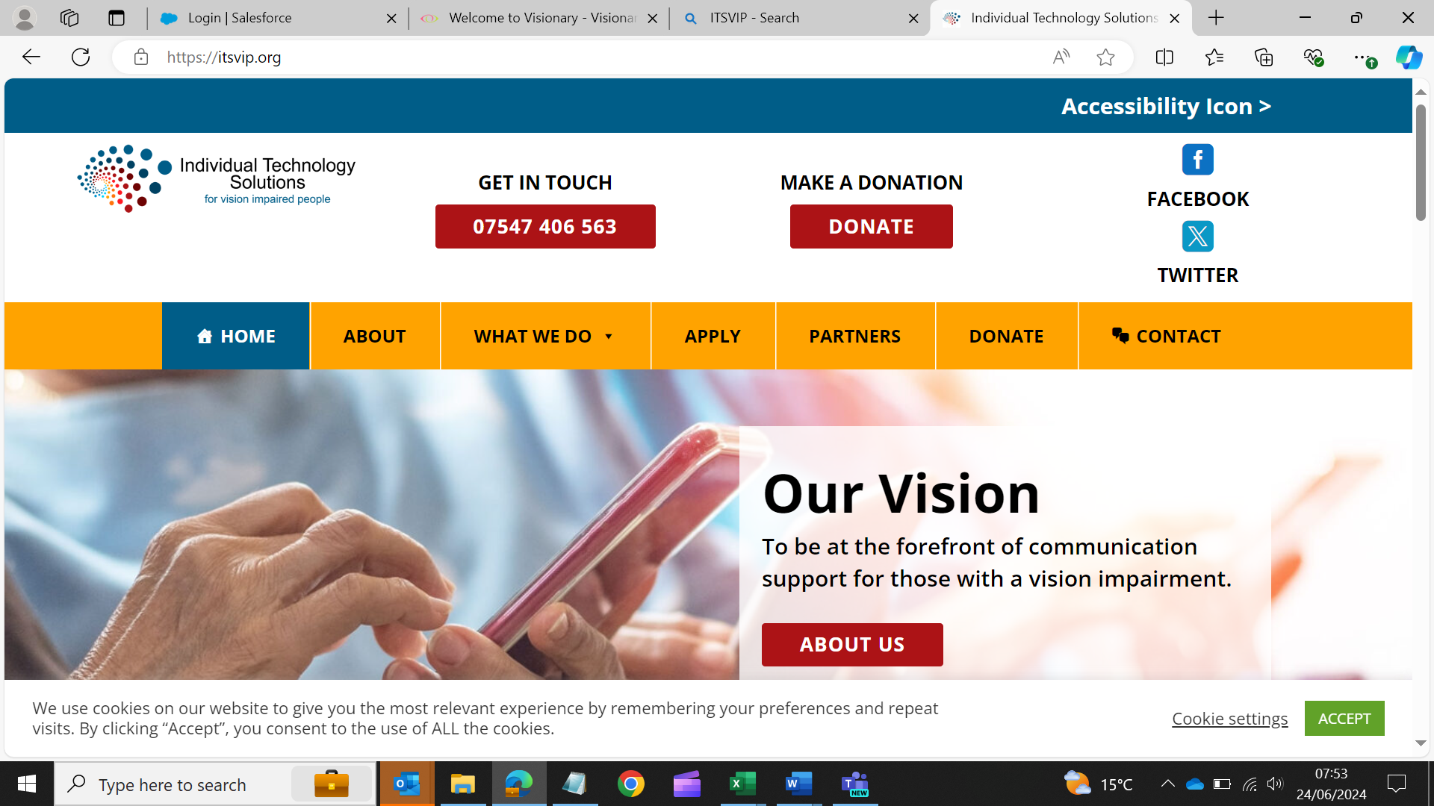

Individual Technology Solutions for Vision Impaired People logo

Individual Technology Solutions for vision impaired people (ITS VIP), previously known as Telephones for the Blind have been supporting blind and partially sighted people for over 50 years. Our mission is to combat loneliness, isolation and enable those with sight loss to live full independent lives using modern communication equipment.

Working closely with our partners from Visionary, local sight loss charities, council sensory teams and other professionals in our sector, we provide grants for landlines, specially adapted mobile phones and tablet computers, along with training and support, to those who would otherwise be unable to afford them.

Generally, the simplest way to apply is to complete the on-line application form. However, for those unable to apply on-line you can download a form from our website. All applications must be submitted by a recognised sponsoring officer and meet the charity’s eligibility criteria.

For more information visit [www.itsvip.org](http://www.itsvip.org)

**New College Worcester**



New College Worcester logo

NCW is a national residential school and college for children and young people aged 11 to 19 who are blind or vision impaired. Every student at NCW has a tailored programme, carefully planned and delivered to meet need according to their own EHCP in three key areas; academic achievement, independent living skills and involvement in extracurricular activities at the College and in the community. The opportunities provided to students in these three areas of provision play a crucial role in the development of confidence and self-esteem and preparation for life beyond our college.

Visit: https://www.ncw.co.uk/

**Optima Low Vision Services**



Optima Low Vision Services Logo

Optima Low Vision Services Ltd is the premier distributor of low vision aids in the UK.

We supply a large and comprehensive range of optical and electronic magnifiers, the largest range of Anti-Glare Filters in Europe, and an increasing range of LED task lamps.

Optima provides low vision training to staff at all levels in all sectors.

To access our current catalogue, please visit: <https://www.optimalowvision.co.uk/documents/Catalogue.pdf>

**RNIB – Connect Radio**

RNIB Connect Radio logo


RNIB – Connect Radio Logo

RNIB Connect Radio broadcasts across the UK to our predominantly blind and partially sighted audience, 7 days a week and 24 hours a day. The radio station provides a range of essential information in an easily accessible format and centres the voices of the blind and partially sighted community. The radio station supports our listeners by offering a ‘one stop shop’ to all types of information, services, and opportunities, as well as a platform on which to share stories, challenges, aspirations, and life hacks.

All our presenters are either blind or partially sighted and we talk to dozens of people from the sight loss community each week ensuring our content is informed by lived experience.

You can listen around the UK on Freeview channel 730, online at [www.rnib.org.uk/connect-radio/](https://eur03.safelinks.protection.outlook.com/?url=http%3A%2F%2Fwww.rnib.org.uk%2Fconnect-radio%2F&data=05%7C02%7Camy.pearman%40visionary.org.uk%7C31b2918e462e4a254de208ddc3913f0e%7C65395a073d564877b61bf53aafe53564%7C0%7C0%7C638881750783072949%7CUnknown%7CTWFpbGZsb3d8eyJFbXB0eU1hcGkiOnRydWUsIlYiOiIwLjAuMDAwMCIsIlAiOiJXaW4zMiIsIkFOIjoiTWFpbCIsIldUIjoyfQ%3D%3D%7C0%7C%7C%7C&sdata=vLW%2BmVXeFy%2B9u6zFX%2F%2FKyoksymsn5ximkyO7EzyeTFQ%3D&reserved=0) and on smart devices. You also find us by saying ‘Alexa, play RNIB Connect Radio.

**Seable Holidays**

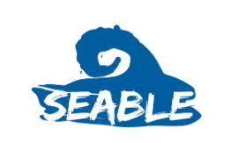

Seable Holidays logo

Seable Holidays is an award-winning social enterprise dedicated to providing accessible, tailored, and group holidays for the visually impaired community. With trained local sighted guides and bespoke activities, we create inclusive, stress-free adventures designed to suit your needs—ensuring independence, confidence, and unforgettable memories in a welcoming and supportive environment.

**Sight and Sound Technology**

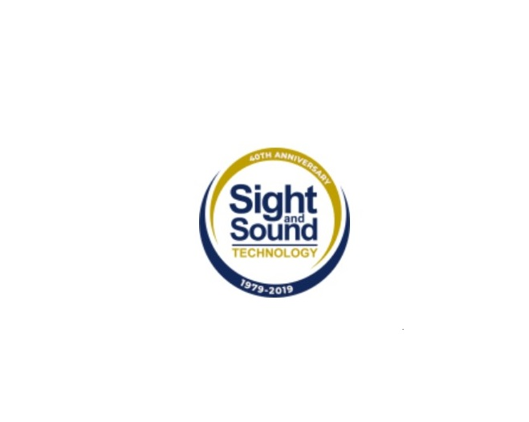

Sight and Sound Technology Logo

For over 40 years, Sight and Sound Technology has been at the forefront of assistive technology, helping individuals who are blind, visually impaired, or have learning and reading difficulties live more independent, connected lives. Our mission is simple: to empower people to overcome barriers and access the world around them through innovative solutions. As we work alongside sight loss charities across the UK we understand the unique needs of the communities you serve. We are committed to providing your charity with the tools, training, and resources necessary to help individuals with sight loss lead fuller, more independent lives. Whether you’re helping clients at home, supporting them in the workplace, or providing educational resources, we offer a range of assistive technologies designed to meet diverse needs. We can provide loan demo equipment so you can trial solutions before committing, as well as tailored demonstrations to ensure your team is confident in using the technology to support your clients effectively. Together, we’re working to improve the lives of individuals with sight loss, ensuring they have the support and technology they need to live with independence and dignity. Get in touch with us today for bespoke information, the loan of demo equipment, or to arrange a demonstration and receive ongoing tech training and support for your charity.

Email: [info@sightandsound.co.uk](mailto:info@sightandsound.co.uk)

Call: 0800 085 6055

Visit: [www.sightandsound.co.uk](http://www.sightandsound.co.uk/)

**Torch Trust**

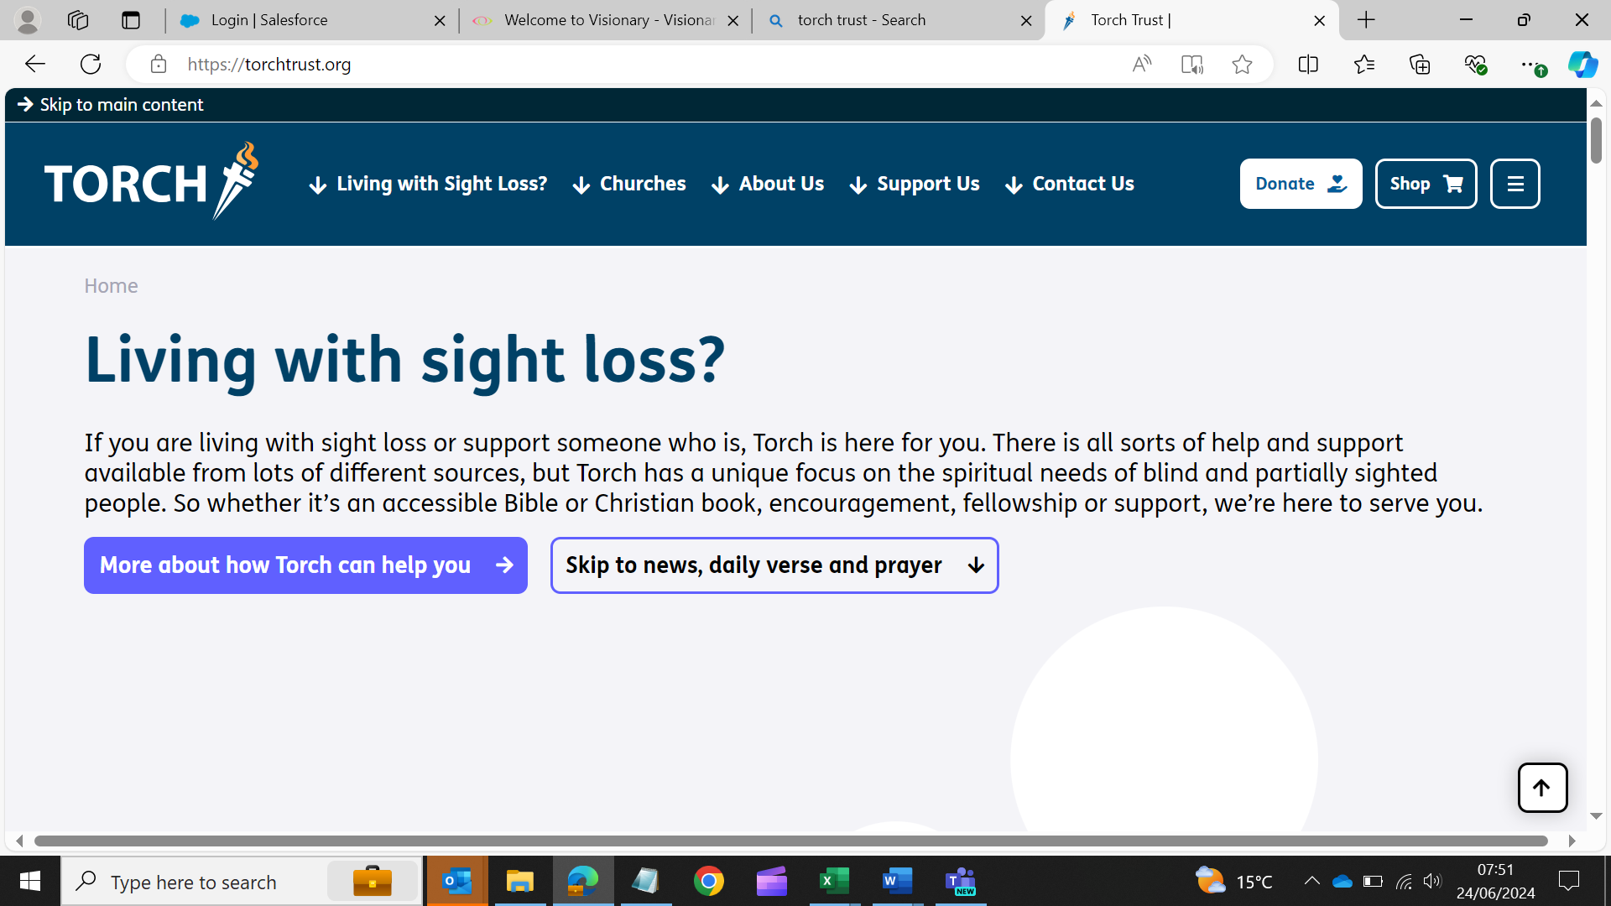

Torch Trust logo

Torch Trust is a national and international Christian charity. We seek to make a difference to the lives of people who are living with sight loss by providing them with the opportunity to access Bibles and other Christian resources, through our free lending library. These are also for sale. We support sight loss friendly churches and offer access to a range of events and services, including holidays for people who are visually impaired, local group meetings and a befriending service.

Web: <https://torchtrust.org/>

**Utility Aid**

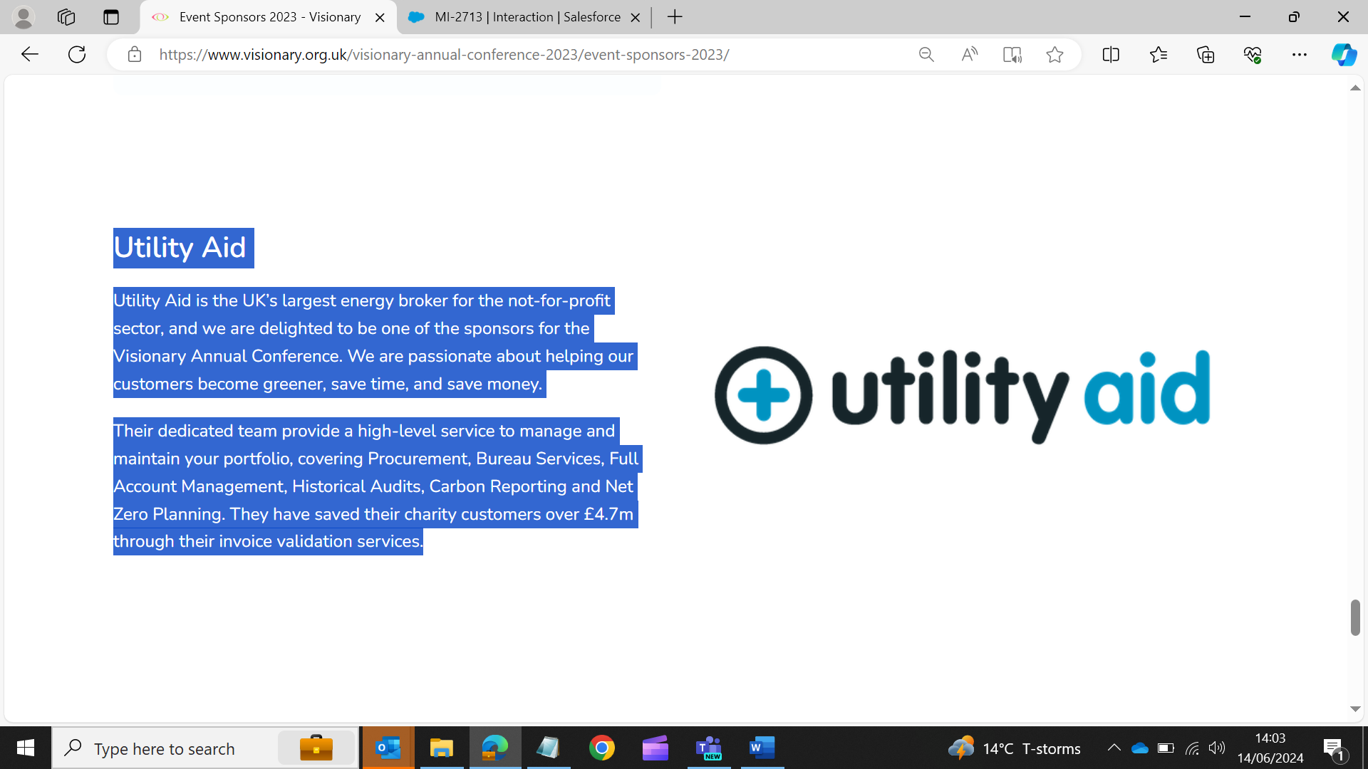

Utility Aid logo

Utility Aid is the UK’s largest energy broker for the not-for-profit sector, and we are delighted to be one of the sponsors for the Visionary Annual Conference. We are passionate about helping our customers become greener, save time, and save money.

Our dedicated team provide a high-level service to manage and maintain your portfolio, covering procurement, bureau services, full account management, historical audits, carbon reporting and net zero planning. We have saved our charity customers over £4.7m through our invoice validation services.

Web: <https://www.utility-aid.co.uk/>

#### Location of Exhibitors

The exhibition space consists of three different areas: upper lounge, lower lounge, and the bar area with a total of eight stands.  Please note the location of each stand is subject to change on the day. Please do not hesitate to ask a member of the Visionary team if you would like an introduction to an exhibitor.

The upper lounge is the first area you find when you enter the building after the reception. You can find the entrance on your right. Once you are in the upper lounge the stands from left to right are Optima Low Vision, Seable Holidays, ITSVIP, New College Worcester and Fight for Sight.

To access the lower lounge, you have a staircase joining the upper and lower lounge and also an entrance from the main hall. If you access the lower lounge from the main hall, on your right you find Associated Optical, Utility Aid and Charitylog.

The third section is the bar area. To access the bar there are two entrances by the main hall, one just after the lower lounge and one opposite the restaurant reception. Accessing the bar area by the first entrance, you find Blind Ambition, Torch Trust, Sight and Sound Technology and RNIB Connect Radio.

Visionary Annual Awards Dinner

If you have joining us for the Visionary Annual Awards Dinner, you are invited to join us from 19:00 for Reception Drinks, sponsored by Associated Optical. We aim to begin seating for dinner at approximately 19:30.

The Visionary Annual Awards celebrate the talent, expertise, and life-changing work of our members and partners. We love putting the spotlight on the incredible difference you’re making in local communities. You can read this year’s award categories and nominees on our website: [https://www.visionary.org.uk/visionary-annual-awards-2025/](https://eur03.safelinks.protection.outlook.com/?url=https%3A%2F%2Fwww.visionary.org.uk%2Fvisionary-annual-awards-2025%2F&data=05%7C02%7Camy.pearman%40visionary.org.uk%7Cb1520796463f4995468a08ddc44cb441%7C65395a073d564877b61bf53aafe53564%7C0%7C0%7C638882555938331012%7CUnknown%7CTWFpbGZsb3d8eyJFbXB0eU1hcGkiOnRydWUsIlYiOiIwLjAuMDAwMCIsIlAiOiJXaW4zMiIsIkFOIjoiTWFpbCIsIldUIjoyfQ%3D%3D%7C0%7C%7C%7C&sdata=%2F8A2H38lCdjyw%2BCtEJhPtjuz%2FLXv051acBEGP%2BRgzrs%3D&reserved=0)

This year’s celebrations will be brought to life at our Awards Dinner, hosted by the brilliant Owen Williams, CEO of Wales Council of the Blind and a Visionary trustee, with support from our fabulous guest host Lisa Cowley, CEO of Beacon Centre for the Blind. Expect a fun-filled evening of recognition, inspiration and plenty of laughs as we move from resounding applause to full-on quiz mode with a friendly (but competitive!) challenge to finish the night.

Nominations were shortlisted by representatives from previous award-winning organisations, sponsors and the Visionary team. Winners have been chosen by Visionary member and partner votes and will be announced during our awards dinner.

As always, a huge thank you to everyone who took the time to share their amazing work and submit a nomination. It’s been truly inspiring to read about your achievements – and not easy for the shortlisting panels to choose!

Thank you to this year's award sponsors:

**Accelerating Impact Award - Sponsored by Fight for Sight**

The Accelerating Impact Award, sponsored by Fight for Sight, recognises organisations that build capacity and create sustainable models to accelerate sector-wide progress, inviting nominations from Visionary members and their national partners. The award encouraged entries which demonstrated capacity-building initiatives that establish lasting foundations through innovative funding, knowledge sharing, or collaborative approaches benefiting blind and partially sighted people.

**Community Partnership Award - Sponsored by Specsavers**

This award, sponsored by Specsavers, highlights exceptional work across communities to improve eye health awareness and outcomes through community engagement, strategic partnerships with commissioning bodies and NHS Trusts, or co-design and collaboration with blind and partially sighted people. Visionary members and partners were invited to share their work and stories, with particularly entries showcasing partnerships with local opticians.

**Community Pathways Award - Sponsored by RNIB**

RNIB have sponsored this award, which celebrates bold and imaginative approaches to building meaningful connections with blind and partially sighted people, or those at risk of sight loss. It recognises Visionary members and partners who stepped beyond the familiar to reach new people and communities through cross-sector partnerships, creative digital platforms, co-designing community initiatives, or other innovative collaborations that expanded their reach and deepened their impact. Nominations were invited which showcased work with new allies, broke down barriers, or opened up new spaces for engagement and support; this is your chance to showcase how working together can transform lives.

**Customer Excellence Award - Sponsored by Guide Dogs**

The Customer Excellence Award, sponsored by Guide Dogs UK, celebrated outstanding dedication to service, support and care within the Visionary network, inviting nominations that showcased exceptional commitment to meeting client needs, creating accessible experiences, and delivering support with empathy and professionalism. Visionary members were invited to share submissions highlighting new standards of customer service excellence, innovative approaches or embedded services through personalised support, communication, co-creation of projects and services, or creating welcoming environments that understood and addressed the needs of blind and partially sighted people in local communities.

Workshops

At registration, you will be given a reminder of your chosen workshops and location. Below, is a recap of the of workshops available throughout the conference. We would like to express our appreciation to all workshop facilitators for dedicating their time, enthusiasm, expertise and knowledge insights at this year's event and sponsors for helping to make it happen.

**Workshop Overview – Day One**

|  |  |
| --- | --- |
| **Session 1** | **Wednesday 24September 2025, 13:30 to 14:45** |
| Option 1: | Measuring Customer Experience Effectively |
| Option 2: | Ethnic Minority Access and Care |
| Option 3: | “Wait...Who do I talk to about that?” Cracking the Code of Health Sector Speak |
| Option 4: | Collaborate for Impact. Making partnerships work for the people we support |
| Option 5: | Vision at Work: A new approach to inclusive recruitment for people with sight loss |
| Option 6: | The Eye Care Support Pathway for Children and Young People with a vision impairment in England |

|  |  |
| --- | --- |
| **Session 2** | **Wednesday 24 September 2025, 15:15 to 16:30** |
| Option 1: | Well intentioned to well executed – Creating your Equality, Diversity and Inclusion (EDI) Action Plan. |
| Option 2: | Acquired Sight Loss: Effective partnerships and a perspective of the nuances of working in a small jurisdiction. |
| Option 3: | Ending Projects and Services with Purpose. |
| Option 4: | Maximising and Measuring Impact. |
| Option 5: | Partnering to Boost Participation in Eye Research. |
| Option 6: | Making It Happen: Starting and sustaining services for children and young people. |

**Workshop Overview – Day Two**

|  |  |
| --- | --- |
| **Session 3** | **Thursday 25 September 2025, 10:30 to 11:45** |
| Option 1: | Practical AI Lessons for the Sector |
| Option 2: | Is your governing document fit for purpose or creating an unexpected tax risk? |
| Option 3: | Sharing a central team – an alternative to mergers? |
| Option 4: | Who Holds the Power? Influencing health decisions that matter. |
| Option 5: | Getting it right, by getting real: Building safe spaces for Lived Experience. |

|  |  |
| --- | --- |
| **Session 4** | **Thursday 25 September 2025, 12:15 to 13:30** |
| Option 1: | Beyond the Entry Fee: Uncovering the true cost of fundraising events. |
| Option 2: | Unlocking the Potential of AI Wearable Technology. |
| Option 3: | Developing positive and productive relationships between Trustees, Chair, CEO and SLT. |
| Option 4: | Community Voice. |
| Option 5: | Supporting blind and partially sighted children, young people and students through education. |

**Sess****ion One: Wednesday 24 Se****ptember, 13:30 to 14:45**

#### Option 1 Measuring Customer Experience Effectively

**Summary:** Every day our customers interact with us in a way that we hope means they will come back and encourage others to use us too. Knowing how good our customers' experiences are is therefore essential if we are to keep improving and keep up with rising expectations.

In this interactive workshop we will explore how meaningful measurement goes beyond basic customer satisfaction surveys. You will learn how to align customer metrics with your strategic goals, ensure your organisation is equipped to act on insights and ultimately prioritise improvement actions. This session will help you measure the right things in the right way so that the data leads to impactful decisions, not just scores and reports.

**Audience:** All

**Geography:** UK wide

**Facilitator:**

**Jerry Angrave, Strategic Customer Experience Consultant, Empathyce**

Jerry Angrave is founder and director of Empathyce, a customer experience consultancy. He is a Certified Customer Experience Professional and works with companies around the world to help make them more customer centric. Jerry chairs the Accessibility Advisory Board at Virgin Atlantic and is a member of the Accessibility Advisory groups at Heathrow and Bristol airports.

#### Option 2 Ethnic Minority Access and Care

**Summary:** Our communities are diversifying and it is important that our reach, engagement and service provision matches up to the communities we serve. Sight Cymru has for many years worked with communities and professionals to break the barriers and open access and care for ethnic minority communities. The workshop will focus on why this work is important and share tested good practices and findings.

**Audience:** Service Providers, Leaders and Trustees

**Geography:** UK wide

**Facilitators:**

**Dr. Bablin Molik, CEO, Sight Cymru**

Bablin graduated in BSc Biochemistry and then went on to complete her PhD in Vision Biology and Glaucoma. She has worked in Sight Cymru for over 12 years and was appointed CEO in 2019. Alongside her work with Sight Cymru, she is also an elected councillor in Cardiff, Lord Mayor of Cardiff 2023/24 and currently the chair of the Adult Social Care Scrutiny Committee. She is also board member for UCAN productions and a Patron at Skills and Volunteering Cymru (SVC).

**Olubunmi Gani-Mustapha, Business Support Manager, Sight Cymru**

Bunmi is the Business Support Manager at Sight Cymru, where she leads projects that promote independence and inclusion for people living with sight loss. Passionate about equality and community engagement, she brings both professional insight and lived experience to her work in the sight loss sector. Bunmi brings a wealth of experience from her background in Business Analysis and Consular Affairs. She obtained a distinction in her Master of Business Administration (MBA) UK and has worked for several years in public service roles, both in the UK and internationally.

**Tosin Adeleke, Awareness Officer, Sight Cymru**

Tosin holds a First Degree in Biology and a Master's in Epidemiology from Nigeria. With experience as a hospital administrator in Nigeria. Tosin relocated to the UK in 2023 and currently serves as an Awareness Officer at Sight Cymru, where he combines his healthcare background with community outreach and education.

#### Option 3 Wait…Who do I talk to about that? Cracking the Code of Health Sector Speak.

**Summary:** Ever found yourself shouting into the void, trying to get a response from someone in the NHS? You are not alone!

Based on the real-world learnings from our recent Specsavers project, this workshop is here to help you cut through the jargon jungle and get your message heard by the right people – whether they’re health professionals, commissioners, or contractors who mysteriously vanish the moment you find out their name.

Six Visionary member organisations bravely took part in our project, which explored how we, as sight loss charities, can make our voices clearer and louder in health settings – and not just to people who already ‘get it’.

In this workshop, we will:

* share what we learned (so you don’t have to reinvent the wheel),
* help you track down who you *should* be talking to (without needing MI5 clearance),
* show you how to tweak your existing materials so they speak the language of NHS-land.

Join us for an honest, practical and slightly irreverent look at how to make your fantastic work stand out in a system that isn’t always easy to navigate – and leave with tools to boost your comms confidence and impact.

**Audience:** Anyone who wants to influence our colleagues working in health, from all sizes of organisations.

**Geography:** England

**Facilitators:**

**Carol O'Brien, CEO, Sight Concern Bedfordshire**

Sight Concern is funded by NHS Integrated Care Board, Hospital Trusts and local authorities to improve beneficiary outcomes by being part of the Bedfordshire eyecare pathway.  Carol balances the time spent nurturing NHS relationships with sustaining the charity’s impact through its larger income stream - grants and contracts.

**Kathie Hughes, Low Vision Advisor, Sight Concern Bedfordshire**

Kathie Hughes is a Low Vision Advisor at Sight Concern Bedfordshire, where she leads their Low Vision Service, supporting individuals living with sight loss to maintain their independence and improve their quality of life. Kathie works closely with clients to provide low vision aids, practical advice, rehabilitation strategies and assistive technology guidance tailored to their individual needs.

**Laura Mitchell, CEO of Berkshire Vision**

**Gill Comley, Head of Projects & Volunteering at Berkshire Vision**

Berkshire Vision do not hold any NHS contracts and have been looking to engage with their two local ICB’s with Specsavers guidance.

**Richard Curtis, NHS Enhanced Optical Services – Service Development Manager, Specsavers**

Richard is part of the team which leads the development of Enhanced Optical services for Specsavers in England. Within his role he balances engagement with the NHS and the expectations of a global organisation. Richard Joined Specsavers 11 years ago having previously spent over a decade working in the NHS in a variety of roles but most notably in the contracting and commissioning of services. Richard loves to cycle and lives in the New Forest with his wife and daughter.

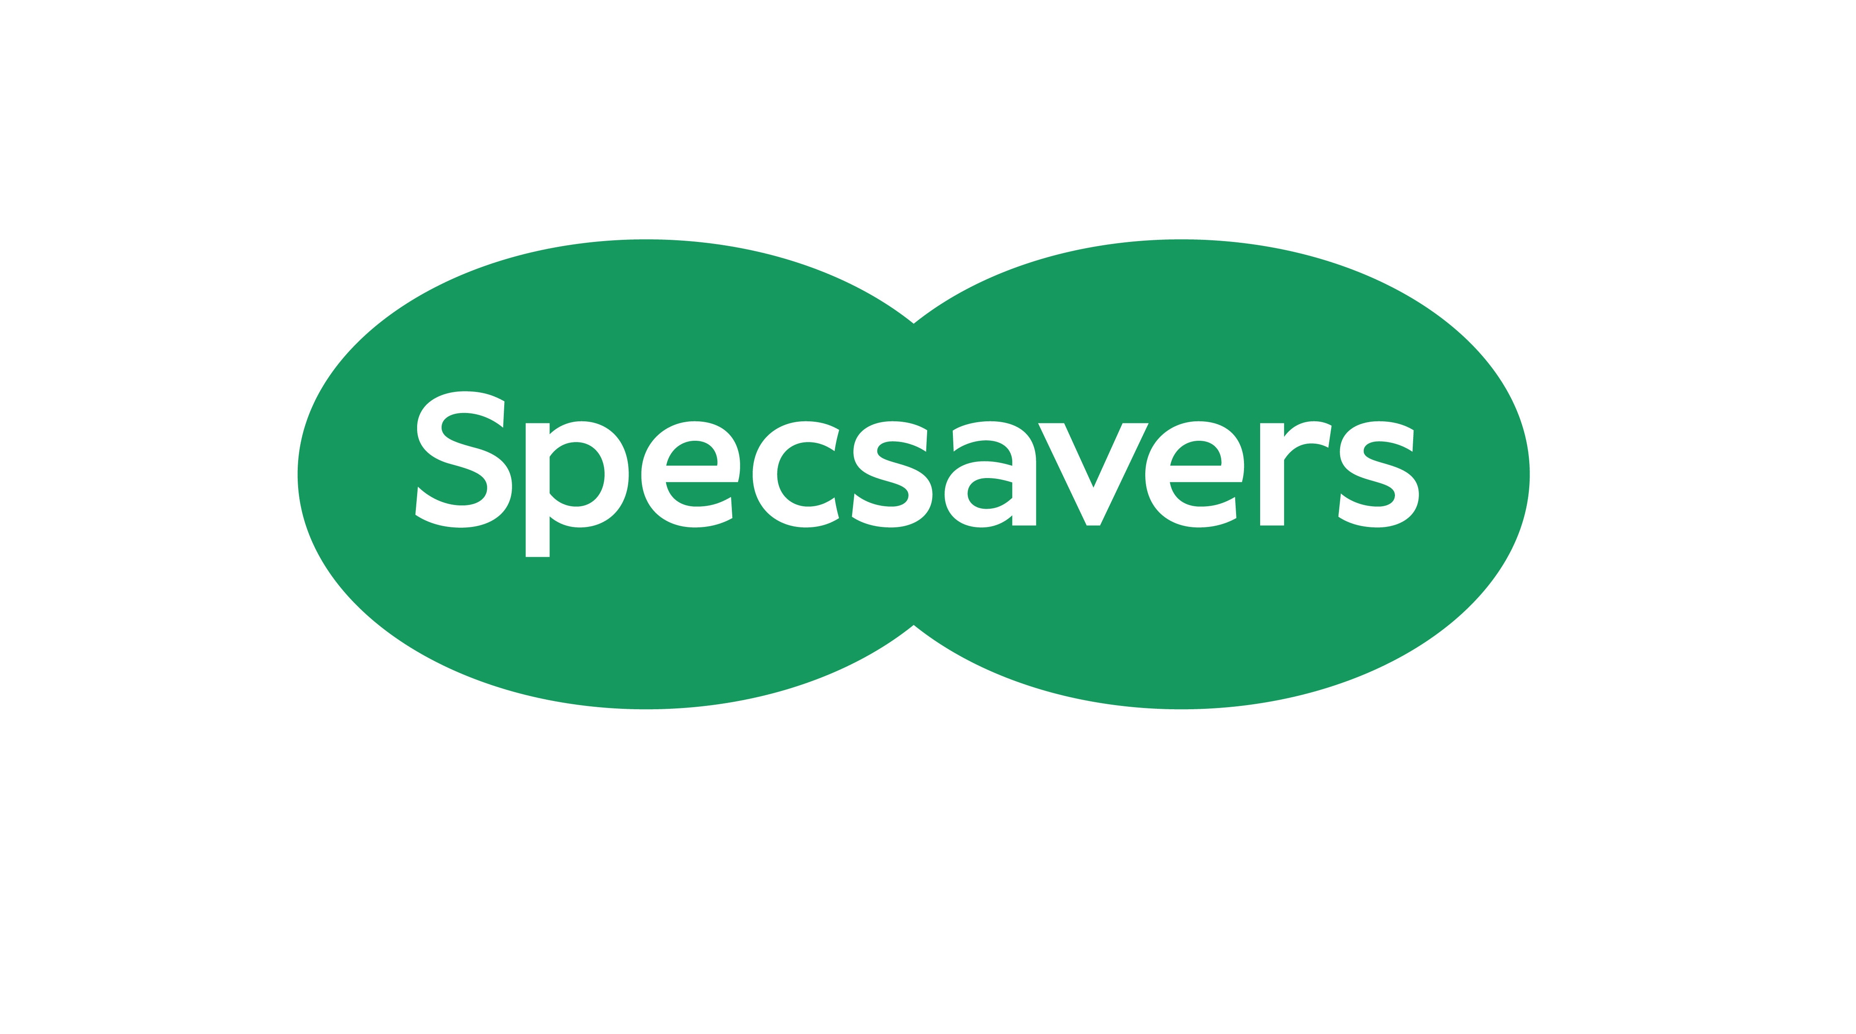

Specsavers logo

**Sponsor:** Thank you to **Specsavers** for sponsoring the **Wait…Who do I talk to about that? Cracking the Code of Health Sector Speak** workshop and project work.

#### Option 4 Collaborate for Impact. Making partnerships work for the people we support.

**Summary:** This interactive workshop will explore what it really takes to build effective partnerships across organisations of different sizes, structures, and cultures. Using insights from the North - West Eyecare Pathway working group as a starting point, we’ll reflect on what has helped—and hindered—collaborative working so far and consider how this learning applies to our own contexts.

Through group discussions and practical tools, we’ll identify what enables strong partnerships, where the sticking points tend to be, and how we might overcome them. Whether you’re already part of a partnership or just starting to explore the potential, this session will help you surface ideas, embrace opportunities for self-reflection, and leave with tangible next steps.

**Audience:** Everyone from any size of organisation

**Geography:** UK wide, the case study is focused on work in England

**Facilitators:**

**Sara Cook, Service Manager, Sight Advice South Lakes**

Sara is the Services Manager at Sight Advice South Lakes, where she leads a wide range of support services for people living with sight loss. Before joining the charity sector, Sara spent 17 years working in education. Over the past three years, she has focused on building partnerships that strengthen local service delivery, improve outcomes for blind and partially sighted people, and create space for honest conversations across organisations of all sizes.

**Colin Elliot, Partnership Development Manager, RNIB**

Colin is RNIB’s Partnership and Development Manager for Northern Ireland and also contributes to development work in NW England. Colin has previously held various roles in the statutory and voluntary sector, notably a regional team leadership role at Guide Dogs.

**Mike Harrison, Partnership Development Manager, RNIB**

Mike is RNIB’s partnership and Development Manager in NW England and has worked in the sight loss sector for over 20 years. Formerly at Henshaws and Action for Blind People, Mike’s role at RNIB has seen him contribute to the development of ECLO nationally and what is now the Eye Care Support Pathway. Mike has lived experience of sight loss which helps inform his work.

#### Option 5 Vision at Work: A new approach to inclusive recruitment for people with sight loss.

**Summary:** This engaging, hands-on workshop invites delegates to explore an inclusive recruitment website specifically designed for visually impaired job seekers. Delegates will receive the site URL and be guided through its accessible features – from job listings to CV submission tools. Co-led by Blind Ambition and RNIB, this interactive session will showcase how visually impaired users can independently navigate and benefit from the platform. We’ll also gather feedback to further refine and improve the service. This session highlights how inclusive tech, co-designed with lived experience, can dismantle barriers and empower blind and partially sighted people in the job market.

**Audience:** Leaders, Trustees, Project/Service Managers, Employment and Inclusion Leads, Digital Inclusion Officers – everyone interested in disability inclusion and employment from all size organisations.

**Geography:** UK wide

**Facilitators:**

**Seema Flower, Founder and Managing Director, Blind Ambition**

Seema Flower is a totally blind entrepreneur and award-winning disability inclusion expert. As founder of Blind Ambition, she works with national and international organisations to improve accessibility and tackle the 75% unemployment rate among blind and partially sighted people.

**Martin O’Kane, Head of Employment and High Education Pathways, RNIB**

Martin leads RNIB’s Employment and Technology Services and has worked in the field of sight loss and employment for many years. He is passionate about removing barriers for people with sight loss to find and retain work.

#### Option 6 The Eye Care Support Pathway for Children and Young People with a vision impairment in England

**Summary:** Produced by Guide Dogs in partnership with the wider sight loss and clinical sector, the Eye Care Support Pathway for Children and Young People with a Vision Impairment is an essential resource for parents, practitioners, service providers and commissioners. The Pathway sets out the journey of support for children and young people as a clear navigable pathway, from initially noticing a possible eye condition, right through to transitioning to adult services (and the adult pathway).

Join us to hear more about the Pathway and to discuss how we can work together as a sector to disseminate and implement this new resource, helping to support both your work and families and young people in your area.

**Audience:** Local service providers, habilitation and QTVI specialists, clinical professionals, and anyone else, from all sizes of organisation, involved in supporting parents, young people and children with a vision impairment**.**

**Geography:** England

**Facilitators:**

**Alex Clarke, Senior Policy, Public Affairs and Campaigns Manager**

Alex Clarke is Senior Policy, Public Affairs and Campaigns Manager at Guide Dogs, working to influence policy and legislation to improve the experiences of children and young people with a vision impairment.

Throughout his career, Alex has had extensive experience leading campaigns to secure positive change for national charities, including Citizens Advice and Age UK.

**Laura Hughes, Chief Executive Officer, Moorvision**

Laura Hughes is the founder and CEO of MoorVision, a sight loss charity offering support to Children and Young People aged 0-29 across Devon and Cornwall. The charity was started as a parent/carer support group in 2007 and now supports almost 300 Children and Young People with VI. Laura is a member of the CYP VI Network Group and an active participant and speaker at these and Visionary meetings and conferences.



**Sponsor:** Thank you to **Guide Dogs UK** for sponsoring and facilitating this workshop.

**Sess****ion Two: Wednesday 24September, 15:15 to 16:30**

#### Option 1 Well intentioned to well executed – Creating your Equality, Diversity and Inclusion (EDI) Action Plan.

**Summary:** This workshop prepares organisations to take meaningful action towards building an anti-oppressive and inclusive workplace culture. The workshop will focus on three main areas.

1. A general refresher on language, frameworks, and skills.
2. A mini assessment of where your organisation stands with its EDI efforts.
3. Building a personalised toolkit for your EDI strategy.

In addition, participants will discuss strategies for moving beyond intentions to action and principles for garnering engagement from stakeholders. During this interactive and hands-on workshop, learners will develop skills for creating and implementing an EDI action plan by building a personalised toolkit.

**Audience:** Everyone

**Geography:** UK wide

**Facilitator:**

**Anuradha Kowtha, Accessibility Consultant, The Kowtha Constellation**

Anuradha Kowtha is the founder and strategist at The Kowtha Constellation. We empower organisations to pioneer accessible and equitable initiatives and create psychologically safe environments that foster innovation, joy, and liberation so that they can attract and retain top talent.



Sight Scotland and Sight Scotland Veterans combined logo

**Sponsor:** Thank you to **Sight Scotland and Sight Scotland Veterans** for sponsoring this workshop.

#### Option 2 Acquired Sight Loss: Effective partnerships and a perspective of the nuances of working in a small jurisdiction.

**Summary:** The workshop will encourage delegates to work through two scenarios to explore access to and use of the different skills and services available, allowing opportunity to share examples of good practice. This will be explored within the context of the Eye Care Pathway and in addition to the variations of working with and without legislated requirements. The workshop will also allow the comparison of working in isolated settings where self-resilience is critical for providing services. The hope is that exploring these scenarios will allow delegates to consider different ways of working to improve the client journey.

**Audience:** Team leaders and those strategically and operationally engaged in partnership working.

**Geography:** UK wide but outlining also nuances of working in isolated areas where broader resilience is not immediately available.

**Facilitators:**

**Mark Coxshall, Chief Executive Officer, EYECAN**

Mark worked in the States of Jersey Police for 30 years and held the rank of Detective Chief Inspector. Mark has a significant background in developing partnerships at local, national and international levels across policing areas and now within the charity sector. In July 2023, Mark assumed his current role as Chief Executive Officer for EYECAN (Formerly the Jersey Blind Society). Mark is a member of Government of Jersey Disability and Inclusion Advisory Board.

**Agnetta Nerac, Community Team Manager, EYECAN**

Agnetta is an Occupational Therapist and worked within the Government of Jersey Health & Community Services for 20 years. Her roles have included working in Community Services, Wheelchair Services, Older Person’s Mental Health Services and latterly as Deputy Head and Head of Service. Agnetta moved to EYECAN in August 2020 to work as part of their community team, and in January 2025 took on the role as Community Team Manager.



Utility Aid logo

**Sponsor:** Thank you to **Utility Aid** for sponsoring this workshop.

#### Option 3 Ending Projects and Services with Purpose.

**Summary:** We often focus on successful launches and implementations of projects and services but rarely plan for effective conclusions and exits. This workshop addresses the critical but overlooked skill of ending initiatives well.

How we manage endings, whether winding down a project, discontinuing a service, or handing over to another provider, significantly impacts stakeholders, determines whether achievements are preserved and shapes future opportunities.

Mismanaged endings can have a negative impact on relationships, waste valuable learning and leave loose ends that drain resources long after the formal conclusion. In contrast, thoughtful endings create opportunities for growth and future success.

Discussion will include:

* + planning effective endings from day one,
  + communicating transparently with all stakeholders including staff and volunteers,
  + capturing and transferring critical knowledge,
  + creating meaningful procedures which acknowledge achievements, recognising and managing the emotional aspects of organisational endings.

Participants will work through real scenarios and share experiences to build practical skills for ending projects well, communicate more confidently about change throughout the process and protect both relationships and the legacy of their work.

**Audience:** Leaders, trustees and anyone developing and managing projects.

**Geography:** UK wide

**Facilitator:**

**Nicola Upton, Consultant, N. Upton Consulting**

Nicola is a charity consultant, specialising in change, leadership, and developing services with impact. She has worked in charities for over 20 years, from the very large to the very small, including as a Director and CEO, leading service delivery and at different times, overseeing income generation, HR, strategy and engagement.

Nicola is committed to supporting charities to improve their resilience and capacity, and to help to answer the ‘knotty questions’ they have with practical, achievable solutions.

#### Option 4 Maximising and Measuring Impact

**Summary:**

Join Fight for Sight, the Thomas Pocklington Trust and the Powell Family Foundation to explore all things impact. We’ll share what we’re looking for as funders and will use what we hear from you – as potential applicants – to inform the shape of future funding. Fight for Sight will share experiences of developing our Theory of Change and Impact framework and will use this to stimulate an open and honest debate about the funding of our sector: what it should focus on, what the quality of the evidence base is and how we work together to accelerate change for blind and vision impaired people.

**Audience:** All

**Geography:** UK wide

**Facilitators:**

**Ellie Southwood – Director of Impact and External Affairs at Fight for Sight**

Ellie joined Fight for Sight following a decade as an elected Councillor on Brent Council. She served in the Council’s Cabinet for 8 years with responsibilities ranging from housing to environmental and highways services. Ellie is a former Chair of the Royal National Institute of Blind People (RNIB) and currently chairs Habinteg Housing Association, which specialises in accessible and adaptable homes.

**Colin Whitbourn – Executive Director at the Powell Family Foundation**

Colin has worked for vision impairment charities for over 20 years including Action for Blind People and RNIB. He is now Executive Director at The Powell Family Foundation.

**Martin Symcox - Head of Partnerships and Projects at Thomas Pocklington Trust**

Martin Symcox is Head of Partnerships and Projects at Thomas Pocklington Trust, a national charity supporting blind and partially sighted people to bring about equity and inclusion in every aspect of society. With over 19 years of leadership experience across the leisure and sight loss sectors, Martin has consistently driven strategic innovation, improved accessibility in sport and leisure, and built lasting partnerships that deliver real impact. Martin has previously served as CEO of Metro Blind Sport, where he led transformative initiatives to expand inclusive sporting opportunities, and as Director at the Royal Life Saving Society UK, the country’s leading water safety charity. Martin also holds a Non-Executive Director role at Seable Holidays, a specialist travel company for people with sight loss. He is a passionate advocate for equity, inclusion and opportunity in every aspect of life.

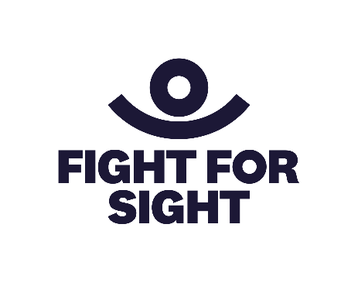

Fight for Sight logo

**Sponsor:** Thank you to **Fight for Sight** for sponsoring this workshop.

#### Option 5 Partnering to Boost Participation in Eye Research.

**Summary:** We know that many people with lived experience of sight loss want to take part in research. Taking part in research can help people make a difference to future generations, support health research and take an active role in their own health care. Over 90% of people who take part in research would consider doing so again. But what’s stopping people?

This workshop, run by Macular Society and Glaucoma UK, will explore the different ways people with lived experience can be part of research, from inception to dissemination. We will investigate how charities funding research, sight loss charities, service users and researchers can work together to encourage participation and make sure the benefits of eye research are felt as widely as possible.

**Audience:** Everyone, particularly with an interest in eye research from all sizes of organisations

**Geography:** UK wide

**Facilitators:**

**Dr Peter Bloomfield, Director of Research, Macular Society**

Peter is Director of Research at the Macular Society and is expanding research programmes across academia and industry. He is a neuroscientist by background and his PhD from Imperial College London focused on human brain imaging.

**Joanna Hodgkinson, Head of Research, Glaucoma UK**

Joanna is Glaucoma UK’s Head of Research, overseeing all aspects of the charity’s research funding and support, including encouraging participation in research and disseminating the findings of the research. Joanna previously worked as Head of Support Services at Glaucoma UK and used to be a science teacher. This means she has a love of helping people make sense of science, including the intricacies of glaucoma research and what it means for them.

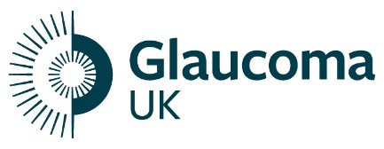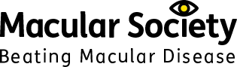

Glaucoma UK logo and Macular Society logo – Beating Macular Disease

**Sponsor:** Thank you to **Glaucoma UK and Macular Society** for sponsoring and facilitating this workshop.

#### Option 6 Making It Happen: Starting and sustaining services for children and young people.

**Summary:** Join Hayley and Nneamaka for an open discussion about what it really takes to deliver great services for children, young people and families. This workshop aims to bring together people just starting out and those with established services. During the workshop Hayley and Nneamaka will share what they've learned, what has worked in their local communities and how ideas have grown into services. This workshop will be an open and honest conversation around the real challenges we face, the practical things that make a difference and personal reflections on developing services. Come prepared to talk about your own experiences, pick up some quick wins from others and leave with new ideas. Whether you're launching something new, trying to improve what you've got, or just want to connect with others facing similar challenges, we hope this workshop will be valuable.

**Audience:** Anyone currently delivering and developing services for children and young people or thinking of starting activities and who doesn’t know where to start.

**Geography:** UK wide

**Facilitators:**

**Hayley Grocock, Chief Executive Officer, Wakefield District Sight Aid.**

Hayley has been CEO of Wakefield District Sight Aid (WDSA) for 8 years. She also facilitates Visionary’s bi-monthly Small Organisations Forum. WDSA is a small, local charity that started exploring activities for children and young people two years ago. Now successfully running a programme of activities, including the only VI youth football team in West Yorkshire, Hayley is looking forward to sharing WDSA’s journey with you.

**Nneamaka Eleje, Children’s Outreach Worker, Merton Vision**

Merton Vision supports blind and visually impaired children and young people across the London Borough of Merton. Nneamaka works directly with children and their families, providing practical support such as helping them access benefits and grants, securing essential equipment and organising inclusive activities for children, their siblings, and families. Merton Vision also delivers vision impairment awareness training in schools to foster understanding and create inclusive environments for visually impaired pupils. Their collective work is focused on empowering families and ensuring every child receives the support they need to thrive.

**Cathy Hurst, Grants Manager, The Powell Family Foundation**

The Powell Family Foundation awards grants to children and young people with a vision impairment and the organisations that support them. Cathy started at TPFF a few months after its inception in April 2023 and is responsible for managing the grant programme.

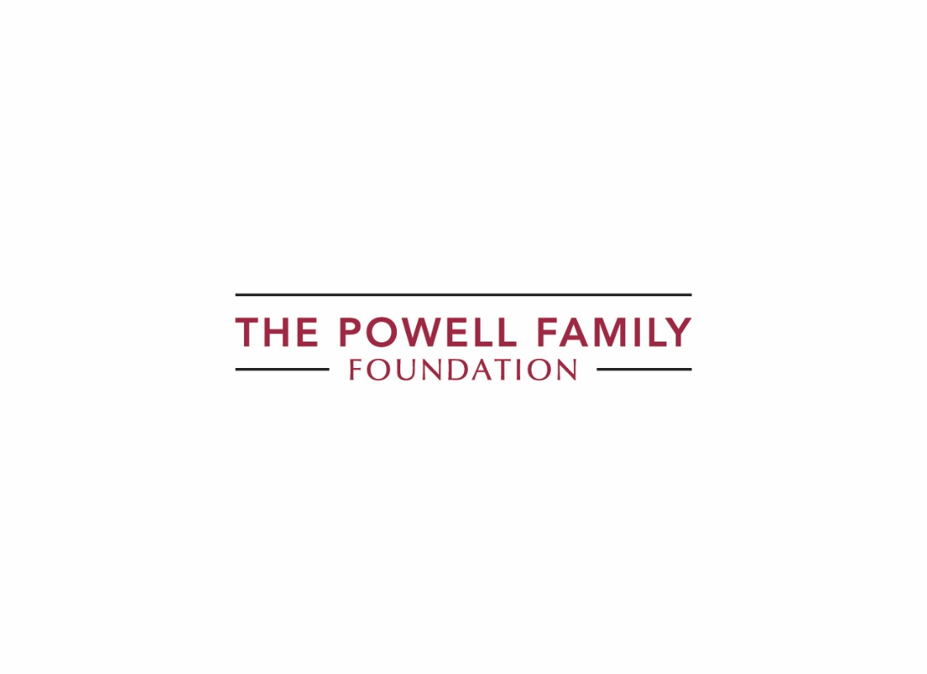

The Powell Family Foundation Logo

**Sponsor:** Thank you to everyone at **The Powell Family Foundation** for sponsoring this workshop

**Session Three: Thursday 25September, 10:30 to** **11:45**

#### Option 1 Practical AI Lessons for the Sector

**Summary:** Join Ben Cohen (Good Innovation) and Peter Bloomfield (Macular Society) for an energising session that cuts through the hype to make AI practical and useful for the sector.

The workshop will kick off with the inside story of the cross-charity AI Collaboration: why ten UK nonprofits teamed up, what they learned, what responsible AI really means, and the myths they busted (spoiler: AI is a people challenge before it’s a tech one). Peter will then share Macular Society’s own journey: wins, stumbles and top tips. Next, delegates will work in small groups to map where their organisations sit on a three-level adoption framework, swap ideas with peers and choose one practical AI use case they can implement tomorrow.

**Audience:** Leaders and Trustees, with content relevant for all sizes of organisations.

**Geography:** UK wide

**Facilitators:**

**Ben Cohen, Director, Good Innovation**

Ben Cohen is a Director at Good Innovation, where he led the cross-sector AI Collaboration: a programme that equipped leading nonprofits with an AI roadmap, toolkit and guidance for responsible adoption

Drawing on a decade of innovation leadership at the British Red Cross and Macmillan Cancer Support, Ben now helps mission-driven teams grow their income and reach.

**Peter Bloomfield, Director of Research, Macular Society**

Peter is Director of Research at the Macular Society and is expanding research programmes across academia and industry. He is a neuroscientist by background and his PhD from Imperial College London focused on human brain imaging.

#### Option 2 Is your governing document fit for purpose or creating an unexpected tax risk?

**Summary:** Gain a solid understanding of your governing document; the importance of its key provisions and what it can mean for your tax obligations.

This session will cover:

* the central role of your organisation’s objects and powers;
* what your governing document can mean for VAT and other taxes;
* the role of members and the board; and
* the process for amending your governing document.

This seminar is essential for anyone involved in the governance or finance functions of a charity.

**Audience:** Trustees, CEOs and Senior Managers

**Geography:** UK wide, but where law is referenced, this will be the law of England & Wales

**Facilitators:**

**Andrew Studd, Partner, Russell-Cooke LLP**

Andrew advises charities, social enterprises, trade associations and other membership and not-for-profit organisations on a wide range of charity and company law issues and commercial matters. He helps guide charity boards through challenging situations and renewal. He provides advice on constitutional and governance matters, commercial contracts, restructuring, mergers and incorporations, funding issues, joint ventures and collaborative working arrangements.

**Ian Brown, Director – VAT, S3TAX**

Ian is a not-for-profit and public sector VAT specialist. Ian works with not-for-profit organisations to ensure they pay the right amount of VAT at the right time by providing advice and support on issues such as VAT registration, VAT recovery and the application of charitable VAT reliefs.



Russell Cooke logo

**Sponsor:** Thank you to **Russell Cooke** for sponsoring and co-facilitating this workshop and to **S3TAX** for supporting the conference.

**About S3TAX**

S3TAX is a sector specialist tax advisory firm, providing the high quality, sector-focused, and value for money tax support and training the third sector demands. Our team’s extensive sector experience showcases our in-depth knowledge and our ability to navigate the intricacies of sector-specific tax regulations, reliefs, and exemptions.

**Contact details: 0345 686 6551 and** [**admin@s3tax.co.uk**](mailto:admin@s3tax.co.uk)



S3TAX Logo

#### Option 3 Sharing a Central Team – an alternative to mergers?

**Summary:** The session will present the joint working model that three neighbouring sight loss charities have developed, using a shared operations team to enhance service delivery and operational efficiency for their respective service users.

The joint working arrangement was developed by Sight Support West of England, Insight Gloucestershire and Wiltshire Sight to ensure people with sight loss have access to comprehensive and high-quality services across the wider local region, whilst maintaining the local identities of the three charities involved, and ensuring the charities benefit from shared cost and management efficiencies.

The model centres on a shared operations team who support three teams of front-line support workers at each charity.  The central team are jointly employed by the 3 organisations and include:

* all senior management posts, including shared CEO,
* Volunteer Coordinator,
* finance and administration,
* fundraising team,
* communications & marketing,
* monitoring and evaluation.

The format of the session will be a presentation of the model followed by Q&A. The presentation will cover a range of issues we have had to work through, including addressing cultural differences, developing financial models for cost sharing, sharing sight loss assessment processes and CRM systems, joining staff teams and adapting management structures, data sharing and VAT implications.

**Audience:** Trustees and leaders of small to medium size organisations

**Geography:** UK wide

**Facilitators:**

**Mike Silvey, CEO, Sight Support West of England**

Mike lives in Bath and has led the team at Sight Support West of England since the charity was formed in 2018. Mike has worked within the charity sector for more than 30 years, from working on rehabilitation of ex-offenders in the UK, to managing education and disability programmes in Cambodia and Rwanda.

**Jen Hall, Head of Fundraising and Communications, Insight Gloucestershire, Sight Support West of England and Wiltshire Sight.**

Jen has been a fundraiser for more than 20 years; working for organisations big and small from nationally recognised brands to local causes.  Jen specialised in individual giving, fundraising strategy and compliance and developing teams and individuals to excel and deliver great campaigns.  Jen joined Sight Support West of England in 2020.  As well as fundraising through “unprecedented times”, Jen developed new processes and ways of working to talk publicly and positively about how and why two charities (Wiltshire Sight and Sight Support West of England) work together.  Along with Mike Silvey and Head of Services Glenda Prall, Jen has led the development of the collaboration with Insight Gloucestershire over the last two years.

#### Option 4 Who Holds the Power? Influencing Health Decisions that Matter.

**Summary:** Lisa Cowley, CEO at Beacon Vision and NHS Non-Executive Director and Steph Cartwright, Group Chief Community and Partnerships Officer at Royal Wolverhampton and Walsall Healthcare Trusts share how, together, we can transform health services and communities.

This workshop will give you an insight into how the health system really works in England and the ways to make connections which will influence decision makers and improve provision for our communities. Join Lisa and Steph to find out which are the meetings, board and roles that really have the power and the language that will get people to sit up and listen.

Learn from Beacon Vision’s experience and find out what you can actually influence, which meetings to target, what roles really have the power and how to communicate with these role holders in a way which will influence how services are delivered.

**Audience:** Everyone from organisations of any size

**Geography:** England focused from an NHS operating model, but principles are relevant across the UK

**Facilitators:**

**Lisa Cowley, CEO, Beacon Vision**

Lisa’s career has been built across the voluntary sector and now she has a foot in both camps as CEO at Beacon Vision and an NHS Non-Executive Director.

**Steph Cartwright, Group Chief Community and Partnership Officer, Royal Wolverhampton and Walsall Healthcare**

Stephanie is passionate about partnerships, the integration of services and co-ordination of care, and leads the place - based partnerships and implementation of neighbourhood health across Wolverhampton and Walsall.

#### Option 5 Getting it Right, by Getting Real: Building safe spaces for Lived Experience.

**Summary:** Join Joanne and Shari for an interactive workshop, helping teams in the sight loss sector build psychologically safe spaces where both visually and non-visually impaired people feel heard, respected and empowered. Through guided discussions, real world scenarios and practical tools, participants explore the shared fear of getting it wrong and how it can create barriers to inclusion.

**Audience:** Everyone. Please note this workshop has a limit of 20 delegates.

**Geography:** UK wide

**Facilitators:**

**Joanne Ardern, CEO, Sheffield Royal Society for the Blind**

Joanne has 24 years of experience in the field of vision impairment at SRSB, joining the Community Advice Officer team in 2001 and then becoming their team leader in 2005. She spent 4 years as Deputy Manager and took over as CEO in 2022. Working her way through the ranks has given her an invaluable perspective of this local charity. She supports the delivery of the charity's services, whilst also supporting all its staff and volunteers. SRSB also operates a residential care home in Sheffield and a division in Rotherham which also offers services for deaf people and hearing aid users. SRSB is 165 years old, Joanne is a bit younger!

**Shari Attuh, Lived Experience Leadership Projects Officer, Thomas Pocklington Trust**

Shari is the Lived Experience Leadership Projects Officer at TPT, with a background in tech, personal branding, and storytelling. She brings a strong focus on inclusive leadership and is working within the sector to amplify underrepresented voices.



Thank you to **RNIB** for sponsoring this workshop.

**Session Four: Thursday 25September, 12:15 to 13:30**

#### Option 1 Beyond the Entry Fee: Uncovering the true cost of fundraising events.

**Summary:** Are you capturing the full value of participating in place purchase events, such as the London Marathon places and fire walks? This workshop helps you measure both the hidden costs and benefits that determine your events' true impact.

Beyond entry fees and materials, we'll explore comprehensive costs including staff time, volunteer coordination, admin expenses, and staff wellbeing considerations. Equally important, we'll examine the powerful hidden benefits: raising awareness of sight loss, converting participants into long-term supporters, building community connections and creating ambassadors for your organisation.

We will explore measuring the true return on investment that goes beyond immediate fundraising income. Learn to capture and quantify the full value including profile raising, ongoing engagement opportunities and outcomes that resonate far beyond the event itself.

Perfect for fundraising managers, charity trustees, and leaders of nonprofit making organisations who want to make strategic decisions based on complete information and maximise the total impact of their fundraising activities.

**Audience:** Anyone involved in fundraising and planning events.

**Geography:** UK wide

**Facilitators:**

**Joanna Waton, Fundraising Manager, MyVision Oxfordshire**

Joanna has worked in fundraising since 2010, with a strong background in Trusts and Grants fundraising. For the past four years, she has been the Fundraising Manager at MyVision Oxfordshire, where she leads the organisation’s fundraising and communications strategy. Her work includes community and events fundraising, individual giving, and trust-based income, helping to support the charity’s vital services.

**Matthew Limb, Community and Events Fundraising Manager, Royal Society for Blind Children**

For the 2026 London Marathon, Matt will be leading The Royal Society for Blind Children (RSBC)'s campaign for his fourth consecutive year as a Community and Events Manager. His track record includes spearheading one of The Children's Society's most successful London Marathon presences. Matt is driven by a desire to continually innovate how charities approach the London Marathon, understanding the significant opportunities it presents.

#### Option 2 Unlocking the Potential of AI Wearable Technology Outline

**Summary:** Join us for a panel session exploring the potential of AI wearable technology and sight loss services response. This session features demonstrations of the latest devices alongside a panel discussion examining how these innovations can complement and enhance existing services.

**Audience:** Everyone

**Geography:** UK wide

**Panel Host: Clare Burgess, CEO, Sensory Services by Sight for Surrey**

Clare is the CEO for Sensory Services by Sight for Surrey. She has worked in the third sector for around 20 years and started her career with Guide Dogs before moving onto roles within mental health and pan-disability charities. Clare is a technology enthusiast, with a particular focus on ‘tech for all’ having previously set up digital inclusion programmes. Clare is the former Chair of TAVIP.

**Panellists:**

**David Quarmby, Chair of Trustees, Outlookers.**

David has been registered blind since a teenager and has developed his interest in technology over the years. He has been employed in numerous capacities in Social Work and Probation and was seconded to work for the National Offender Management Service as Assistive Technology Coordinator for 6 years.

**Matthew Horspool, General Manager, The Braillists Foundation**

Matthew has been blind since birth, with a career spanning over ten years in the visual impairment sector in roles which bridge the boundaries between braille and technology. As a freelance trainer and consultant, he specialises in helping visually impaired people to make the most of assistive technology in the workplace. Matthew is also the General Manager of the Braillists Foundation, championing braille through a mixture of work on the ground and international standards-setting efforts.

In his free time, he is a Trustee of Coventry Vision Hub and sings in the choir at Coventry Cathedral.

**Tommy Dean, Operations Technology Specialist, Guide Dogs**

Tommy Dean is a Technology Specialist at Guide Dogs. He tests accessible mainstream and assistive technologies, then supports specialists across the organisation to build the skills they need to use and share them effectively.

**Sponsor:** This workshop is funded by the Tech Hub Project, a Vision Partnership project led by Guide Dogs UK

#### Option 3 Developing positive and productive relationships between Trustees, Chair, CEO and SLT

**Summary:** An opportunity to consider how you develop and maintain positive relationships between trustees and senior management. We will consider the respective roles of trustees and senior managers and how to get the best out of these relationships – looking to find the right balance for sharing and understanding responsibilities as a team and how best to support each other in doing this.

**Audience:** Chairs, Trustees, CEOs and other senior management. Please note, this workshop has a limit of 20 delegates.

**Geography:** UK wide

**Facilitator:**

**Alison Oliver, Director, Alison Oliver Consulting Limited**

Alison has spent over 25 years working in the commercial and third sectors as a consultant, executive director and non-executive director. She has been working in the third sector for the last 12 years, most recently as a charity consultant specialising in finance, governance, strategy, transformational change, stakeholder engagement and relationship management. Prior to that she was Director of Strategic Partnerships at Thomas Pocklington Trust (TPT), the CEO of Visionary, and Finance Director at TPT. Alison is a chartered accountant and, in her earlier career, worked at PriceWaterhouseCoopers leading consultancy projects and then as Finance Director of a private property group. She has also held various trustee roles over the last 17 years.

#### Option 4 Community Voice

**Summary:** This interactive session will explore what we have achieved through the Community Voice Partnership; for our community and for the partner organisations.

The Community Voice project has secured £920,000 over 7 years and brings together two charities supporting: disabled people, vision impaired people, people who are deaf or hard of hearing, people with autism, neurodiversity, learning disabilities, and long-term health conditions.

We’ll talk about our engagement, and the benefits and complexities of taking a participant led approach across such a diverse community.

We will share our experience of making the Partnership an attractive business case for funders as well as the impact, lessons learnt and where to go next…

We hope everyone will leave the session with some ideas for participant engagement, tools for effective partnerships and strategies for developing a business case for funders. We want the session to be interactive, so please bring some examples of your own!

**Audience:** Service Managers, Project Managers and operational staffof small to medium sized local organisations.

**Geography:** UK wide – although Lottery Funding experience in England

**Facilitators:**

**Sarah French, Chief Executive, Sense Ability Matters**

Sarah’s experience of working in the public and charity sectors started in the days of the Single Regeneration Budget and European Regional Development Fund…. Fast forward many years and she’s still trying to find security and sustainability for our community and colleagues. Maybe partnerships are the answer??

**David Appleton, Community Voice Coordinator, Sense Ability Matters**

David joined Sense Ability Matters in 2022 as the Community Voice Coordinator. He sees every conversation as an opportunity and his experience, passion and commitment makes sure that every outcome is achieved! David will share his own experience of creating networks, navigating partnerships and enabling our Community’s Voice.



Utility Aid logo

**Sponsor:** Thank you to **Utility Aid** for sponsoring this workshop.

#### Option 5 Supporting blind and partially sighted children, young people and students through education

**Summary:** Come and find out about Thomas Pocklington Trust and Guide Dogs working in partnership to support children, young people and students, their families and the professionals that support them. We provide expert information, advice and guidance supporting students to navigate primary school from year 2 onwards, secondary school, college and university.

In the workshop we talk about how the partnership came together, our approach to advice and advocacy, what we are trying to achieve and explore possible ways of working together to support more people to navigate education.

**Audience:** Everyone

**Geography:** UK wide

**Facilitators:**

**Tara Chattaway, Head of Education, Thomas Pocklington Trust**

Tara lives in Bristol and is Head of Education at Thomas Pocklington Trust (TPT). The Education team at TPT works to support children, young people and adults in education. This is through information, advice and guidance, providing high quality resources, working with students, sharing their experiences and shaping services. They also lobby and influence government and decision makers to improve access to education for blind and partially sighted students of all ages.

Tara has worked in the sight loss sector for over 17 years and has a strong background of working in policy and campaigning roles.

**Kerry Kernan, Children Young People & Families Operations Lead, Guide Dogs**

Kerry lives in Worcester and is the Operations Lead at Guide Dogs for Children, Young People and Families, working across the whole of the UK. She leads a range of the CYPF services at Guide Dogs including Habilitation, Technology, Buddy Dogs and Family Outreach. Most recently Kerry has worked in close partnership with TPT in establishing the exciting new education partnership.

Kerry has worked at Guide Dogs for five years and before this worked in secondary education for over 20 years with a strong background in education leadership.

Visionary Conference Team

We are a small team at Visionary. We are incredibly lucky to have amazing colleagues from our members and partners supporting us this year to help make this event happen. A huge thank you to Kent Association for the Blind, Sight Advice South Lakes and Glaucoma UK for lending us your brilliant colleagues for the duration of this year’s conference. Come and meet the dedicated conference team for 2025:

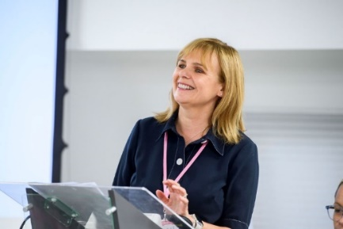

Fiona Sandford, speaking at the 2023 Visionary Annual Conference

**Fiona Sandford, CEO, Visionary**

Hi everyone!

I’ve been part of the Visionary team since 2018 and have been working in the sight loss sector for quite a while now – and I still absolutely love it! One of the best parts of my job is getting to meet so many amazing people and having all kinds of interesting chats along the way.

Outside of work, I recently qualified as a leadership coach and now run my own online coaching practice – it's something I'm really passionate about. I’m also proud to be a trustee for Amma Birth Companions, a brilliant Glasgow-based charity that supports women during pregnancy and birth who are facing things like poverty, isolation or language barriers.

When I’m not working, you’ll usually find me spending time with my lovely family – especially my wee sidekick and granddaughter, Rose. I love travelling with my husband, going to gigs, getting stuck into a good book and just generally enjoying life!

I’m always up for a chat about any of these things – so come and find me and share your recommendations!

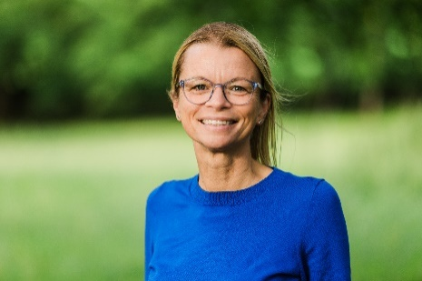

Amy Pearman, standing outside in a field

**Amy Pearman, Operations Director, Visionary**

Hello and welcome! I've been part of the Visionary team since 2021, having worked within member organisations since 2015. I have recently joined the Board of Trustees at a local charity in South Cumbria. I am also a committee member for a local athletics club and can often be found getting over-excited (some say competitive) watching our junior athletes racing. When I'm not working, you'll usually find me watching my teenage children competing in various sporting activities, accompanying my daughter to concerts (ranging from Fleetwood Mac tributes to the real Taylor Swift and all sorts in between), or running around the fells in the Lake District with my Beagle/Border Terrier cross (he is definitely the faster one of the two of us). I am looking forward to welcoming you all to the conference, so please come and say hello - I love a good chat!



Raquel Garrido-Sorriano, a selfie!

**Raquel Garrido-Soriano, Membership Engagement and Support Co-ordinator, Visionary**

Hola everyone! I have been part of Visionary since April 2022, after leaving a ten-year career in finance and the banking sector.

When I’m not working, you will find me in the woods, regardless of the weather. My highest peak reached (for now) is the Pedraforca; an emblematic mountain, 2.506m, in the province of Barcelona, reasonably close to my hometown. Less technical than Ben Nevis in Scotland!

My other big passion is to work with emotions and well-being; I find deep fulfilment in supporting others, and being supported, in connecting with the emotions that can hold us back from fully flourishing, through holistic techniques like Womb Blessing ceremonies, Bioneuroemotion, Eurythmy and others. One of the most valuable lessons I learned during clowning training many years ago, which continues to guide me, is that all emotions are valid; you just need to reconnect with yours to be in balance.

Whether you need a hug or a chat, I’m here!

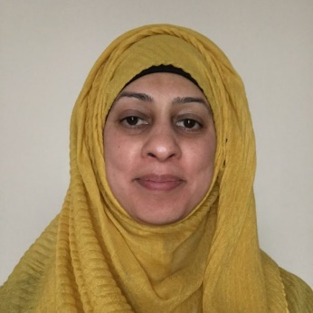

Tayyaba is smiling, wearing a yellow hijab.

**Tayyaba Kamal, Business, Events and Communications Co-ordinator, Visionary**

Tayyaba has been part of the Visionary team since 2020, having previously worked with Vision 2020. Tayyaba’s role as Visionary’s Business, Event and Communications Co-ordinator means that she is the first point of contact when you get in touch with Visionary.

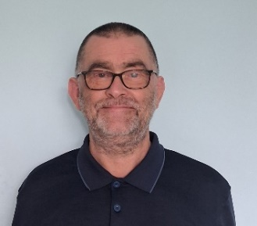

Chris Wilsden, a head shot of Chris against a white background, smiling.

**Chris Wilsdon, Service Manager (Health and Wellbeing), Kent Association for the Blind**

Hi everyone. This is my second time linking up with the fantastic Visionary team at Conference to lend a hand and, in a small way, help ensure a great experience for you all.

My day job is as a Service Manager (Health & Wellbeing) for Kent Association for the Blind which involves, amongst other things, looking after our award winning Counselling Team and brilliant Eye Clinic Liaison Officers.

In my spare time I play the piano (badly) and the ukulele (even worse). I love listening to live music and can often be found at gigs in small venues around London and its environs. I also enjoy travel and am always keen to explore new places and experience new things (ask me about an unexpected encounter in Bratislava with 300 bikers from all over Europe!). I’m also a keen amateur cook and can often be found over a hot stove. The team at Visionary work incredibly hard to put on this amazing conference so I hope you enjoy it – and please do come and say hi.

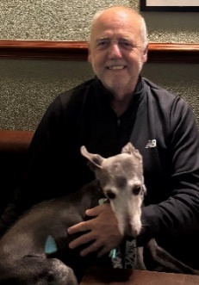

Tim Ward with his Whippet, Peter

**Tim Ward, Assistive Technology Coordinator, Sight Advice South Lakes**

Hi everyone! I've been with Sight Advice South Lakes, a wonderful small sight loss charity, for 8 years now. I started as an Assistive Technology Coordinator and have since expanded my role to currently include Community Support Worker and ECLO at our local hospital eye clinic. I love creating digital communities and helping people navigate technology, and I'm also a trained Low Vision Practitioner dispensing magnifiers and other aids on behalf of the NHS. My career journey has been quite varied - I've been a Performance Manager, a Goatherd in France and even worked in a Romany circus! In my spare time, I'm a digital wildlife artist and sell my work to shops and galleries throughout the Lakes and Dales, which perfectly combines my love of technology with our stunning local landscape. I'm married and share our home in Tebay, Westmorland with two elderly whippets who keep me entertained. We're perfectly positioned between the Yorkshire Dales and Lake District National Parks, and yes, we're practically neighbours with the famous Tebay Motorway Services! I'm looking forward to meeting you all at the conference, so please come and say hello!

Daniel smiling against a white wall, wearing a suit and glasses


Daniel Whitbread smiling against a white wall, wearing a suit and glasses

**Daniel Whitbread, Head of Support Services, Glaucoma UK**

I’ve worked for Glaucoma UK for around 18 months as Head of Support Services, and it’s great to have the opportunity to help out at the Visionary conference this year! I’ve worked for a number of different charities and not for profits in my career, including Samaritans, RABI and Oxford University, generally in service delivery roles. In my spare time I am generally to be found floundering in a pool, lake or the sea, and more recently I’ve started coaching junior cricket, as my son is pretty keen. I look forward to meeting you all at the conference.

Assistive Listening System (ALS)

Conference Aston has installed a new Assistive Listening System in The Main Meeting Room, Meeting Room 144 and Meeting Room 145. To access this system please use this step-by-step guide:

**Step-by-Step guidance to connect to the Assistive Listening System (ALS):**

1. Download the Sennheiser MobileConnect App:

Option 1: For Android Users:

1.1 Open the Google Play Store on your device.

1.2 Search for Sennheiser MobileConnect.

1.3 Tap Install to download the app.

Option 2: For iOS Users:

1.1 Open the App Store on your device.

1.2 Search for Sennheiser MobileConnect.

1.3 Tap Get to download the app.

1. Ensure you are connected to the **_Conference WiFi** network.
2. To connect to the ALS:

3.1 In the MobileConnect app, **locate and** **tap** on the **QR code** **icon.**

3.2 Use your device’s camera to **scan** the provided **QR code below:**

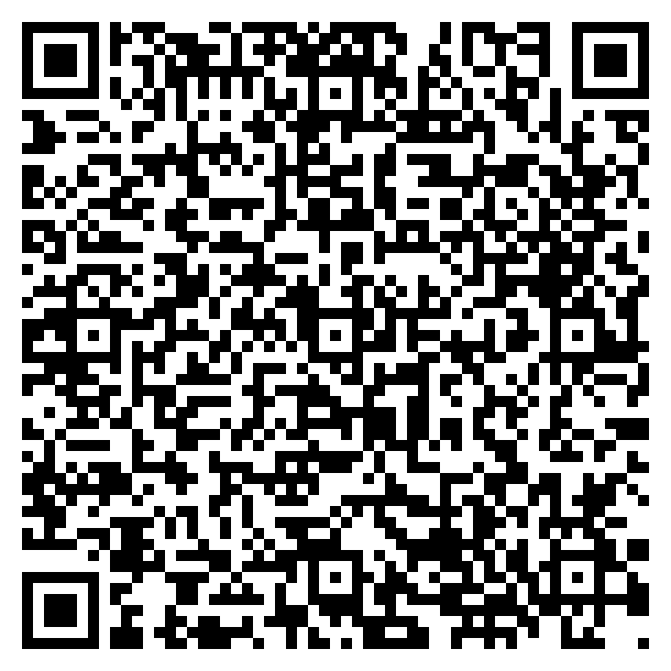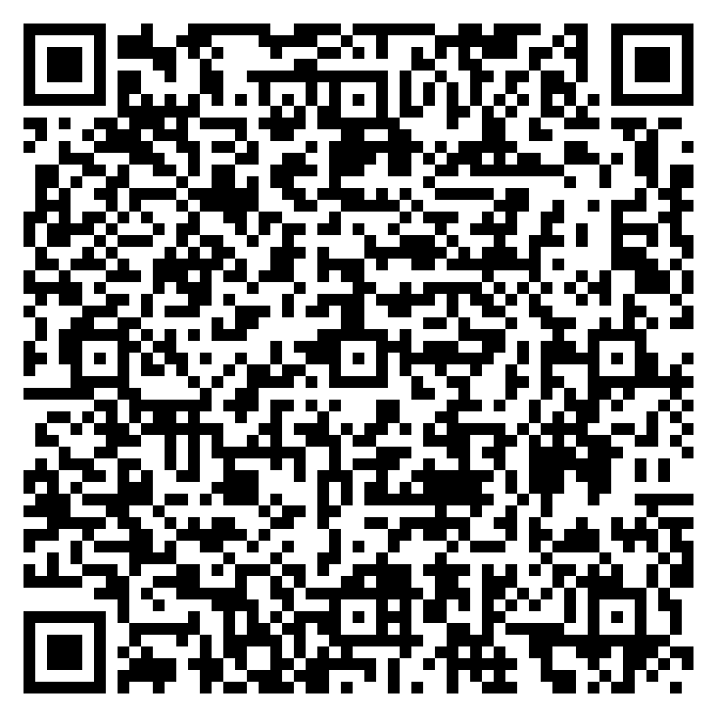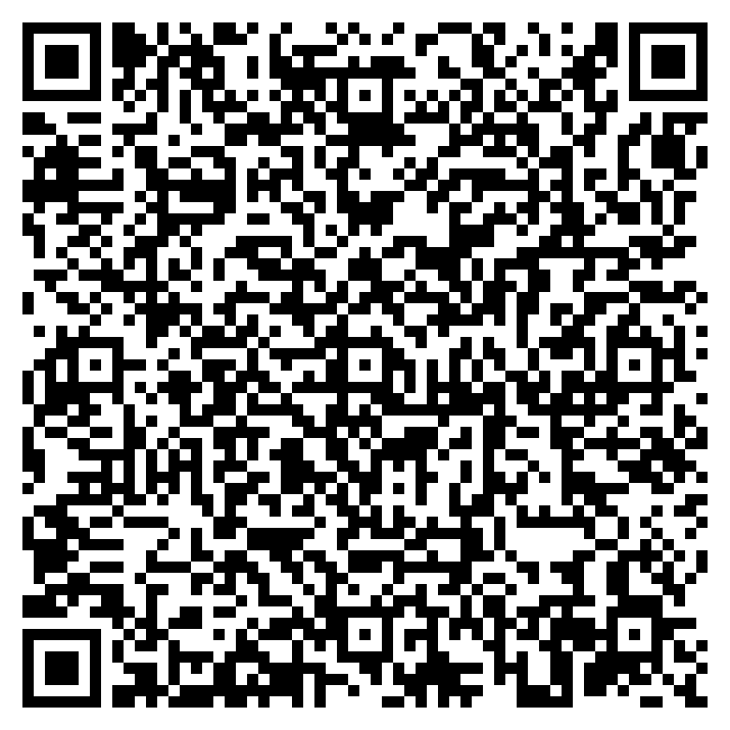 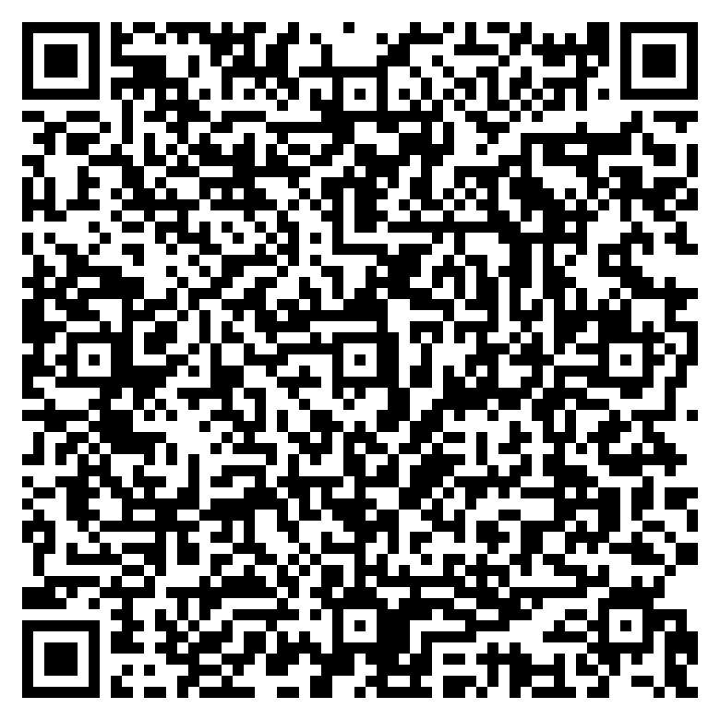

1a 1b/c 144 145

**Ensure your headphones or hearing aids are connected to your phone and tap onto Listen.**

If you need any help or have any questions, please contact the Conference Aston support team on **0121 204 5365**.

Quick Guide to using NaviLens

First steps:

1. Install the free NaviLens app on Google Play or App Store. The application can be downloaded from these links:

* App Store: [https://apps.apple.com/us/app/NaviLens/id1273704914](https://apps.apple.com/us/app/navilens/id1273704914)
* Google Play: <https://play.google.com/store/apps/details?id=com.neosistec.NaviLens>

1. Run the application, accept the permissions and terms of use and privacy policy.
2. Start using the application by orienting the camera towards the environment until you hear a "click" sound that will indicate that a marker has been detected.

In the initial screen of NaviLens, you will find a simple interface composed of a central screen where the codes detected will appear and a bottom menu with buttons. You can interact with the codes you detect by selecting them with a double tap using your screen reader. NaviLens codes or markers are detected with their reading through the mobile camera.

Therefore, the camera must be oriented towards the outside trying to make its orientation the most appropriate depending on where the codes are placed (walls, floor, height, etc.)

Each time the mobile device's camera detects a code, the device will make a "click" sound that will inform the user that there is a NaviLens code signalling a component.

The reading of the code will begin immediately, NaviLens will announce the information contained in the marker (the room number or name).

You can stop the reading by making a "Shake" gesture. The "Shake" gesture is executed by performing a wrist turn. If the phone is in an upright position, put the device horizontally (landscaped) and return it to an upright position.

When NaviLens finishes reading the information contained in the code, it will begin to play sounds to indicate the location of the signalled element. Information in vocal instructions can be obtained by activating them in the configuration (Settings – Location Mode – Voice Instructions). It will begin to say vocal instructions (right, left, front, back, up, etc.) that will help you reach the signalled element.

After detecting a code, while you do not make the shake gesture or click on the tag to obtain the information, the app will also perform this locution, and it will indicate the distance to the element and guidance instructions to get to it. When the camera detects more than one marker, the app will indicate the detection of each one by a "click" and when it reads each one it will indicate 1 of X, 2 of X, etc.

Of all the codes, the one that is most central to the device's camera will be read first.

If the mobile camera detects a "magnet" code such as at a bus stop, this code will be spatially positioned by the system and the 360 Vision mode will automatically open, setting the stop code as a destination. Then, as if it were a magnet, it will guide you towards it by sounds, vocal instructions and haptic vibrations. 360 mode will continue to guide you to the location of the code even if the mobile device camera loses it from sight.

You can find out more information about how NaviLens works in this YouTube video: <https://www.youtube.com/watch?v=aemZ5ed4gD8>

Health and Safety Information

General Evacuation Plan



Conference Aston Logo

This General Evacuation Plan has been shared by Conference Aston.

The hotel and conference centre are fitted with a fire alarm system that is activated automatically when a fire is detected but can also be manually activated by operating a fire alarm call point. The sound of the alarm is a two-tone siren. The siren is accompanied by a voice command: “This is a fire alarm, please leave the building immediately via the nearest available exit”.

If the alarm sounds you should leave the building, immediately, using the nearest suitable exit to the outside. If you are on a floor from which you cannot exit, without using a lift, you should make your way to the nearest refuge point, if safe to do so. Lifts must not be used in the event of a fire.

Information for mobility impaired persons: to ensure we can assist you, should there be a need to evacuate the building, please make your presence and requirements known to our team on arrival.

A refuge point is a temporary safe space for you to await assistance during an evacuation. It comprises a fire-resistant enclosure that has direct access to a safe route to a floor exit, stairwell, evacuation lift or final exit. Within Conference Aston, refuge points are located on each floor in the lobbies of lift 1 (This is the lift to the right of reception) and lift 2 (This is the lift opposite the restaurant entrance) and on levels 1, 2 and 3 of stairwells 2a, 3 and 3a. These are marked with a large green panel on the wall, containing an emergency intercom.

Once in the refuge point you should contact reception using the refuge communicator in the middle of the green panel or a mobile phone (telephone 0121 359 2292) to indicate your presence in a refuge. You will be asked for your name, the location of the refuge point and your mobile telephone number so that the Security Office can keep in contact with you to provide you with information about the alarm and your evacuation. The majority of fire alarm activations are due to reasons other than fire, so you should not worry and remain calm.

You will not be evacuated unless it is necessary to do so. If it is necessary to evacuate you and there is not a suitable lift, then you may be asked to transfer to an evacuation chair. This is a specially designed chair for descending staircases. You are encouraged to try one of these at an early point during your time in the venue. This can be arranged by contacting our hotel reception team on 3011 who will liaise with our safety office to organise this for you.

If you have any concerns about the use or suitability of an evacuation chair, please let us know as soon as possible.

We will ensure your requirements are reviewed and alternative arrangements made. A Personal Emergency Evacuation Plan (PEEP) may be required, and again, this can be arranged through contacting our Reception Team who will ensure your PEEP is developed with the Aston University Safety Office.

Should you have any concerns, do not hesitate to call the Conference Aston’s reception team (extension 3011) or Aston University Security (0121 204 4803) who will be happy to offer assistance.

If required, further information is available from:

The Safety Office, Main Building, G93

0121 204 4805 [safety@aston.ac.uk](mailto:safety@aston.ac.uk)

Specific Evacuation Plans

For Guests with mobility needs:

In the event of an emergency, we ask those guests with additional evacuation needs, which would prevent them from evacuating the building safely, to do the following.

If on the ground floor - make yourself known to a staff member who will be able to assist you in your evacuation.

If on the First Floor meeting room corridor - make your way to the nearest refuge point, if safe to do so. Activate the call button on the refuge point communicator and indicate clearly your name, your original room number and the refuge point you are at. Assistance will be sent to evacuate you from the refuge point. Please do not move from this point, as long as safe to do so, as our Fire Wardens or the fire brigade will be on their way to you.

If staying with us overnight and therefore staying in the hotel on the 2nd - 5th floor – make your way to the nearest refuge point if safe to do so. Activate the call button on the refuge point communicator and indicate clearly your name, your original room number and the refuge point you are at. Assistance will be sent to evacuate you from the refuge point. Please do not move from this point as long as safe to do so, as our Fire Wardens or the fire brigade will be on their way to you.

Within Conference Aston, refuge points are located in the lobbies of lifts 1 and 2, on levels 1, 2 and 3 of stairwells 2a, 3 and 3a.

If unable to get to a refuge point safely - call ‘222’ from your bedroom, meeting room or corridor telephone and alert security of your location. Assistance will be sent to evacuate you from the refuge point. Please do not move from this point as long as safe to do so, as our Fire Warden or the fire brigade will be on their way to you.

At all times, when staying with us at Conference Aston, please ensure that our team are aware of your special requirements, to ensure we can allocate a bedroom in close proximity to a refuge point.

For blind or partially sighted guests:

In the event of an emergency we ask those guests with additional evacuation needs, preventing them from evacuating the building safely, to do the following.

If on the ground floor - make yourself known to a staff member who will be able to assist you in your evacuation.

If on the First and Fifth floor – please remain in your meeting room or bedroom and call ‘222’ from the phone within the room and alert security of your location. Assistance will be sent to evacuate you if you are at risk. Please do not move from this point as long as safe to do so, as our Fire Warden or the fire brigade will be on their way to you.

For guests who are deaf or hearing impaired:

Vibrating (mobile) alarms are available on reception which can be issued to guests with hearing impairment upon arrival. These are linked to the fire alarm system and start vibrating as soon as the alarm is raised.

Should you wish to receive assistance as per the above General Evacuation Plan from our staff, please make our reception staff aware of this at the earliest opportunity; otherwise we presume that you will make your own evacuation to the fire assembly point.

Emergency Evacuation Routes

**A step-by-step guide to navigating Aston Conference Centre and instructions on emergency exits.**

**Entrance and reception area**

* As you stand outside the Aston Conference Centre facing the main entrance, behind you, to the right and left are grass banks with no steps. Directly behind you is a grass verge that raises slightly with a step up.
* To enter the building from the main entrance there are three options. Facing the main entrance to the left is an automatic rotating door which turns anticlockwise. The door starts to rotate on approach and can be manually pushed if required. In the centre there is a manual opening door and to the right is an automatic door, which opens on approach.
* Entering through the automatic door on your right there is a slight lip on the floor in line with the frame and there is a non-slip matt on entering. There are several more non-slip mats as you move through the entrance around the door area.
* Once inside the building there is a seating area in front of you slightly to the right. Turn left, on your right-hand side and you will find the events welcome desk (open from 8am to 10am), lift to the bedrooms and reception desk. This has a lowered accessible countertop to the left-hand side.

**Conference registration area**

* Walking past the reception desk with it on your right the floor starts a gentle slope down toward the restaurant and toilets at the end of the corridor. Along the corridor to the left is a ceiling to waist height glass window.
* Continuing down the corridor after the first slope there is a levelled-out section and to the right of this is the conference registration area. The conference registration consists of two long rectangle tables at waist height.

**Lounge, bar and emergency exit**

* The floor continues, on a descending slope, for the second time with a handrail to the right at waist height.
* As you reach the second levelled out part of the floor to the right there is the entrance to the lounge. This is a wide, high archway opening.
* As you continue down the corridor the floor declines again for a third slope with a handrail to the right at waist height. Once you reach the flat levelled out section to the right, there is the wide high arch opening for the bar. Directly opposite the bar is the exit to the outside courtyard. There is a lip at the door, and it opens out onto a flat level. About 4ft ahead there are 2 steps up onto another level. This door would be used as an emergency exit.

**Restaurant, toilets, lift and stairs**

* Continuing further down the corridor to the left there are ceiling to waist high windows. The floor remains flat from here. The floor changes surface from stone to wood with a smoother texture. Once the surface changes you are approaching the restaurant and toilets.
* At the end of the corridor, you turn right to the toilets and stairwell. The lift is on the right approx. 20ft before the end of the corridor. You then turn left entering a narrower corridor which bends right. You will find the female toilets to your left, the male toilets straight ahead and on your right, you will find the accessible toilets and baby changing facilities.
* To access the stairwell and the emergency exit turn right at the end of the main corridor. The exit is straight ahead of you and the stairs are on the right-hand side as you go through the first door.

**Conference rooms, courtyard**

* Turning left at the end of the main corridor or walking straight ahead from the toilet area is the entrance to the restaurant. There is a straight walk through the centre of the restaurant towards Conference Room 1. As you walk through the restaurant, there are double doors on your left leading to the outside courtyard. The floor continues to be wood, and the noise levels increase.
* As you approach the conference room area the floor surface changes from wood to carpet. As this happens, you turn left to enter a corridor. Along this corridor on the right-hand side there are three sets of double doors about 3 metres apart. These doors open outwards. These are the doors to conference room 1.
* Continuing past the conference room 3, which is on the left, there are toilets, female, male and accessible on your left and on the right is another door to conference room 1. This enters conference room 1 on the left- hand side when facing the front of the room.
* From any exit from conference room 1 turn left to head back towards the restaurant.

**First floor conference rooms**

* When exiting the restaurant to the main corridor there is a lift to the left which takes you to the first floor to conference rooms 122, 123, 127,139, 144, 145. The lift has two sets of opening doors, when exiting the lift on the first floor the opposite doors will open to entering the lift. The lift has audio announcements.
* When exiting the lift turn right then turn left walking through a set of doors that open towards you. This brings you to the meeting room corridor.
* On the right side of the meeting corridor there are conference rooms 122,123. To the left are more meeting rooms and straight ahead is an emergency exit and conference room 127.
* At the start and end of the meeting corridor there are self-closing fire doors in an event of an emergency. These doors will all be re-opened after an evacuation.

**First floor toilets, tea/coffee station and fire exit**

* Once at the end of the meeting room corridor turn left into a narrow corridor with office doors either side. At the end of this corridor there are female and male toilets to the left. These toilets are the nearest when using conference rooms 122, 123,127.
* Just past the toilets there is a self-closing door that opens inwards. Walking forward there is a tea and coffee station to the left and to the right of this there are 3 sets of bar tables with 6 stools about 4ft high
* Walking past the tea and coffee station to your left you come to another narrow corridor with meeting rooms on either side. There is a self-closing door at the end of this corridor and more female and male toilets on the left-hand side.
* On your right there is a fire exit for conference rooms 144, 145. This door is on the left as you exit these meeting rooms. There is a very small L shape corridor here to navigate to the fire exit.
* Exiting conference room 145 the emergency exit is the second door on the left. This will be the only unlocked door here. It is a wide opening outward door.
* Once through the door you are on a resting area which is a flat landing in between stairwells. To the left of the door, when facing it, is the refuge box or communications button with security. There is braille on the bottom of this red box, which is about 30cm by 15cm in size. To the left of this box when facing it there is a plaque with the name of the floor and building also in braille underneath.
* In an event of an emergency exit if you require assistance this is where you would wait.
* From the resting area, moving forward to the stairs the upward stairs are to the right and the downward stairs to the left. There is a rail either side but the right handrail is continuous around the stairs. Follow these stairs right to the bottom and the fire exit door is straight ahead on the lower level. This door leads to the outside space and this is a self-shutting security door with an opening bar/handle.
* Turning left at the bottom of the stairs brings you back to the side door to conference room 1. Turning right will bring you to male, female and accessible toilets. Turning the second left will bring you to the corridor that leads to the restaurant and back through to the main corridor to the reception desk at the front of the building.

Visionary Annual Conference
24-25 September 2025

**Working with you, we inspire change and create opportunities to make a better world for everyone affected by sight loss.**

* **Connect**: Connecting individuals from organisations together and organisations to each other.
* **Develop**: Developing platforms for collaboration and joint initiatives with local and national partners.
* **Share**: Sharing knowledge and expertise to help members be all they can be.
* **Inspire**: Amplifying and harnessing member voices to inspire innovation and create change.

Email: [visionary@visionary.org.uk](mailto:visionary@visionary.org.uk)

Web: [www.visionary.org.uk](http://www.visionary.org.uk)

LinkedIn: @Visionary_UK

#VisionaryConference25

“Visionary” is the working name of Visionary - Linking Local Sight Loss Charities, a CIO registered in England and Wales as charity number 1135360, charity in Scotland number SC044163

#### Blank Page and End of Document