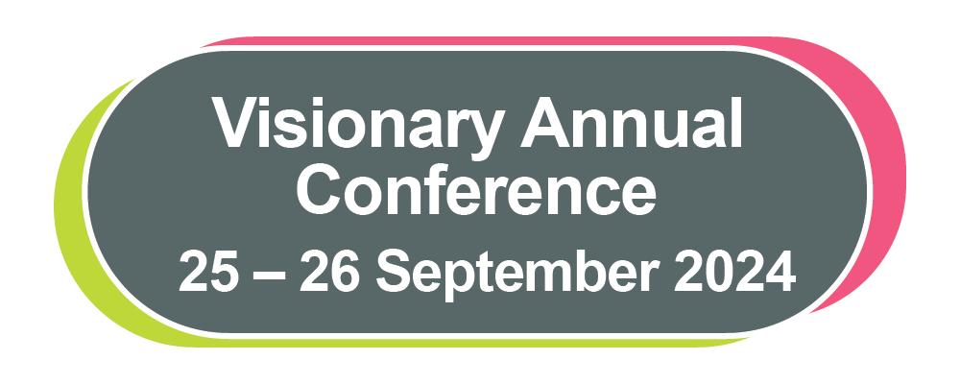

# Visionary Annual Conference

# Delegate Pack

25 – 26 September 2024

Roche Products Ltd has provided arm’s length, financial sponsorship of the Visionary Annual Conference 2024. Roche has had no input or influence on the programme or selection of speakers.

Contents

Welcome 3

Annual Conference 2024: Programme 4

Tuesday 24 September 2024 4

Wednesday 25 September 2024 4

Thursday 26 September 2024 5

Join us on X (previously known as Twitter) 6

Speaker Profiles 6

Finding Your Way Around the Conference 13

Prayer Room and Quiet Spaces 13

Networking and Connecting with Colleagues 14

NaviLens 15

Thomas Pocklington Trust 16

Conference Sponsors and Funders 18

Member 18

National Partners 19

Corporate Sponsors and Funders 24

Exhibition 2024 29

Exhibitors 29

Location of Exhibitors 36

Vision Partnership 37

Visionary Annual Awards Dinner 38

Workshops 39

Workshop Overview – Day One 39

Workshop Overview – Day Two 40

Session One: Wednesday 25 September, 13:45 to 15:00 41

Session Two: Wednesday 25 September, 15:30 to 16:45 47

Session Three: Thursday 26 September, 10:45 to 12noon 54

Session Four: Thursday 26 September, 12:15 to 13:30 63

Quick Guide to using NaviLens 70

Emergency Evacuation Routes 72

## Welcome

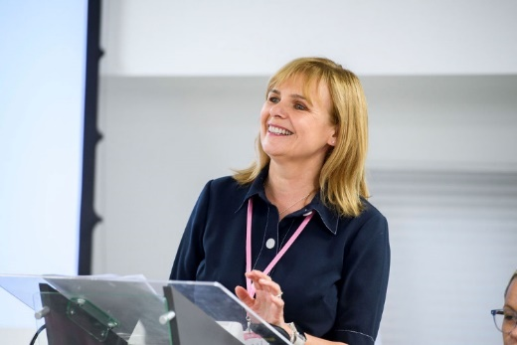  
Fiona Sandford, CEO, Visionary

Photo: Tracey Welch Photography

Hello Visionaries and welcome to our 2024 conference!

Whether you're a conference newbie or veteran, prepare yourselves for an experience that will uplift your spirits, pique your curiosity, and set your imagination into overdrive!

This year our conference will get off to a flying start with Dr Amit Patel, Fern Lulham, James Watson O’Neill, Ellie Southwood, Professor Leon Davis, and Nikhil Sonpal. They're so amazing, they practically need their own action figures - find out more below. There is also a fabulous and interesting exhibition for you to enjoy and lots of networking opportunities to catch up with everyone. As ever, we have an extensive workshop programme developed in response to what you tell us is important to you.

As mentioned, we have gone digital - no more delegate packs destined for landfill - everything you need is at your fingertips on our website - [Visionary Annual Conference 2024 - Visionary](https://www.visionary.org.uk/visionary-annual-conference-2024/).

Visionary may be a tiny team, but we certainly pack a punch! This entire endeavour is only possible due to the generous support of our members and partners - that's you, dear reader. We would also like to extend a special note of gratitude to our friends at Thomas Pocklington Trust for their ongoing funding and support.

So buckle up and get ready for the conference of the year!

Fiona

P.S. Don't be shy – please say hi to us!

## Annual Conference 2024: Programme

Welcome to the Visionary Annual Conference 2024.

On arrival at the conference, you will receive a personalised programme detailing your workshop selections and meeting rooms. Please ensure you attend the sessions you have registered for, as we have arranged all the venue logistics based on everyone’s selections.

### Tuesday 24 September 2024

16:00 – 18:00 Conference Registration Open

16:00 – 16:45 Venue Familiarisation Tour – meet at the Visionary Registration Desk

### Wednesday 25 September 2024

**08:30 – 10:30 Registration opens with Exhibition and Networking**

09:00 – 09:30 Venue Familiarisation Tour – meet at the Visionary Registration Desk

10:30 – 12:00 Opening Address followed by Fireside Chat

**12:00 – 13:45 Lunch, Networking and Exhibition**

13:45 – 15:00 Workshop Session 1

**15:00 – 15:30 Break and Exhibition**

15:30 – 16:45 Workshop Session 2

18:45 – 19:30 Reception Drinks

**19:30 onwards Visionary Annual Awards Dinner**

### Thursday 26 September 2024

08:30 – 09:15 Registration

09:15 – 10:15 Welcome and Keynote Session with Villa Vision

**10:15 – 10:45 Break**

10:45 – 12:00 Workshop Session 3

**12:00 – 12:15 Break**

12:15 – 13:30 Workshop Session 4

13:35 – 13:45 Closing Remarks

**13:45 – 15:00 Lunch in the Courtyard Restaurant**

**15:00 onwards Depart at your leisure. Please don’t forget to come and say goodbye to the Visionary team!**

## Join us on X (previously known as Twitter)

We are delighted you are joining us at the Visionary Annual Conference 2024.

Please join the discussion on X **@visionary_uk** and use the hashtag **#VisionaryConference24**.

We would love you to share your thoughts during the event. Share with us which workshops you've attended, what aspects you've found enjoyable, who you've had the chance to meet, and any other experiences you'd like to mention.

We hope you find value in your time at the conference and enjoy connecting with colleagues from across the Visionary network and beyond.

## Speaker Profiles

We are so excited about the opening addresses planned for this year's conference.

Day One will begin with an engaging fireside discussion hosted by Fern Lulham. Fern will be joined by our fabulous guests: Dr. Amit Patel, Eleanor Southwood, and James Watson O'Neill. Thank you to Fight for Sight for sponsoring our Fireside Chat session at the Visionary Annual Conference 2024.

Day Two will start with Prof. Leon Davies, Aston University, and Nikhil Sonpal from Villa Vision. Together, they will share their innovative project and lead a discussion on how it can be replicated in other local communities. Thank you to EssilorLuxotticafor sponsoring our keynote session and creating the opportunity to invite Villa Vision to join us at this year’s conference.

We are honoured to welcome all our speakers to the conference and are delighted to share their profiles.

**Fern Lulham, BBC Broadcaster and Producer**

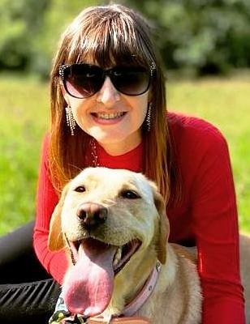

Fern sitting on the grass wearing a red top and dark sunglasses. Fern is cuddling her guide dog Nancy who has her tongue out.

Fern Lulham is a public speaker, broadcaster, audio description narrator, disability awareness trainer and qualified psychotherapist. Little wonder then that she describes herself as a freelance communicator.

Born severely visually impaired and now registered blind, Fern's passion for communication started in early childhood when she would use an egg-whisk for a microphone to "interview" friends and family!

Drawing on her lived experience of sight loss, Fern is a powerful public speaker. She delivers engaging speeches that produce light bulb moments for her audiences, inspiring them to meet the challenges we all face whether disabled or not. Her CV includes a TEDx talk entitled "What online dating looks like when you're blind" which achieved a standing ovation from an audience of nearly a thousand people.

Never one to pass up the chance of an adventure, Fern studied for her degree in Radio Broadcast Communication thousands of miles from home at Western Carolina University in the USA. She has gone on to use that experience as a presenter, reporter, and producer of many radio broadcasts, including for BBC Radio 4 and the World Service.

**Dr Amit Patel, Author, Broadcaster, Motivational Speaker and DEI Consultant**



Dr Amit Patel has a beard and moustache. He is smiling, wearing a blue and white check shirt standing against a pink background.

Dr Amit Patel is a best-selling author, diversity, equity and inclusion consultant, motivational speaker, disability rights campaigner. He also sits on the Board of Trustees for Fight for Sight. He is registered severely sight impaired (blind) since 2013. Amit was matched to Kika, his first guide dog in 2015. Kika was the inspiration for Amit to write his book called ‘Kika & Me’ which was published by Pan Macmillan in 2020.

Amit is also known as a broadcaster, presenter and media personality. He has appeared in various online and print media in the UK and around the world. He regularly features as a specialist contributor to multiple national news and broadcast media outlets. Committed to achieving greater representation of disabled people across all areas of life, Amit strives every day to challenge himself and challenge other people’s perceptions of disability.

**Eleanor Southwood MBE, Director of Social Impact, Fight for Sight**

Eleanor is smiling and is wearing a black top with a yellow necklace with overlapping discs.


Eleanor is smiling and is wearing a black top with a yellow necklace with overlapping discs.

Until March 2023, Ellie was a member of Brent Council’s Cabinet. Over the past eight years she has been accountable for core council services, including waste management and highways: housing, including building the first council homes in decades: local welfare and financial inclusion: and jobs, economy and citizen experience. She is passionate about good quality, equitable local services.

Ellie is a former chair of the Royal National Institute of Blind People (RNIB) where she led the organisation through a statutory review by the Charity Commission, financial transformation and significant modernisation. She currently chairs Habinteg Housing Association, which specialises in accessible and adaptable homes across England. Ellie’s earlier career spans the public private and non-profit sectors and she brings significant public policy, campaigning and organisational change experience. Ellie is blind and lives in North West London where she is a local Councillor for Queens Park, Brent.

**James Watson O'Neill OBE, CEO, SignHealth**

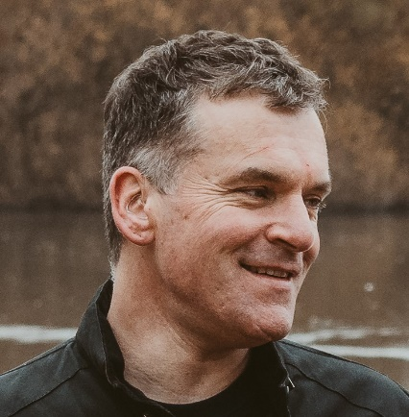

James is looking to the side smiling. There is a lake and trees in the background.

James joined the deaf health charity SignHealth as chief executive in 2016 and has worked in the charity sector since 2001, including a variety of roles at Scope and the NSPCC. James is a trustee of the Voluntary Organisations Disability Group and co-chair of the working group on EDI within the Civil Society Group. James is also a Fellow of the Royal Society of the Arts, Manufactures and Commerce and a Leadership Fellow at the Society of Leadership Fellows at the College of St George at Windsor Castle. James was awarded an OBE for services to Deaf people in the Queen’s New Year’s Honours 2022.

**Professor Leon N. Davies PhD, FCOptom, Prof Cert Med Ret, FAAO, SFHEA, Chair in Optometry & Physiological Optics, Interim Head of School, Optometry, Chair of the Board of Trustees & Past President, The College of Optometrists**

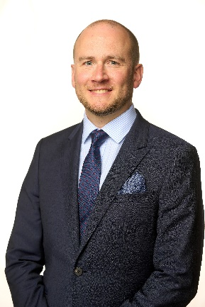

Professor Leon Davies, smiling and wearing a navy suit, light blue shirt and a blue tie.

Leon Davies is an optometrist and Professor of Optometry & Physiological Optics at Aston University, Chair of the Board and Immediate Past President of The College of Optometrists. Professor Davies is a Liveryman of the Worshipful Company of Spectacle Makers, a Fellow of both the College of Optometrists and the American Academy of Optometry, and a Senior Fellow of the Higher Education Academy. He is a past Clinical Editor of Optometry Today, and past Editor-in-Chief of the peer review journal Optometry in Practice. In 2022, he was appointed an Honorary Professor at the University of Bradford.

He has served as an external examiner for taught undergraduate and postgraduate degree programmes in Bradford, Bristol, Cardiff, Glasgow, Plymouth and Singapore. Leadership roles at Aston include Director of Research of the Optometry and Vision Science Research Group (2010-2017) and Head of the School of Optometry (2016-2021 & 2024). He has served as a member of Council (2015 to date) and Board Trustee of the College of Optometrists (2016 to date), Chair of their Research Committee (2016-2020), Vice President (2020-2022), President (2022-2024) and in April 2024 was appointed Chair of the Board of Trustees.

Leon has over 65 peer reviewed publications and has been awarded over £3M of funding for his research from UKRI, the EU, charities and a number of multinational organisations. His research is focused on presbyopia and the restoration of ocular accommodation to the ageing eye. He has successfully supervised 17 doctorates, 13 research fellows and has acted as an external examiner for PhD and professional doctorate theses in Australia, Hong Kong, Spain and the UK. He is a recipient of the College of Optometrists Research Fellowship Award (2008), and was awarded the inaugural Neil Charman Medal for research excellence in optometry, optics and vision science (2010).

**Nikhil Sonpal BSc (Hons) Optometry MCOptom and Project Manager, Villa Vision**

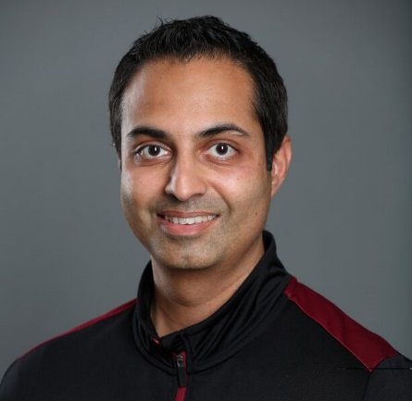

Nikhil is smiling and wearing a black sweatshirt with burgundy panels on the shoulders.

Nikhil is a GOC registered Optometrist and current Project Manager for Villa Vision, an eye health initiative delivered through Aston Villa Football Club’s charitable arm, the Aston Villa Foundation.

Having played an integral role in the design and development of the Villa Vision programme, Nikhil has created a double award nominated and award-winning initiative that has enabled over 14,000 interventions amongst school-aged children across the city of Birmingham. This dedication to the initiative has recently led to Nikhil being named Aston Villa’s Premier League Community Captain for 2024.

With a career spanning more than 20 years in the optics industry, Nikhil has previously had roles as a community-based optometrist, clinical lead, and practice manager for a large UK multiple, collaborated with Moorfields Eye Hospital on eye disease research, and is also the founder of a community-based eye health awareness initiative.

**Villa Vision**

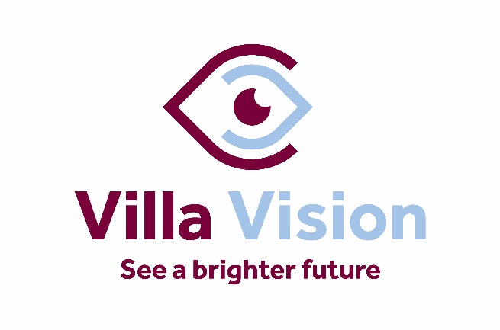

Villa Vision logo – See a brighter future.

We are delighted to welcome Professor Leon Davies, President of the College of Optometrists, and Nikhil Sonpal, Lead Optometrist and Project Manager for [Villa Vision](https://www.avfc.co.uk/foundation/our-areas/villa-vision/) to this year’s event. Together they will share the innovative work undertaken in partnership between Aston University's Optometry School and the Aston Villa Foundation, the charitable arm of Aston Villa Football Club.

Villa Vision, the first initiative of its kind in the UK which aims to increase knowledge and awareness of the importance of having an eye test. It also shows how preventative measures can ensure, among a host of benefits, a lifetime of good vision. This is achieved through the delivery of a programme of eye health awareness lessons in the classroom along with free vision and colour vision screening. This is followed up with more comprehensive eye test and free glasses to children and young people who require them. The service is delivered using a fully operational custom-designed mobile eye care unit. Delegates will be offered the opportunity to explore this innovative facility as one of the workshop options on **26 September**.

## Finding Your Way Around the Conference

A huge welcome back to Conference Aston for the Visionary Annual Conference 2024!

At registration you will receive a list of your workshop selections and the meeting room for each session. To assist with accessing the different workshops, lunch and refreshments, a tactile map will be located at the Visionary Registration Desk which will be there for the duration of the event.

We have arranged for the team at Conference Aston to conduct familiarisation tours of the venue, to assist with navigation around the public spaces and finding workshop rooms. If you would like to join the familiarisation tour, please meet at the Visionary registration desk at the following times:

* Tuesday 24 September at 16:00
* Wednesday 25 September at 09:00

We are grateful to Glaucoma UK for their support in creating this delegate pack, the development of our audio version and enabling us to use NaviLens across the conference. Once again, the team at Galloways have recorded our audio delegate pack. Thank you all so much for your support.

It was wonderful to work with RNIB – Business Services again this year, to create a range of accessible event information, include eBraille, large print and PDF versions of our delegate pack. To find out more please visit: [rnib.org.uk/business](https://www.rnib.org.uk/professionals/business-professionals/)

## Prayer Room and Quiet Spaces

During your time at Conference Aston, you are invited to visit the Martin-Luther King Multi-Faith Centre. You are very welcome to use this space for prayer, reflection, or quiet time away from the main conference. The Martin-Luther King Multi-Faith Centre is a short walk from the main entrance of Conference Aston. Please ask at the hotel reception for directions. There are male and female Islamic prayer rooms in both the main university building and the Students’ Union building. Please contact the hotel reception for opening times. For more information, please visit the Chaplaincy website - [Chaplaincy | Aston University](https://www.aston.ac.uk/current-students/health-and-wellbeing/chaplaincy).

## Networking and Connecting with Colleagues

The opportunity to network and connect with colleagues is an important element of the Visionary Annual Conference.

We are pleased to offer additional networking opportunities during lunch on both days of the conference. We are creating themed lunch tables around core themes/topics which have been prevalent throughout the year (see below). You are invited to join any table which is an area of interest to you. This will allow you to meet with colleagues with a shared interest. You may choose to have your main course and dessert at different tables to network with different people!

**Wednesday 25 September 2024**

* Campaigning
* CEOs and Leaders
* Children and Young People
* Technology

**Thursday 26 September 2024**

* Project and Service Leads
* Small Organisations
* Trustees
* Income Generation

## NaviLens

We are pleased to be offering information via the NaviLens navigation app again this year. We will use their generic packages in the public areas of Conference Aston along with personalised codes to assist with networking.

**What is NaviLens?**

NaviLens uses a specially designed QR code that can be read from very short and long distances depending on the size of the code. Each code generated is unique, containing audio and visual text to assist with your navigation around the venue. To benefit from NaviLens during the conference please download the NaviLens App from Google Play or the Apple App Store.

**How will NaviLens be used during the conference?**

Each delegate name badge will feature a unique code. Once you have downloaded the app you will be able to scan your name badge and name badges of other delegates. NaviLens will read the person’s name, organisation and tell you how far away from you they are. You should also be able to scan a group of people and NaviLens will read everyone’s name and place them in terms of distance from you.

We will also feature NaviLens during lunch. Each table will feature a different code to assist with networking. In addition, each conference and meeting room used by Visionary will also have a NaviLens code on the door and at the front of the room. You will be able to scan the code to make sure you are joining the correct workshop. We will also place a NaviLens code on each table for dinner, so you will be able to find your table with ease.

A quick guide to using NaviLens is included at the end of the delegate pack.

## Thomas Pocklington Trust

We would like to share special thanks to **Thomas Pocklington Trust**.

On behalf of the Visionary team, trustees, and our entire network we are hugely grateful for the support Visionary receives from Thomas Pocklington Trust. Their support enables us to be responsive to the needs of our members, partners and in turn enhance the support available to blind and partially sighted people in local communities across the UK.

**About Thomas Pocklington Trust**

**Who We Are**

Thomas Pocklington Trust is a leading advocate for equality of blind and partially sighted people. We are a charitable organisation with a dedicated staff team, over half of whom are blind or partially sighted, and we have over 200 dedicated volunteers who have lived experience of sight loss. Our mission is to support blind and partially sighted people to bring about equity and inclusion in every aspect of society.

**What We Do**

Our work is focused on championing the needs and aspirations of blind and partially sighted people, fully recognising the depth and complexity of the challenges faced. We address these challenges not only within our local communities across the country through direct action by members of our Sight Loss Councils, but also at the heart of our national government and policy structures. We are a leader in providing direct grants that target systemic change and improvements for blind and partially sighted people.

Our mission is to support blind and partially sighted people to bring about equity and inclusion in society and their own lives. We achieve this by focusing on significant life milestones for blind and partially sighted people, including ensuring that they are able to thrive in education, fostering positive employment opportunities and promoting overall health and wellbeing, with timely health interventions when needed.

In addition to addressing equality in life opportunities, our strategy is designed to support blind and partially sighted people at every stage of their journey through the education system, further training or employment and their chosen careers.

**How we do it**

We aim to:

* Provide information, resources and advice guidance to students in or entering education, and the professionals/parents/carers that support them. Reduce unemployment rates among blind and partially sighted people of working age, encouraging more employers to create accessible workplaces and generating employment opportunities for blind and partially sighted people.
* Ensure unrestricted access to all healthcare services for blind and partially sighted people, thereby removing barriers that limit their overall health, fitness and wellbeing.
* Campaign against injustices faced by blind and partially sighted people while actively promoting the creation of more inclusive, accessible and equitable communities and society at large. Find out more about Thomas Pocklington Trust campaigns.

We support blind and partially sighted people to lead the lives they want to by:

* Providing information, advice, guidance and resources to students in or entering secondary school, college or university, along with their families, carers and the professionals who support them.
* Supporting people looking to start, restart or progress their careers.
* Encouraging engagement and volunteering, continually expanding our network of Sight Loss Councils across the UK.

Web: <https://www.pocklington.org.uk/>



Thomas Pocklington Trust logo

## Conference Sponsors and Funders

We can't wait to welcome you on 25 and 26 September 2024 for two days packed with wonderful speakers, interactive workshops, presentations and networking. Thank you to our fabulous sponsors and funders, for their support for making it all happen – we’re incredibly grateful for your support.

We are honoured to share more information from our members, partners, funders, and corporate sponsors with you.

### Member

**Sight Scotland and Sight Scotland Veterans**



Sight Scotland / Sight Scotland Veterans logo

Sight Scotland is Scotland’s largest sight loss charity. Our diverse services span all ages and stages of sight loss and visual impairment. It also includes the Royal Blind School in Edinburgh and specialist learning services across Scotland, residential care for children and adults, community services, and research funding into sight loss conditions.

We also run the Scottish Braille Press which provides supported employment – half of the employees of the Scottish Braille Press are disabled people, including people with visual impairment. Our community services are reaching out to support even more people with sight loss in Scotland, as well as their relatives and carers.

Sight Scotland Veterans provides support to armed forces veterans in Scotland – including those who served National Service – who are affected by sight loss, regardless of the cause. The charity helps veterans with sight loss regain confidence, restore their independence and make new connections.

Together, our charities are determined that no one should face sight loss alone.

Web: [www.sightscotland.org.uk](http://www.sightscotland.org.uk)

### National Partners

**Fight for Sight**

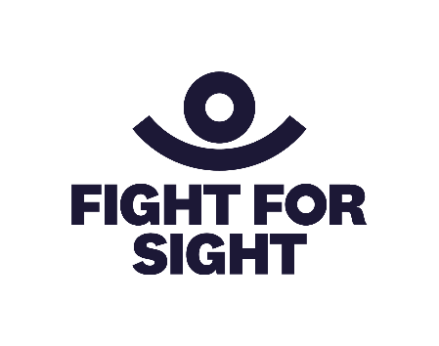

Fight for Sight logo

Imagine being told that you, or someone you love, is losing their sight. In that moment, two profound questions demand urgent answers:

* Can this be stopped?
* How will I live my life?

Currently, research into preventing and treating sight loss is chronically underfunded, receiving a mere 1.5% of publicly funded health research grants: people who are blind or vision impaired are three times more likely to experience loneliness and isolation than the general population.

We find and fund the brilliant minds and bright ideas that put change in sight. Our researchers are at the forefront, making breakthroughs and discoveries that will help us better understand, prevent, diagnose and treat eye disease. The partnerships we build and initiatives we support are changing life for blind and vision impaired people.

We are Fight for Sight and we won’t stop until we: Save Sight. Change Lives.

Web: [www.fightforsight.org.uk](http://www.fightforsight.org.uk)

**Glaucoma UK**



Glaucoma UK logo

At Glaucoma UK, it is our vision to bring an end to preventable sight-loss from glaucoma.

We are a membership charity passionate about making sure that people living with glaucoma have a say in how and where their care and treatment are delivered. We provide a host of support services to help people at all stages of their glaucoma journey, including a helpline, online webinars, face-to-face support groups, information leaflets and booklets and a website full of information and advice about the disease. We also provide training and an annual conference for glaucoma care professionals.

In addition to our support services, Glaucoma UK funds an annual grants programme to support UK researchers as they work to find out more about the causes and prevention, early detection, diagnosis and treatment of glaucoma and allied conditions.

Web: [www.glaucoma.uk](http://www.glaucoma.uk)

**Guide Dogs UK**

[Guide Dogs UK logo in navy blue.  A paw print to the left and Guide Dogs text to the right.
](http://www.guidedogs.org.uk)

Guide Dogs logo

Guide Dogs is here to help the two million people living with sight loss live the life they choose. Our expert staff, volunteers and life-changing dogs are here to help people affected by sight loss live actively, independently, and well. We understand that living with sight loss is different for everyone and our services reflect that. From the very first enquiry, our experts talk and listen to people’s needs and aspirations and offer advice and provide support.

A partnership approach is central to what we do, and we know how important it is to learn from others and work together to share ideas and expertise to help change lives. The Visionary conference offers a fantastic opportunity to celebrate the innovation across the sector and we’re delighted to sponsor the Develop and Share Award to recognise the power of collaboration.

Web: [www.guidedogs.org.uk](http://www.guidedogs.org.uk)

**Macular Society**

[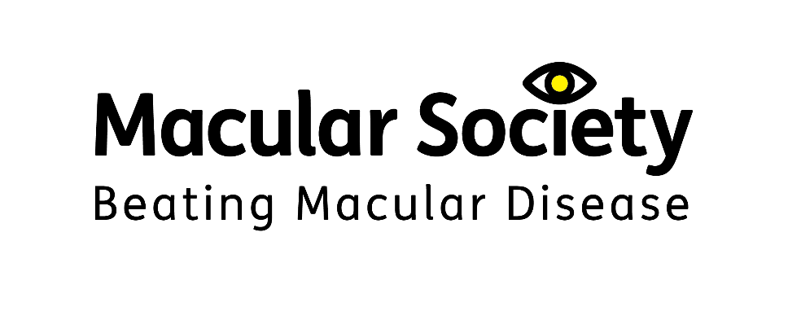](http://www.macularsociety.org.uk)

Macular Society logo – Beating macular disease

Macular disease is the biggest cause of sight loss in the UK, with around 300 people diagnosed every day. The Macular Society is determined to beat the fear and isolation of macular disease with world-class research, and the best advice and support.

The Macular Society works in close collaboration with local and regional sight loss organisations, and the members of Visionary, to support people affected by this devastating condition and to beat macular disease, for good. The conference is a great opportunity to share experiences and learn from each other, in order to continue to improve the lives of those living with sight loss.

Web: [www.macularsociety.org](http://www.macularsociety.org)

**RNIB (Royal National Institute of Blind People)**

[](http://www.rnib.org.uk)  
RNIB logo – See differently

RNIB, the Royal National Institute of Blind People, is one of the UK's leading sight loss charities. We offer practical and emotional support to blind and partially sighted people, their families and carers. We raise awareness of the experiences of blind and partially sighted people and campaign for change to make our society more accessible for all. We want to change our world so there are no barriers to people with sight loss.

RNIB is delighted to sponsor and support the Visionary Annual Conference. We wish to build stronger more productive relationships at a local level and are seeking to engage with local sight loss charities to provide more opportunities for blind and partially sighted people and improve equity of access. If you are interested in having a discussion, please get in touch with the team via [email RNIB Charity Partners](mailto:charity.partners@rnib.org.uk).

Web: [www.rnib.org.uk](http://www.rnib.org.uk)

**RNIB – Business Services**



RNIB Business Services logo

The Royal National Institute of Blind People (RNIB) is the largest sight loss charity in the UK. At RNIB, we are passionate about accessibility and usability. This includes supporting local societies and charities to use our services and ensure blind and partially sighted people have the information they need in their required reading format.

We are pleased to be supporting this year’s Visionary conference by providing the conference information in a range of accessible formats including large print and braille.

Our expert consultants have valuable lived experience and want to ensure businesses websites, apps, products and services not only comply with current legislation, but are accessible and usable to all users. Through web audits, user testing, training, accessible design and consultancy, we aim to help businesses maximise the value of their products and services through a tailored approach.

To find out more please visit: [Business professionals | RNIB](https://www.rnib.org.uk/professionals/business-professionals/)

**Special offer:** Visionary members can get accessible documents at **cost price**. More information is available in our Members and Partners Benefits Brochure on the [Visionary Knowledge Hub](https://www.visionary.org.uk/knowledge-hub/), in the Member and Partner Benefits section. Please note, registration is required.

**Thomas Pocklington Trust**



Thomas Pocklington Trust logo

At Thomas Pocklington Trust we strive for equality of blind and partially sighted people in every aspect of society. We are a charitable organisation with a dedicated staff – over half of us are blind or partially sighted, and we have over 200 fabulous volunteers who have lived experience of sight loss.

Our strategic focus is on four areas affecting key life chances: Education; Employment; Health and Fitness; Access, Inclusion and Equality.

By collaborating with partners, we develop and implement activities and services that promote independence and improve lives. We provide employment opportunities, support educational pathways and provide grants to organisations helping to meet our goals. Moreover, we spearhead campaigns to protect against future legislation that could limit opportunities.

In bringing together lived experience from across the country, the Visionary Conference 2024 acts as a catalyst for sharing knowledge, ideas and best practice. We are thrilled to be involved.

Visit: [www.pocklington.org.uk](https://www.pocklington.org.uk/)

### Corporate Sponsors and Funders

**Associated Optical**



Associated Optical logo – Partner of Eschenbach

Since 1983 Associated Optical, Eschenbach’s UK partner, has sought to provide eye-care professionals with innovative magnification devices to further enhance their patient care. Working closely with all of our key manufacturers and education team, our aim is to inspire our customers to further improve people’s lives using patient-centred optical solutions.

Our key brands include Eschenbach Optik for Optical and Digital magnification, Ocutech Bioptics & LiveEyewear for Cocoons FitOvers and Filters.

Web: <https://www.associatedoptical.com/>

**Bayer**



Bayer logo

Bayer plc has provided sponsorship funding to the Visionary Annual Conference 2024.

Web: [www.bayer.co.uk](http://www.bayer.co.uk)

**EssilorLuxottica**



EssilorLuxottica logo

EssilorLuxottica is a global leader in the design, manufacture and distribution of ophthalmic lenses, eyewear and Instruments. From design and development to distribution, we cover every step of the value chain, starting with a powerful R&D platform committed to making EssilorLuxottica a laboratory for med-tech, design and innovation.

Our global footprint is well balanced and diversified and it guarantees the highest levels of service. At EssilorLuxottica, everything we do daily is driven by our strong Mission to help people "see more and be more."

This guides our strategy, inspires our approach to sustainable development and ultimately drives our ambition to help eliminate uncorrected poor vision in a generation. We believe that good vision is a basic human right and has the power to change everything. It allows us to unleash our full potential, allowing us to learn better, keep us safe and promote a more inclusive society. Yet uncorrected poor vision affects 1 in 3 people around the world.

Driven by this Mission, we created the OneSight EssilorLuxottica Foundation, which aims to help eliminate uncorrected poor vision by 2050 by raising awareness on the importance of good vision and creating permanent access to vision care globally.

EssilorLuxottica proudly supports Visionary a sponsor of the forthcoming 2024 Annual Conference in Birmingham on Wednesday 25th and Thursday 26th September.

Web: [www.essilor.com/uk-en/](http://www.essilor.com/uk-en/)

**Roche UK**



Roche logo

At Roche UK, we focus our energy and investment in developing tests and treatments that change lives and give us more quality time with the people we love. And, together with others, we’re solving healthcare’s greatest challenges; helping to achieve better results by connecting early diagnosis to targeted treatment and ongoing support.

**Roche Products Ltd has provided arm’s length, financial sponsorship of the Visionary Annual Conference 2024. Roche has had no input or influence on the programme or selection of speakers.**

Russell Cooke



Russell-Cooke logo

We are delighted to sponsor the Visionary Annual Conference and to be delivering a workshop for 2024 delegates. We’re also very pleased to continue our ongoing support for Visionary members through the Member and Partner Benefits, please [email Raquel](mailto:raquel.garrido-soriano@visionary.org.uk) for more information.

Russell-Cooke’s charity and not-for-profit team is one of the country’s leading charity law practices. We are a team of lawyers who work exclusively with charities and other not-for-profit organisations. We have substantial breadth and depth within the team, with lawyers who specialise in a wide range of areas, including governance, operational and commercial matters, employment, property, intellectual property, safeguarding and data protection.

Many members of the team are charity trustees. The team is supported by other specialist lawyers throughout the firm where required. Russell-Cooke is one of the country’s top 100 law firms and has over 200 lawyers and other legal professionals based across three offices in London.

Web: <https://www.russell-cooke.co.uk/>

**Specsavers**

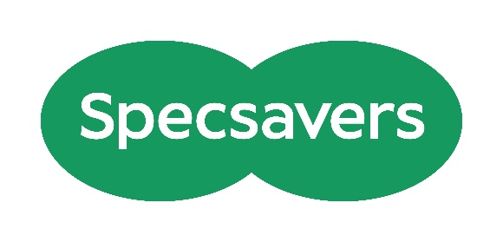

Specsavers logo

As the leading provider of optometry services for NHS Primary Care and the largest provider of community audiology services, Specsavers changes lives through better sight and hearing. Each practice is owned and run by experts who care for communities throughout the UK. There are currently more than 2,700 optics, audiology, domiciliary and ophthalmology businesses with more than 43,000 dedicated colleagues throughout the UK, Ireland, Norway, Sweden, Denmark, Finland, Australia, New Zealand and Canada and this year we have cared for more than 44 million people worldwide.

For more information visit [www.specsavers.co.uk](https://eur03.safelinks.protection.outlook.com/?url=http%3A%2F%2Fwww.specsavers.co.uk%2F&data=05%7C02%7Camy.pearman%40visionary.org.uk%7Ca23f3029aba04e541afb08dcb777c91a%7C65395a073d564877b61bf53aafe53564%7C0%7C0%7C638586973251807608%7CUnknown%7CTWFpbGZsb3d8eyJWIjoiMC4wLjAwMDAiLCJQIjoiV2luMzIiLCJBTiI6Ik1haWwiLCJXVCI6Mn0%3D%7C0%7C%7C%7C&sdata=XDXNcKJQWf4Cb80Hvd2vb0a7w9L%2FhL9q9i9Lmd1%2B7AQ%3D&reserved=0)

**The Powell Family Foundation**

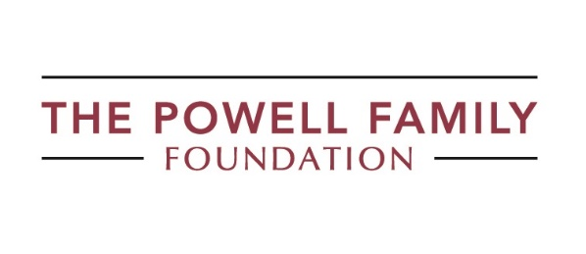

The Powell Family Foundation logo

We provide grants to individuals and charities, with the aim of creating opportunities for children and young people with a vision impairment to reach their full potential.

To learn more about us or apply for a grant please visit our website [https://tpff.org.uk/](https://eur03.safelinks.protection.outlook.com/?url=https%3A%2F%2Ftpff.org.uk%2F&data=05%7C02%7Camy.pearman%40visionary.org.uk%7C115bc94217c545783f6908dc96b4592e%7C65395a073d564877b61bf53aafe53564%7C0%7C0%7C638550948555974368%7CUnknown%7CTWFpbGZsb3d8eyJWIjoiMC4wLjAwMDAiLCJQIjoiV2luMzIiLCJBTiI6Ik1haWwiLCJXVCI6Mn0%3D%7C0%7C%7C%7C&sdata=cPY3rERlyTkiYfR9haI5GK4LSrbbn%2Fde%2FpPQs17AixE%3D&reserved=0)

**Utility Aid**



Utility Aid logo

Utility Aid is the UK’s largest energy broker for the not-for-profit sector, and we are delighted to be one of the sponsors for the Visionary Annual Conference. We are passionate about helping our customers become greener, save time, and save money.

Our dedicated team provides a high-level service to manage and maintain your portfolio, covering Procurement, Bureau Services, Full Account Management, Historical Audits, Carbon Reporting and Net Zero Planning. We have saved our charity customers over £4.7m through their invoice validation services.

Web: <https://www.utility-aid.co.uk/>

## Exhibition 2024

Welcome to our annual exhibition!

This guide provides all the essential information about this year's event, taking place on Wednesday, 25 September 2024, from 8:30am to 5:00pm.

We're excited to showcase a diverse range of exhibitors, including several new organisations to our event. Below you'll find details about each of the organisations joining us this year.

## Exhibitors

**Associated Optical**

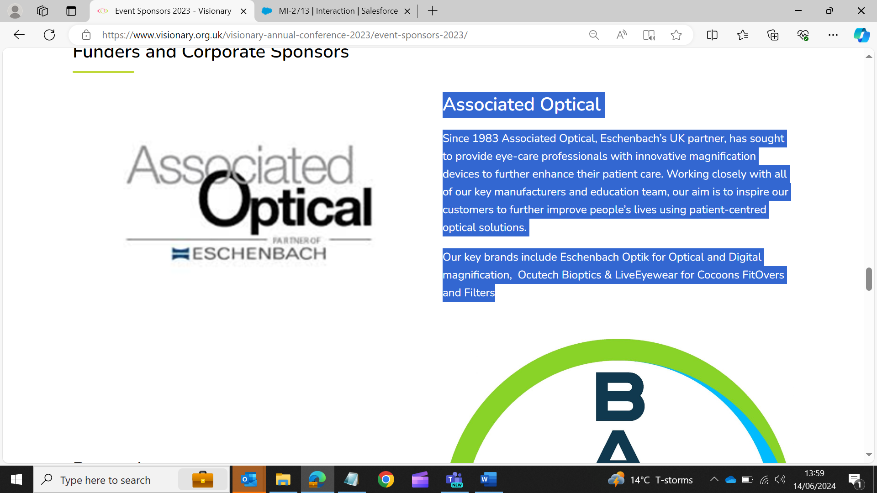

Association Optical logo – Partner of Eschenbach

Since 1983 Associated Optical, Eschenbach’s UK partner, has sought to provide eye-care professionals with innovative magnification devices to further enhance their patient care. Working closely with all of our key manufacturers and education team, our aim is to inspire our customers to further improve people’s lives using patient-centred optical solutions.

Our key brands include Eschenbach Optik for Optical and Digital magnification, Ocutech Bioptics & LiveEyewear for Cocoons FitOvers and Filters.

Web: <https://www.associatedoptical.com/>

**Dizions**

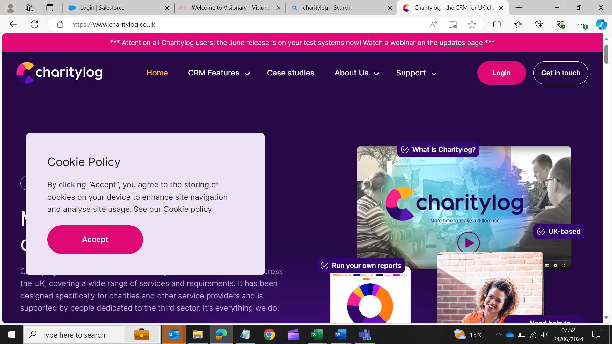

Charitylog logo

Charitylog is a cloud based CRM system used by over 900 charities. Typically, these charities provide services to clients and have to report to funders and commissioners, demonstrating impact and outcomes. It will help you manage the personal information you collect and support your organisation in meeting GDPR compliance. Whether your work is mainly 1:1 case work or group activities, in the office or in homes, Charitylog can provide the tools for recording activity and outcomes, as well as reporting.

Web: <https://www.charitylog.co.uk/>

**Fight for Sight**



Fight for Sight logo

Imagine being told that you, or someone you love, is losing their sight. In that moment, two profound questions demand urgent answers:

* Can this be stopped?
* How will I live my life?

The merger of Fight for Sight and Vision Foundation and our subsequent rebranding mean we are uniquely placed to answer both questions positively.

As Fight for Sight, we find and fund the brilliant minds and bright ideas that put change in sight. Our researchers are at the forefront, making breakthroughs and discoveries that will help us to better understand, prevent, diagnose and treat eye disease. The partnerships we build and initiatives we support are changing lives for blind and vision-impaired people.

We are Fight for Sight: we won’t stop until we: Save Sight. Change Lives.”

Please come to our exhibition stand to discover more about our journey to date and our ambitious plans for the future.

Web: [www.fightforsight.org.uk](https://eur03.safelinks.protection.outlook.com/?url=https%3A%2F%2Flinkscan.io%2Fscan%2Fux%2FaHR0cDovL3d3dy5maWdodGZvcnNpZ2h0Lm9yZy51ay8%3D%2FF2F28C8CC1E2046C0DCDFC2828067D62BBF2BEFF06DC570F384C60B613F1A424%3Fc%3D1%26i%3D1%26docs%3D1&data=05%7C02%7Camy.pearman%40visionary.org.uk%7C3709c64185d04fcd27ad08dcb843f5ef%7C65395a073d564877b61bf53aafe53564%7C0%7C0%7C638587849259646915%7CUnknown%7CTWFpbGZsb3d8eyJWIjoiMC4wLjAwMDAiLCJQIjoiV2luMzIiLCJBTiI6Ik1haWwiLCJXVCI6Mn0%3D%7C0%7C%7C%7C&sdata=p%2BlnUtp3S5eIdsk5TSsIFSVJfPfNBqzSno3IY6ejF9M%3D&reserved=0)

**ITS VIP**

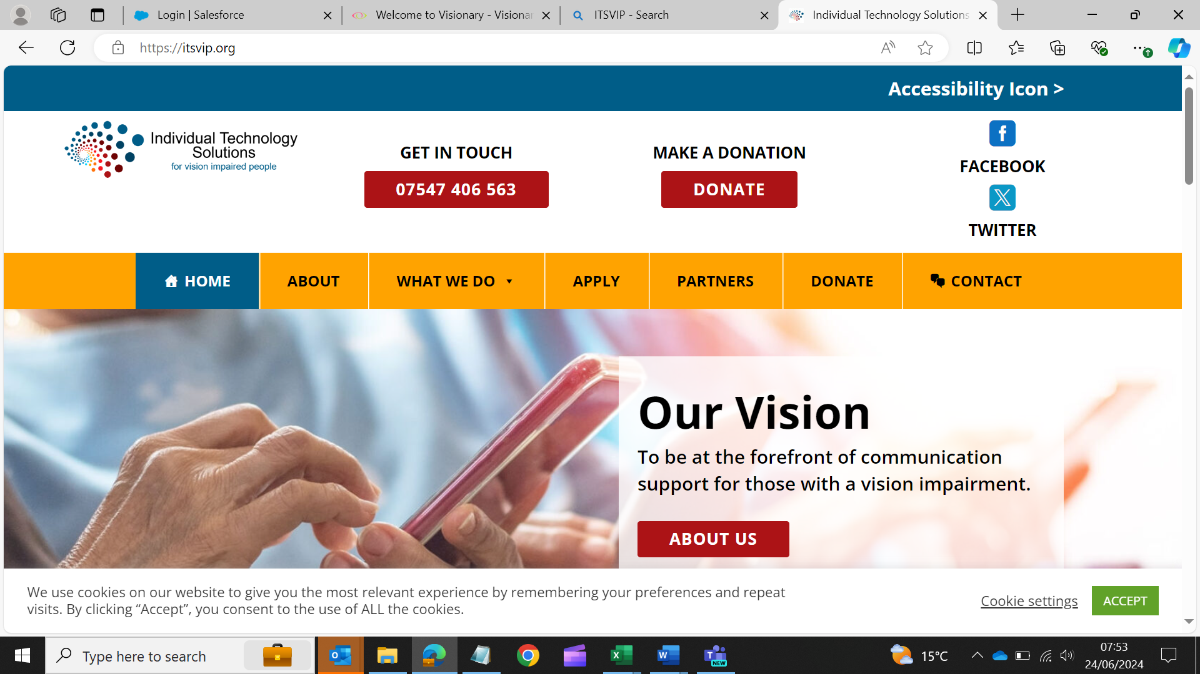

Individual Technology Solutions for Vision Impaired People logo

Individual Technology Solutions for vision impaired people (ITS VIP), previously known as Telephones for the Blind have been supporting blind and partially sighted people for over 50 years. Our mission is to combat loneliness, isolation and enable those with sight loss to live full independent lives using modern communication equipment.

Working closely with our partners from Visionary, local sight loss charities, council sensory teams and other professionals in our sector, we provide grants for landlines, specially adapted mobile phones and tablet computers, along with training and support, to those who would otherwise be unable to afford them.

Generally, the simplest way to apply is to complete the on-line application form. However, for those unable to apply on-line you can download a form from our website. All applications must be submitted by a recognised sponsoring officer and meet the charity’s eligibility criteria.

For more information visit [www.itsvip.org](http://www.itsvip.org)

**RNIB (Royal National Institute of Blind People)**

[](http://www.rnib.org.uk)

RNIB logo – See differently

RNIB is one of the UK’s leading national sight loss charities supporting blind and partially sighted people. Our vision is a world where blind and partially sighted people can participate equitably. We recognise everyone’s unique experience of sight loss and offer help and support to people. This can be anything from practical and emotional support, campaigning for change, reading services and the products we offer in our online shop. We’re a catalyst for change – inspiring people with sight loss to transform their own personal experience, their community and, ultimately, society as a whole. Our focus is on giving them the help, support and tools they need to realise their aspirations.

RNIB is delighted to sponsor and support the Visionary Annual Conference. We wish to build stronger more productive relationships at a local level and are seeking to engage with local sight loss charities to provide more opportunities for blind and partially sighted people and improve equity of access. Opportunities include sharing information, training, support, resources etc. where RNIB is actively seeking to collaborate. If you are interested in having a discussion, please get in touch via [email RNIB Charity Partners](mailto:charity.partners@rnib.org.uk).

Web: <https://www.rnib.org.uk/>

**RNIB Connect Radio**

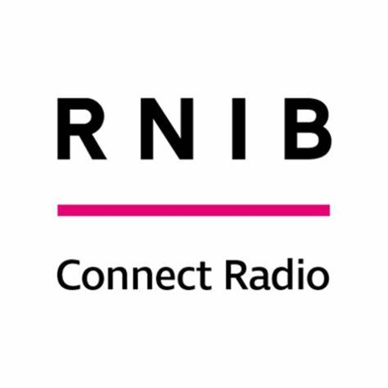

RNIB Connect Radio logo

Broadcasting 7 days a week and 24 hours a day, RNIB Connect Radio broadcasts to an audience of over 80,000 blind and partially sighted people across the UK to provide a range of essential information in an easily accessible format to our listeners while centring the voices of the blind and partially sighted community.

RNIB Connect Radio is a crucial tool in the RNIB’s armoury of supporting blind and partially sighted people and offers an easily accessible ‘window’ to all types of information, services, opportunities, solutions, and support.

All our presenters are either blind or partially sighted ensuring we broadcast from a position of knowledge and experience.

We serve the UK and you can listen on Freeview channel 730, online at [RNIB Connect Radio | RNIB](https://www.rnib.org.uk/connect-radio/) and on 101 FM in the Glasgow area. We are also available via smart devices or you can say ‘Alexa play RNIB Connect Radio’.

**Sarabec®**

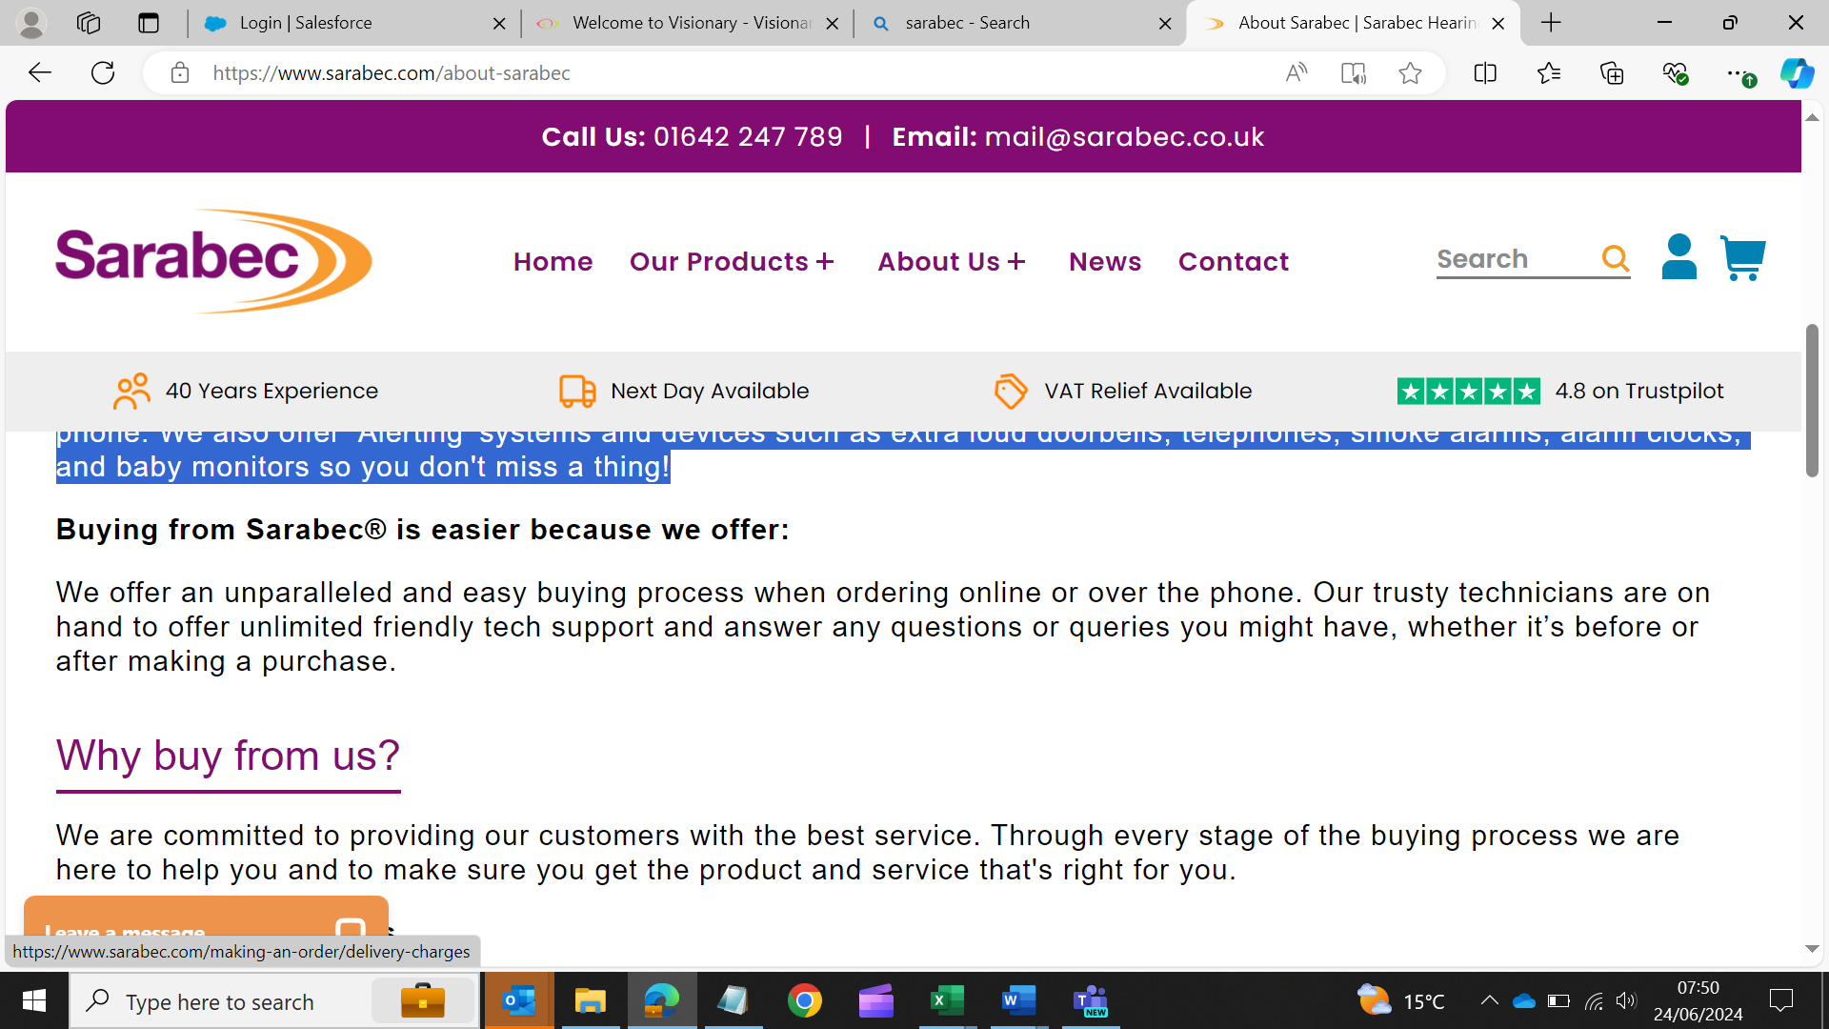

Sarabec® logo

We aim to make life a little easier for those with hearing difficulties, hearing loss, or sight impairments by providing high-quality assistive devices, products, and accessories that you can rely on so you can stay in touch with friends and relatives, know what’s happening at home, and enjoy recreational time.

We have a wide selection of products including; **TV listeners, amplified telephones, extra loud doorbells, alerting systems like smoke alarms, alarm clocks, and baby monitors** to help keep you safe, independent and aid your daily living.

At Sarabec®, we offer simple hearing solutions for anyone with or without a hearing aid. Our listening devices help you hear the TV and radio. They let you listen at a volume that is suitable for you without affecting those around you.

Our telephones come in a range of amplified corded, cordless, and mobile options so you can comfortably chat on the phone. We also offer ‘Alerting’ systems and devices such as extra loud doorbells, telephones, smoke alarms, alarm clocks, and baby monitors so you don't miss a thing!

Web: <https://www.sarabec.com/>

**Tracey Welch Photography, Sponsored by Specsavers**

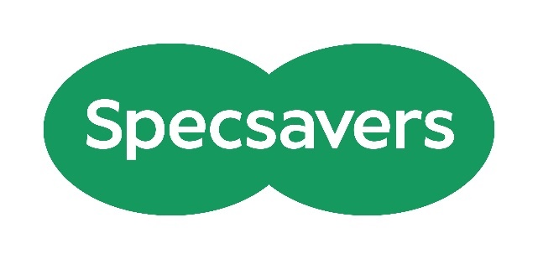

Specsavers logo

Specsavers invite you to visit the photographer, Tracey Welch, during your time at the conference.  Tracey will be taking photos throughout the event and will also be available to take individual profile, team or group photographs.

Please let Raquel know if you would like to book a photography slot, either in advance by email, [Raquel.garrido-soriano@visionary.org.uk](mailto:Raquel.garrido-soriano@visionary.org.uk), or on the day.

Web: [www.specsavers.co.uk](https://eur03.safelinks.protection.outlook.com/?url=http%3A%2F%2Fwww.specsavers.co.uk%2F&data=05%7C02%7Camy.pearman%40visionary.org.uk%7Cf1396a77e69840ddc11408dcb7801f8a%7C65395a073d564877b61bf53aafe53564%7C0%7C0%7C638587008166488661%7CUnknown%7CTWFpbGZsb3d8eyJWIjoiMC4wLjAwMDAiLCJQIjoiV2luMzIiLCJBTiI6Ik1haWwiLCJXVCI6Mn0%3D%7C0%7C%7C%7C&sdata=iUal76A9AZDjykQT328%2BcDwrvN%2BAsHJSbtg%2BnbmZ8K8%3D&reserved=0)

**Torch Trust**

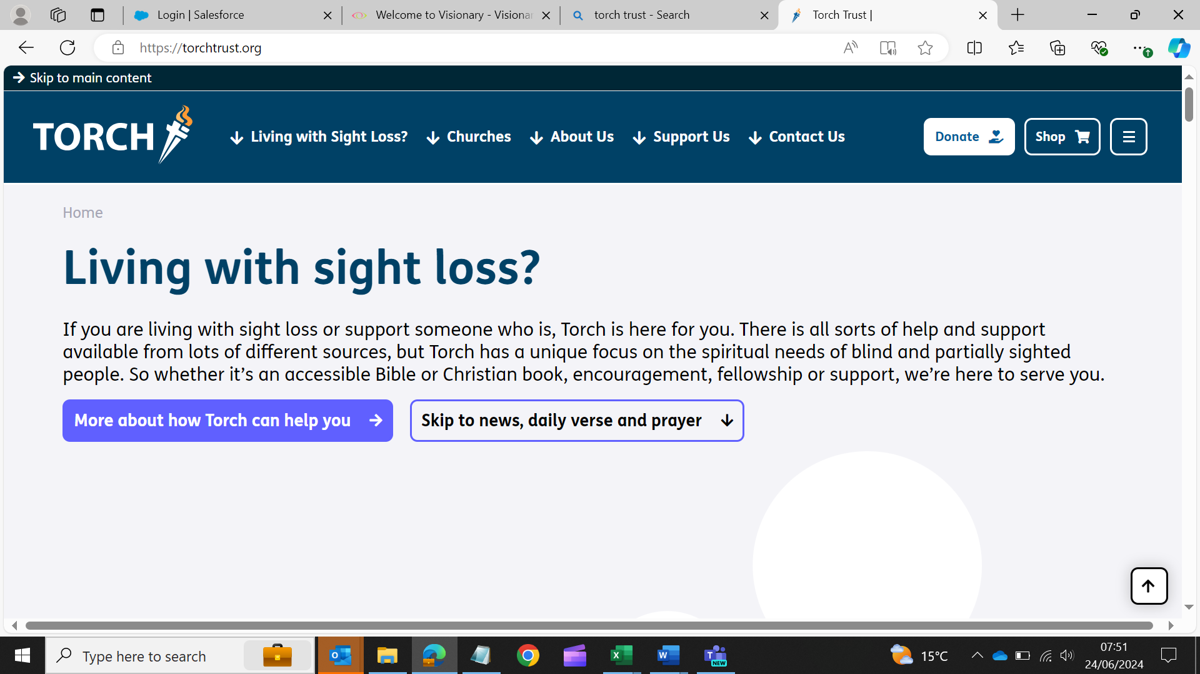

Torch Trust logo

Torch Trust is a national and international Christian charity. We seek to make a difference to the lives of people who are living with sight loss by providing them with the opportunity to access Bibles and other Christian resources, through our free lending library and for sale. We support sight loss friendly churches and offer access to a range of events and services, including holidays for people who are visually impaired, local group meetings and a befriending service.

Web: <https://torchtrust.org/>

**Utility Aid**

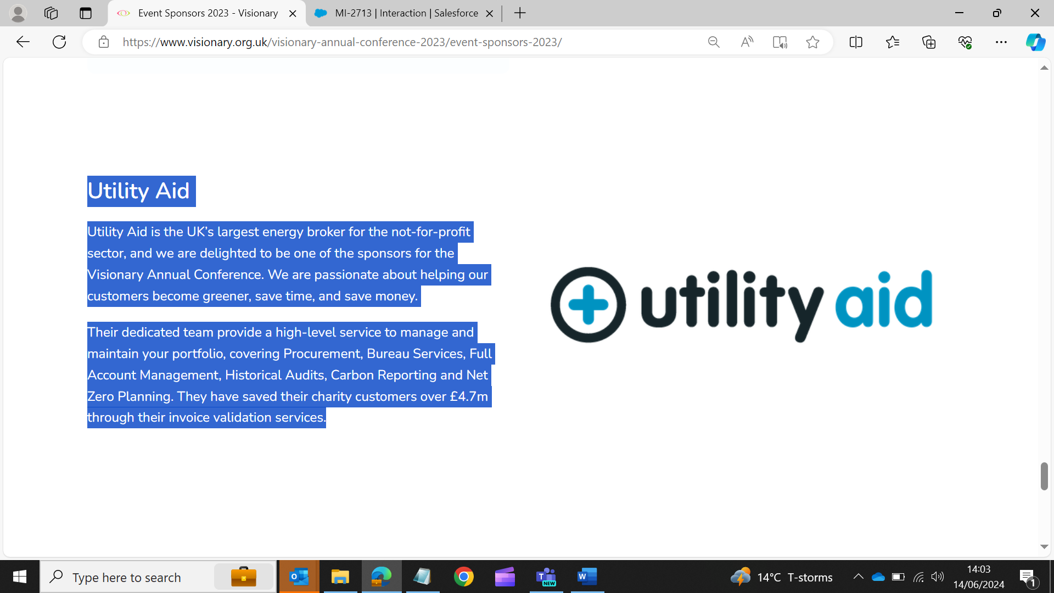

Utility Aid logo

Utility Aid is the UK’s largest energy broker for the not-for-profit sector, and we are delighted to be one of the sponsors for the Visionary Annual Conference. We are passionate about helping our customers become greener, save time, and save money.

Our dedicated team provide a high-level service to manage and maintain your portfolio, covering procurement, bureau services, full account management, historical audits, carbon reporting and net zero planning. We have saved our charity customers over £4.7m through our invoice validation services.

Web: <https://www.utility-aid.co.uk/>

### Location of Exhibitors

The exhibition space consists in three different areas: upper lounge, lower lounge, and bar area with a total of eight stands. Please note the location of each stand is subject to change on the day. Please do not hesitate to ask a member of the Visionary team if you would like an introduction to an exhibitor.

The upper lounge is the first you find when you enter the building after the reception. You can find the entrance on your right. Once you are in the upper lounge the stands from left to right are ITSVIP, RNIB, Sarabec®, Utility Aid and Fight for Sight.

To access the lower lounge, you have a staircase joining upper and lower lounge and also an entrance from the main hall. If you access the lower lounge from the main hall, on your right you find Associated Optical, Torch Trust and Charitylog.

The third section is the bar area, to access the bar are there are two entrances by the main hall, one just after the lower lounge and one opposite the restaurant reception. Accessing the bar area by the first entrance, you find the Specsavers press office on your right.

## Vision Partnership

Eight leading charities in the UK sight loss sector have formed the Vision Partnership (formerly VI Charity Sector Partnership). The partnership's purpose is to focus on the big issues that improve the lives of people with sight loss and those at risk of developing sight loss.

The founding partners are Blind Veterans UK, Glaucoma UK, Guide Dogs, Macular Society, Retina UK, RNIB, Thomas Pocklington Trust and Visionary.  All workstreams have representation from Visionary members and several workstreams are also supported by other sight loss organisations, including Fight for Sight and SeeAbility. The Vision Partnership is chaired by Matt Stringer, CEO of RNIB, and supported by CEOs from all partner organisations, each of whom sponsors different workstreams.

Earlier this year, the Vision Partnership undertook an independent strategic review to reassess its purpose, ambition, strategic focus, and identity. This review aimed to reconfigure the partnership's structures where necessary to ensure effective delivery and future fitness for purpose.

As a result of this review, four strategic priorities were identified:

1. Political influencing
2. Developing an evidence base, including data collection
3. Prevention, including services and medical research funding
4. Independent living and vision rehabilitation

The Vision Partnership have developed a program of activities and processes to support these four strategic priorities.

In response to feedback from last year's conference, this year delegates are invited to join three workshops aligned with the work of the partnership. This will allow space and time to explore the priorities in more detail, understand future plans, and influence the direction of the work.

For the latest impact report and more information, please visit the Visionary website: [Vision Partnership - Visionary](https://www.visionary.org.uk/knowledge-hub/visionpartnership/).

## Visionary Annual Awards Dinner

Welcome to the Visionary Annual Awards Dinner, sponsored by Fight for Sight.

You are invited to join us from 18:45 for Reception Drinks, sponsored by Associated Optical. We aim to begin seating for dinner at approximately 19:30.

We are looking forward to welcoming you to a relaxing evening featuring a three-course dinner, followed by presentation of the winners of this year's Visionary Awards.

Our annual awards strive to recognise and celebrate the impactful services delivered by sight loss charities and the positive difference made to the lives of blind and partially sighted people. As always, a huge thank you to everyone who took the time to share their amazing work and submit a nomination. It is wonderful to read about your incredible achievements – it makes decision making very challenging for the shortlisting panels!

Thank you to this year's award sponsors:

* **Children and Young People Award - Sponsored by The Powell Family Foundation**

**This award** showcases how Visionary members and partners make a positive difference to the lives of blind and partially sighted children and young people.

* **Community Impact Award -** Sponsored by Specsavers

This award highlights the amazing work taking place across communities to improve eye health outcomes for people in local communities.

* **Connect and Collaborate Award -** Sponsored by RNIB

This showcases how Visionary members and partners have transformed or created a service by collaborating with others to connect with blind and partially sighted people, or those at risk of sight loss in new and innovative ways.

* **Develop and Share Award -** Sponsored by Guide Dogs UK

This award celebrates service developments and applauds the generosity we see every day from the Visionary member and partner organisations.

* **Innovate and Inspire Award -** Sponsored by Fight for Sight

This award celebrates Visionary members and partners who have forged ahead with ground-breaking approaches, ideas, and initiatives.

## Workshops

When you arrive at the conference, you will be given a refresher on your chosen workshops and their respective meeting locations. Below, you'll find a recap of the of workshops and presentations available throughout the conference.

We'd like to express our appreciation to all workshop facilitators for dedicating their time, enthusiasm, and sharing their knowledge and insights at this year's event.

Workshop Overview – Day One

|  |  |
| --- | --- |
| **Session 1** | **Wednesday 25 September 2024, 13:45 to 15:00** |
| **Option 1:** | Inclusion - Where Do **YOU** Fit In? |
| **Option 2:** | Telling real life stories - the pitfalls and the positives |
| **Option 3:** | Awareness, prevention, and improving lives |
| **Option 4:** | Key issues in charity governance |
| **Option 5:** | Journey to Net Zero |
| **Option 6:** | Vision Partnership: Getting involved in eye research: why and how |

|  |  |
| --- | --- |
| **Session 2** | **Wednesday 25 September 2024, 15:30 to 16:45** |
| **Option 1:** | Recruit, retain and uplift – maximising your fundraising |
| **Option 2:** | Enhancing Engagement with Integrated Care Boards and Commissioners |
| **Option 3:** | Insight, Passion and Achievement: Creative Writing for VIPs |
| **Option 4:** | Internships:  A springboard to employment |
| **Option 5:** | A Holistic Approach to Low Vision |
| **Option 6:** | Active EYES |

Workshop Overview – Day Two

|  |  |
| --- | --- |
| **Session 3** | **Thursday 26 September 2024, 10:45 to 12noon** |
| **Option 1:** | Demystifying AI: It's not a trend. Why you should engage. |
| **Option 2:** | Villa Vision: Visit the mobile unit |
| **Option 3:** | Putting the Human in HR |
| **Option 4:** | Children and Charles Bonnet Syndrome |
| **Option 5:** | Rehab Crisis – Ways Forward? A look at models for solution. |
| **Option 6:** | Vision Partnership: The Eye Care Support Pathway – Including the patient voice and working together to deliver our aims. |

|  |  |
| --- | --- |
| **Session 4** | **Thursday 26 September 2024, 12:15 to 13:30** |
| **Option 1:** | Visual Impairment, Autism and Neurodiversity in Children and Young People |
| **Option 2:** | CVI: Certification and Registration in Northern Ireland & Wales |
| **Option 3:** | Manage stress and burnout, to boost resilience and wellbeing in the workplace |
| **Option 4:** | Making Health Accessible |
| **Option 5:** | Boccia: The sport for all (practical session) |
| **Option 6:** | Vision Partnership: Political Influencing, collaborating for change |

**Session One: Wednesday 25 September, 13:45 to 15:00**

**Option 1 Inclusion - Where Do YOU Fit In?**

**Facilitator:**

* Fern Lulham, BBC Broadcaster and Producer

**Summary:** In a safe environment, delegates will be challenged and facilitated to critically examine their own strengths and weaknesses in achieving inclusion. We will explore the emotions we are all influenced by when it comes to inclusion, eg embarrassment, anxiety as well as defensiveness and use them as a personal and actionable roadmap for change. Ultimately, these feelings are the driving force behind impactful decisions, from who gets hired to how we interact with those around us and where we feel we belong.

Delegates will gain awareness over their barriers and insecurities around inclusion, and uncover the opportunity to make different choices when it comes to their actions, attitudes and beliefs going forward. This underlines the need for change in individuals rather than bland organisational statements. In a down-to-earth, creative and meaningful way, we will cut to the heart of inclusion and what it means for all of us in our everyday lives. Delegates will get to know themselves better and learn the key skills which will allow them to stand out when it comes to fitting in.

**Audience:** All

**Geography:** UK wide

**Biography:**

**Fern Lulham, BBC Broadcaster and Producer**

Fern Lulham is a public speaker, broadcaster, audio description narrator, disability awareness trainer and qualified psychotherapist.  Little wonder then that she describes herself as a freelance communicator. Born severely visually impaired and now registered blind, Fern's passion for communication started in early childhood when she would use an egg-whisk for a microphone to "interview" friends and family!

Fern's engaging communication style produces lightbulb moments for her audiences that help them to meet the challenges we all face, whether disabled or not.

**Option 2 Telling real life stories - the pitfalls and the positives**

**Facilitator:**

* Mairi Damer, Communicator in Chief, Word Up Communications

**Summary:** Hearing or seeing stories about real life experience is always going to be more attractive to audiences, funders and policymakers than dry data and statistics. When told well, the power of people’s individual or shared stories is undeniable, but using “lived experience” as a promotional or marketing tool comes with significant risks as well as benefits.

In this session, Mairi Damer of WORD UP Communications, and former BBC Radio Scotland producer, champions a careful, sensitive and strategic approach when using real people, and outlines ways to avoid some of the potential pitfalls. Mairi will draw on her own experience from broadcasting and campaigning work to illustrate the good, the bad and the ugly of real life stories.

During the session we’ll also discuss practical issues like informed consent, reimbursement, re-use and overuse of case studies, and setting a realistic lifespan for real life stories.

**Audience:** Everyone who is likely to use case study/real life stories

**Geography:** UK wide

**Biography:**

**Mairi Damer, Communicator in Chief, Word Up Communications**

Mairi is a former BBC Radio Scotland producer who brings 15 years’ worth of media experience to her Glasgow-based communications business. A one-woman anti-jargon warrior, she always aims to help her clients communicate clearly, confidently and coherently.



Sight Scotland / Sight Scotland Veterans logo

**Sponsor:** Thank you to **Sight Scotland and Sight Scotland Veterans** for sponsoring this workshop.

**Option 3 Awareness, prevention, and improving lives**

**Facilitators:**

* Lisa Hollyhead, CEO, Sight For Wight
* Helen Brown, Head of Impact and External Income, Beacon Centre for the Blind
* Devante Claridge, Community Engagement Worker, MyVision Oxfordshire

**Summary:** Join Beacon Centre for the Blind, Sight for Wight (mentioned in Facilitators section above), and MyVision Oxfordshire for an engaging workshop focused on how to reach more people. Whether it's by launching services to benefit the community or educating people of all ages about eye health, this workshop will provide valuable insights. Discover their new initiatives aimed at raising awareness about visual impairment within local communities and businesses, and learn strategies for fostering stronger engagement.

This workshop will look at methods for delivering preventive education in schools and reaching people who aren’t currently part of the sight loss community. Delegates will also look at the positive impact of outdoor activities, such as walking and talking in green spaces, enhancing the quality of life and boosting confidence for blind and partially sighted people.

**Audience:** All

**Geography:** UK wide

**Biographies:**

**Lisa Hollyhead, CEO, Sight For Wight**

Lisa is a Chartered Accountant by trade but is now the CEO of the Isle of Wight Society for the Blind which holds the sensory service contract for the Isle of Wight. Lisa is registered DeafBlind.

**Helen Brown, Head of Impact and External Income, Beacon Centre for the Blind**

Helen Brown, Head of Impact and External Affairs at Beacon Centre for the Blind, is passionate about leveraging her lived experience of disability to highlight the challenges faced by the sight loss community, drawing on her background as a journalist to tell compelling stories and using impact reporting to showcase the transformative power of targeted interventions.

**Devante Claridge, Community Engagement Worker, MyVision Oxfordshire**

Devante Claridge, Community Engagement Officer, MyVision Oxfordshire, has lived with a visual impairment all his life. Devante knows first-hand the importance of creating awareness and integration of people with a visual impairment in the community and has one sole ambition, to enrich the lives of blind and partially sighted people and others.  Devante also volunteered as a befriender, to support others with their mental wellbeing, which has given him transferable skills.

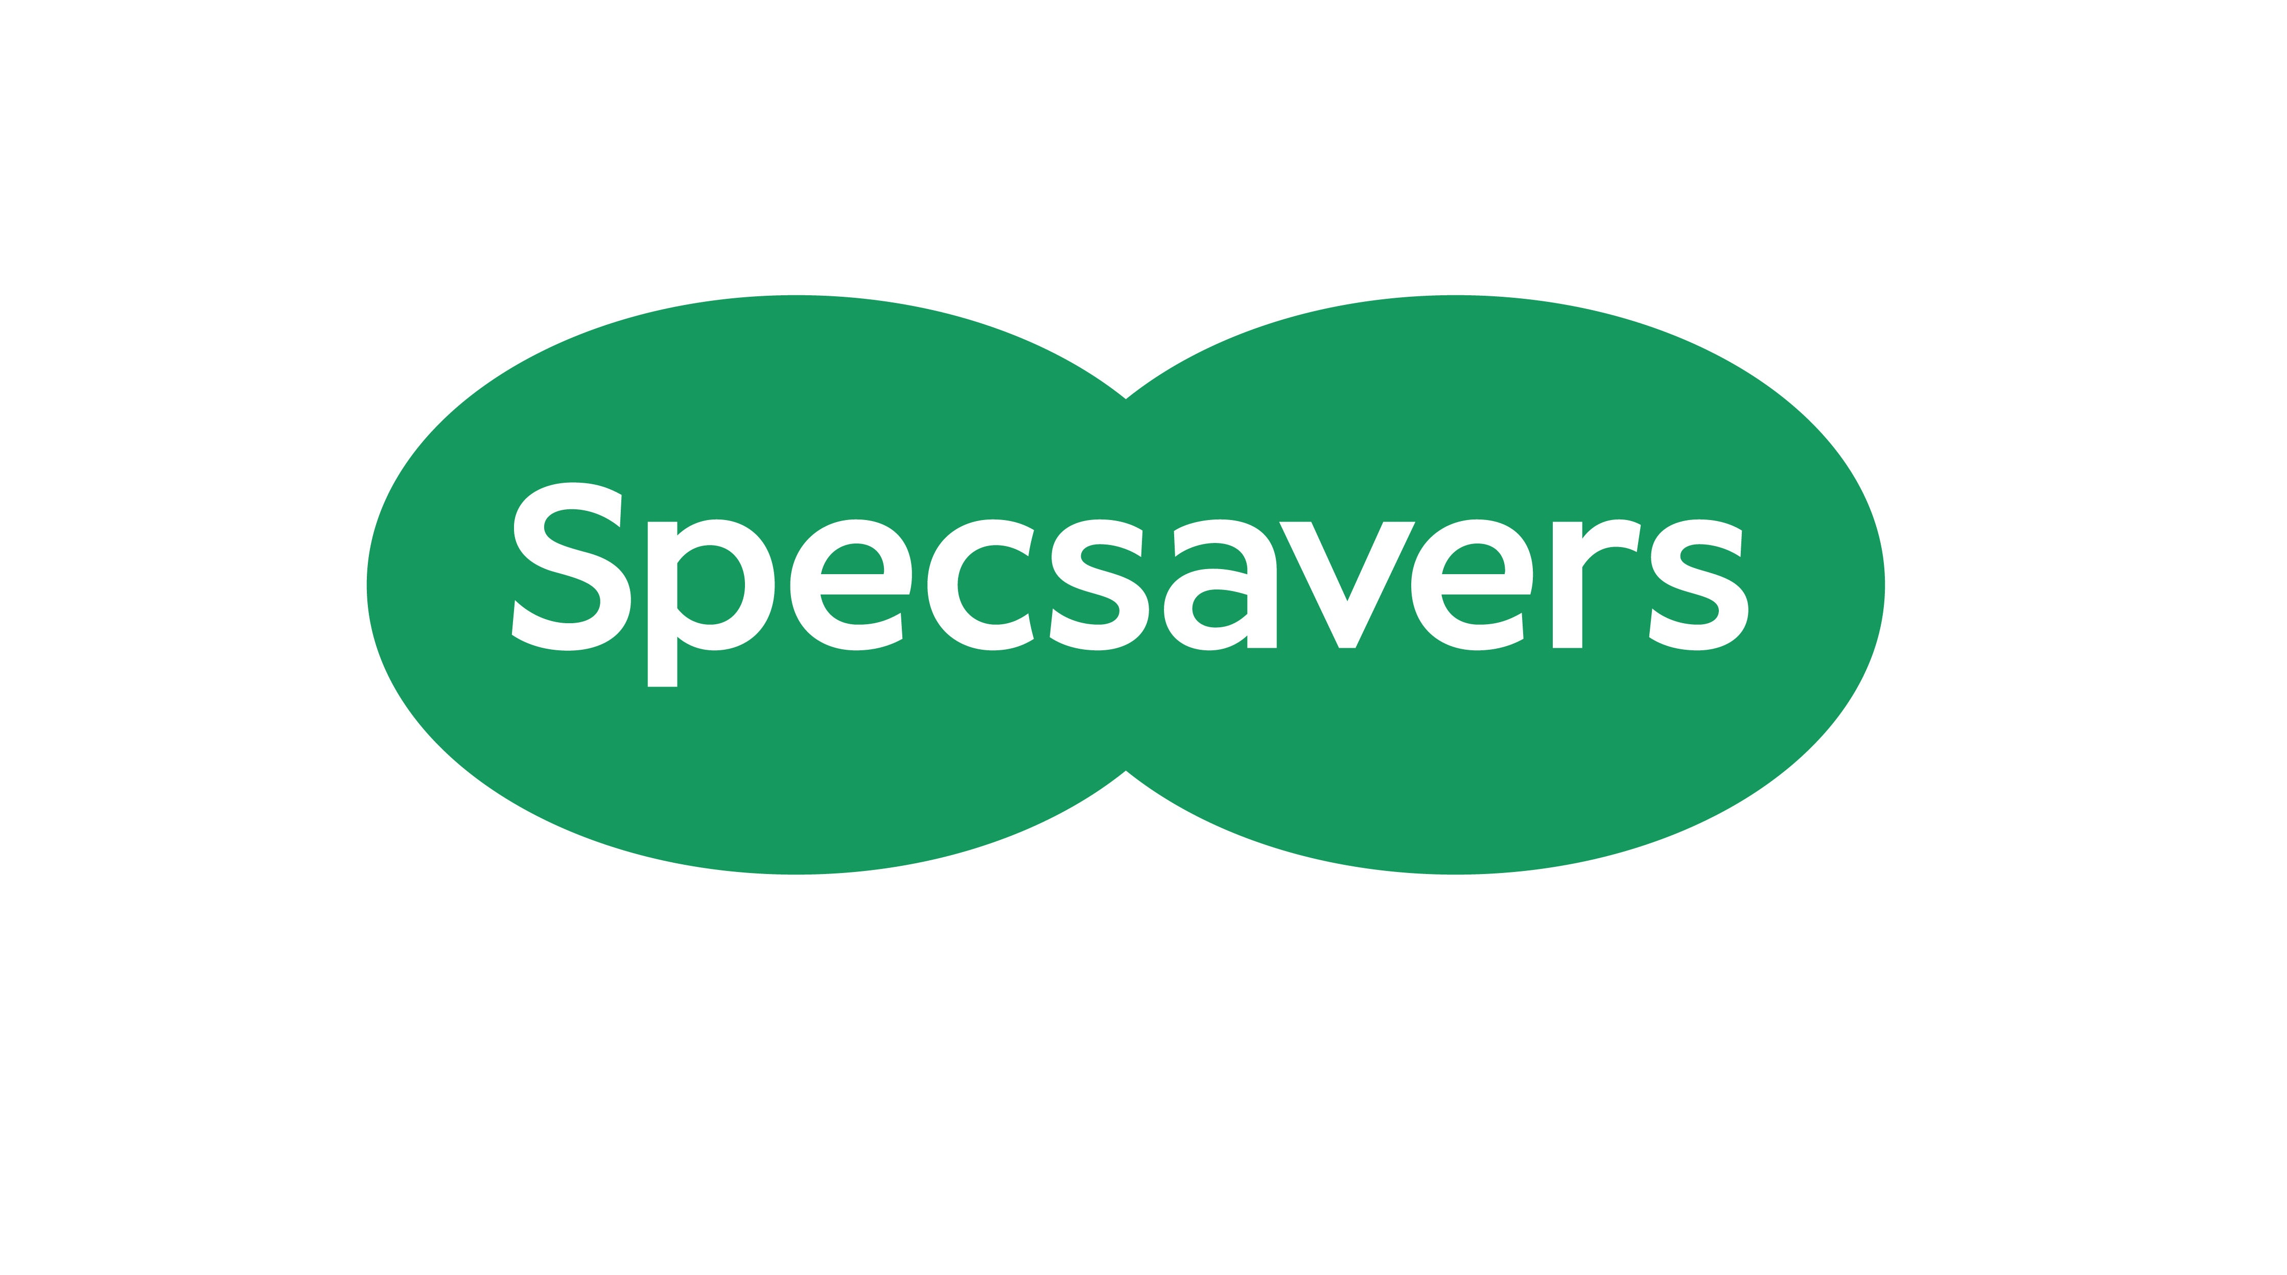

Specsavers logo

**Sponsor:** Thank you to **Specsavers** for sponsoring this workshop and project work.

**Option 4 Key issues in charity governance**

**Facilitator:**

* Gareth Roy, Senior Associate, Russell Cooke

**Summary:** Good governance is fundamental to a charity’s success. This workshop will explore some key issues in relation to charity governance and we’ll discuss how to get your charity’s governance right. We’ll cover:

* Trustee duties
* Conflicts of interest management
* Where to draw the line between strategy and operations
* Risk management

Active engagement and knowledge sharing will be encouraged during the session.

**Audience:** Everyone – particularly Trustees and Senior Management.

**Geography:** All, but where law is referenced this will be the law of England and Wales, but there will be signposting to Scottish law.

**Biography:**

**Gareth Roy, Senior Associate, Russell Cooke**

Gareth is an experienced charity lawyer, advising a wide range of organisations across the sector from large, national charities to small, local organisations. He specialises in advising charities on governance and commercial matters. Gareth is also a charity trustee himself, sitting on the board of the Money and Mental Health Policy Institute.



Russell-Cooke logo

**Sponsor:** Thank you to **Russell Cooke** for sponsoring and facilitating this workshop.

**Option 5 Journey to Net Zero**

**Facilitator:**

* Emily Berry, Partnership Manager, Utility Aid.

**Summary:** In this workshop, participants will gain practical insights and tools to develop and implement effective sustainability ideas.

**Audience:** All

**Geography:** UK wide

**Biography:**

**Emily Berry, Partnership Manager, Utility Aid**

Emily has a passion for supporting the third sector to save time and money on their energy provision. Emily supports our partners and their members and is delighted to be working in partnership with NCVO. She believes that collaboration is key to achieving a sustainable future and regularly holds webinars and discussion groups to provide tips which will help you identify potential areas of cost recovery and support you in reducing energy consumption and wastage.

**Option 6 Vision Partnership: Getting involved in eye research: why and how**

**Facilitators:**

* Dr Peter Bloomfield, Director of Research, Macular Society
* Joanne Hodgkinson, Head of Research, Glaucoma UK

**Summary:** Research is critical to our understanding of eye health and disease. It informs how we live, how we treat conditions and how we design the health system. Eye research is dramatically underfunded and this needs to change. In this workshop, you will learn about the range of eye research happening at Glaucoma UK and the Macular Society and you will find out how you can get involved.

Co-hosts Joanna Hodgkinson (Glaucoma UK) and Dr Peter Bloomfield (Macular Society) will take you through the value of different types of research, sources of funding and how more action on research in sight loss and visual impairment can make a difference. There will be an opportunity to design your own research questions and suggest areas of research that should be prioritised. You will also learn how Visionary members can help people take part in research and ensure the voices of those with lived experience of sight loss are heard in the design and delivery of eye research.

Overall, you will come away from the session with a better understanding of how best to engage with meaningful research. We will identify clear ways for patients and charities to come together to ask, and answer, vital questions to fight sight loss.

**Audience:** All

**Geography:** UK wide

**Biographies:**

**Dr Peter Bloomfield, Director of Research, Macular Society**

Peter is Director of Research at the Macular Society. He is a neuroscientist by background and his PhD from Imperial College London focused on human brain imaging. Over the last 15 years, he has conducted research across a range of medical and life sciences topics, from novel treatments to technology to improve care. He is a trustee and interim chair of the Healthcare Quality Improvement Partnership who promote healthcare quality improvement through audit.

**Joanna Hodgkinson, Head of Research, Glaucoma UK**

Joanna is Glaucoma UK’s first Head of Research. The charity has funded research for many years, and Joanna’s role is to set a research strategy and ensure the charity is funding the most impactful research. Prior to this, Joanna was Head of Support Services at Glaucoma UK, having previously worked in strategy for the Ministry of Defence and as a chemistry teacher.

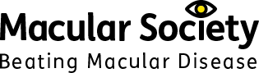

Glaucoma UK logo (left) and Macular Society logo – Beating macular disease (right)

**Sponsor:** Thank you to **Glaucoma UK and Macular Society** for sponsoring and facilitating this workshop.

**Session Two: Wednesday 25 September, 15:30 to 16:45**

**Option 1 Recruit, retain and uplift – maximising your fundraising**

**Facilitator:**

* Ellie Lynch, Adviser – Fundraising Strategy Expert, Charities Aid Foundation (CAF)

**Summary:** Using insights from companies, donors and charities, this interactive session will explore ways to recruit, retain and uplift donors to maximise your fundraising. Philanthropy relies on human connection, and if you fail to make an emotional connection through your campaigns, you’re not going to gain and keep donors.

This session will explore the ways that you can capitalise on this human connection, with real life tips to implement into your fundraising.

**Audience:** All

**Geography:** UK wide

**Biography:**

**Ellie Lynch, Adviser – Fundraising Strategy Expert, Charities Aid Foundation**

Ellie is currently an Adviser at Charities Aid Foundation (CAF), where she works with corporate clients and high-net-worth individuals to maximise their philanthropic impact, as well as working with charities to upskill them on a range of topics, all designed to improve their resilience and sustainability. Ellie’s previous experience includes supporting and advising on communications for fundraising from major donors, trusts and foundations, and corporates at British Heart Foundation and Alzheimer’s Society. Prior to this, Ellie ran the research and conference programme at the Foundation for Social Improvement (FSI), focusing on topics such as fundraising, governance, impact, and strategy for small charities across the UK.

**Option 2 Enhancing Engagement with Integrated Care Boards and Commissioners**

**Facilitators:**

* Frank Moore, Head of Enhanced Optical Services Operations at Specsavers
* William Green, Industry Engagement Manager, Specsavers.

**Summary:** Join Specsavers for an interactive workshop, in which they will share their knowledge and experiences in effectively engaging and influencing Integrated Care Boards (ICBs) and commissioners.  Delegates will gain insights into strategies and best practices for building strong relationships with their local ICBs.

Through interactive sessions and case studies, Specsavers will provide practical guidance on tailoring your approach, crafting compelling narratives, and navigating the complexities of the ICB and commissioning processes.

Additionally, this workshop will feature a collaborative segment with Visionary, where participants will have the opportunity to explore the potential for participating in an exciting project focused on enhancing engagement with ICBs and commissioners.

**Audience:** All

**Geography:** Primarily England

**Biographies:**

**Frank Moore, Head of Enhanced Optical Services Operations at Specsavers**

Frank’s mission at Specsavers is to ensure that patients can access their NHS eyecare in a location that they can easily get to - and help to ensure that avoidable sight loss is avoided.

**Will Green, Industry Engagement Manager, Specsavers**

Will is part of a team which has a clear focus to improve access to care, working with colleagues across the eye and hearing health sector to deliver that mission and working with journalists, policy makers and stakeholders to progress that vision.



Specsavers logo

**Sponsor:** Thank you to **Specsavers** for sponsoring and facilitating this workshop.

**Option 3 Insight, Passion and Achievement: Creative Writing for VIPs**

**Facilitators:**

* Jessica Eastman, Volunteer Group Leader, Creative Writing Group, Coventry Resource Centre for the Blind
* Richard Warren, Volunteer, Creative Writing Group, Coventry Resource Centre for the Blind

**Summary:** The Creative Writing Group at Coventry Resource Centre for the Blind (CRCB) has been operating for six years. The group’s leaders will talk about the transformation it has brought to members and how the group works. They will also talk about how collaboration with the local theatre and a media CIC has developed and allowed the writing group’s first collection to be published as an audiobook, and how those collaborations will operate in the future. There will be a focus on how to replicate similar groups in other organisations, with practical advice from experience and plenty of opportunities to ask questions.

**Audience:** Everyone, in particular Project/Service Managers

**Geography:** UK wide

**Biographies:**

**Jessica Eastman, Volunteer Group Leader, Creative Writing Group, Coventry Resource Centre for the Blind**

After 30+ years working in adult education teaching adult literacy, supporting learners with a range of additional needs on all sorts of courses and teacher training, Jessica retired and volunteered to start a creative writing group at CRCB.

**Richard Warren, Volunteer, Creative Writing Group, Coventry Resource Centre for the Blind**

Richard is a professional advertising copywriter/Creative Director (now semi-retired), and an amateur theatre director at the Criterion Theatre, in Coventry. He has been volunteering as a scribe with the Creative Writing Group for five years, and has directed the audiobook.



Utility Aid logo

**Sponsor:** Thank you to **Utility Aid** for sponsoring this workshop.

**Option 4 Internships: A springboard to employment**

**Facilitators:**

* Joshua Feehan, Head of Internships, Thomas Pocklington Trust
* Helen Brown, Head of Impact and External Income, Beacon Centre for the Blind
* Kaydey Johns, Community Support Intern, Beacon Centre for the Blind

**Summary:** Enhancing employment opportunities and the representation of lived experience across the sector is a high priority for all.  We are collaborating with Thomas Pocklington Trust (TPT) to develop a workshop that will showcase and highlight the exceptional impact which the Get Set Progress programme, (a partnership between TPT and RNIB) is making within the sector and beyond.

In this workshop, which is currently in the early stages of development, we will hear from an employer, a previous intern and a current intern who will share their experiences on how they have benefitted from the programme.

The workshop will provide insights into the significant strides being made by the Get Set Progress programme in promoting inclusivity and empowering individuals with visual impairments in the workforce. It will also offer valuable guidance for organisations seeking to foster a more diverse and inclusive work environment.

**Audience:** All

**Geography:** UK wide

**Biographies:**

**Joshua Feehan, Head of Internships, Thomas Pocklington Trust**

Joshua has been the Head of Internships at TPT for the past 18 months. He has helped to oversee the expansion of the programme from a small Internal scheme, to now offering 30 internships a year across the UK in a range of different industries. Joshua is motivated to see greater representation of blind and partially sighted people in employment at all levels of the labour market. This passion was born through his own personal lived experience of sight loss. Joshua has been in the sight loss sector for nearly 10 years holding positions in both local and national organisations.

Outside of work, Joshua is currently undertaking barrister training at the University of Law where he is about to start his final year.

**Helen Brown, Head of Impact and External Income, Beacon Centre for the Blind**

Helen Brown, Head of Impact and External Affairs at the Beacon Centre for the Blind, is passionate about leveraging her lived experience of disability to highlight the challenges faced by blind and partially sighted people. She draws on her background as a journalist to tell compelling stories and use impact reporting to showcase the transformative power of targeted interventions.

**Kaydey Johns, Community Support Intern, Beacon Centre for the Blind**

Kaydey is the Community Support Intern for the Beacon Centre for the Blind through the Get Set Progress programme at TPT. Kaydey’s background has been in care with SEN children and has changed to work in the visual impairment sector due to being registered as severally sight impaired in July 2023.

 

RNIB logo – See differently (left) and Thomas Pocklington Trust logo (right)

**Sponsor:** Thank you to **RNIB and Thomas Pocklington Trust** for sponsoring this workshop.

**Option 5 A Holistic Approach to Low Vision**

**Facilitators:**

* Dr Louise Gow, Head of Eye Health, Optometry and Low Vision, RNIB
* Claire Huddleston, Service Manager, Vision Support Barrow and District
* Preeti Singla, Optometry and Low Vision Engagement Manager, RNIB

**Summary:** An in-depth discussion of case records highlighting how best to support people with low vision from a holistic perspective, with a particular focus on practical support and multidisciplinary / integrated care.

**Audience:** All, in particular Low Vision service providers and managers, people involved in the commissioning of services, and people interested in providing low vision services.

**Geography:** UK wide

**Biographies:**

**Dr Louise Gow, Head of Eye Health, Optometry and Low Vision, RNIB**

Louise has 30 years experience as an optometrist working in primary care, university, hospital and also in the third sector. She has a portfolio career as specialist optometrist in low vision and learning disabilities. Currently running the low vision strategy work, health and social care professionals training and low vision clinic at RNIB. She also works as bank staff for St Thomas Hospital, London in the low vision clinic and during term time provides one clinic a week for SeeAbility Special Schools eye care service. Louise is also a GOC registrant member of the registration committee.

**Claire Huddleston, Service Manager, Vision Support Barrow and District**

Claire is the Service Manager at Vision Support Barrow and District (VSBD) since 2022, but has been with the charity since 2017. Before that, Claire volunteered for VSBD for 3 years. Claire began her journey with them as part of her Masters Degree in Social Care. As her knowledge of the work they do grew, she became inspired by everything they achieved, so when the opportunity to join the team arose, she jumped at the chance. Claire is driven by a passion to maintain and develop new services for the clients they support and is always looking for new opportunities to help VSBD grow as a charity.

**Preeti Singla, Optometry and Low Vision Engagement Manager, RNIB**

Preeti Singla is an IP optometrist with over 20 years’ experience in high street and hospital optometry. She currently works as the Optometry and Low Vision Engagement Manager for RNIB where she provides training and resources for eyecare professionals to enable them to better support their patients with visual impairment. She has a keen interest in glaucoma and low vision rehabilitation and has a master’s degree in clinical optometry and a professional certificate in glaucoma. Preeti sits on the editorial board of the College of Optometrist’s Acuity journal as well as being a member of the College of Optometrist’s Clinical Management Guidelines Review Group.



RNIB logo – See differently

**Sponsor:** Thank you to **RNIB** for sponsoring this workshop.

**Option 6 Active EYES**

**Facilitator:**

* Oksana Tyminska, Vista Early Years Project Manager, VISTA

**Summary:** Active EYES is an interactive resource pack that supports early years practitioners to understand the importance of eye development in young children. Created to help promote good eye health and help promote avoidable visual impairment.

The activities relate to the Early Years Foundation Stage (EYFS) statutory framework and can be incorporated into the curriculum of early years setting.

Delegates will be taken through some of the creative and fun activities included in the resource pack. Come prepared to move, to play and talk about a very important part of a child’s development.

**Audience:** All delegates will find this workshop useful, especially where there's a focus on early intervention and prevention.

**Geography:** UK wide

**Biography:**

**Oksana Tyminska, Early Years Project Manager, VISTA**

Oksana is a Nottingham based dance and visual artist, with over 30 years’ experience in community, education and engagement in spaces such as galleries, parks and theatres. She is the Early Years Project Manager and creator of Active EYES.

**Session Three: Thursday 26 September, 10:45 to** **12noon**

**Option 1 Demystifying AI: It's not a trend. Why you should engage.**

**Facilitator:** Flóra Raffai, Rapport Coaching

**Summary:** Join us for an interactive workshop which will explore the benefits and risks of using Generative AI at work and the very real drawbacks of ignoring AI completely.

**Audience:** All

**Geography:** UK wide

**Biography:**

**Flóra Raffai, Founder of Rapport Coaching**

Flóra Raffai is the Founder of Rapport Coaching, specialising in coaching, training, and consulting with small organisations. She has extensive experience as a small charity CEO and trustee. Since 2015, she has led small charities in the health, education, and community development sectors, and she is currently the Chair of the Cambridge Council for Voluntary Service (CCVS). Flóra is an accredited coach with the European Mentoring & Coaching Council (EMCC) and author of "Chief Everything Officer: A Field Guide for Small Organisation Leaders." She is passionate about enabling small charities to have a huge impact through strategic development, effective operations, and positive leadership.

**Option 2 Villa Vision – Visit the mobile unit**

**Facilitators:**

* Professor Leon N. Davies PhD, FCOptom, Prof Cert Med Ret, FAAO, SFHEA, Chair in Optometry & Physiological Optics, Interim Head of School, Optometry, Chair of the Board of Trustees & Past President, The College of Optometrists
* Nikhil Sonpal BSc (Hons) Optometry MCOptom and Project Manager, Villa Vision

**Summary:** Villa Vision, the first initiative of its kind in the UK, aims to increase the knowledge and awareness of the importance of having an eye test and how preventative measures can ensure, among a host of benefits, a lifetime of good vision. This is achieved through the delivery of a programme of eye health awareness lessons in the classroom along with free vision and colour vision screening.  This is followed up with more comprehensive eye test and free glasses to children and young people who require them.  This service is delivered using a fully operational custom-designed mobile eye care unit. Delegates will be offered the opportunity to explore this innovative facility as one of the workshop options on 26 September.

**Audience:** All

**Geography:** UK wide

**Biographies:**

**Professor Leon N. Davies PhD, FCOptom, Prof Cert Med Ret, FAAO, SFHEA,** **Chair in Optometry & Physiological Optics,Interim Head of School, Optometry**

Professor Leon Davies is an optometrist and Professor of Optometry & Physiological Optics at Aston University, Chair of the Board and Immediate Past President of The College of Optometrists. Professor Davies is a Liveryman of the Worshipful Company of Spectacle Makers, a Fellow of both the College of Optometrists and the American Academy of Optometry, and a Senior Fellow of the Higher Education Academy. He is a past Clinical Editor of Optometry Today, and past Editor-in-Chief of the peer review journal Optometry in Practice. In 2022, he was appointed an Honorary Professor at the University of Bradford. He has served as an external examiner for taught undergraduate and postgraduate degree programmes in Bradford, Bristol, Cardiff, Glasgow, Plymouth and Singapore.

Leadership roles at Aston include Director of Research of the Optometry and Vision Science Research Group (2010-2017) and Head of the School of Optometry (2016-2021 & 2024). He has served as a member of Council (2015 to date) and Board Trustee of the College of Optometrists (2016 to date), Chair of their Research Committee (2016-2020), Vice President (2020-2022), President (2022-2024) and in April 2024 was appointed Chair of the Board of Trustees.

**Nikhil Sonpal BSc (Hons) Optometry MCOptom, Project Manager, Villa Vision**

Nikhil is a General Optical Council (GOC) registered Optometrist and current Project Manager for Villa Vision, an eye health initiative delivered through Aston Villa Football Club’s charitable arm, the Aston Villa Foundation.

Having played an integral role in the design and development of the Villa Vision programme, Nikhil has created a double award nominated and award-winning initiative that has enabled over 14,000 interventions amongst school-aged children across the city of Birmingham. This dedication to the initiative has recently led to Nikhil being named Aston Villa’s Premier League Community Captain for 2024.

With a career spanning more than 20 years in the optics industry, Nikhil has previously had roles as a community-based optometrist, clinical lead, and practice manager for a large UK multiple, collaborated with Moorfields Eye Hospital on eye disease research, and is also the founder of a community-based eye health awareness initiative.



EssilorLuxottica Logo

**Sponsor:** Thank you to EssilorLuxotticafor sponsoring this workshop.

**Option 3 Putting the Human in HR**

**Facilitator:**

* Helen Griffin, Head of Human Resources at Battersea Dogs and Cats Home

**Summary:** Prepare to embark on a transformative journey as we welcome Helen Griffin, Head of Human Resources at Battersea Dogs and Cats Home, to our conference. With her infectious passion and extensive experience in the charity sector, Helen is poised to captivate delegates with a workshop that promises to revitalise the way we approach Human Resource (HR) Management.

In this high-energy session, Helen will share innovative strategies that transcend traditional HR boundaries, creating a dynamic and inclusive environment where employees feel truly empowered, supported, and valued. Discover how to craft HR processes that not only meet legal and statutory obligations but also foster a culture of trust, collaboration, and continuous growth.

Helen will share insights, best practices, and real-world examples that will highlight the role of HR in driving organisational success. From cultivating a diverse and inclusive workforce to nurturing talent and fostering employee engagement, this workshop will equip you with the tools to unlock the full potential of your most valuable asset – your people.

**Audience:** All

**Geography:** UK wide

**Biography:**

**Helen Griffin, Head of Human Resources at Battersea Dogs and Cats Home**

Helen is an experienced senior people professional with over 25 years in the voluntary sector working for a variety of charities. She’s passionate about people and culture, creating impact, and enabling organisations to be great places to work and volunteer. Currently working at Battersea Dogs and Cats Home, Helen is due to take up a new director role at Hearing Dogs for Deaf People in September.

**Option 4 Children and Charles Bonnet Syndrome**

**Facilitators:**

* Luke Spink, Charles Bonnet Syndrome Information Manager, Esme’s Umbrella
* Dr Lee Jones, Post-Doctoral Research Fellow, NIHR Clinical Research Facility, Moorfields Eye Hospital
* Miles Northwood, Volunteer, Esme’s Umbrella
* James Edward Kilpatrick, Film Maker

**Summary:** Luke Spink, Charles Bonnet Information Manager of Esme's Umbrella, will lead a workshop exploring why childhood diagnosis of Charles Bonnet Syndrome (CBS) lags behind adults and how to increase awareness and support. Evidence from a recent study will be presented, and we will hear Miles Northwood's lived experience.

After screening the film "Aspectum," we will discuss ways to introduce CBS to children and encourage them to share their experiences. Key questions include: Who should initiate these discussions? How should CBS be explained? What support could help? Should there be parent/carer support groups? Peer support for children?

The workshop will discuss ideas for organisations to increase CBS awareness among those working with children and to agree future action.

**Audience:** All

**Geography:** UK wide

**Biographies:**

**Luke Spink, Charles Bonnet Syndrome Information Manager, Esme’s Umbrella**

Luke is Charles Bonnet Syndrome Information Manager at Esme's Umbrella, where he is dedicated to raising awareness and providing information about Charles Bonnet Syndrome. Additionally, Luke is the Senior Engagement Officer at Halifax Society for the Blind, committed to improving the lives of visually impaired people within Calderdale.

**Miles Northwood, Volunteer, Esme’s Umbrella**

Former England blind cricketer, development officer for the World Blind Cricket Council and international director for Blind Cricket England and Wales. Miles is also Community Fundraising Relationship Manager at Guides Dogs UK.

**Dr Lee Jones, Post-Doctoral Research Fellow, NIHR Clinical Research Facility, Moorfields Eye Hospital**

Lee has a background in Health Psychology and a PhD in Optometry and Visual Science. He has previously worked as a research fellow at Moorfields Eye Hospital and Queen Elizabeth Hospital Birmingham working on a range of projects relating to age-related eye health. He currently works at the UCL Institute of Ophthalmology. For his contributions to psychology, he was awarded the William Inman Prize from the British Psychological Society.

His area of expertise is in measuring the impact of visual impairment on quality of life and evaluating interventions designed to improve health outcomes. He is working on several projects relating to Charles Bonnet syndrome including research into children's and military veteran's experiences of the condition and developing interventions to mitigate the impact of visual hallucinations.

**Option 5 Rehab Crisis – Ways Forward? A look at models for solution.**

**Facilitators:**

* Sharon Schaffer, CEO, Support 4 Sight
* Michelle Thompson, CEO, Blind and Sight Impaired Society
* Lisy Hollyhead, CEO, Sight for Wight,
* Jonathan Dixon, Director of Operations, Essex Sight
* Ruth Pye, Senior Commissioning Officer, Essex County Council
* Emma Dowker, Trainee Vision Rehabilitation Specialist, Sight for Wight

**Summary:** The crisis in rehabilitation services is well known, but how can this be resolved? This workshop looks at 2 newly implemented models from 2 vastly different regions, both of which utilise local sight loss charities expertise to find a solution.

**1. Essex** – One of the highest populations of people estimated to be living with sight loss has three sight loss societies, three Integrated Care Systems, one local authority, and some of the most affluent urban areas alongside areas of highest national deprivation.

**2. Isle of Wight** – one of the smallest unitary authorities with UK’s highest ageing population and one charity directly employing Rehabilitation Officer for the Visually Impaired (ROVI’S) and Vision Rehabilitation Specialist Apprentice.

Learn how we maximise expertise and utilise skills to avoid duplication and ensure that each person receives the services they need in a timely manner, and how we join up the Eye Care Support Pathway to ensure that all those on it are ‘Waiting Well’ and supported on their journey.

This interactive workshop will look at the process involved in commissioning and implementing these models, the glitches, outcomes and future visions for an optimised rehab service. Join commissioners, local society leads and Sensory Service managers to look at possible solutions for your locality.

**Audience:** Everyone with an interest in sensory service provision

**Geography:** UK wide

**Biographies:**

**Sharon Schaffer, CEO, Support 4 Sight**

With Support 4 Sight, and the England Vision Strategy before that, Sharon is committed to ensuring that everyone receives the support they need at the time they need it, through joined up, person centred services. Support 4 Sight is currently co-delivering the newly redesigned Essex Sensory Contract.

**Michelle Thompson, CEO, Blind and Sight Impaired Society(BASIS)**

Michellw has been with BASIS since 2017, based in South Essex. She is currently working in partnership with other local and national sensory charities to deliver the sensory contract in Essex.

**Lisa Hollyhead, CEO, Sight for Wight**

Lisa is a Chartered Accountant by trade but is now the CEO of the Isle of Wight Society for the Blind which holds the sensory service contract for the Isle of Wight. Lisa is registered DeafBlind.

**Jonathan Dixon, Director of Operations, Essex Sight**

Johnathan worked for the Essex Sight for 6 years, having previously worked in sport and disability sport development, co delivering the sensory contract in Essex.

**Ruth Pye, Senior Commissionng Officer, Essex County Council**

Having worked in the sensory space for 5 years, Ruth is passionate about the difference our interventions and support can make for people. She is also passionater about the impact raising awareness can have to improve accessibility and increase the effectiveness of early intervention monies.

**Emma Dowker, Trainee Vision Rehabilitation Specialist, Sight for Wight**

Formerly working exclusively with children, Emma decided on a complete career change and started her training at Sight for Wight in November last year. Her formal Apprenticeship with Vision Rehabilitation Training began on 1 May 2024 which entails, day release to London, one day a week set aside for study and the remainder of time working alongside the team of assessors and qualified VRS.  Emma will qualify in April 2026.



Guide Dogs logo

**Sponsor:** Thank you to **Guide Dogs UK** for sponsoring this workshop.

**Option 6 Vision Partnership: The Eye Care Support Pathway – Including the patient voice and working together to deliver our aims.**

**Facilitators:**

* Helen Doyle, Strategic Engagement Manager – NHS, RNIB
* David Anderson, CEO, ELVIN and Pathways Project Lead, Visionary
* Denise Crone, Chief Executive Officer, Sutton Vision
* Jayshree Vasani, Eye Care Support Pathway – Delivery and Implementation Manager, RNIB

**Summary:** The Eye Care Support Pathway report was endorsed by 23 sector partners and launched on 16 November 2023.  The report is a resource designed for professionals to highlight the non-clinical support needs of people with eye care needs and sight loss.

A public facing resource has also been developed which can be used by people with eye care needs and their family, friends and carers to ensure at each stage of the pathway they understand their eye care journey; their diagnosis and how to access practical and emotional support.

This workshop will explore how people with lived experience were involved in the development of the Eye Care Support Pathway over the last three years. We will also discuss how we are moving to implementation and highlight how we are working together across the sector to do this.

The workshop audience will learn:

* How they can get involved in this work moving forward.
* How they can meaningfully engage across the sector and with people with lived experience.
* How they can use and implement the Eye Care Support Pathway in their local area.

**Audience:** All

**Geography:** UK wide

**Biographies:**

**Helen Doyle, Strategic Engagement Manager – NHS, RNIB**

Helen Doyle is Strategic Engagement Manager to the NHS at RNIB. Her background is in health research, and she has a number of publications across health policy and more recently in visual impairment and the third sector. She has worked in the eye care and sight loss sector for 17 years. Her previous role was as a research and insight manager where she focused on evidencing the need for support for people with eye care needs. In her current role at RNIB she has been working on the development of the Eye Care Support Pathway collaborating across the eye care sector to ensure people with eye care needs and their support requirements are central.

**David Anderson, CEO, ELVIN and Pathways Project Lead, Visionary**

David is currently Chief Executive of ELVIN (formerly Accrington & District Blind Society). David was seconded to Visionary from ELVIN to lead on our RNIB and Visionary Pathways Project which worked alongside six member organisations to understand and shape the response of the local voluntary sector to the implementation and delivery of the Eye Care Support Pathway.

**Denise Crone, Chief Executive Officer, Sutton Vision**

Denise Crone is currently Chief Executive at Sutton Vision, a local sight loss charity based in the London borough of Sutton. Prior to joining the sight loss sector, Denise worked for several national cancer charities. She has 25 years’ experience within the voluntary sector and also spent over 10 years in different NHS commissioning roles. She is one of the Visionary members involved with the Eye Care Support Pathway project and has worked alongside colleagues to raise awareness of the pathway with both the South West London ICB and the Opthalmology Clinical network.

**Jayshree Vasani, ECSP – Delivery and Implementation Manager, RNIB**

Jayshree Vasani is a dedicated professional with a passion for improving eyecare accessibility and support, particularly for individuals with visual impairments and those from diverse backgrounds. She is GOC Registered Dispensing Optician and recently completed a two-and-a-half-year tenure as RNIB Eye Care Liaison Officer (ECLO). She played a pivotal role in providing practical and emotional support to patients acting as a bridge between medical and social care. She is continually seeking better ways to support and empower the community.

In her current role as RNIB Strategic Engagement Manager: Eye Care Support Pathway, she is tasked with leading efforts to drive forward the vital message of embedding non-clinical support into all parts of the eye care journey for better patient outcomes.

Jayshree co-founded the BAME VISION GROUP, where she works tirelessly to raise awareness about the importance of eyecare for all, including the BAME diaspora. Her aim is to ensure that underrepresented voices are heard and involved in the transformation of eye care services.



RNIB logo – See differently

**Sponsor:** Thank you to **RNIB** for sponsoring this workshop as part of the Pathways Project.

**Session Four: Thursday 26 September, 12:15 to 13:30**

**Option 1 Visual Impairment, Autism and Neurodiversity in Children and Young People**

**Facilitators:**

* Charlotte Mellor, Parent Service, VICTA
* Olivia Knight, Occupational Therapist, Great Ormond Street Hospital
* Eleanor Yule, Consultant Paediatrician, Great Ormond Street Hospital

**Summary:** Join Charlotte, Eleanor and Olivia for an informative workshop, which will:

* Share an overview regarding concepts of neurodiversity – reviewing definitions of autism/autism spectrum conditions.
* Review development of social communication and joint attention skills, in children and young people with visual impairment.
* Highlight the evidence base for early intervention and support of social communication vulnerabilities.
* Share our top tips for how to open conversations about neurodiversity and autism with the families we support.

**Audience:** Anyone working with children and young people with visual impairment.

**Geography:** UK wide

**Biographies:**

**Charlotte Mellor, Parent Service, VICTA**

Charlotte uses her lived experience as a parent of a child with neurodiversity and visual impairment, to inform the support she provides to families through VICTA Parent Services. Amongst many activities, she has facilitated workshops for parents who have questions about how to best support their children if they have concerns regarding autism and neurodiversity.

**Olivia Knight, Occupational Therapist, Great Ormond Street Hospital**

Olivia is a highly skilled Occupational Therapist with expertise in supporting children with autism and neurodisability. She is part of the Multi Discipline Team alongside Eleanor in the Developmental Vision Clinic at Great Ormond Street Hospital, who provide specialist assessment and recommendations for children with visual impairment.

**Eleanor Yule, Consultant Paediatrician, Great Ormond Street Hospital**

Eleanor is a Consultant in Paediatric Neurodisability. She works alongside Olivia in the Developmental Vision Clinic at Great Ormond Street Hospital. She has a passion for child centred, strength-based approach to supporting children with disabilities.

**Option 2 CVI: Certification and Registration in Northern Ireland & Wales**

**Facilitators:**

* A.J.Jackson: BSc (Hon 1st) PhD, FCOptom (DipTp IP), FAAO (LV Dip Res), FBCLA, Consultant Optometrist & Director Northern Ireland Clinical Research Network.
* Gwyn Samuel Williams: MBBS FRCOphth, MSc (Med Ed), Ophthalmologist Swansea Bay University Health Board

**Summary:** Certification and registration of those who are sight impaired (SI) provides commissioners, and the providers of health and social care support to those with vision loss, with quantifiable data on the extent of blindness and visual impairment within a community. In this presentation Drs Williams and Jackson will describe their experiences of the processes involved in their respective homelands and highlight new and exciting developments.

Delegates should leave with a clear indication as to how certification/registration data can be used as an important tool in advocating for improved services for blind and partially sight people.

**Audience:** All

**Geography:** UK wide

**Biographies:**

**A.J. Jackson: BSc (Hon 1st) PhD, FCOptom (DipTp IP), FAAO (LV Dip Res), FBCLA, Consultant Optometrist & Director Northern Ireland Clinical Research Network.**

Prof Jackson (JJ) has been a hospital optometrist for almost 40 years and has pursued a career in evidence based secondary care optometry, working in teaching hospitals, universities and professional colleges in Northern Ireland, England, United States and Australia. Jonathan has co-authored more than 130 peer-reviewed papers many of which demonstrate his interest and commitment to improving service quality for those with a visual impairment. Central to this has been his role since 2014 in coordinating CVI certification in Northern Ireland. In 2017, he was awarded an American Academy of Optometry Low Vision Research Diploma. He has also been honoured with an honory lifetime Fellowship by the College of Optometrists. In 2022 he was appointed as the Director of the Northern Ireland Clinical Research Network.

**Gwyn S. Williams MBBS FRCOphth, MSc (Med Ed), Ophthalmologist Swansea Bay University Health Board**

Gwyn Williams is a Consultant Ophthalmologist at Singleton Hospital in Swansea and honorary associate Professor at Swansea University, having previously been Llywydd of the RCOphth in Wales and clinical lead for ophthalmology. He is passionate about revamping eyecare in Wales, which is why he stood as the Parliamentary Candidate for Plaid Cymru in Swansea West with the tagline ‘putting the i in Plaid.’ He likes reading writing and hiking and whilst this biography was written before the election and the result is unknown, he will continue to fight for eyecare whatever the result!

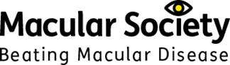

Macular Society logo – Beating macular disease

**Sponsor:** Thank you to **Macular Society** for sponsoring this workshop.

**Option 3 Manage stress and burnout, to boost resilience and wellbeing in the workplace**

**Facilitator:**

* Karen Janes, Director, The KJ Way

**Summary:** Come along to learn powerful evidence-based mindful tools and practices to help you manage stress, avoid burnout, whilst increasing your resilience and well-being at work. You’ll learn practices you can immediately start using, both in your professional and personal life, to create positive and meaningful change for yourself and your team.

You’ll learn about the benefits of mindful approaches in the workplace. You’ll also be able to try a range of meditations and micro practices to provide extra support, energy or relief when you need it, and hear ways to integrate mindful approaches into everyday working life.

The tools shared will be secular, trauma sensitive, neurodiversity informed and adapted to the workplace, so they are inclusive, supportive, and welcoming for all. This session is suitable for beginners as well as people with previous mindfulness experience.

**Audience:** All

**Geography:** UK wide

**Biography:**

**Karen Janes, Director, The KJ Way**

With 20 years of experience in leadership roles in the charity sector, Karen Janes is now on a mission to transform the way we work - from the inside out!

Through The KJ way, Karen helps organisations to build sustainable and flourishing workplace cultures that meet their business goals. She teaches powerful brain-based tools that people can seamlessly integrate into their working day and across organisational culture helping them to manage stress, build resilience, and improve focus and effectiveness.

This translates into high performing, engaged and resilient teams, committed to the success of your business. The KJ Way takes care of your people so they can take care of your business.

**Option 4 Making Health Accessible**

**Facilitators:**

* Eamonn Dunne, Partnerships & Projects Development Manager, Thomas Pocklington Trust
* Mark Belcher, Head of Enablement, Henshaws

**Summary:** Blind and partially sighted people are entitled to the best possible outcomes when using health and care services. However, significant inequities exist across these services.

From getting communications in the wrong format to visiting clinics that are impossible to navigate and staff that haven’t had vision impairment awareness training, there is much to do the create equity.

This workshop draws on practical experience of working with sector partners, the NHS and care providers to showcase examples of what can be done to make health and care services accessible and fit for purpose.

You’ll also hear from Visionary members about what they are doing locally to make health and care services more accessible.

**Audience:** All, particularly colleagues involved in health promotion projects or advocacy/advice services.

**Geography:** UK wide, but with an emphasis on England

**Biographies:**

**Eamonn Dunne, Partnerships & Projects Development Manager, Thomas Pocklington Trust**

Eamonn has worked for Thomas Pocklington for 8 years and is their health lead. He is committed to ensuring health and care services are provided on an equitable basis for blind and partially sighted people.

**Mark Belcher, Head of Enablement, Henshaws**

Mark has worked at Henshaws for 17 years and has a wealth of experience of developing innovative solutions to improve the lives of blind and partially sighted people.

**Option 5 Boccia: The sport for all (practical session)**

**Facilitators:**

* Judith Crawford, Sporting and Partnerships Worker, Sight Scotland Veterans
* Alison Shaw, Education & Learning Manager, Scottish Disability Sport

**Summary:** Boccia is a target sport played from a seated position. It can be played on any type of surface in any sized facility with very minimal equipment. Boccia is a sport that adapts to the person so can be a lifelong activity and is ideal for mixed ability groups. The aim of this workshop is to show the inclusivity of Boccia and the fun that can be had through practical involvement, focusing on the adaptability to individual players and venues. For sighted people attending, we have simulation specs allowing them to play with a temporary visual impairment if they wish.

Support and resources are already available across the UK through Scottish Disability Sport, Disability Sport Wales, Disability Sport Northern Ireland and Boccia England.

**Audience:** All

**Geography:** UK wide

**Biographies:**

**Judith Crawford, Sporting and Partnerships Worker, Sight Scotland Veterans**

Judith looks to engage visually impaired veterans in physical activities. Judith introduced Boccia across Sight Scotland Veterans (and Sight Scotland) as a way of an inclusive activity that could be easily delivered on any scale across the country.

**Alison Shaw, Education & Learning Manager, Scottish Disability Sport**

Alison works with people with a wide range of disabilities. Scottish Disability Sport as the Governing Body for Boccia in Scotland supports communities through training courses, sourcing equipment and hosting events.

**Option 6 Vision Partnership:  Political influencing, collaborating for change**

**Facilitators:**

* Eleanor Briggs, Head of Policy, Public Affairs and Campaigns, Guide Dogs UK
* Sophie Dodgeon, Head of Policy and Public Affairs, RNIB
* Helen Wheatley, Head of Operational Services and Development, Blind Veterans UK

**Summary:** The July 2024 General Election brought about changes in government and local representation. As a sector it is crucial that we understand the new landscape, adapt our influencing strategies, and collaborate accordingly.

During this workshop, delegates will delve into the intricate world of political advocacy, exploring effective techniques to engage with the post-election government and local Members of Parliament (MPs). Our facilitators will provide valuable insights and practical tools to help you navigate the complexities of policymaking and decision-making processes.

Through interactive sessions and case studies, participants will learn how to craft compelling narratives. Delegates will also learn how to produce accessible campaigns and leverage various channels to amplify their voices to drive positive change for the blind and partially sighted community.

Key topics covered in the workshop include:

* Understanding the post-election political landscape and its implications for advocacy efforts.
* Developing strategies for influencing government officials and local MPs, with consideration for country and regional differences.
* Building strategic partnerships and collaborations for greater impact.

**Audience:** All

**Geography:** UK wide

**Biographies:**

**Eleanor Briggs, Head of Policy, Public Affairs and Campaigns, Guide Dogs UK**

Eleanor Briggs joined Guide Dogs this year as Head of Policy, Public Affairs and Campaigns. She has more than twenty years' experience in campaigning, working in the children's sector and disability organisations including Action for Children, the National AIDS Trust and Turning Point. She began her career in the civil service working on equality and diversity policy.

**Sophie Dodgeon, Head of Policy and Public Affairs, RNIB**

Sophie Dodgeon has worked in charity campaigning for more than 20 years, including heading up campaigning for international development charity CAFOD, and establishing a policy and public affairs function for Rainbow Trust Children's Charity. Sophie joined RNIB in 2021 and is currently the Interim Head of Policy and Public Affairs.

**Helen Wheatley, Head of Operational Services and Development, Blind Veterans UK**

Helen Wheatley has worked in policy and partnership development for more than 20 years including as Assistant Director at the Council for Disabled Children leading on transition to adulthood, championing participation and working on regulatory changes. Helen joined Blind Veterans UK in 2016 and works as Head of Operational Service and Development for northern England, Scotland and Northern Ireland managing staff teams and leading on service development.

## Quick Guide to using NaviLens

First steps:

1. Install the free NaviLens app on Google Play or App Store. The application can be downloaded from these links:

* [App Store](https://apps.apple.com/us/app/navilens/id1273704914)
* [Google Play](https://play.google.com/store/apps/details?id=com.neosistec.NaviLens)

1. Run the application, accept the permissions and terms of use and privacy policy.
2. Start using the application by orienting the camera towards the environment until you hear a "click" sound that will indicate that a marker has been detected.

In the initial screen of NaviLens, you will find a simple interface composed of a central screen where the codes detected will appear and a bottom menu with buttons. You can interact with the codes you detect by selecting them with a double tap using your screen reader. NaviLens codes or markers are detected with their reading through the mobile camera.

Therefore, the camera must be oriented towards the outside trying to make its orientation the most appropriate depending on where the codes are placed (walls, floor, height, etc.)

Each time the mobile device's camera detects a code, the device will make a "click" sound that will inform the user that there is a NaviLens code signalling a component.

The reading of the code will begin immediately, NaviLens will announce the information contained in the marker (the room number or name).

You can stop the reading by making a "Shake" gesture. The "Shake" gesture is executed by performing a wrist turn. If the phone is in an upright position, put the device horizontally (landscaped) and return it to an upright position.

When NaviLens finishes reading the information contained in the code, it will begin to play sounds to indicate the location of the signalled element. Information in vocal instructions can be obtained by activating them in the configuration (Settings – Location Mode – Voice Instructions) and it will begin to say vocal instructions (right, left, front, back, up, etc.) that will help us reach the signalled element.

After detecting a code, while you do not make the shake gesture or click on the tag to obtain the information, the app will also perform this locution, and it will indicate the distance to the element and guidance instructions to get to it. When the camera detects more than one marker, the app will indicate the detection of each one by a "click" and when it reads each one it will indicate 1 of X, 2 of X, etc.

Of all the codes, the one that is most central to the device's camera will be read first.

If the mobile camera detects a "magnet" code such as at a bus stop, this code will be spatially positioned by the system and the 360 Vision mode will automatically open, setting the stop code as a destination and, as if it were a magnet, guiding towards it by sounds, vocal instructions and haptic vibrations. 360 mode will continue to guide you to the location of the code even if the mobile device camera loses it from sight.

You can find out more information about how NaviLens works in this YouTube video: [NaviLens Basics Tutorial – YouTube](https://www.youtube.com/watch?v=aemZ5ed4gD8).

## Emergency Evacuation Routes

**A step-by-step guide to navigating Aston Conference Centre and instruction on emergency exits.**

**Entrance and reception area**

* As you stand outside the Aston Conference Centre facing the main entrance, behind you, to the right and left are grass banks with no steps. Directly behind you is a grass verge that raises slightly with a step up.
* To enter the building from the main entrance there are three options. Facing the main entrance to the left is an automatic rotating door which turns anticlockwise. The door starts to rotate on approach and can be manually pushed if required. In the centre there is a manual opening door and to the right is an automatic door, which opens on approach.
* Entering through the automatic door on your right there is a slight lip on the floor in line with the frame and there is a non-slip matt on entering. There are several more non-slip mats as you move through the entrance around the door area.
* Once inside the building there is a seating area in front of you slightly to the right. Turn left then a right turn to approach the reception desk, which has a lowered accessible countertop to the left-hand side.

**Conference registration area**

* Walking past the reception desk with it on your right the floor starts a gentle slope down toward the restaurant and toilets at the end of the corridor. Along the corridor to the left is a ceiling to waist height glass window.
* Continuing down the corridor after the first slope there is a levelled-out section and to the right of this is the conference registration area. The conference registration consists of two long rectangle tables at waist height.

**Lounge, bar and emergency exit**

* The floor then continues on a descending slope for the second time with a hand rail to the right at waist height.
* As you reach the second levelled out part of the floor to the right is the entrance to the lounge. This is a wide high archway opening.
* As you continue down the corridor the floor declines again for a third slope with a hand rail to the right at waist height. Once you reach the flat levelled out section to the right is the wide high arch opening for the bar. Directly opposite the bar is the exit to the outside courtyard. There is a lip at the door, and it opens out onto a flat level then about 4ft ahead there are 2 steps up onto another level. This door would be used as an emergency exit.

**Restaurant, toilets, lift and stairs**

* Continuing further down the corridor to the left has ceiling to waist hight windows and the floor remains flat from here. The floor changes surface from stone to wood with a smoother texture. Once the surface changes you are approaching the restaurant and toilets.
* At the end of the corridor, you turn right to the toilets and stairwell, the lift is on right approx. 20ft before the end of the corridor. You then turn left entering a narrower corridor which bends right. You will find the female toilets to your left, the male toilets straight ahead and on your right find the accessible toilet's’ and baby changing facilities.
* To access the stairwell and the emergency exit turn right at the end of the main corridor. The exit is straight ahead of you and the stairs right-hand side as you go through the first door.

**Conference rooms, courtyard**

* Turning left at the end of the main corridor or walking straight ahead from the toilet area is the entrance to the restaurant. There is a straight walk through the centre of the restaurant towards Conference Room 1. As you walk through the restaurant there are double doors on your left leading to the outside courtyard. The floor continues to be wood, and the noise levels increase.
* As you approach the conference room area the floor surface changes from wood to carpet. As this happens you turn left to enter a corridor. Along this corridor on the right-hand side there are three sets of double doors about 3 metres apart. These doors open outward. These are the doors to conference room 1.
* Continuing past the conference room 3, which is on the left, there are toilets, female, male and accessible on your left and on the right is another door to conference room 1. This enters conference room 1 on the left hand side when facing the front of the room.
* From any exit from conference room 1 one turn left to head back toward the restaurant.

**First floor conference rooms**

* When exiting the restaurant to the main corridor there is a lift to the left which takes you to the first floor to conference rooms 122, 123, 127,139, 144, 145. The lift has two sets of opening doors, when exiting the lift on the first floor the opposite doors will open to entering the lift. The lift has audio announcements.
* When exiting the lift turn right then turn left walking through a set of doors that open toward you. This brings you to the meeting room corridor.
* On the right side of the meeting corridor there are conference rooms 122,123 to the left are more meeting rooms and straight ahead is an emergency exit and conference room 127.
* At the start and end of the meeting corridor there are self closing fire doors in an event of an emergency. These doors will all be re opened after an evacuation.

**First floor toilets, tea/coffee station and fire exit**

* Once at the end of the meeting room corridor turn left into a narrow corridor with office doors either side. At the end of this corridor there are female and male toilets to the left. These toilets are the nearest when using conference rooms 122, 123,127.
* Just past the toilets there is a self closing door that opens inwards. Walking forward there is a tea and coffee station to the left and to the right of this there are 3 sets of bar tables with 6 stools about 4ft high.
* Walking past the tea and coffee station to your left you come to another narrow corridor with meeting rooms either side. There is a self closing door at the end of this corridor and more female and male toilets on the left hand side.
* On your right there is a fire exit for conference rooms 144, 145. This door is on the left as you exit these meeting rooms. There is a very small L shape corridor here to navigate to the fire exit.
* Exiting conference room 145 the emergency exit is the second door on the left. This will be the only unlocked door here. It is a wide opening outward door.
* Once through the door you are on a resting area which is a flat landing in between stairwells. To the left of the door, when facing it, is the refuge box or communications button with security. There is braille on the bottom of this red box, which is about 30cm by 15cm in size. To the left of this box when facing it there is a plaque with the name of the floor and building also in braille underneath.
* In an event of an emergency exit if you require assistance this is where you would wait.
* From the resting area, moving forward to the stairs the upward stairs are to the right and the downward stairs to the left. There is a rail either side but the right hand rail is continuous around the stairs. Follow these stairs right to the bottom and the fire exit door is straight ahead on the lower level. This door leads to the outside space and this is a self shutting security door with an opening bar/handle.
* Turning left at the bottom of the stairs brings you back to the side door to conference room 1. Turning right will bring you to male, female and accessible toilets. Turning the second left will bring you to the corridor that leads to the restaurant and back through to the main corridor to the reception desk at the front of the building.

Visionary Annual Conference 2024 
25- 26 September 2024 

**Working with you, we inspire change and create opportunities to make a better world for everyone affected by sight loss.**

* **Connect**: Connecting individuals from organisations together and organisations to each other.
* **Develop**: Developing platforms for collaboration and joint initiatives with local and national partners.
* **Share**: Sharing knowledge and expertise to help members be all they can be.
* **Inspire**: Amplifying and harnessing member voice to inspire innovation and create change.

Email: [visionary@visionary.org.uk](mailto:visionary@visionary.org.uk)

Web: [www.visionary.org.uk](http://www.visionary.org.uk)

X (Formerly Twitter): @visionary_uk

LinkedIn: @Visionary_UK

#VisionaryConference24

“Visionary” is the working name of Visionary - Linking Local Sight Loss Charities, a CIO registered in England and Wales as charity number 1135360, charity in Scotland number SC044163

Blank Page