Eye Care Support Pathway – Scotland V.1
(Document aimed at health and social care professionals working in the sector, third sector workforce, patient champions/leads etc)

Table of Contents (to be edited)
Eye Care Support Pathway – Scotland V.1 1
Table of Contents (to be edited) 1
Foreword 2
Executive summary 3
Acknowledgements 3
Need for a Scotland-wide eye care support pathway. 4
Demand for eye care is at an all-time high and is increasing. 5
Eye care pathways need to change. 6
Difficulties in accessing information, advice, and support – a UK-wide issue. 8
The eye care support pathway 9
Understanding the information, advice and support people require. 10
Stage 1: Having an initial appointment. 10
Waiting across the pathway 12
Stage 2: Having a diagnosis confirmed. 13
Stage 3: Support after diagnosis 16
Stage 4: Living well with my condition. 20
Implementation Framework 23
Requirements 24
Governance 24
References 25
Acknowledgements 28
Appendix 1: Eye care pathway 29
Appendix 2: Pain points 30
Stage 1: Having my initial appointment. 31
1.1b Seek advice, attend appointment, get a referral (NHS). 32
1.2 Minor Eye Conditions Service (MECS) and/or regular screening services 32
1.3 Receive appointment letter, research, preparation. 33
Stage 2: Having your diagnosis confirmed. 33
2.2 Managing your condition and treatment. 34
Stage 3: Post diagnosis support 35
3.1 Referral to Eye Care Liaison Officer (ECLO) 35
3.2 ECLO provides immediate support. 36
3.3 Ongoing ECLO support 37
Stage 4: Living well with my condition 38
4.1 Referral to Low Vision Clinic (LVC) 38
4.2 Low vision assessment, support, signposting 40
5.1 Completion of Certificate of Vision Impairment (CVI) 40
6.1 Initial telephone contact with Local Authority 41
6.2 Specialist Assessment and Support with Vision Rehabilitation Specialist (VRS) 42
6.3 Creation of personal action/care plan 43
7.1 Registration and Welfare/Disability Benefits & Concessions 44
8.1 Initial contact with third sector 45
8.2 Engage with third sector. 46
8.3 Continuously review personal action plan. 46
Appendix 3: Detailed breakdown of a person’s support requirements across each stage of a typical eye care journey. 47
Appendix 4: Models of best practice, quality frameworks, and standards for eye care advice and support 54
Information 54

Foreword

TBC

Supported by

VI sector

Executive summary
To be added

Acknowledgements
The eye care support pathway has been developed in partnership with health and social care professionals, people with lived experience of eye care needs and sight loss, the third sector and key organisations across the eye care sector. We would like to thank everyone for their valuable insights and contributions to the development of this work.

A list of the organisations that have contributed to this document and the development of the eye care support pathway can be found in Appendix X.

Organisations which have provided endorsement for the eye care support pathway can be found on page X

Need for a Scotland-wide eye care support pathway.

Whether we carry out a strategic review of eye care, audit our existing eye care pathways or reflect on our personal practices, we have the opportunity to change the way eye care services are experienced by people across Scotland. This report addresses the pain points outlined by people with eye care needs and presents the key requirements needed to empower people to actively participate along their eye care journeys. We need to transform the way in which we deliver information, advice and support across Scotland and integrate nonclinical support into existing eye care pathways.

A new eye care support pathway infographic (page x) has been co-designed to highlight people’s needs at four key stages. This allows practitioners to focus on their particular stage, as well as to understand the requirements end to end. The support pathway provides a framework of what good support can look and feel like from a person’s perspective.

This document provides a foundation to build on, asks us to challenge ourselves and question our preconceived ideas, approaches, practices and conversations, so we can move forward positively together across the eye care sector to embed support at every stage.

We know that:

- Support is offered, but support services are not equitable [ref UK].
- The eye health information which is provided is not always accessible and can be of variable quality, depending on where people look.
- Advice is available but it is not always easily obtained [ref UK]

We do not necessarily need to commission new services to initiate the eye care support pathway, but we do need to:

- Think differently.

- Redesign our clinical and social care eye pathways to ensure information, advice and support is embedded at every stage.

- Initiate new referral routes to information, advice, and support services.

- Optimise the use of existing and new technology.

- Continue to collaborate to ensure nobody with eye care needs, or their family and carers, are left alone without the information, advice and support they require on their eye care journey.

Demand for eye care is at an all-time high and is increasing.

The 2023 version of the RNIB Sight Loss Data Tool states that the number of people estimated to be living with sight loss in Scotland is 183,000 and reports the number of registered blind or partially sighted people to be 34,492, as stated in the last Scottish Government returns for 2010, published in 2011.
Scotland is the only country in the UK to provide free universal NHS funded eye examinations. In 2022/23 approximately 2.26 million eye examinations were undertaken in Scotland. This is an increase of 2.4% compared to 2021/22. The number of eye examinations increased every year from around 1.57 million in 2006/07 to over 2.34 million in 2018/19, before falling to 2.18 million in 2019/20. In 2020/21 there was an abrupt drop in eye examinations due to COVID-19 pandemic restrictions.Ophthalmology is the largest outpatient speciality in Scotland, with 267,474 outpatient appointments in 2021/22.

Lack of timely intervention leads to higher costs for the health and social care system and the pandemic has made a challenging situation worse and led to missed appointments, delays to treatments, and further waiting time rises. A transformation of eye care services has now started to ensure the system is fit for purpose and to improve outcomes for people, for example, the NHS Community Glaucoma Service.

Delays to diagnosis and treatment can lead to avoidable sight loss, poorer quality of life and high levels of stress and anxiety for people while they wait.

Delays also have a serious economic impact. Eye health related conditions cost the UK £25.2 billion a year (set to rise to £33.5 billion in 2050).

As our population ages, this already high demand is set to increase. There are approximately 183,000 people living with sight loss in Scotland today, with the 2032 projection for sight loss population in Scotland to be 214,000. The World Health Organisation notes that “everyone, if they live long enough, will experience at least one eye condition, in their lifetime”.

At the same time of increasing pressures within NHS and social care, the inclusion of the third sector (voluntary, community and social enterprise) to support local public bodies has grown, with early evaluations of their impact now being reported.

During the pandemic, the third sector had a key role in connecting communities, providing support, and reducing isolation. The Scottish sight loss sector, for example, provided additional support to blind and partially sighted people, through adapting and expanding telephone-based support and online resources and activities. ​As a result of these successful interventions, this work has continued post pandemic. The role of the third sector is intrinsic to improving population outcomes, whether at a national or at a local level.

Eye care pathways need to change.

Most eye care pathways are designed to support the management and or treatment of an eye condition and the statutory services that people are entitled to as they progress through their eye care journey. Limited attention is given to the nonclinical information, advice and support people may require. This may be from providing a range of practical support around employment, driving, money or household activities to emotional support and reducing the risk of isolation.

Pathways are not typically described end to end with different services focusing on their specific part of the pathway. This can mean people fall between the gaps when they transition between services. Having information, advice, and support to help people navigate their eye care journey is important.

As our governments and health and social care systems move to integrate health and social care, there is a significant opportunity to ensure all our pathways maximise the support that is available to all, and that our future eye care pathways are fully integrated.

By overlaying the eye care support pathway with existing clinical and social care eye care pathways we can identify key information, advice, and support touchpoints relevant to each eye condition, and integrate nonclinical information, advice, and support into them.

This will support the transformation of eye care pathways, providing a more holistic, person-centred approach to care and more effective use of Scotland’s eye care assets to better support people wherever they are on their eye care journey.

The NHS Recovery Plan 2021 – 2026, Scotland sets out a similar model of ensuring that there is patient-focused support:

“[Patients] will be treated with dignity, respect and compassion. We will treat the whole person, not just your condition.”

In addition, the Modernising Patient Pathways (MPP) team are responsible for driving improvements in planned care across Scotland, in line with the priorities set out in the NHS Recovery Plan. This includes the development of clinically led Speciality Delivery Groups (SDGs), which act as the main delivery vehicle for implementing improvement. The SDGs are based around an individual clinical speciality and bring together key multidisciplinary stakeholders from across Scotland. This included the set-up of the Cataract Sub-Specialty Delivery Group which brought together key ophthalmology clinical, operational and managerial experts from across NHS Scotland and Scottish Government. Within this, the SDGs recognised the need for:

- Processes: Working collaboratively to redesign and develop specialty service provision across NHS Scotland to implement proven approaches including Active Clinical Referral Triage (ACRT) and Discharge Patient Initiated Review (PIR). Developing and reviewing minimum standards for ACRT and Discharge PIR, progressing implementation plans within the specialty.
- Pathways: Providing Clinical Leadership to shape and guide the development of high quality specialty services in Scotland; ensuring implementation and alignment with relevant national guidelines and standards. Reducing unwarranted variation by standardising service provision and pathways on a best-of-class and once-for-Scotland basis wherever possible. Creating and disseminating resources and educational materials
- Workforce: Identifying and progressing opportunities within the Specialty in relation to workforce initiatives, in collaboration with partners such as NHS Scotland Academy and NES. Highlighting new approaches to staffing (including theatre staffing) and encouraging adoption and scaling as approaches are shown to work
- Innovation: Providing a forum for sharing and learning and to support spread and adoption of proven pathways and approaches (e.g. by linking in to the Accelerated National Innovation Adoption process)
- Measurement: Ensuring that the benefits to be delivered are clearly defined, ensuring that measures are in place that will provide evidence of benefit, and working with Public Health Scotland to advise on future opportunities for the Atlas of Variation.

However, even with plans and policies in place, there is evidence to suggest that the health and care pathway is still inconsistent for people, and postcode lottery led.

Difficulties in accessing information, advice, and support.

Over the last two years RNIB, with the wider eye care sector, have been building an evidence base on which to develop an eye care support pathway. From research, mapping the pathway end to end and listening to people with lived experience of sight loss/eye conditions, it is clear that people experience problems at every stage of their eye care journey and that the impact of sight loss can be significant.

“The whole world came crushing down around my shoulders; I went downhill very, very quickly”.

In total over 100 pain points have been identified across a typical eye care journey and are listed in appendix 2. Pain points are where people experience a problem. This may include a lack of information, advice, or support; a delay; a lack of clarity with what happens next; or poor communication.

“I think there should be less focus on the medical aspect of it all and more on me as a whole person. I am more than a medical condition.”

Using the pain points as a basis for improvement, individual support requirements have been identified to create an eye care support pathway underpinned by three thematic needs. These are:

- understanding my eye care journey.
- understanding my diagnosis.
- having access to practical and emotional support.

A Scotland-wide Eye Care Support Pathway.

Through developing a Scotland-wide eye care support pathway our shared ambition is that:

‘From the moment someone realises that “something isn’t quite right” with their sight, through to diagnosis and being able to live confidently – and independently - with their condition, people have access to the information, advice and support they need’.

Through embedding information, advice and support we can together:

- Intervene earlier, freeing up precious NHS and social care resources whilst improving people’s quality of life.

- Provide better, person-centred eye care services with increased engagement, understanding, self-support and self-advocacy at every stage of person’s eye care journey.
- Reduce eye health inequalities including reducing the inequity of access to care.

- Improve health, wellbeing, and independent living.

- Improve levels of eye health literacy.

- Increase compliance with agreed treatment options and protocols and promote shared decision making.

- Support the reduction in non-attendances in outpatient settings.

- Reduce the impact of eye disease on the Scottish economy through maximising employment and prevention of people leaving work unnecessarily due to eye care and sight loss.

- Provide early and continued support for those waiting to access care and treatment.

The eye care support pathway

Eye care pathways can be complex and, while often described in a linear manner, people may enter, leave, and re-enter several times depending on their condition. (Appendix 1). Typically, any end-to-end pathway is made up of a number of key stages.

The eye care support pathway mirrors this approach and is made up of four key stages with periods of waiting in between, alongside three thematic needs. These four stages also reflect a typical health and social care journey starting from presentation of the problem, through to treatment, discharge and after care.

The information, advice and support people need applies to all stages of the pathway, as well as people being empowered to ‘wait well’ as they transition between services.

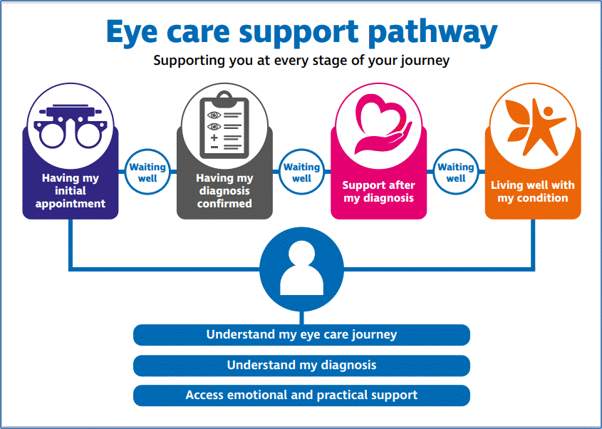

[Diagram 1: The eye care support pathway]

Understanding the information, advice and support people require.

Stage 1: Having an initial appointment.

Outcome: People understand there is something to investigate. They will receive or know where to go for information and advice about different eye conditions. They understand who they are seeing and why.

For most people their first touch point regarding a concern about their eyes and/or their sight is an appointment with a GP, an optometrist, or a visit to A&E. This may be a routine appointment such as an eye test or it could be a concern about a change in vision. At this initial stage people want to:

Having my initial appointment
Eye care journey | - Understand who they are seeing.  - Know what will happen next and when.  - Know that they can physically or virtually access the appointment.  - Understand why it is important to attend eyesight tests or know how to re-access the most appropriate service if their eye condition changes.
Eye condition | - Have access to specific eye health literature, from a trusted source.  - Receive any information, in a format that meets their communication needs.  - Be able to ask questions, in a safe and supported environment.
Emotional and practical support | - Know where to get support to manage any anxiety about what they have been told and what is planned next.  - Know where to get information, advice, and support to help with day-to-day activities such as employment, driving, benefits, care.  - Have the opportunity to speak to someone when they want to.

Please note - the full support requirements identified at each stage can be found in Appendix 3.

At the initial appointment stage, there can be a lack of information and advice. When people need to be referred on or followed up, they can be unclear what happens next and when. Tests may be carried out with little explanation. Optometrists and GPs may not be able to provide a diagnosis and need to refer on to secondary care. Information is key at this early stage and information needs to be readily accessible and tailored to the person’s needs.

Example of good practice:

Optometry Scotland pilot project is now referring people directly from primary services to ECLOs. A referral was made to an ECLO, and the patient was contacted by telephone. They still attend regular appointments and IVT treatment in the Ophthalmology Clinic, and their consultant made a referral for the Low Vision Service (LVS) and suggested Sight Impaired certification. During the phone call, the ECLO explained the difference between certification and registration, and informed about processing CVI form and different benefits/concessions available after being registered. Sight support was discussed through Visibility Scotland, RNIB and Ability Net and offered referral for further input. Agreed contacting ECLO from local Ophthalmology clinic to clarify LV appointment. Informed about accessible technology for smart phone, iPad/tablet, and PC - agreed sending information via email with links to various services. As the result the patient received information needed and support from the appropriate services.

Referring into nonclinical support services from primary care, primary eye care or secondary care from outset is now becoming feasible with the integration of support organisations within IT systems.

In future, commissioners and fundholders could include nonclinical advice and support requirements into community, primary and secondary eye care settings.

Waiting across the pathway

Waiting times rank as one of the public’s main concerns with the NHS. In Scotland, the Treatment Time Guarantee (TTG) requires that following the decision to treat, all eligible patients should wait no longer than 12 weeks for treatment as an inpatient or day case. In June 2023, there were 61,119 new outpatients waiting for treatment within ophthalmology. It is important therefore that people can wait well for tests, diagnoses and treatments. Whilst waiting people want to:

Waiting well
Eye care Journey | - Be clear about what to expect next and when  - Receive any information, in a format that meets their communication needs.  - Know who to contact/ how to get updated wait times.
Eye Condition | - Be able to access as much information as they want about a suspected diagnosis and get advice if required  - Know what to do if anything changes with their eye condition.
Emotional and practical support | - Know where to get support to manage any anxiety about what they have been told and what is planned next.  - Know where to get information, advice, and support to help with day-to-day activities such as employment, driving, benefits, care.  - Speak to someone when they want to.  - Know who to contact for any further questions.

Waiting for a referral, diagnosis and/or treatment is inevitably a time of stress and worry and, at this critical time, people need access to information such as wait times, what tests are planned and what the process is, as well as access to practical and emotional support. It is also important if a person’s eye condition changes, they know the steps they need to take and who they need to contact.

“I lost my sight waiting for an appointment.”

It is important to ensure appointment letters are accessible and that alternative options are in place due to the increased use of self-check-in touch screens, locked doors and doorbells for security at health care settings.

“... [I do not feel confident to assert my rights for accessible information], because I worry, I’m not worthy enough as I can just about manage with standard print for short lengths of time.”

In 2020, RNIB Scotland released the report “Communication Failure? A review of the accessibility of health information for blind and partially sighted people”. Its findings showed that patient confidentiality is breached due to individuals relying on carers, relatives or friends to read appointment letters on their behalf.

The Scottish Government is piloting an Electronic Patient Record (EPR) within ophthalmology which will have the function to clearly state from the beginning of a patients journey which accessible format they would prefer. In addition, Scottish Health Boards have their own accessible information policies and procedures to ensure of a more consistent approach across the patient's journey.

Example of good practice:

NHS Tayside - if a patient has requested that they require information in a different format, then medical records will note this in TrakCare (patient administration management system) and the staff will put this in as an alert. The medical records staff will also note and document this on the waiting list comments section within TrakCare. Any appointment letters that require to be translated will be seen as an alert on the TrakCare system if the patient/clinical staff have informed medical records. Clinical staff can also put an alert on TrakCare so it is in the system for future access to our services. TrakCare can print appointment letters in large print, and we know from information/statistics that Ophthalmology services have the highest request for large print.

Stage 2: Having a diagnosis confirmed.

Outcome: People understand their diagnosis and know where to access the practical and emotional support they need to understand their diagnosis. They can take control.

For many people, the point of diagnosis is one of the most difficult parts of the pathway. At this stage people need information, advice, support and empathy to help them prepare for a change in their sight, whether temporary or permanent. People need time to ask questions and feel listened to. People want to:

Having a diagnosis confirmed
Eye care journey | - Receive a sensitive diagnosis.  - Understand the next steps and how their condition will be treated and managed and whether treatments are available
Eye condition | - Be offered specific eye care information.  - Understand their eye condition and implications.  - Be able to participate in their chosen treatment options and understand if there is no available treatment for their condition.  - Be able to communicate their eye condition and how it affects their life to others.  - Know out their genetic diagnosis if they opted for testing  - Be provided with information about Charles Bonnet Syndrome and how it might affect them
Emotional and practical support | - Speak with an Eye Care Liaison Officer (ECLO) or vision support service to be able to access support in person/remotely.  - Understand that the nursing team can provide information and support as part of my care.  - Know about how to access nurse counselling  - Know where to go and be able to access to practical support and information.  - Know about low vision services, the CVI process and what other eye care services they may need to access in the future.

Diagnosis is a hugely emotional experience which can leave people feeling confused, overwhelmed, and anxious about what lies ahead.

“The whole world came crushing down around my shoulders; I went downhill very, very quickly.”

Being provided with a life changing diagnosis can prompt a strong emotional response and therefore it is important that the clinical team are able to put in place access to listening and support services, whilst providing an empathetic diagnosis.

‘I was told in no uncertain terms by the doctors - quite callously, I thought… 'the sight's gone in that eye, cells have been damaged beyond repair', 'that's gone, forget that'. That was actually said to me.

Across Scotland, the sight loss sector provides emotional and practical support for those living with a sight condition, their family members and carers. For example, the ECLO (Eye Care Liaison Officers) service within secondary care in ophthalmology, enable patients, family members and carers to navigate and access the complex range of services across health and social care, and access emotional and practical support to help them maintain their confidence and independence. The sight loss sector work closely with clinical teams within ophthalmology departments with recognition of the essential role vision support services play to support patients across the eye care pathway.

“It's given me peace of mind because I know that the help is there for me, if I were to need any in the future. They made me feel at ease which I thought was nice and it's nice to know that there are other people out there who have sight conditions as well, and it's not just me.” (PEQ Scotland 2022)

“This service is absolutely excellent. The ECLOs are so knowledgeable, and as a clinician I find their support indispensable as they have the time and skills needed to really help our patients struggling with visual impairment” (CEQ Scotland 2022)

However, emotional, and practical support is not universal across Scotland nor commissioned as standard within eye care services, this results in a postcode lottery of support available.

Example of good practice:

An RNIB Scotland ECLO was contacted by a patient by phone. As requested by the patient, all interaction continued with their daughter. The daughter states that her dad is still able to cover some household tasks including cooking and cleaning and is still too frightened to progress with cataract surgery. However, after his recent appointment he is keen to move forward. They discussed the eye condition/treatment, including eye health information services through Sight Scotland and Visibility. The daughter stated that a domiciliary visit might be the best option. As a result of this call, the patient is on the waiting list for the Low Vision Service and received additional information from Visibility Scotland’s Patient Support Service.

Emotional support should be provided early in a person’s eye care journey, as well as at this key stage, as people often do not seek help until they have reached a crisis point. Mental health support, in the form of counselling, has been shown to be beneficial to wellbeing, with people accessing this support reporting fewer worries about their eye related problems and reablement.

For people who may have complex and/or rare conditions, it is equally important that there is access to information and advice and support throughout their eye care journey as well as working in partnership with specialist third sector organisations who may for example also fundraise for research and develop complimentary specialist information, advice, and support services.

Stage 3: Support after diagnosis

Outcome: People can manage their sight condition, it’s treatment and care. They understand the Certificate of Vision Impairment and Registration processes and the benefits. They know where to turn for further support and have regular check-ins with their optician/doctor.

Providing people with information, advice and support post diagnosis is critical to enable people to come to terms with their condition, their life, and the impact on the lives of the people around them. People want to:

Support after diagnosis
Eye care journey | - Be able to understand if their condition is hereditary and what that means.  - Know about research related to their condition and how to get involved in clinical trials if they are interested and suitable.
My Eye Condition | - Be able to understand how their condition may develop.  - Be able to participate in ongoing treatment or receive support, if required
Emotional and practical support | - Know where to go and be able to access practical support and information.  - Know about organisations that support people with their condition.  - Be able to talk to someone with the same condition as them if they want to.  - Know whether they can continue to drive or not and what steps they need to take.

Post diagnosis people may require ongoing treatment with multiple appointments and may be referred to other health and social care services at the same time. Ensuring support is in place and frontline staff are empathetic is important. Being aware of what sight loss means and how to guide people in health and social care settings can only improve a person’s experience when accessing services.

“When I went for my eye check up at the hospital and the lady that took me into the room said, ‘have a seat over there’ so I said ‘sorry’, so she says, ‘have a seat over there’ and I said, ‘I’m not sure where there is’ and she says, ‘on the green chair’, I said ‘is that left or right”

Example of good practice:
Since 1965, Fight for Sight is the leading UK charity dedicated to
funding pioneering eye research. It is currently funding a number
of studies into the main causes of sight loss including glaucoma,
macular degeneration and inherited conditions. Recent research includes a UCL study which successfully analysed the effectiveness of a laser-based treatment for glaucoma compared with eye drops. The results could potentially improve the way glaucoma is treated across the world.

the world.

For people to manage their condition well post diagnosis they want to:

Support after diagnosis: ongoing management
Eye care journey | - Understand how their condition will be managed, how many appointments they should expect and where they will be.  - Know about low vision services, the CVI process and what other eye care services, that are relevant and available to them.
Eye Condition | - Know how to manage any treatment and understand how their condition may affect their vision in the future.  - Be able to understand the importance of following the treatment plan they have been given (eye drops, clinical appointments etc.)
Emotional and practical support | - Know about the support they may need in the future (e.g. low vision advice) and know how to access it.  - Know they can continue to seek advice and support and where that support is available from.  - Know where to go and be able to access to practical support and information such as daily activities of living, employment, and leisure.

To get the best clinical outcomes, people need to follow treatment protocols, understand treatment regimens, and appropriately administer medication.

Unfortunately, this is not always the case with people commenting on poor communication, lack of understanding and lack of support.

“I knew about this [requesting accessible formats] but have been told I can manage without large print by some people which puts me off requesting it.”

“When having a new operation, everything was inaccessible, leaflets about the operation, food etc.”

With the continued development of new product innovations to improve medication compliance and running shared campaigns across NHS Scotland and third sector, there are further opportunities to improve compliance and to improve communication, understanding and treatment adherence.
Example of good practice:

The launch of a new NHS Community Glaucoma Service in Scotland sees treatment offered closer to patients’ homes. Thousands of patients will be cared for at their local community optometry practice rather than in the hospital as part of a new NHS community glaucoma service. The flagship eyecare service is being rolled out in NHS Greater Glasgow and Clyde and will expand across Scotland over the next two years. It is expected to register an estimated 20,000 patients once complete. As part of the service, patients with lower risk glaucoma or treated ocular hypertension will be safely cared for in community optometry practices, closer to home, rather than having to travel to hospital, helping to reduce waiting times pressures in hospitals.

NHS Community Glaucoma Service accredited providers are specialist community optometrists, who are fully qualified in the ongoing treatment and management of glaucoma and ocular hypertension. By placing this service in the community, eligible patients will receive care in a more flexible manner and there may be less of a requirement for travel.

Further support at this stage can also become available when someone becomes eligible for a Certificate of Vision Impairment (CVI) and can then also be included on the local authority’s register of blind and partially sighted people.

An eye specialist will decide whether someone can be certified as severely sight impaired (blind) or sight impaired (partially sighted). The person will receive a copy of their CVI, and a copy will also be sent to their Local Authority who should contact the person to ask if they wish to be included on its register of blind and partially sighted people. This then unlocks further statutory support.

Certification does not automatically lead to registration however and there is poor understanding of these processes, low awareness of the benefits amongst professionals and inconsistent administrative processes. (ref – UK-wide) and Scottish context.

People should be offered a CVI as soon as they are eligible to ensure that they can access support and rehabilitation in a timely manner. People want:

Support after diagnosis: certificate of registration
Eye care journey | - Be able to understand the registration process and the support that can be accessed through the Local Authority and what happens at each stage.  - Be able to access low vision services, if appropriate.
Eye condition | - Be able to understand their eye condition and what to do if they notice any changes.
Emotional and practical support | - Have the opportunity to speak to health care professional/ECLO about the registration process and what it means for them.

Consultants and other members of the clinical team may benefit from training to enable them to understand the benefits of certification and registration and to recognise when a patient may be eligible. It is also important that administrative processes and standard operating procedures are applied consistently to ensure that all appropriate patients have the opportunity for certification, and to ensure they do not fall between the gaps between health and social care as part of onward registration.

Currently vision support services within secondary eye care often need to step in and act as an advocate in the CVI process.

Example of good practice:

CVI example

Also in future, consideration should be given to broaden the professional groups able to register people with a CVI.

As well as certification and registration processes, people and practitioners are also generally unaware of the role and value of Low Vision services. Referrals to clinics are not mandatory and rely on individual practitioner knowledge. Referrals are often made late, and there can be geographic inconsistencies and significant variation of wait times.

Stage 4: Living well with my condition.

Outcome: People understand what statutory services are available and how to access vision rehabilitation and other support,

People know what their rights and benefits they are entitled to. They feel emotionally and practically supported and feel positive about the future. They have confidence to live safely and independently.

With the right support blind and partially sighted people, as well as those with temporary sight loss, can come to terms with changes in their eye health and adjust their lifestyles.

“I discovered many other things that I’m good at; my eyesight doesn’t have to limit me or define me... I knew that I had to compensate intellectually as I couldn’t do things physically as well as other people and it helped me to develop and invest more time in education.”

People will typically transition from health to social care with access to statutory support services. At this stage people want to:

Living with my condition: statutory services
Eye Care Journey | - Be prepared for the Vision Rehabilitation Specialist (VRS) visit.  - Understand what will happen at the VRS visit and what social care/statutory support can offer.  - Understand there may be a wait for a visit and what support they can seek in the interim from other services/support organisations.
Eye condition | - Know how to manage their condition while they wait for vision rehabilitation support and what to do if their condition/circumstances change.
Emotional and practical support | - Know where to go and be able to access to practical support and information such as daily activities of living, employment, and leisure whilst they wait.  - Know who to contact and be able to speak to someone if they want to  - Understand where else they may be able to get support from.

Accessing social care, such as vision rehabilitation, can build confidence and enable independence, as well as avoid health and social care costs [ref?].

However, provision of vision rehabilitation is patchy, with some areas across Scotland offering a good service, and some none at all. There are approximately … vision rehabilitation officers in Scotland, which equates to … people with sight loss per rehabilitation officer. Waits can be long and are generally not published. It is therefore important that health and social care professionals continue to refer people to support organisations who can connect people to other people with their condition, provide advice and support and in some cases rehabilitation.

Example of good practice:

RNIB’s Living Well with Sight Loss courses provide telephone and face to face group sessions where blind and partially sighted people can meet others experiencing sight loss and learn about services and support available both pre and post diagnosis.
Courses cover a wide range of topics from understanding benefits to technology. The service also offers “Focus On” courses covering topics like confident living, money and family and friends’ courses.

Example of good practice:

SVSSG – example of vision rehabilitation

The importance of supporting people to live life independently and have the same equity of access is critical and is life changing.

“Before you start that mobility training, everywhere I went I had to hang onto my wife. Once I got that mobility training I could go on my own, I could go for a walk on my own, I could go to the shop on my own, I could go to the doctors on my own, and it’s so brilliant…. perhaps I’m not that useless, perhaps I can do things for myself, and it gives you a hell of a lot of confidence back.”

Working with a vision rehabilitation specialist people want to:

Living with my condition: vision rehabilitation
Eye care journey | - Be able to co-develop an action plan with their vision rehabilitation specialist.
Eye Condition | - Be able to manage their ongoing eye-condition  - Be confident they can live and independently with their condition.
Emotional and practical support | - Feel they can engage in their action plan.  - To be able to access support in different ways as their situation changes.  - Be able to talk to/link in with other people in the same situation as them.  - Know they can go back to their ECLO/advice provider/local authority sensory team at any stage.

It is important that people are able at any stage to reassess their needs and access support when they need it. However, there is a lack of knowledge around the ability to be reassessed if circumstances change.

For young people transitioning to adult services, it is important that this is planned over a period of time and not left until they reach the age when they move from paediatric to adult services.

People want to:

Living well: continuous review
Eye Care Journey | - Fully understand all the different stages of the pathway and who to contact at each stage if they need further help/re-access services.  - Transition between services seamlessly and when moving from paediatric to adult services this is planned well in advance, with all parties involved.
Eye condition | - Understand their eye condition/vision may change and know what to do if this happens.
Emotional and practical support | - Know how to find support that is relevant to them.  - Feel confident in accessing the support.

Implementation Framework

To achieve the requirements set out within this report will require long term commitment, investment, and support. The sector will need to continually invest time, expertise and effort to ensure nonclinical information, advice and support, as identified in the eye care support pathway, is integrated into ophthalmic pathways and social care.
The eye care sector working with people with lived experience have collaborated to truly understand the challenges, the needs and the requirements that are essential for people to navigate and participate in their eye care journey successfully.

Scottish Health Boards will have a pivotal role to ensure health and social care is integrated across eye care to ensure people experience a smooth transition between services are not lost between them.

Requirements
To reduce the ‘pain’ people experience today, will require us to:

- Have an integrated approach to clinical and nonclinical support when commissioning eye care services.
- Have an integrated approach to strategic and operational eye care planning, ensuring eye care pathways are co-designed and person centred with support needs considered.
- Have a proactive approach to prevention and avoidable sight loss with organisations working collaboratively to increase the number of people having regular eye tests, with a focus on where there is greatest inequality.
- Strengthen the relationships between health, social care and the third sector, working with the third sector to co-ordinate and collaborate information, advice and support offers so it is easy for the public to navigate and access support.
- Focus on developing and delivering a year-on-year eye care support pathway improvement plan, which forms part of any national transformation plans.
- Co-design, measure and evaluate improvements, working alongside people with lived experience of sight loss/eye conditions.
- Ensure that all appropriate front line staff have basic sight loss awareness training and guiding across the NHS and social care.
- Have digitally enabled eye care pathways which interoperate with health, social care and the third sector.

Have commitment locally and nationally to ensure joined up decision making across the whole end to end pathway with a commitment to create or re-establish local eye health networks or equivalent.

Governance

To deliver the eye care support pathway and integrate nonclinical information, advice, and support into existing clinical and social care pathways, we need to bring the right people and partners together to oversee, advise on and implement key parts of the programme across Scotland.

We also need to increase awareness of the support pathway to both the public and the wider sector and highlight the work that is being undertaken to improve people’s experiences of their care. We need to hold each other to account for delivery.

Building on the foundations of the cancer strategy (Ref) and the partnership approach undertaken to develop the eye care support pathway, we propose the following:

- The creation of a new eye care support pathway task force for each nation with task and finish groups set up to deliver agreed annual improvement programmes.

- The creation of a new nonclinical information, advice and support task and finish group to specifically focus on people waiting at any point along the pathway - supporting NHS and social care teams working on reducing health and social care waiting lists.

- That annual work programmes are incorporated into national transformation health and social care plans/strategies

References

To be added

Acknowledgements

The following representatives and bodies have been involved in the development and production of this report:

- RNIB Scotland
- Sight Scotland
- Visibility Scotland
- Guide Dogs Scotland
- Etc...
- Wider SLS
- Optometry Scotland
- Eye Health Scotland

In addition, representatives from across the UK were involved in the initial endorsement:

- Royal College of Ophthalmologists
- Clinical Council for Eye Health Commissioning
- Association of Optometrists
- College of Optometrists
- Royal College of Nursing
- ADASS
- Visionary Network
- Guide Dogs
- Thomas Pocklington Trust
- Professional Rehab Network
- Department of Health and Social Care
- Macular Society
- BAME
- Glaucoma UK
- Retina UK
- SeeAbility
- RNIB

This research is built on an extensive review across the UK...

Appendix 1: Eye care pathway

This pathway was designed to identify the typical journey and stages of the eye care pathway.

Graphic/text to be updated and enlarged to ensure accessible
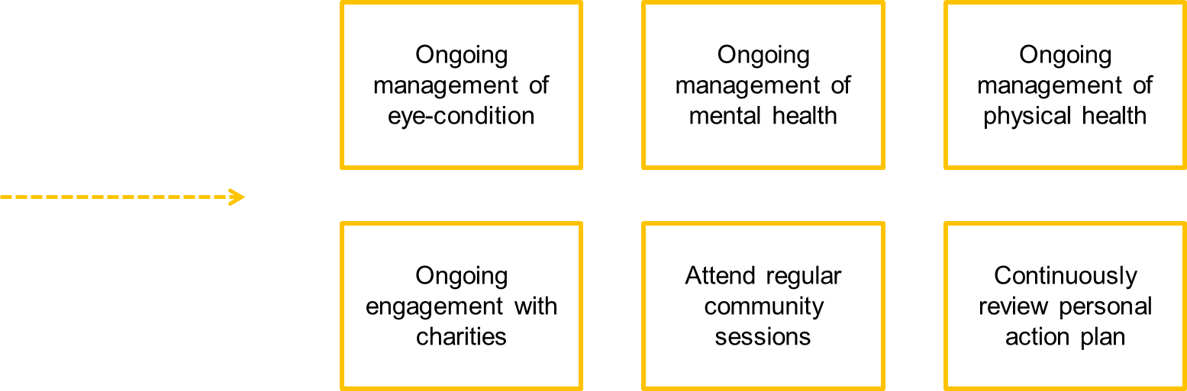
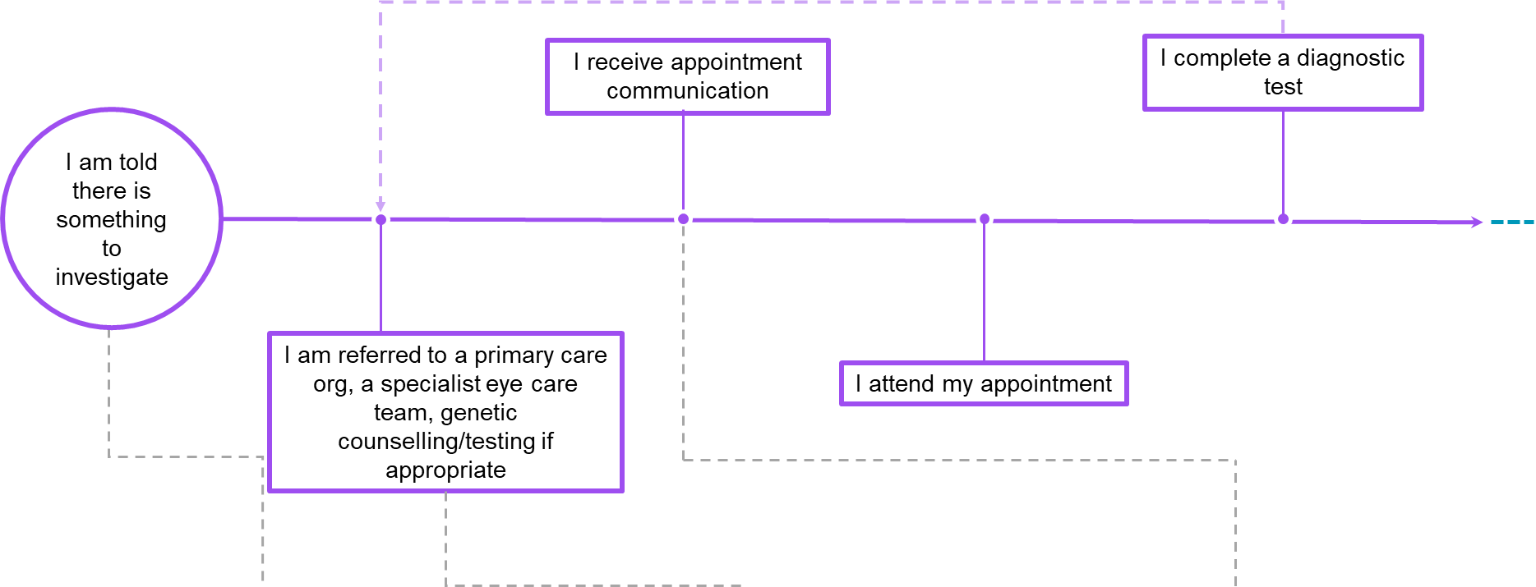
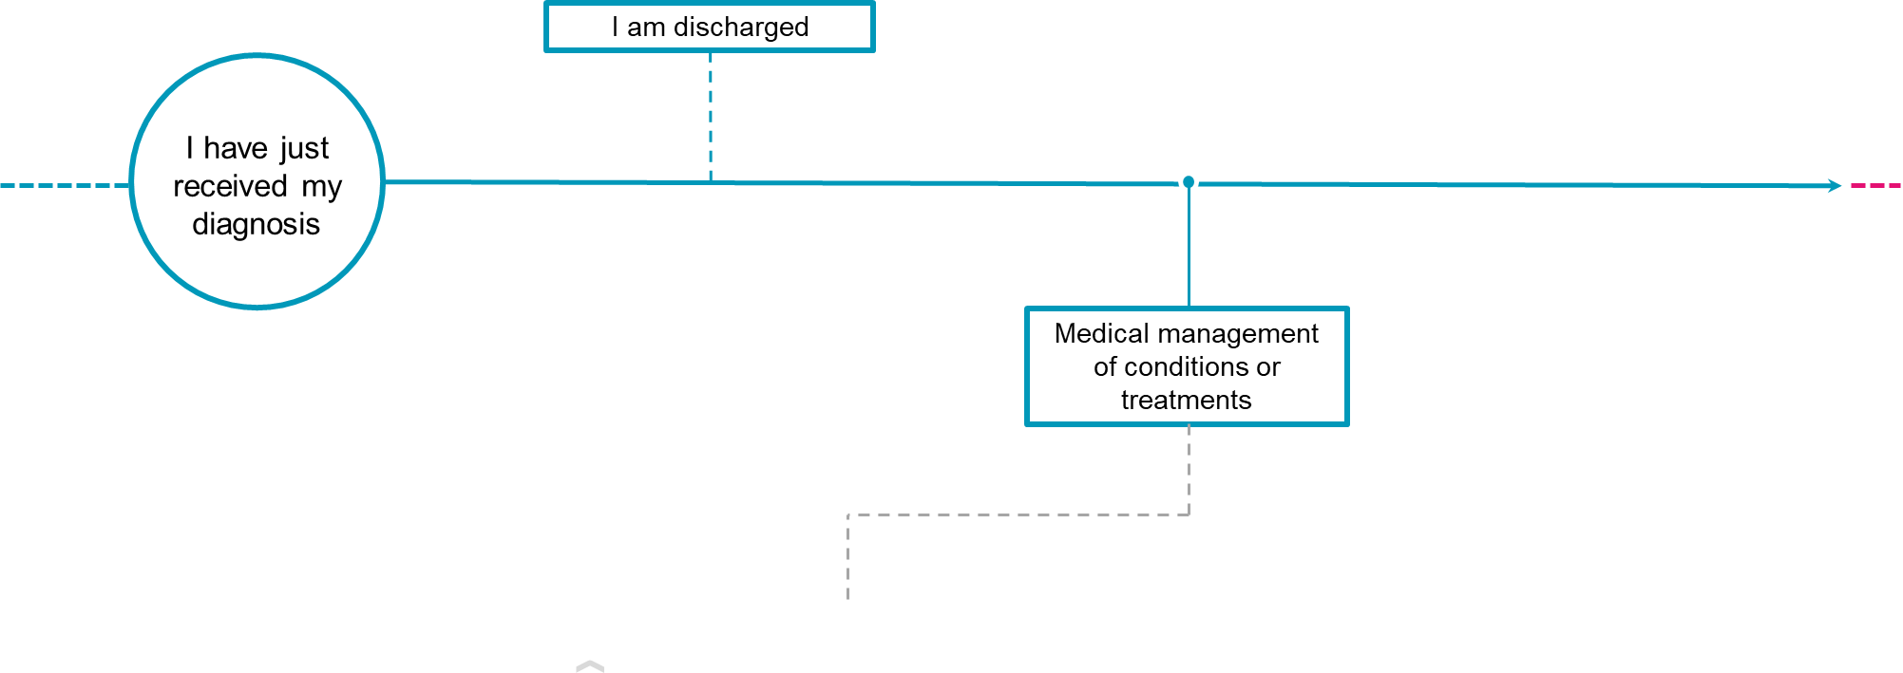
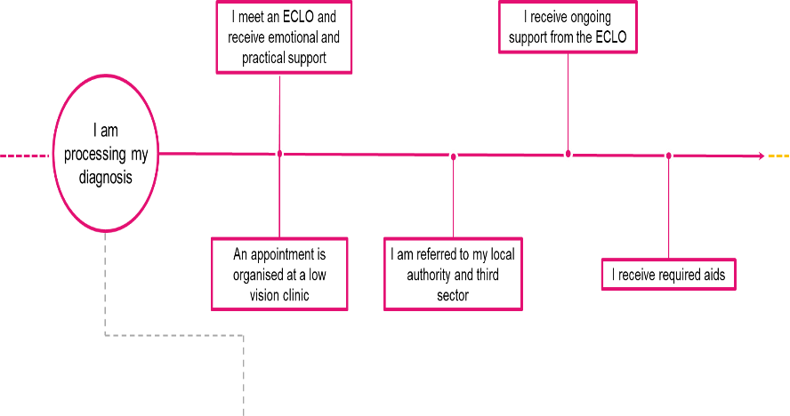
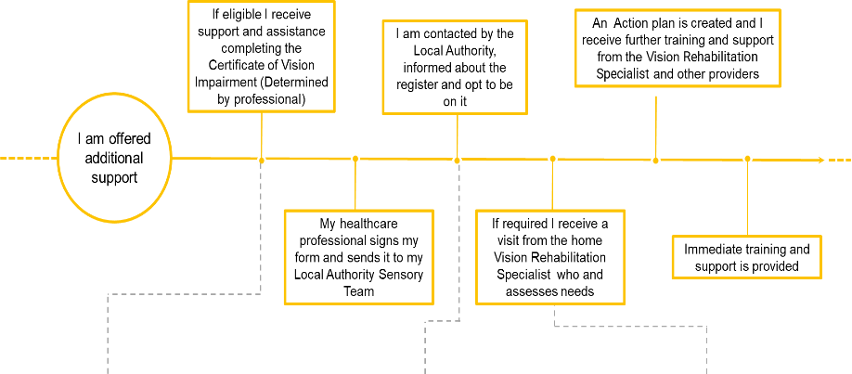

Stage 1 Stage 2 Stage 3 Stage 4

Appendix 2: Pain points
Pain points are where people experience a problem. This may include a lack of information, advice, or support; a delay; a lack of clarity with what happens next; or poor communication.

Reducing pain points will both improve the quality of care and quality of life for a person.

As part of our research and insights work RNIB undertook an extensive research review, including an end-to-end mapping of the current pathway and its associated pain points. More information can be found within the Eye care support pathway insights report.

The specific pain point work was determined by primary research and an extensive literature review administered by Kinneir Durfort (2022) unpublished report for RNIB which is available on request.

Stage 1: Having my initial appointment.

1.1a Seeks advice, attend appointment get a referral

Pain point | Associated experience
Person not attending regular eye-test | Late identification with little room for pre-habilitation
Opticians not giving suspected diagnosis information | Anxious wait with no ability to undertake research
Time pressure on opticians and primary care resulting in lack of information and unnecessary referrals | Frustration and upset due to wasted time

1.1b Seek advice, attend appointment, get a referral (NHS).

Pain point | Associated experience
Unclear correct route of entry for conditions | Confusion and delay in seeing appropriate specialist
GP / 111 may need specialist equipment and specialist to investigate and refer on | Feeling of wasted time and engagements, feeling of being ‘bounced around’
GP / 111 may overservice or underservice conditions | Unnecessary anxiety or delayed diagnosis
A&E access is difficult and delayed without referral/on call service | Long anxious wait times, could result in delayed treatments.

1.2 Minor Eye Conditions Service (MECS) and/or regular screening services

Pain point | Associated experience
MECS not available in all areas | Geographic inequities of care
Bounced between optometrist and hospital before referral to MECS | Frustration and unnecessary worry
Poor communication between stakeholders including no shared IT systems | Disjointed experience including patient having to relay outcomes – undermining trust in professionals.
In some areas, location of clinics | Person may struggle to travel to locations

1.3 Receive appointment letter, research, preparation.

Pain point | Associated experience
Appointment communication in inaccessible format | Lack of privacy asking for support and potential missed appointments
Lack of information about suspected eye-condition | Inability to do research and concern that they could be doing more to help
Appointments not always timely | Condition could be worsening in interim
Multiple layers of triage and lack of geographic consistency in triage process | Delayed appointments and stakeholder frustration

Stage 2: Having your diagnosis confirmed.

2.1 Eye Clinic Appointment and Diagnosis

Pain point | Associated experience
Poor referral may result in seeing wrong specialist | Further delays and frustration
Inaccessible and difficult to navigate environments | Missing or being late to appointments. Frustration and upset.
Lonely and boring waiting environments | Increasing anxiety around appointment
Health care professionals under time and resource pressure | Lack of information provided to person, lack of emotional support, reduced referrals to supporting services.
Lack of empathy and understanding from health care professionals. | Feeling of being a burden, further upset.
Onward referrals to social care/support services relying on individual clinicians’ knowledge and motivation. | Lack of referrals to supporting services.

2.2 Managing your condition and treatment.

Pain points | Associated experience
Optimum moment for signposting to other services unclear. | Lack of support referrals resulting in increasing isolation an inability to cope.
Travel and multiple appointments burdensome and disruptive | Frustration and decreasing engagement in condition.
Gradual or fluctuating sight loss makes it difficult to identify when to move onwards in pathway | Lack of emotional and practical support
Continuing accessible issues with environment and communications | Missed appointments, lack of privacy and decreasing feeling of independence.
No easy access to doctors for follow up support | No clear point of contact could result in anxiety and missed important changes.

Stage 3: Post diagnosis support

3.1 Referral to Eye Care Liaison Officer (ECLO)

Pain point | Associated experience
Person not referred for non-clinical support | Lack of emotional and practical support leading to isolation and struggling to cope
Geographic inconsistencies in service provision | Person unable to access service.
Referral to ECLO often made late in journey | Late support for person at point of crisis rather than preventing crisis
Lack of awareness of ECLO prior to appointment | Person may not have scheduled in appointment, may not have time to stay.
No standardised referral method | Delays in support offered.
Some locations have no dedicated ECLO environment | ECLO visibility in hospital low resulting in lower referrals
ECLO service poorly explained and not intuitive | Person may decline appointment.
Disagreement in order of pathway steps | Person ‘bounced between’ services.

3.2 ECLO provides immediate support.

Pain point | Associated experience
Unsuitable space for sensitive conversations | Person feeling uncomfortable and not getting proper support
Person rushed if others are waiting | Full range of support not offered resulting in unmet needs
Phone appointments difficult for emotional support | Inadequate emotional support provided resulting in person struggling to cope
Person resistant or overwhelmed | Inadequate support and may result in a negative perception of service.
Difficult to convey array of support available in single conversation | May result in overloading person or alternatively not offering full range of required support.
ECLO may not be in (working at other site / day off) at time of visit | Person missing out on face-to-face emotional support

3.3 Ongoing ECLO support

Pain point | Associated experience
Limited follow ups | Burden on person to ‘reach-out’ may result in isolation
Where follow-ups happen patient may not remember or be confused around ECLO role and initial engagement | Confusion and frustration around intrusion
Difficulties in communicating the array of support available | Person missing important support services, unmet patient needs.
Poor interoperability between pathway stakeholders resulting in delays of information when supporting patient | Delays in processing and support
Person’s communication preferences may not be feasible | Person resistant to engage.
ECLO may leave / staff change | Inconsistent service and requirement to re-establish relationships

Stage 4: Living well with my condition

4.1 Referral to Low Vision Clinic (LVC)

Pain point | Associated experience
Referrals not mandatory, resulting in reliance on individual practitioners’ knowledge and motivations | Person unable to access support
Geographic inconsistencies in service provision and quality | Inequalities in support depending on location.
Referral to LVC often made late in journey | Late support, limiting opportunity for pre-hab.
Community LVCs can have restrictive referral criteria | Person unable to access support
Wait times can vary significantly across trusts | Person’s skills may decline during wait time resulting in struggle to cope.
Referrals from outside of eye-clinic vary in quality | Diagnosis needs to be reconfirmed.
Disagreement in order of pathway steps | Person ‘bounced between’ services.

4.2 Low vision assessment, support, signposting

Pain point | Associated experience
Person unaware of role and value of low vision clinic | Missed appointments and limited engagement in techniques resulting in struggling further down the line
Variation in service level across geographies | Geographic inequities in care
No formal follow up process, variation based on practitioner | Burden on person to reach out may result in person struggling to cope.
Once discharged difficult to get patient back into system | Person unable to gain further support once discharged.
Charity organisations delivering service have greater ability to refer internally | Disparity of care across geographies
Poor coordination between services | Delays in delivering support.

5.1 Completion of Certificate of Vision Impairment (CVI)

Pain point | Associated experience
Person resistance to CVI | Person delaying or refusing to sign CVI
Manual processes, human error, and the need to post forms between stakeholders | Delays in form completion, forms being sent back and delays to onwards support.
Difficult to define point of certification particularly for long term and fluctuating conditions | Person not getting support when needed.
Person feeling rushed into CVI | Person unable to ask questions
Delays in posting due to sending in batches or forms being misplaced | Delays in onward support.
Poor clinician understanding of CVI (and registration eligibility, process, and benefits | Subjectivity in whether clinicians offer certification to person.
External pressures to reduce certification rates due to perception of high rates meaning ‘failure’ around treatment. | Clinicians hesitant to certify person.

6.1 Initial telephone contact with Local Authority

Pain-point | Associated Experience
Telephone call problematic for some people (hearing loss, working hours, busy home etc.) | Person unable to fully engage in conversation resulting in delays of care
CVIs delayed or lost in the system between hospital and local authority | Delays in form completion, forms being sent back and delays to onwards support.
Incomplete CVIs returned to hospital | Delayed support
Delays in phone call due to under resourcing and long wait lists | Confused and frustrated person awaiting calls and delayed support.
Lack of collaboration between health and social care | No clear point of contact for follow ups
Person unaware of purpose and value of visual rehabilitation. | Person declining assessments due to lack of understanding.
Initial calls made by staff with no training in impact of sight loss | Incorrect triage, patients with urgent needs not being seen promptly.

6.2 Specialist Assessment and Support with Vision Rehabilitation Specialist (VRS)

Pain point | Associated experience
Lack of VRSs resulting in long waits for assessment and follow on training | Delays in care, person continues to struggle to cope
Lack of service in some parts of country | Inequities in care across country
Low morale across social care leading to intolerable work pressures. | Delays in care due to high caseloads and insufficient staffing levels
No overarching monitoring body to ensure quality of service | Variation in quality of assessment and service – patient continuing to struggle in areas services should support
Signposting relies on individual VRSs knowledge | Variation in levels of support
Person unsure of how to access or re-access service | Person not reaching out, resulting in isolation, and struggling to cope

6.3 Creation of personal action/care plan

Pain point | Associated experience
Action/care plan seen as box-ticking exercise by some | Lack of consistency and consideration in plans, difficulty for patient to track process
Plan drawn up that cannot be delivered due to lack of resources | Frustration and disappointment for patient, continued struggling to cope
Plan not provided in accessible formats | Difficult for person to engage with own care, lack of privacy when asking others to support
Referral not followed up on due to capacity of rehabilitation team | Delays in support and training

7.1 Registration and Welfare/Disability Benefits & Concessions

Pain point | Associated experience
Confusing terminology and terms used interchangeably | Frustration and confusion by the person resulting in lack of engagement in process
Sub-contracting the register management to other organisation can cause confusion | Confusion as to why organisations are approaching them and how they got their details
Long delays between CVI and registration due to poor interoperability and communication between stakeholders | Long delays in support
Person does not understand benefits of registration (minority of cases) | Decline to be registered
Register not kept up to date or utilised to support community (e.g., C19 messaging) | Lack of Local Authority engagement with patient population
Inaccessible and challenging benefits system | Person denied support.

8.1 Initial contact with third sector

Pain point | Associated experience
3rd sector efforts tend to focus on support at the end of the patient’s journey | Engagement with person late in process after useful pre-habilitation periods
Person hesitant to ask for help and only engage at crisis point | Late engagement when person has already suffered.
Often reliant of proactive person, made difficult by GDPR restricting passing on of information | May result in person not reaching out when help needed. Person becomes isolated.
Regional and national charities offering overlap | Confusion over where to start and could result in less that optimum services delivered
Offering is vast and difficult to communicate | Difficulties in finding the right services to support.
Lack of secure referral routes from NHS/GOV email addresses | Person not being referred inwards, missing opportunities for support.

8.2 Engage with third sector.

Pain point | Associated experience
Lack of relevant support for some demographics (particularly age relevant) | Frustration trying to find support well suited to them
Limited resources resulting in delays and limitation on support available | Long waiting period where person may be struggling to cope. Frustration at service provision.
Vast services difficult to navigate | Feeling of being overwhelmed. Frustration when trying to find support.
Many services post pandemic is reliant on technology | Isolation for a person who is not strong technology users.

8.3 Continuously review personal action plan.

Pain point | Associated experience
Unclear who the point of contact is for various plan action points | Confusion and wasted time and effort trying to find contact for particular points
VRS under resourced resulting in lack of time to review plan effectively | Feeling of not being valued and stagnation on plan
Plans seen as a tick boxing exercise and not used effectively | Stagnation on plan actions and lack of relevant new actions added.
Lack of knowledge around the ability to be reassessed if circumstances change | People struggling to cope and not reaching out for more support.

Additional Table to be added re living with my condition and pain points (check when c-19 table still relevant)

Appendix 3: Detailed breakdown of a person’s support requirements across each stage of a typical eye care journey.

The support requirements tabled below mirror those identified as part of our primary research and therefore are in first person tense. The table within the main body of the report have been changed to support the tense used within the report.

Person’s Support Requirement – My Initial Appointment

Key Stages | I am told there is something to investigate | I have been told I am getting referred to an eye-health specialist |  |  | I have received my appointment communications
My Eye Care Journey | - I understand who they are seeing.  - I know what will happen next and when.  - I understand why it is important to attend eyesight tests or know how to re-access the most appropriate service if their eye condition changes. | - I am clear about what to expect next.  - I have had clear information about the next steps in a format which is accessible to me.  - I understand I may have to wait and know how to manage the waiting time |  |  | - I am prepared for my appointment at the hospital I know what I want to ask about.  - I can access my appointment
My Eye Condition | - I have access to specific eye health literature, from a trusted source.  - I receive any information, in a format that meets their communication needs.  - I be able to ask questions, in a safe and supported environment. | - I understand as much as I want to about my suspected diagnosis.  - I know what to do if anything changes with my condition |  |  | - I understand what condition I may have or what it is they are concerned about.  - I understand any risks and have clear expectations of what it will mean.  - I understand the urgency of my appointment and can self-advocate
Practical and Emotional Support | - I know where to get support to manage any anxiety about and I have been told and what is planned next.  - I know where to get information, advice and support to help with day-to-day activities such as employment, driving, benefits, care.  - I have the opportunity to speak to someone when they want to. | - I have been offered waiting well support and referred to the eyecare support team.  - I know who to contact if I have any further questions.  - I have had the opportunity to speak with an ECLO/advice provider |  |  | - I have had the opportunity to speak with an ECLO/advice provider.  - I feel emotionally prepared for potential outcomes.  - I understand that the nursing team involved in my care can provide information and support to help me
Person’s Support Requirement – Having my diagnosis confirmed.

Key Stage | I have just received my diagnosis
My Eye Care Journey | - I have received a sensitive diagnosis.  - I understand the next steps and how my condition will be treated and managed and whether treatments are available
My Eye Condition | - I have been offered specific eye care information.  - I have an understanding of my eye condition.  - I understand my eye condition and its implications.  - I can engage with my chosen treatment options and understand if there is no available treatment for my condition.  - I can communicate my eye condition and how it affects my life to others.  - I know that genetic testing is available to, and I have been referred for genetic counselling.  - If I opted for genetic testing, I may know my genetic diagnosis.  - I am able to communicate my eye condition and how it affects their life to others.  - I have been provided with information about Charles Bonnet Syndrome and how it might affect me
Practical and Emotional Support | - I know where to get support to manage my anxiety about what will happen next.  - I understand that the nursing team can provide information and support as part of my care.  - I know how to access nurse counselling, if required.  - I know where to go and be able to access to practical support and information.  - I have been given Low vision advice and information about the CVI process has been explained to me.  - I have spoken with an Eye Care Liaison Officer (ECLO) or access support.
Person’s Support Requirement – Support after my diagnosis

Key Stages | I am processing my diagnosis |  |  | I am managing my condition
My Eye Care Journey | - I understand if my condition is hereditary and what that means.  - I know about research related to my condition and how to get involved in clinical trials if I am interested. |  |  | - I understand how my condition will be managed, how many appointments I should expect and where they will be.  - I am aware of what may be ahead depending on my condition and understand the low vision and Certificate of Visual Impairment (CVI) process
My Eye Condition | - I understand how my condition may develop |  |  | - I know how to manage my treatment and understand how my condition may affect my vision in the future.  - I understand the importance of following the treatment plan I have been given (e.g., attending my clinic appointments or using my eye drops as advised)
Practical and Emotional Support | - I have access to emotional and practical support.  - I know about organisations which support people with my condition.  - I am able to talk to other people with the same condition as me |  |  | - I know about the support I may need in the future (such as Low Vision advice) and know how I can access it.  - I know I can go back to my ECLO/advice provider at any stage
Person’s Support Requirement – Living with my Condition.

Key Stages | I am eligible for a CVI |  | I am waiting for engagement with my Local Authority |  |  | I am working with my Vision Rehabilitation Specialist (VRS)
My Eye Care Journey | - I understand the CVI process and what happens next.  - I understand the registration process and the support I can access through my local authority.  - I understand I can access a Low Vision Service |  | - I feel prepared for the VRS visit.  - I understand what will happen at the VRS visit.  - I accept there may be a wait for the visit |  |  | - I feel confident about what to do if my needs change.  - My vision rehabilitation specialist has developed a personal action plan with me
My Eye Condition | - I understand my eye condition and what to do if I notice any changes |  | - I know how to manage my condition while I wait for support |  |  | - I can manage my ongoing eye-condition.  - I feel able to live independently with my condition
Practical and Emotional Support | - I understand how the CVI works and what I am entitled to.  - I have spoken with an ECLO who has explained the registration process to me.  - I have information and support around employment and benefits.  - I know about support from key organisations and have been referred to a LWWSL course |  | - I understand where else I might be able to get support from  - I know about the support available to me while I wait.  - I know who to contact if I have any questions |  |  | - I feel confident engaging with my action plan.  - I am able to access support in different ways as my situation changes.  - I am able to talk to/link in with other people in the same situation as me.  - I know I can go back to my ECLO/advice provider at any stage.
Person’s Support Requirement – Continuous Review

Key Stages | I am monitoring my eye condition
My Eye Care Journey | - I fully understand all the different stages of the pathway and who to contact at each stage if I need further help
My Eye Condition | - I understand my eye condition/vision may change and know what to do if this happens
Practical and Emotional Support | - I know how to find support that is relevant to me as an individual.  - I feel confident in accessing the support

Person’s Support Requirements- Waiting
My Eye Care Journey | • I am clear about what to expect next and when  • I have received information, in a format that meets their communication needs.  • I know who to contact and how to get updated wait times  • I am able to prepare for the types of questions I may wish ask about.  • I know that I can ask for a physically or virtually access the appointment.  • I receive information in format that meets my communication needs.
My Eye Condition | • I am able to access as much information as I want about a suspected diagnosis and get advice if required  • I know what to do if anything changes with my eye condition.  • I am able to access as much information as I want prior to the appointment.  • I understand the urgency of the appointment and can self-advocate/access support during the appointment.
Practical and Emotional Support | • I know where to get support to manage any anxiety and what I have been told and what is planned next.  • I know where to get information, advice and support to help with day-to-day activities such as employment, driving, benefits, care.  • I can speak to someone when I need to.  • I know who to contact for any further questions.  • I can access emotional and practical support if I want to at any time.  • I feel emotionally prepared for potential outcomes.  • I understand that the nursing team can provide information and support as part of my care.

Appendix 4: Models of best practice, quality frameworks, and standards for eye care advice and support

Information
There is a great deal of information available, the examples shown below are not an exhaustive list but show the range of information that can be used in the treatment of people with sight loss.

Legislation
Equality Act 2010: https://www.legislation.gov.uk/ukpga/2010/15/contents
Patient Rights (Scotland) Act 2011: https://www.legislation.gov.uk/asp/2011/5/contents

Communication
NHS Scotland Interpreting, Communication Support and Translation National Policy: https://www.healthscotland.scot/media/3304/interpreting-communication-support-and-translation-national-policy.pdf

Waiting Well
Using NHS Scotland and community services: https://www.nhsinform.scot/waiting-well/using-nhs-scotland-and-community-services/
Right Care Right Place: https://www.nhsinform.scot/right-care
Eyes.Scot - Scotland’s national website for eye care services and eye health information: https://www.eyes.scot/
Information from ECLOs
The RNIB produces ECLO guides which include condition specific information as well as information about employment, dementia, and strokes. https://www.rnib.org.uk/professionals/health-social-care-education-professionals/health-professionals/information-and-guidance-for-eye-clinic-staff/

Patient Support Services: https://visibilityscotland.org.uk/our-services/

Low vision guidance
National Low Vision Service Scotland: https://www.eyes.scot/for-the-public/support-for-visually-impaired-people-and-those-at-risk-of-sight-loss/low-vision-services/

Guidance available on CVIs includes.
Certification and registration: https://www.eyes.scot/for-the-public/support-for-visually-impaired-people-and-those-at-risk-of-sight-loss/certification-and-registration-adults/

Sight Scotland: https://sightscotland.org.uk/articles/information-and-advice/registering-sight-impaired-or-severely-sight-impaired-scotland

Guidance available regarding local authority care includes.
Glasgow Caledonian University Graduate Low Vision Rehabilitation course: https://visibilityscotland.org.uk/visibility-scotland-news/re-instatement-of-graduate-low-vision-rehabilitation-course/

Communication Failure? A review of the accessibility of health information for blind and partially sighted people: https://media.rnib.org.uk/documents/Communication_Failure.pdf
https://www.publichealthscotland.scot/publications/ophthalmic-workload-statistics/ophthalmic-workload-statistics-statistics-as-at-year-ending-31-march-2023/
RNIB Sight Loss Data Tool
https://www.eyes.scot/for-the-public/nhs-community-glaucoma-service/
State of the UK’s eye health 2021, Specsavers (2021)
Time to focus, Fight for Sight (2020)
See RNIB Sight Loss Data Tool - statistics on sight loss | RNIB | RNIB and A National Statistics Publication for Scotland: Registered Blind and Partially Sighted Persons, Scotland 2010, Scottish Government, 2010 at https://www.gov.scot/publications/registered-blind-partially-sighted-persons-scotland-2010/.
World Report on Vision, World Health Organisation (2019)
Local health and social wellbeing: the contribution of the VCSE-sector to local health and social wellbeing in Buckinghamshire-Oxfordshire and Berkshire West. Durham University (2023)
RNIB – COVID report https://www.rnib.org.uk/professionals/health-social-care-education-professionals/knowledge-and-research-hub/reports-and-insight/coronavirus-living-with-sight-loss-through-lockdown/
https://www.gov.scot/binaries/content/documents/govscot/publications/strategy-plan/2021/08/nhs-recovery-plan/documents/nhs-recovery-plan-2021-2026/nhs-recovery-plan-2021-2026/govscot%3Adocument/nhs-recovery-plan-2021-2026.pdf
https://www.nhscfsd.co.uk/our-work/modernising-patient-pathways/specialty-delivery-groups/cataract/
Long-term monitoring of health inequalities, Scottish Government, March 2023: https://www.gov.scot/publications/long-term-monitoring-health-inequalities-march-2023-report/pages/1/
Jones L, Taylor DJ, Sii F, Masood I, Crabb DP, Shah P. Only eye study 2 (OnES 2): ‘Am I going to be able to see when the patch comes off?’A qualitative study of patient experiences of undergoing high-stakes only eye surgery. BMJ Open. 2020;10(11)
People’s experiences of accessing Eye Care services. RNIB (2023), https://www.rnib.org.uk/professionals/health-social-care-education-professionals/knowledge-and-research-hub/reports-and-insight/peoples-experiences-of-accessing-eye-care-services/
Stage of Treatment, Waiting Times, Inpatients day cases and new outpatients, Public Health Scotland, September 2023 https://publichealthscotland.scot/publications/nhs-waiting-times-stage-of-treatment/stage-of-treatment-waiting-times-inpatients-day-cases-and-new-outpatients-5-september-2023/
People’s experiences of accessing Eye Care services. RNIB (2023), https://www.rnib.org.uk/professionals/health-social-care-education-professionals/knowledge-and-research-hub/reports-and-insight/peoples-experiences-of-accessing-eye-care-services/
Communication Failure? A review of the accessibility of health information for blind and partially sighted people, RNIB Scotland, 2020: https://media.rnib.org.uk/documents/Communication_Failure.pdf
Interpreting, Communication Support and Translation National Policy, Public Health Scotland, 2020: https://publichealthscotland.scot/publications/interpreting-communication-support-and-translation-national-policy/
Sight loss pathway: Final report, Anglia Ruskin University, Vision, and Eye Research Institute (2022)
Abid
Sight loss pathway: Final report, Anglia Ruskin University, Vision, and Eye Research Institute (2022)
RNIB’s Voice of the customer report 4 (Oct – Dec 2021), RNIB (2022)
Communication Failure? A review of the accessibility of health information for blind and partially sighted people, RNIB Scotland, 2020: https://media.rnib.org.uk/documents/Communication_Failure.pdf
Communication Failure? A review of the accessibility of health information for blind and partially sighted people, RNIB Scotland, 2020: https://media.rnib.org.uk/documents/Communication_Failure.pdf
RNIB, Guide Dogs and Thomas Pocklington Trust (2022) VI Lives: An in depth understanding of the experiences of people living with vision impairment in the UK.
RNIB’s Voice of the customer report 4 (Oct – Dec 2021), RNIB (2022)
Patient Pathway Detailed Breakdown, Kinneir Dufort (2022) Unpublished report for RNIB. Available on request

