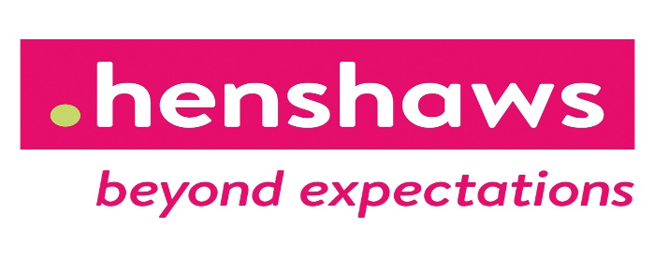

**8-12 year olds who have a visual impairment, join Ellie from Henshaws every Friday for 6-8 weeks for the I can do it course based in St.Vincents school.**

**Starting Friday 20th January 2023, 1-3pm**

**FREE swimming sessions to be included from Friday 3rd February**

**6–8-week program we will learn 6 different topics to promote independence and confidence.**

**Which include:**

**- Social and emotional skills**

**- Keeping myself and others safe**

**- Daily living skills and mobility**

**- Kitchen skills and cooking**

**- Transitions, goals, and aspirations**

**- quizzes, games and have lots of fun whilst making new friends!**

**For more information, please contact ellie on Ellie.thompson@henshaws.org.uk**

**07850914124**

Parent or carers name and phone number: ____________

Your childs name and age : ____________________

Do you consent for photographs to be taken for henshaws closed facebook group and to be shared with the funders YES / NO

Does your child have any additional needs, if yes please note here ____________________

Does your child have any allergies

__________________________

Please sign here for consenting your child can attend the 6-8 week I can do it course