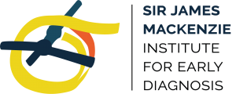
The Lady Margaret Skiffington Trust Scholarship

Outline
In July 2022, the Sir James Mackenzie Institute for Early Diagnosis, which is part of the School of Medicine at the University of St. Andrews, was granted approximately £99’000.00 to offer a PhD opportunity to an individual with sight loss. The PhD will be a four year, fully funded opportunity with student stipend, and offers a fantastic opportunity to join a world leading Research Institute at the University of St. Andrews.

About the Mackenzie Institute
The Mackenzie Institute was established in 2019 to become an International Centre of Excellence for Interdisciplinary Research across multiple research streams and disciplines. We are spread across multiple schools – Biology, Chemistry, Computer Science, Geography & Sustainable Development, Mathematics & Statistics, Medicine, Psychology & Neuroscience and Physics & Astronomy, collaborating internationally with research ongoing involving England, the Republic of Ireland, Germany, Canada, the United States and United Arab Emirates.
The Institute is multi-disciplinary, involving qualitative and quantitative research specialising in areas such as behavioural sciences, physiology, health services research, clinical trials, health economics, implementation research and dissemination. We are a patient focussed organisation, involving members of the wider population at all stages of research and recognising their contributions formally in published papers and disseminated works.
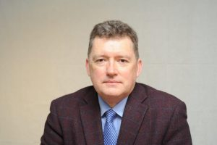
The Institute is led by Prof. Peter Donnelly, who has also enjoyed roles with the Scottish Government as Deputy Chief Medical Officer, and as the Chief Executive Officer of a large Public Health Agency in Canada. Professor Donnelly’s ambition for the Institute is to make a difference in communities, not only in Scotland but globally. A good example of the sort of projects he is keen to support is the work of Arclight. Launched by the Blakie/Williams team at St Andrews, it is a revolutionary frugally designed and affordable pocket-size device, which assists in examining the eyes and ears. It could help save the sight or hearing of millions of people around the world. Additionally, the Institute is pioneering significant research into the early detection of lung cancer led by the work of Prof Frank Sullivan and colleagues, as well as much more.
Prof Peter Donnelly, Institute Director and Professor of Public Health Medicine.

About the Lady Margaret Skiffington Trust
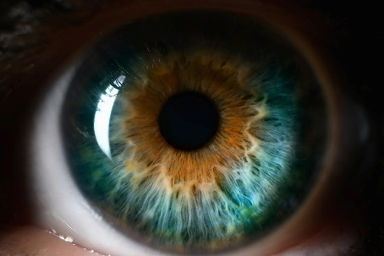
The Lady Margaret Skiffington Trust has as its principal object to benefit blind and visually impaired people who live in East Fife or who come to East Fife for rehabilitation or training.
Lady Margaret died in January 2004, leaving her estate for the benefit of the blind and partially sighted in North-East Fife - she herself had lost her sight in later years – with the Lady Margaret Skiffington Trust having been established with the objectives of improving the quality of life for blind and partially-sighted people through provision of aids to support daily life, training and rehabilitation, and for provision of indoor and outdoor spaces offering a sensory experience, for example scented gardens and sensory rooms.
After Lady Margaret died in 2004, her trustees sold her property and policies in 2005, the money raised providing the capital through which the Trust generates its available funds.

The Opportunity

Background;
This is a four year PhD opportunity in collaboration with The Lady Margaret Skiffington Trust and the University of St. Andrews Sir James Mackenzie Institute for Early Diagnosis.

Project;

The Mackenzie Institute will endeavour to assist the individual throughout their studies with additional
equipment and support where required in accessible formats. The successful individual will decide their
specialised topic area of interest at the end of their first year, however we would suggest particular focus on
the area of impending sight loss and sight degeneration, and how early diagnosis could prevent or
ameliorate these conditions.

The Candidate;

Applicants should have a 2:1, First Class Honours Degree or equivalent in a relevant discipline.
It is essential that the applicant is registered as sight impaired or severely sight impaired. The programme will
supply additional equipment and support required to accommodate the needs of the candidate.

Funding;

The trust and the University have agreed a student stipend for the 4 year duration of the PhD at £67,310.88, broken down yearly to;
Year 1 Year 2 Year 3 Year 4 Totals
Stipend 16,077.27 16,559.59 17,056.38 17,617.64 67,310.88

We have also set aside additional funding for student fees and support equipment if required. The University have a dedicated student support network for disabled students, and are liaising with a past alumni of The Royal Blind School and Doctor in a relevant research field to ensure we implement appropriate support networks when the candidate starts.

Further information

Prof Donnelly and his team are happy to discuss the opportunity with anyone who may be interested, and welcome discussion via email, telephone, online, or in person. We can be reached on the below details;

Email: Reach us here
Call: 01334 463599
MS Teams: Call us now
Address: The Mackenzie Institute, School of Medicine, University of St. Andrews, North Haugh, St. Andrews, KY16 9TF

The Mackenzie Institute - Read more here
The Lady Margaret Skiffington Trust - Read more here

