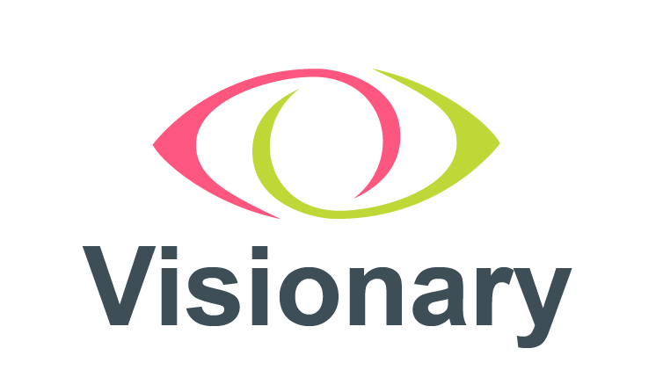

Visionary Form of Proxy

We, (Name of Visionary Member organisation, in block capitals)

___________________________________________________________________

of, (Address) _____________________________________________________

_____________________________________________________
being a full member of Visionary – Linking Local Sight Loss Charities, hereby appoint the Chairman of the meeting or (See Note 1)

___________________________________________________________________

as my proxy to vote on my behalf at the Annual General Meeting to be held virtually via Zoom on Thursday 17 November 2022 at 9.15am and any adjournment thereof.

Resolutions | For | Against
- To receive and adopt the Annual Report and Accounts for the period ended 31 March 2022
- Confirmation of appointments made during 2022: You have one vote per candidate | For | Against
- Arash Andalibi-Abadan
- Mark Upton
- Philip Mills
- Shahina Pardhan
- Susan Hoath
- Tom Harte
- Re-election of Directors, retiring by rotation – please indicate below the directors you wish to re-elect to the board (all are eligible). You have one vote per candidate | For | Against
- Arash Andalibi-Abadan
- Mark Upton
- Owen Williams
 | For | Against
- Special Resolution: Conversion to CIO
- Special Resolution: Adoption of new constitution

Notes:

- If any other Proxy is preferred, please cross out “The Chairman of the Meeting”, insert the name of the person you wish to appoint and initial the alteration.

- Please indicate with an “X” in the appropriate box above, how you wish your vote to be cast for each resolution. In the absence of any specific direction your proxy will vote or abstain at his/her own discretion.

- To be valid this proxy form must be returned to Amy Pearman to be received not later than 9.15am on Tuesday 15 November 2022

This can be sent by post to:

Visionary – linking local sight loss charities
First Floor
3 Queen Square
London
WC1N 3AR

or by completing the form, scanning and e-mailing it to visionary@visionary.org.uk

or by competing the online proxy form via this link: Visionary AGM - 17 November 2022 - Resolution Proxy Voting

Signed: _______________________________________ Date: ________

