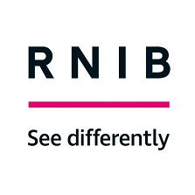
Emotional Impact of Sight Loss (EISL) One Day Workshop

Course Overview

This one-day workshop has been developed by the Counselling and Wellbeing Team at the RNIB, to recognise and support frontline staff in responding to client need, often in emotive and challenging circumstances.

It is designed to help you to identify your strengths as well as the most helpful responses to clients in distress, appropriate to your roles. It also aims to support you to enhance your own personal resilience through exploring the skills that equip us to be emotionally resilient in the face of adversity.

Aims:

- To look at some of the most common emotional impacts related to sight loss
- Enhance skills and confidence in supporting clients in distress.
- Recognise and affirm personal and professional boundaries, Limitations and Resilience.
- Enhance your own sense of personal effectiveness and working with difficult situations.
- Recognise and develop own self-care strategies.

EISL Course Dates 2022 - February to August

- Wednesday 9th February 2022

- Wednesday 16th March 2022

- Tuesday 5th April 2022

- Wednesday 11th May 2022

- Friday 10th June 2022

- Thursday 7th July 2022

- Wednesday 3rd August 2022

To apply please complete the application form: Application Form

If you have any questions or require further information please contact Tina Doyle: tina.doyle@rnib.org.uk

