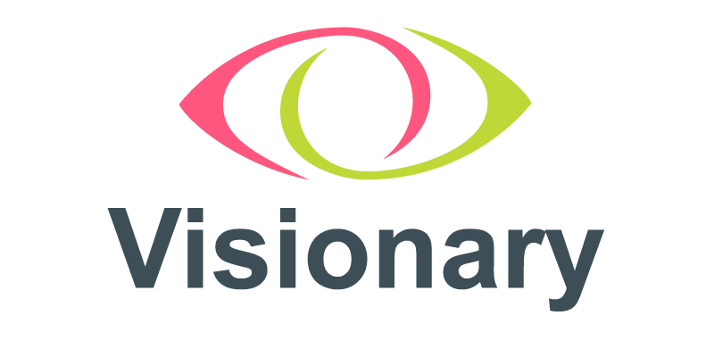

Membership Support Co-ordinator

Role Information and
Application Pack

“Visionary was the silver lining from the pandemic – the support, advice and sharing across the sector created a catalyst for collaboration across national and local organisations. It would never have happened so successfully without Visionary”
Nik Demetriades, Warwickshire Vision

About Visionary

Visionary is a membership organisation for local independent charities that support blind and partially sighted people across the UK. These independent local charities provide practical, on the ground, services for local people with sight loss. Bringing together a wealth of experience and expertise in the sector, Visionary acts as the collective voice for local organisations. We encourage and support sharing between members, make connections between people and organisations and support the development of services, strategies, partnerships and collaborations. Our strategy for 2022 – 2025 is attached.

Structure of Visionary
We like to think of ourselves as a small but perfectly formed team! We are a group of creative individuals; completer finishers. We are people who enjoy a good policy or two and who love a beautiful diagram and a description with lots of adjectives!

What brings us together are shared values, respect for each other and the people and organisations we work with. We all want to make the world a better place and we have created a flexible structure which allows us to play to our strengths and be able to respond to a frequently changing external environment.

Visionary’s Organisation Chart

Description of Chart
The organisation chart above has the Board of Trustees at the top and the CEO underneath reporting to the Board of Trustees. Under the CEO are the Partnerships & Innovation Lead and Communications & Events Lead. The Partnerships & Innovation Co-ordinator is under the Partnerships & Innovation Lead. The Membership Support Co-ordinator and the Communications & Events Co-ordinator work under the Communications & Events Lead.

Job Description

Position: Membership Support Co-ordinator

Responsible to: Communications and Events Lead

Salary: £28,000 pa

Hours: Full time (36 hours per week)

Contract: Permanent

Location: Home based
With a requirement of employment that the post holder be prepared to work at any additional or different locations as may be necessary. The role involves regular travel throughout the UK with overnight stays a necessity.

Note: We recognise that we are hoping to find two skills sets in one person with this role! If you feel you have one of the skill sets and would be willing to learn the other set, please apply! We may also consider splitting the role into two part time roles – so again, please apply if this is of interest.

Job Purpose
The main purpose of this and all Visionary roles, is to play an active and influential part in improving the local visual impairment sector so that people living with such impairment have equality of opportunity, wherever they are in the UK.
Visionary is an agent for positive change within the sector and all roles are part of that. This role is responsible for developing our offering for members in addition to the development of member and partner relationships and their retention.
Main duties & responsibilities
We are a responsive organisation, and the needs of our members often change. Job descriptions and duties are therefore also subject to change to allow us to do what our members need us to do. The following list is intended to give you an idea of key priorities for the coming strategic period.
In particular, you will take a lead on:
- developing and maintaining our offering for members, including discounted services from corporate partners
- developing and maintaining corporate partnerships
- developing and maintaining our Professionals Associated with Visionary category
- ensuring Team Visionary know and understand the member offering
- managing our customer relationship management system (Salesforce).

Offering
- Working alongside colleagues, develop our Visionary offering for members.
- Build on existing relationships with corporate partners to develop our offering to members.
- Create new relationships and develop offers which benefit our members.

Members and Partners
- Retain current members and partners.
- Carry out member and partner renewals.
- Ensure that all relevant data is captured on Salesforce.
- Seek out potential members and partners from the local and national sight loss sector.

Professionals Allied to Visionary (PAV)
- Develop this new category
- Maintain and manage relationships
- Co-ordinate renewals
- General administration of PAV

CRM Management
- Understand why we need a CRM database, what we use it for and how it can support more efficient running of the charity.
- Build and run reports from CRM (Salesforce) as required by the Visionary team.
- Input data into the CRM (Salesforce) and ensure that the existing contact and permissions data remains accurate and up to date.

Online Sessions
- Facilitate and deliver Visionary on-line sessions

General
- Provide targeted support and advice to members.
- Carry out annual visits with members – analyse the findings and make recommendations.
- Assist with the design, organisation and delivery of our events, sessions, and annual conferences.
- Attend and if necessary, facilitate, Visionary regional and country meetings

With colleagues you will:
- assist with showing impact measurement
- monitor and evidence outcomes
- produce an analysis of Visionary’s activities
- make recommendations for change and improvement
- gather and share good news stories
- participate in our generic information service.

Where this post fits within Team Visionary
We have a team approach to our work and how we deliver it. Everyone has a valid role to play, which is respected and recognised. We play to our strengths and seek support with our weaknesses. You have a responsibility to yourself and your colleagues to do your job and to help your colleagues do theirs.
We are passionate about finding the right person to work with our members and partners, so if, for instance, Salesforce is a development area for you – let’s have a chat about it! We are open to exploring the opportunity to split this role.
Within our team, you are the person who ensures we retain and nurture our existing membership and where appropriate, attracts new members. You also assist with retaining and nurturing partner relationships.
You find out what offers we can make available to our members and develop relationships to create a tangible offer to our members.
You help us make best use of our CRM.
You will use CRM generated information to carry out membership and partnership renewals, event attendance, produce reports and data.
You work with the Partnership and Innovations Lead to make sure we are gathering information on the lasting impact we create, and you work with the team to ensure that our ideas and connections can be recorded and analysed.
And it goes without saying (although we are saying it!) at all times, you will remain within the set budget and adhere to the boundaries we establish.

Reporting and Accountability
You will, as required, report to the Communications and Events Lead and, where appropriate, to other colleagues on all relevant activity. This will include supporting the Chief Executive in preparation of all relevant reports.
You will be accountable for Visionary’s compliance with our own policies, procedures and quality standards and also any appropriate external regulatory requirements and standards. You will ensure that policies and procedures are reviewed on a regular basis to provide fit for purpose guidance.
You are expected to contribute to the wider strategic development of the charity and be a role model in the demonstration of Visionary’s values and competencies.

About You
What kind of person likes to work here?
First and foremost, you should have a desire for social change. You might not fully understand the importance of people with lived experience being in control of their own destiny – but you should want to find out why that is a good thing!
You will be competent and comfortable using CRM’s – ideally Salesforce. If this is an area of development for you, talk to us about it and let’s explore opportunities together.
You will enjoy working with others and sharing success however you will also be comfortable working alone with a fair degree of autonomy whilst being part of an accountable and trusted team.
If you are open to new ideas and feel comfortable with change then you are probably going to be ok. People who like the same routine every day are less likely to be ok.

Person Specification
Knowledge and Skills
Essential
- High level of competency (and confidence) using a CRM (ideally Salesforce).
- Good understanding of the not-for-profit sector and challenges local organisations face.
- Proven ability to develop effective and productive relationships.
- Excellent communication skills, including written and presentation.
- Excellent organisational skills with the ability to manage your own workload, work independently and achieve results.

Desirable
- To be a Certified Salesforce Administrator or have equivalent experience.
- Knowledge of corporate social responsibility and how to tap into this.
- Knowledge of the sight loss sector.
- Knowledge and experience of working within a membership organisation.

Experience
Essential
- Daily use of a CRM (ideally Salesforce).
- Experience of building relationships between organisations.

Desirable
- Experience of developing member offers.
- Experience of developing relationships with corporate partners to generate and secure offers.

Personal qualities
Essential
- Commitment to Visionary’s values, mission and purpose.
- Versatile and flexible - open to new ideas and comfortable with change.
- Willing to listen, learn and adapt.
- Open and honest.
- Comfortable working independently and managing own workload across a range of priorities.
- Creative
- Thoughtful
- Ability to follow through / completer/finisher.
- Independent but part of a team.
- Confident.

How to apply for the role
To apply for this role please complete the online application form via the link below by 5pm on Friday 11 February 2021.
Membership Support Co-ordinator: Application Form (tfaforms.com)
Equal Opportunities Monitoring (tfaforms.com)
If you have any questions or would like an information discussion about the role, please do not hesitate to get in touch via email, visionary@visionary.org.uk and we will be in touch.

We look forward to hearing from you

