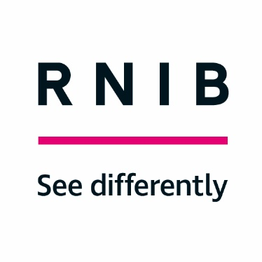
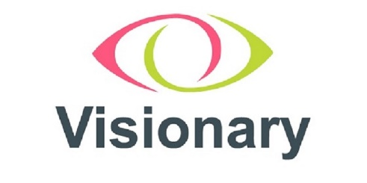
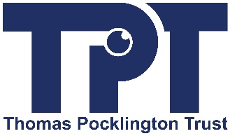

Living Well With Sight Loss (LWWSL)

Telephone based courses

Seed Funding

Thank you for your interest in applying for Visionary/RNIB’s Living Well with Sight Loss (LWWSL) seed funding opportunity (funded by RNIB and Thomas Pocklington Trust [TPT]).

This small fund aims to help Visionary members with an income of under £150k per annum to set up and run telephone-based LWWSL courses over a 15-month period.

Grants of up to £1500 are available.

We look forward to receiving your completed applications by 22 February 2022

Purpose of the seed funding
The fund aims to support up to 4 small Visionary member organisations from across the UK, with income of less than £150k per annum, to set up and deliver telephone based LWWSL courses. The courses will be aligned to the new RNIB 'LWWSL Quality Framework and Practice Guidelines' (details included in the downloadable recording) and successful organisations will work in partnership with RNIB.

We want to support organisations who believe that LWWSL could have a positive impact in their area, but do not have the resources to develop and deliver courses. The aim is to open up the LWWSL programme to more people across the UK and to sustain delivery beyond the term of the funding.

Additional free support
RNIB will provide the following support for successful applicants:

Training and skills sharing

- Facilitation training (approximately 2hrs dependent on experience): Delivered via Microsoft Teams, potentially alongside other delivery partners.
- Content training (60 – 90 mins): To cover the content of the course.

Delivery support

- RNIB will co-deliver courses until partners are confident enough to deliver independently.
- A facilitation guide will be provided to support delivery staff. This is for reference, i.e. the approach to delivery is flexible and can be tailored to the needs of individual organisations as long as delivery partners adhere to the core components of the Quality Framework.

Marketing and promotion

- RNIB will provide an electronic poster that will identify partners as the delivery agent. The poster can be edited to include course information, times, dates, venues and contact details.
- RNIB will advertise partners’ LWWSL courses on RNIB’s website and via RNIB’s Community Connections, ECLOs and UK wide Sight Loss Advisers.

Funding conditions
Successful applicants will be required to:

- Complete RNIB facilitation training.
- Observe RNIB facilitation of sessions.
- Co-deliver a LWWSL course with RNIB.
- Deliver at least 3 telephone-based courses over a maximum of 15 months.
- Engage with a minimum of 8 participants/carers/friends and family per course.
- Commit to a Memorandum of Understanding (MOU) with RNIB which sets out the principles for the collaboration. Copy of MOU will be provided with the application pack.

Guidance for applicants
Please read the guidance below carefully – if there is anything you don’t understand, or if you need more information about the quality framework and the partnership model, please email lucille.corrigan@rnib.org.uk

Eligibility
- Your organisation must be a Visionary member.
- Your organisation should have an annual income of less than
£150k.
- Your organisation must not currently be delivering Living Well with Sight Loss courses (or similar).
- Your organisation should have existing employees or volunteers with knowledge /experience of working with people with sight loss and have the capacity required to deliver courses (without going out to recruitment).
- Your organisation should have the infrastructure needed to support telephone-based course delivery.
- Your organisation should have the following up to date policies in place:

  - Safeguarding
  - Privacy & Confidentiality
  - Data Protection and GDPR
  - Health & Safety
  - Complaints & Representation

Value of the fund
We have remaining funds of £4,900 available. This has been generously provided by TPT and RNIB.

The maximum amount you can apply for is £1500.

What the funds can cover
- Staffing/volunteer delivery costs or expenses.
- Administration costs.
- Development time.
- Contribution to overheads (including Zoom license).

What the funds won’t cover:
- Capital equipment

Reporting requirements
An interim progress report (at 7 months) and final report are required.

Process
Completed applications should be submitted via the online form by22 February 2022.

A panel comprising RNIB and Visionary will assess the applications. We will inform all applicants of the outcome by Friday 4 March 2022.

All projects must be completed by 30 June 2023.

