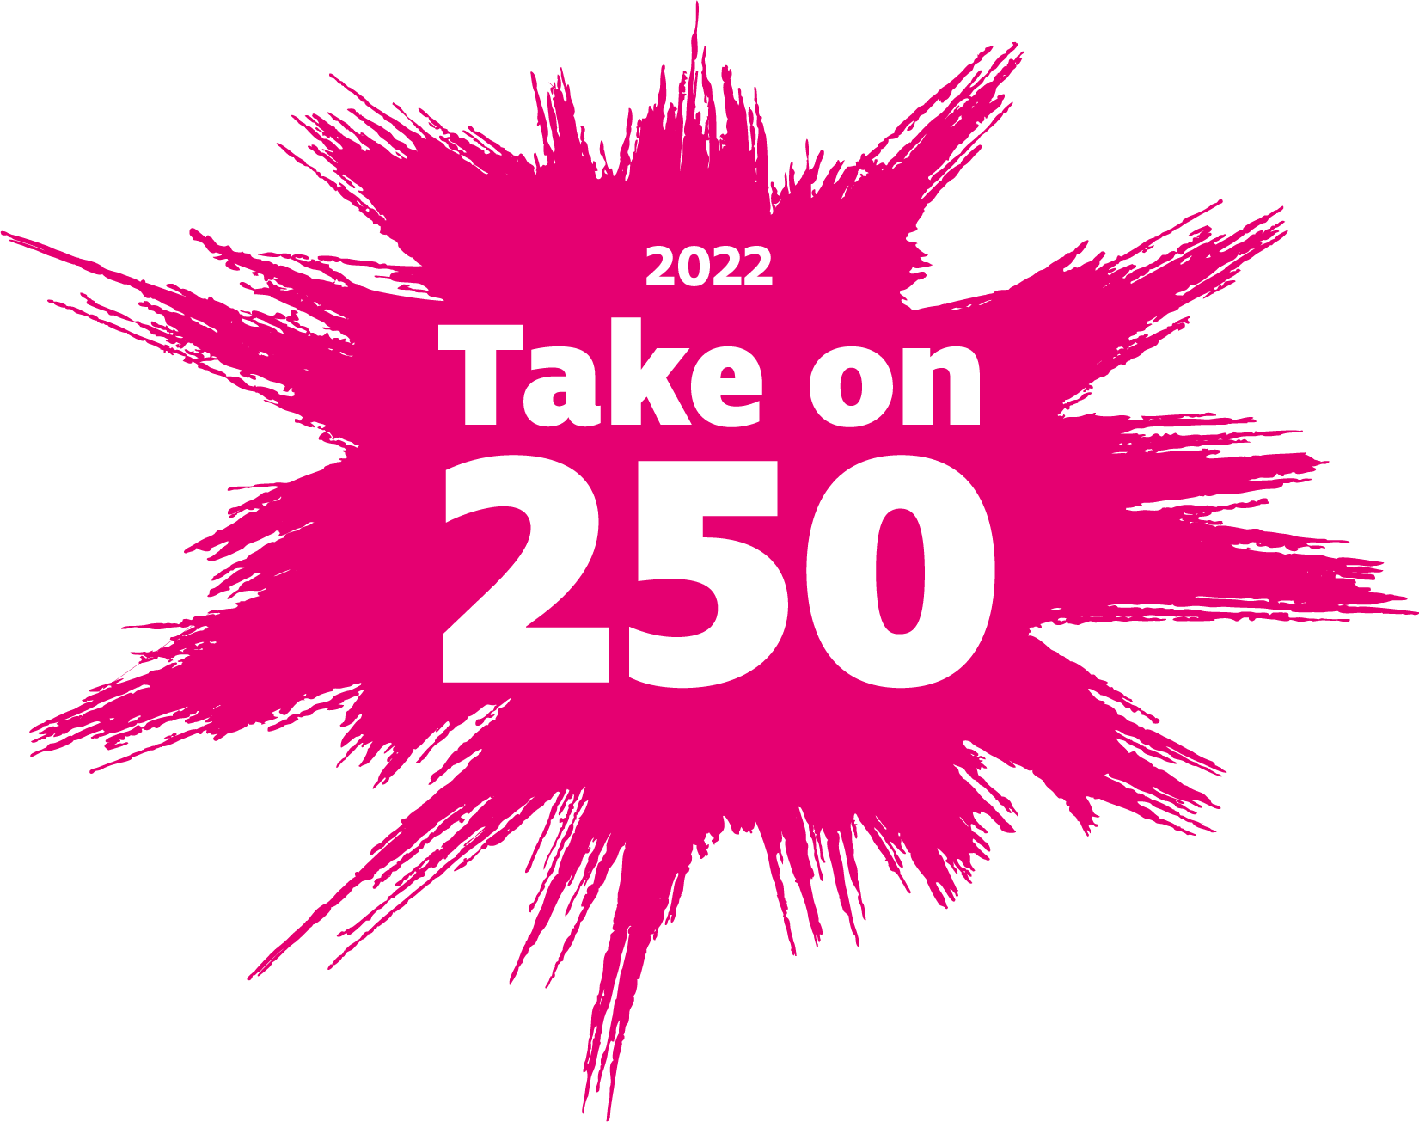

Take on 250
2022 Toolkit

Contents
Overview 3
Messaging 4
Event Name 4
Strapline 4
Key shared messages 4
Challenge ideas 4
Fundraising 5
Sponsorship pledge 5
Collecting sponsorship 5
Marketing 6
Brand 6
Logo 6
Posters 7
Website……………………………………………………………………7
Social Media 8
PR 9
Brand Guidelines 9
Stewardship Plan 9
Third party fundraising guidelines 10
Legal……………………………………………………………………… 10
Reporting 10
Questions 11

Overview

‘Take on 250’ is a virtual fundraising challenge bringing UK sight loss charities together to raise vital funds to support blind and partially sighted people.

Based on the statistic that 250 people in the UK start to lose their sight every day, the simple premise of Take on 250 is to choose any activity and complete 250 within the month of January 2022.

Anything goes from running 250 miles, knitting for 250 minutes, completing 250 press-ups to making 250 cupcakes. The flexibility of this challenge means it’s open to everyone, no matter their age, interests or fitness level. It encourages people to use their imagination to come up with the perfect challenge for them.

Participants can register for free and set their own fundraising target. Any money they do raise will go directly to the sight loss charity they have chosen to support by Taking On 250.

Each charity will be responsible for its own marketing, recruitment and stewardship, with the support of the assets in this toolkit.

2022 will act as a pilot year so do please keep notes on an any improvements so we can consider for future years.

RNIB is providing this campaign toolkit to you in order to support the sight loss sector. When you use it, you agree to follow these guidelines, not bring RNIB’s name into disrepute and to obtain consent from RNIB prior to its reuse.

Messaging

Event Name
Take on 250

Strapline
Choose your challenge and make a fresh start in 2022

Key shared messages
- Every day in the UK, 250 people begin to lose their sight, and that’s why we need you to Take on 250 for [charity name].

- New Year is the perfect time for a fresh start. So why not push yourself with a challenge and brighten up your January.

- Choose a new challenge or take on something you know you love. Either way, it’s a great kick start to your New Year. Walking, running, cycling or swimming; cake-baking or singing; dancing or knitting; it’s all up for grabs – and you complete 250 of whatever challenge you decide. It could take 250 minutes or hours, involve 250 steps or laps, 250 repetitions or making 250 items.

- You get to choose your own fundraising target; we just ask you to raise as much as you can.

Challenge ideas
The possibilities for Take on 250 challenges are endless. Providing a range of suggestions will inspire people to come up with an idea which is fun and achievable for them. Each charity can tailor the ideas they share to their audience.

Here are a few to get you started:

- Bake 250 cakes
- Walk 250 laps of your local park
- Do 250 minutes of yoga
- Cycle 250 miles
- Write 250 poems
- Climb your stairs 250 times
- Sing 250 song requests
- Complete 250 squats per day

Fundraising

Sponsorship pledge
There is no minimum sponsorship pledge for Take on 250 and participants are just asked to raise as much as they can. We recommend encouraging them to set their own target and suggesting they aim to raise £100.

Collecting sponsorship
Online fundraising is the quickest and easiest way for supporters to raise funds for Take on 250 and we strongly recommend using JustGiving.

If your charity isn’t already a member you can join here.

Each charity can create its own branded campaign page for Take on 250. This allows you to track how much has been raised and means you and your supporters can see all the fundraising activity connected to the event in one place.

JustGiving will then provide a URL & QR code specifically for supporters to create a fundraising page linked to your Take on 250 campaign.

To access this URL go to “View existing campaigns” within your JustGiving account. Click “Actions” in the top right hand corner of your Take on 250 campaign and select “Page creation link” from the drop down. You can then copy the link.

Including this in stewardship emails will make it more straightforward for participants to set up their pages and start fundraising straight away. Individuals can also share the QR code for their individual page via social media, WhatsApp etc.

Marketing
The concept of Take on 250 is simple and fun, and this goes for the marketing too. We suggest focusing on social media and reaching out to existing warm audiences using the assets provided, as these are the key activities that drove recruitment in the 2021 campaign.

To amplify the campaign, we are sharing with you some marketing materials that can be updated with your own logo.

While the event name and logo are displayed as Take on 250, within marketing or stewardship copy we would encourage charities to refer to it as Take on 250 for [your charity name] to make it more bespoke.

Take on 250 Logo
This was designed for use on your charity’s website, JustGiving campaign page, poster templates, emails, sponsorship forms and certificates

We have provided a variety of logo formats for you to use, see the brand guidelines section below. These logos have been sent as a zip file.

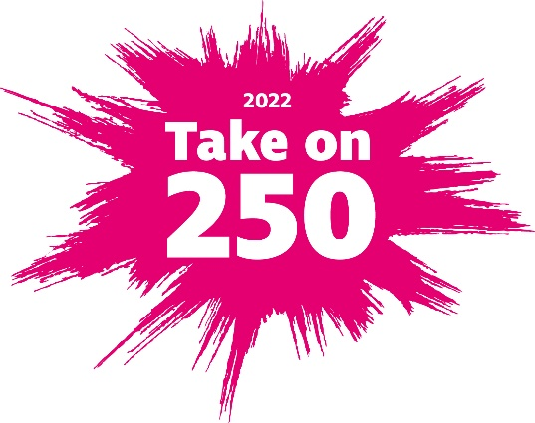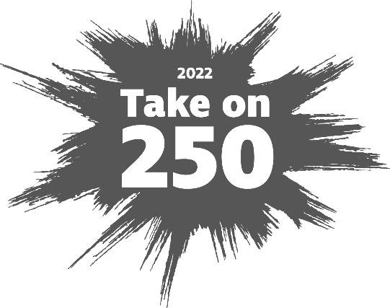

Take on 250 Posters

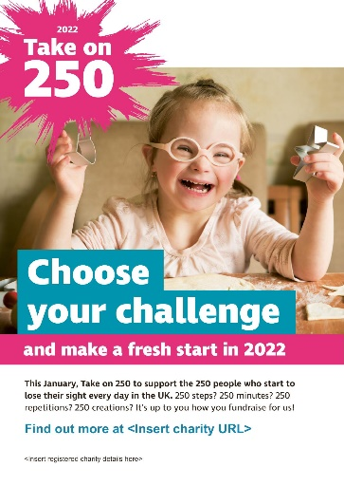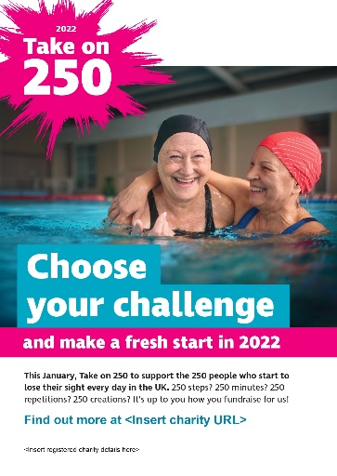

We have provided two versions of the Take on 250 poster (above) in an editable pdf format. You can add your logo in the top right-hand corner of the poster. Please see the RNIB version below to see how we have positioned the charity logo.

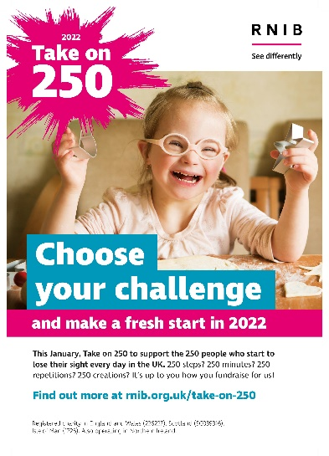
Please do update your charity posters to include your logo, website and charity information as required. The brand guidelines offer guidance on how to lay out your poster.

Website

For inspiration on how to create your web pages for Take on 250, please take a look at the RNIB website.

Social Media
Social media promotion could include a mixture of organic posts and paid adverts. Vary the content depending on the type of challenge you are looking to promote. From fitness to knitting, cake baking to stair climbing!

Encouraging participants to share photos and videos of their challenges is a great way to create more momentum around the event.

The official event hashtag is #TakeOn250 and we suggest including it in all your posts. The strength of all participating charities using this hashtag should create more traction on social media and amplify our campaigns. It will also allow individuals to search on the hashtag and see what others are doing and be inspired by their activity too.

For accessibility purposes, we ensure each word of the hashtag is capitalised and always include image descriptions.

Example posts

Launch
We need you to #TakeOn250 for [charity name]

Make a fresh start this New Year and take on a new challenge. Just complete 250 of whatever activity you choose to make a huge difference for people facing sight loss in the UK.

[Link to your website] -

Challenge specific: cycling
Every day in the UK 250 people start to lose their sight, that’s why we need you to #TakeOn250 for [charity name].

The possibilities are endless for your New Year challenge: cycle 250km, get out on your bike 250 times, go for a 250 minute ride – it’s up to you!

[Link to your website] -

PR
The toolkit includes a template press release which could be sent to local press when Take on 250 is launched. Highlighting that 37 charities from across the sight loss sector are coming together to promote the event, there is space for each charity to include their own cause-related messaging, link to their event webpage and contact information.

Brand Guidelines
For guidance on how to use the logos we have provided, please refer to the Brand Guidelines pdf which we have also sent across. This will also provide tips on how to space and position your own logo.

If you have queries about which logo to use for digital or print etc, please refer to this blog post for tips. Otherwise, do contact us on the email below and we will try to help.

Stewardship
Stewardship for Take on 250 could include a mix of emails, phone calls and mailings. Each charity will have its own ideas and can put its own plan in place.

The toolkit includes an example stewardship email which could be sent to participants immediately after they sign up.

Below is an outline of the stewardship plan for Take on 250 2021 to provide some inspiration of what could be included.

Below is a table with 5 rows and 4 columns, and a title.

Stewardship Plan
Date | Channel | Key Messages | Call to Action
Immediately after registration | Email | Welcome to Take on 250 | Set up your fundraising page
31 December | Email | Good luck | Set up/promote your fundraising page
15 January | Email | You're halfway there.  Charity messaging, why your fundraising is important | Set up/promote your fundraising page
1 February | Email | Congratulations Final donations and fundraising deadline | Send in your final donations
15 March | Mailing | Thank you letter and certificate | Other ways to support

Third party fundraising guidelines
Each individual charity will have their own policies and guidelines about third party fundraising.

Remind individuals they take on their challenges at their own risk and it’s their responsibility to organise all aspects of the challenge - whether it be cake baking or mountain climbing! Participants should also make it clear they have organised their chosen Take on 250 activity "in aid of" your charity and understand the charity will not accept any responsibility or liability.

Legal

This Campaign consists of our “toolkit” which includes this document, the template press release, example stewardship email, logo and marketing materials.

In consideration of the mutual promises set out in this document, the parties agree;
- The use of the “Take on 250” logo is subject to consent from RNIB.
- To obtain RNIB’s consent for any subsequent use of “Take on 250” Campaigns
- Not to bring RNIB into disrepute

Reporting
Each charity will be asked to provide a simple evaluation report on its Take on 250 campaign and feedback by 31 March 2022. 2022 is our pilot year and your feedback will help us measure the success of the campaign and identify future improvements and opportunities.

You’ll be asked to provide:
- An overview of marketing activity
- Recruitment figures
- Number of active fundraisers
- Total income
- Overview of most popular activities

Questions
If you have any questions please contact Andrea Glover, Strategic Engagement Manager Third Sector at RNIB. You can reach her at charity.partners@rnib.org.uk or 07717 301741.

