Sports Week – Fri 31st July start – Zoom Fri 7th August Zoom
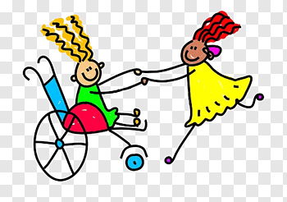
Moorvision’s first ever virtual sports week will get you up and going when you thought that it was time to take it easy!
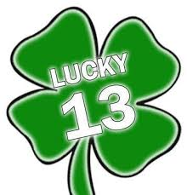
This week we would like your children to choose three (or more) of the following six activities that should cover all ages and abilities. Take photos, make recordings, keep a diary of what they are doing and catch up with us on Fri 7th August at 10.30am on Zoom. Zoom link to be sent out to anyone who requests it. If you can’t make the Zoom session, email photos or post on Moorvision’s Facebook or Twitter pages (@MoorvisionDevon). Certificates will be sent to all children who take part.

Activity 1. Lucky 13
Moorvision has been going for 13 years (not unlucky for us!) and we have grown from 5 to 170 families in that time. Can you do 13 of one or more of the following things every day?
Run, walk or go in your wheelchair up and down the garden or path?
- Star jumps
- Hop on one leg
- Jump
- Press ups (adults!)
- Clap your hands
- Skip with or without a rope
- Stretch up to the ceiling and down to your toes

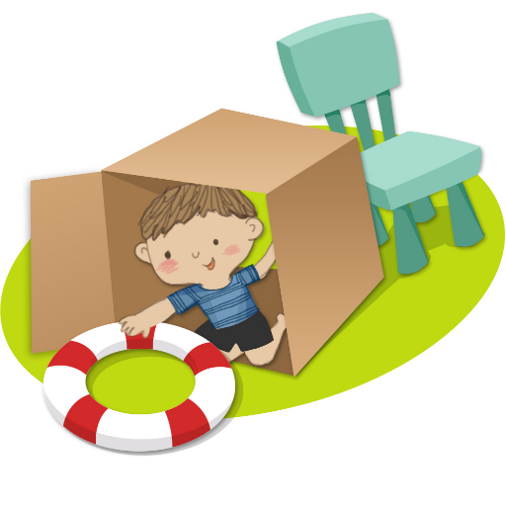
Activity 2. Make an Obstacle course
Choose 5 or 6 of the items below to make your obstacle course and then see who can do it the fastest!
Climb over something – bricks, wood, cushions, up and down a slope
Go through something – a play tunnel, a hula hoop, two poles 3 ft apart, criss-cross strings
Get wet in something – go through a paddling pool or someone spraying a garden hose!
Balance and navigate
– walk/run/wheel along a raised object (wooden plank etc)
– follow a windy piece of brightly coloured string or a path of lights
– follow a jangly sound such as wind chimes or a musical shaker
Go under something – a tree branch, string between two branches or posts, a pool noodle threaded between two chairs or held by someone

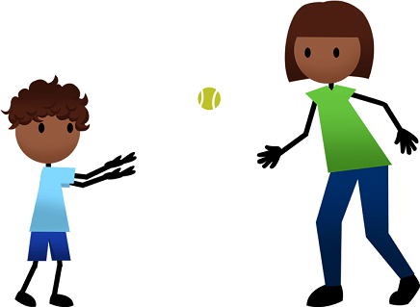
Activity 3. Catching and throwing
Throw things – soft balls, balls with bells, bean bags, small cushions, soft toys, scrunched up newspaper or foil, jangly bells into buckets, bowls, bins, muffin tins, plastic cups – the target can be as near or as far away as is needed. See how many you can get in!
Try to catch one of the objects above that is thrown to you – see how many you can catch.
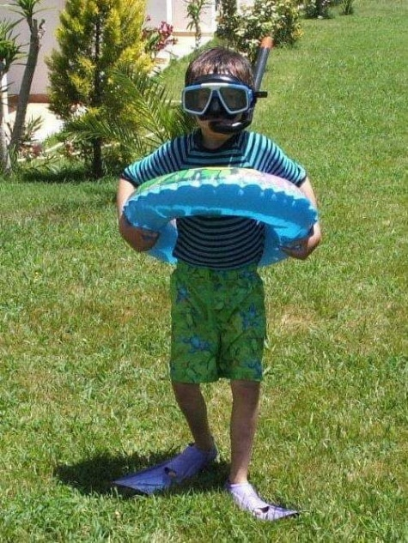
Activity 4. Dress up relay race.
Relay races are always a favourite and this one will be even more fun.
Lay out an assortment of clothes and accessories (depending on the weather this could be sun hat, sandals, sunglasses, beach wrap, armbands, rubber ring, snorkel etc or raincoat, umbrella, wellies, hat, scarf etc.)
Arrange them at various intervals in the area you have with one set for each child. The child has to run or wheel to the first item, bring it back to the start, put it on, run to the second item etc, until all of the items are back and being worn! Take photos of them all dressed up! If it’s a very hot day, you could add a bit of a soaking at various points! Fine to put on swimwear above other clothes!
Yes, this is my Thom in the photo.

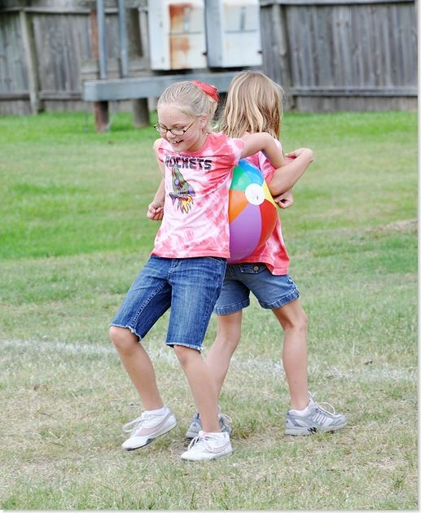
Activity 4. Balloon race. Great for teamwork.
Another old favourite. Blow up a balloon (or use a large ball if easier). Working in pairs, get the balloon to the end and back of the garden or down a 50 m track WITHOUT using your hands, arms or teeth! Squash it between your tummies, backs, chests, wheelchair, whatever you can find. If you drop it, you’ll have to go back to the beginning! Compete against another team if possible and do the best of three. PLEASE ONLY DO THIS ACTIVITY WITH SOMEONE FROM YOUR IMMEDIATE FAMILY/SOCIAL BUBBLE.

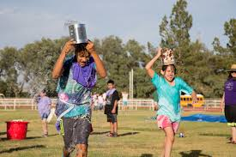
Activity 5. Bucket Challenge
This race is perfect for a hot summer day. Each child needs to hold a bucket of water on their head (or in their hands if easier) whilst completing a tricky or simple obstacle course (see above for ideas). The winner is NOT the person who completes the course the quickest but whoever has the most water left in their bucket at the end.

Activity 6. Egg and Spoon Race
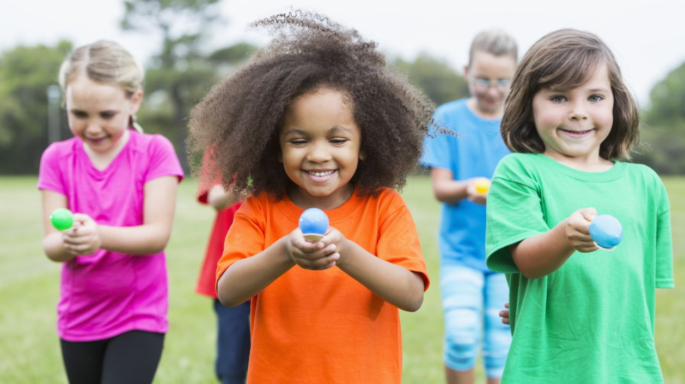
No sports day would be complete without an egg and spoon race really!
Hard boil the egg - if an egg is too precious to use at this time choose a small ball and a larger spoon.
a. How many lengths of the garden/park etc can you do in 2 minutes? If you drop it pick it up and carry on. If you succeed the whole 2 minutes without dropping it you also get a point.
b. Race against everyone else in your household to see who can get the egg from a to b the fastest without dropping it. If you drop it, you can pick it up but you have to count to ten without moving forward as a penalty!

