Fri 24th July start – Fri 31st July Zoom – Virtual Nature week
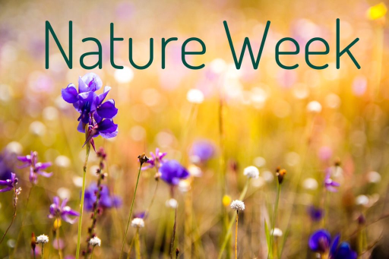
The one thing that most of us can still do is enjoy nature. This might be in a park or even in your garden. There is so much out there to see and do and you’ll be finding out some fun facts and helping animals and plants at the same time.
This week we would like your children to choose three (or more) of the following seven activities that should cover all ages and abilities. Take photos, write and draw, make recordings, keep a diary and catch up with us on Fri 31st July at 10.30am on Zoom. Zoom link to be sent out to anyone who requests it. If you can’t make the Zoom session, email photos or post on Moorvision’s Facebook https://www.facebook.com/groups/161483982931 or Twitter pages (@MoorvisionDevon)

1. Sensory Scavenger Hunt
1. Feel the wind on your face
2. Smell a flower
3. See or feel a pattern on a leaf or flower
4. Feel the bark on a tree or bush
5. Put your fingers in the earth
6. Feel 3 different size and shape stones or rocks
7. Listen to the birds chirping – can you hear the different sounds?
8. Feel 3 different kinds of leaves
9. Listen to water running (stream, river or even garden hose!)
10. Listen to an insect buzz – how does it make that noise?
11. Smell the grass
12. Feel the sun
13. Taste the rain (we’re bound to have some!)
14. Find something prickly
15. Find your favourite thing

Sensory Scavenger Hunt |  | Done
1. Feel the wind on your face
2. Smell a flower | 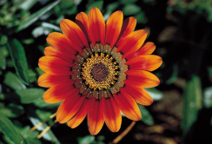
3. See or feel a pattern on a leaf or flower | 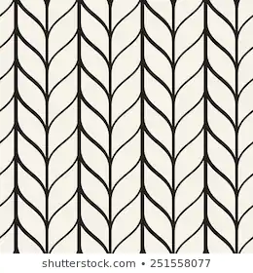
4. Feel the bark on a tree or bush | 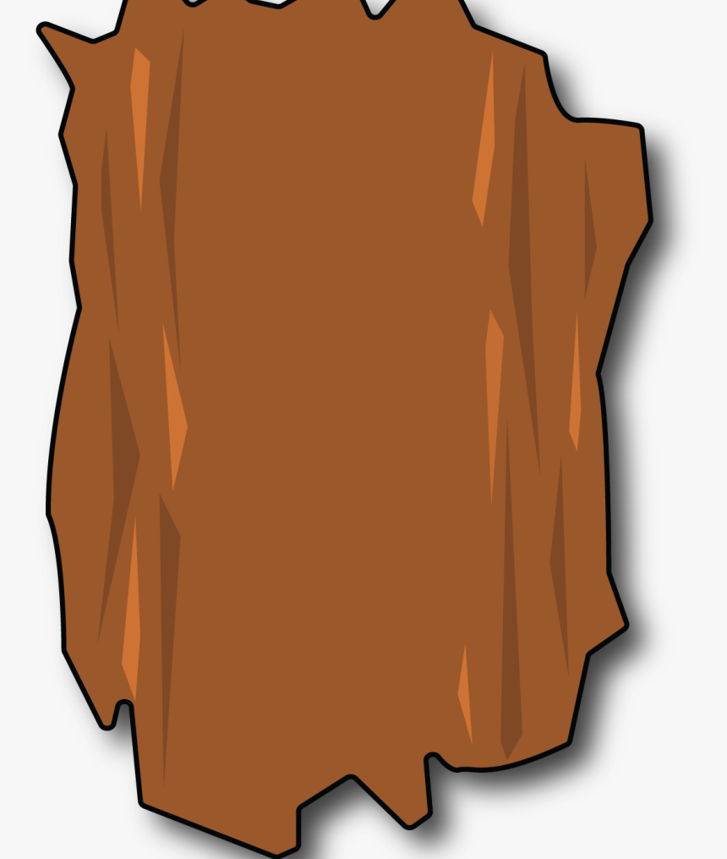
5. Put your fingers in the earth | 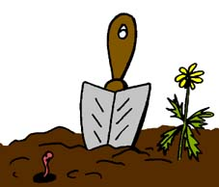
6. Feel 3 different size and shape stones or rocks | 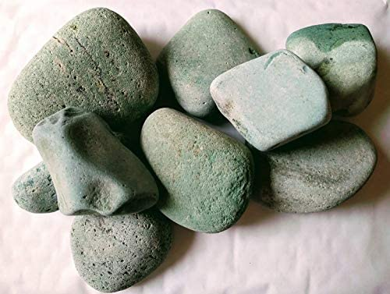
7. Listen to the birds chirping – can you hear the different sounds? | 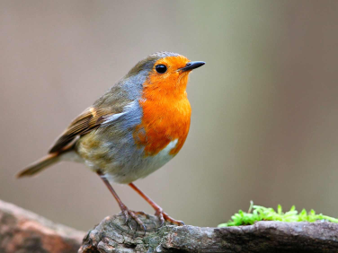
8. Feel 3 different kinds of leaves | 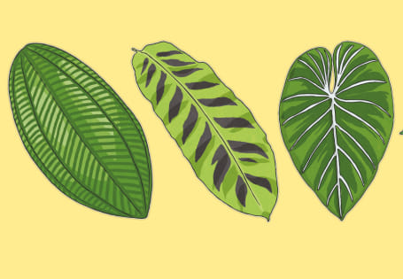
9. Listen to water running (stream, river or even garden hose!)
10. Listen to an insect buzz – how does it make that noise? | 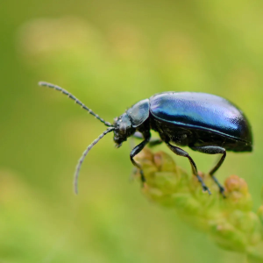
11. Smell the grass | 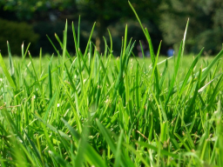
12. Feel the sun (hopefully!) | 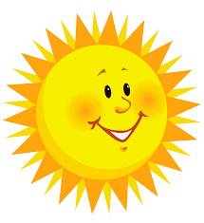
13. Taste the rain (we’re bound to have some!) | 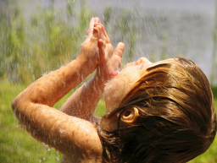
14. Find something prickly | 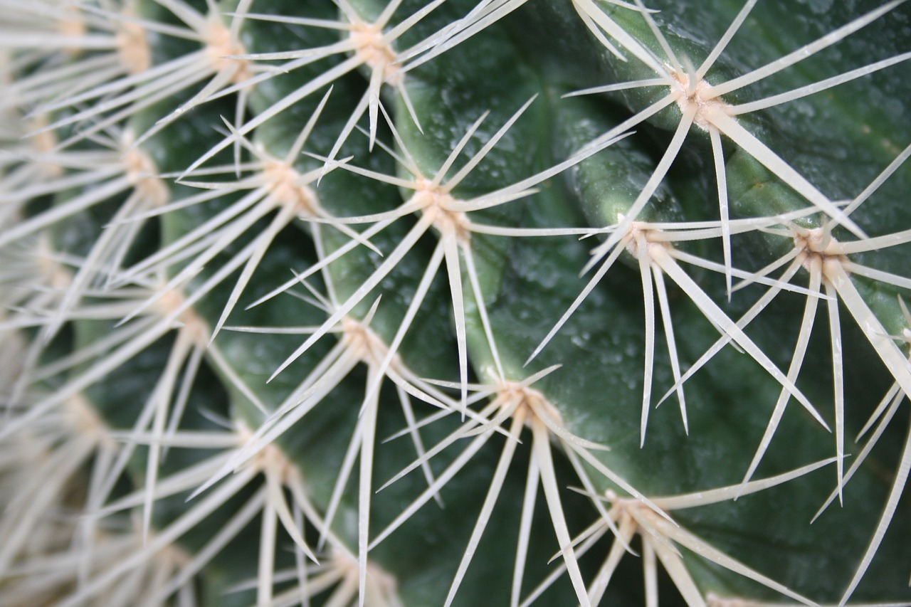
15. Find your favourite thing | ?

2. Make a Tree Bird Feeder
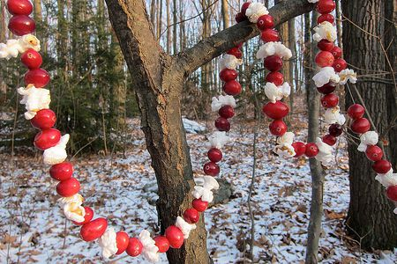
You will need:
Berries, seeds, raisins, apples
Popped popcorn
String
Fabric strips
Needle with large eye
Thread – strong cotton

Directions
Find a tree or bush in your garden or in the garden of someone you know well (ask permission).
String the popcorn, berries, seeds, raisins, and apple pieces onto a thread. This is done by threading a needle with a two-foot long thread, tying a knot at the bottom, then putting the needle through the foods one at a time.
The two-foot-long threads can be tied together once they have the food on them.
Go out to the tree and loop the food thread around the branches.
Many birds will be attracted to your feeder tree!

3. Move like minibeasts
This is a great way to get young children active and help them burn off some excess energy. You can do it outdoors or inside. Challenge your kids to:
- lie on the ground or sit in a chair and wriggle like a worm
- flap their arms like a butterfly flutters its wings
- put their hands on the floor or a table and scuttle about like a spider
- do some giant leaps like a cricket with your legs or hands
- curl up into a ball like a woodlouse.
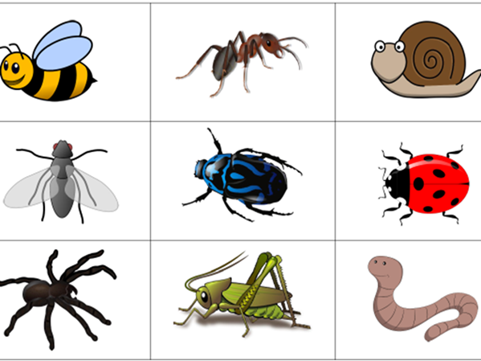

4. Make an animal or forest out of Lego
Many families will have Lego, wooden blocks or other building toys at home. So challenge your kids to make something inspired by nature. You could all work together to make one big scene, like a springtime woodland or a giant tree. Or you could have a contest to see who can build the best minibeast, mammal or bird.
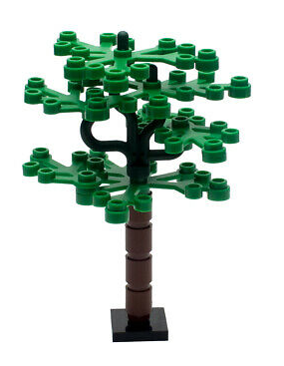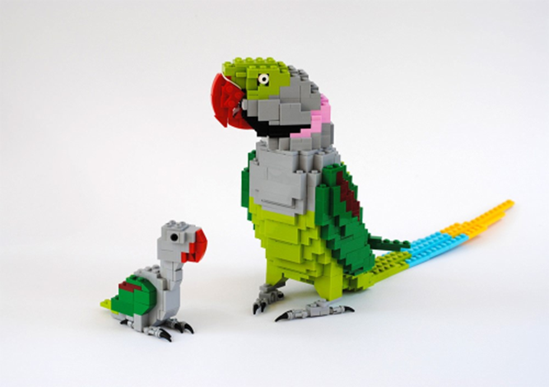
5. Write a story or poem inspired by nature
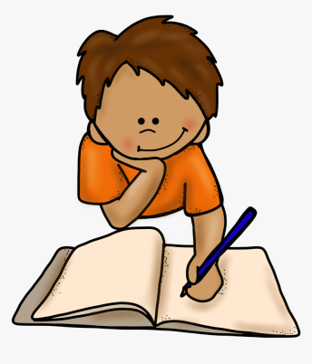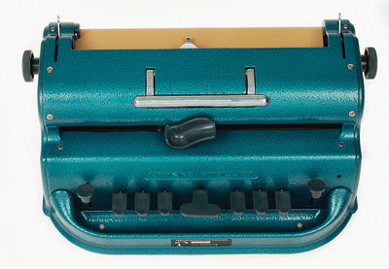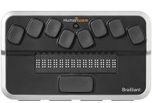

If your kids love writing, then get those creative juices flowing with a story or poetry challenge. Kick things off if needed by giving them the first sentence and encouraging them to write the rest.
You could also jot ideas on scraps of paper, then get kids to choose some at random that they have to incorporate into their story. These could include:
- A tree has fallen in the woods
- A character has gone missing
- An animal is shouting an alarm call
- There are some mysterious footprints to follow
- A dog is trying to lead you somewhere
- There is a strange noise coming from the forest
- A mystery delivery of roses has appeared
- The boat disappeared down the river
Gather together as a family and share the stories you've written. They'll make great bedtime stories too when you've read all the books you have at home.

6. Listen to the birds
We all know that our feathered friends are pretty but have you ever stopped to listen to their stunning songs?
Get up early (but not too early!) and see how many different birds you can hear? Keep a record over two or three days.
What sort of sounds are they making – high pitched, low and squawky, repeated chirruping?
Do you know which birds are making any of the sounds?
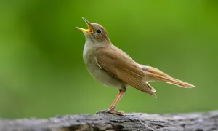

7. Make a map
Using pen, tactile materials or a computer, draw a map of a local park, your garden or your local area. Use as much detail as you can or keep it simple if you prefer.
Show areas of grass, flowers, trees, water, rocks, paving, play areas etc. You can use colour or different texture materials to show the different areas.
