Moorvision Virtual Summer Festival
Fri 21st Aug Start – Tues 1st September Zoom
What a better way to end the summer holidays (we hope!) than having your own festival in your own garden, balcony or even living room if it pours with rain! We have given you 10 days for this one so you can make the most of the bank holiday weekend or simply pick a day when the weather looks good. Just chose a day (or days if you are feeling adventurous) and get that summer festival feeling into your own home.
There will be a Zoom session on Tues 1st Sept at 11am to share your fun with others – or you can share via the Facebook page or email us some photos.
Certificates will be sent to all children who take part.

Stay safe
Do feel free to invite a small number of family and close friends but please ensure to follow ALL government guidelines on gatherings, social distancing and mask use, especially if any have recently changed. Please ensure that you have hand sanitiser readily available, avoid sharing food, use disposable paper plates and wooden cutlery and keep visitors outside wherever possible.
1. First you have to think of a name for your festival!
Try combining parts of your surnames or first names with your area, interests and music tastes. Or pick a name that describes your family the best. You don’t have to use real words!
A few ideas from me below:
- Mestival (garden in a mess!)
- Metalmania (Thom’s choice of music!)
- Huggy Festival (from our surname Hughes)
- Darbyville (from our Guide Dog, Darby)
I’m sure you can do better!!

2. Music
What festival would be complete without music!! We can’t promise you the headline stars but you can magic them into your garden by rigging up some speakers outdoors or on a windowsill and connect to your phone or whatever you usually play music from.
Here are some ideas for famous festival music but stick to what you know and love the best!

Oasis
Radiohead
U2
The Killers
Stereophonics
Red Hot Chilli Pipers
Imagine Dragons
Fatboy Slim
Stone Roses
Weezer
Elbow
Bastille
Florence + The Machine
Blink-182
Fall Out Boy
Greenday
Progidi
Paul Weller
Coldplay
Mumford and Sons

3. Decorations
No need to spend a fortune on decorations for your festival – here are some free and low-cost ideas that will keep your children busy in the days leading up to the festival.
- Dig out the Christmas lights from the attic (only use these outdoors if they are marked for outdoor use).
- Borrow solar lights and electric candles from anyone who can lend them to you. (Please do not use real candles with young children around).
- Make your own bunting – cut triangles out of strong coloured paper, card, cereal boxes, wallpaper samples, scrap material etc, or paint designs onto white paper triangles, punch holes using a hole punch and thread onto string or present ribbon.
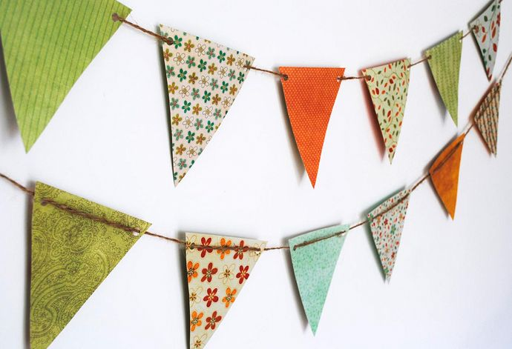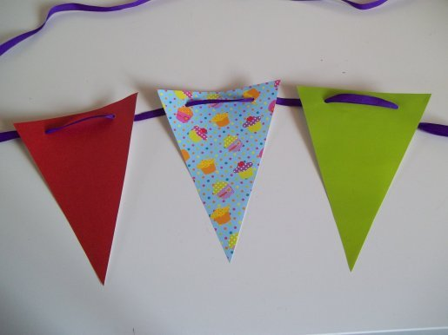
- Make your own flower bunting – same idea as above but cut different size flower shapes out of paper, card or felt, decorate as you choose and string up in a chain.
- Make your own paper chains – simply cut coloured paper, wallpaper samples etc into strips and glue the ends together to make the chains.
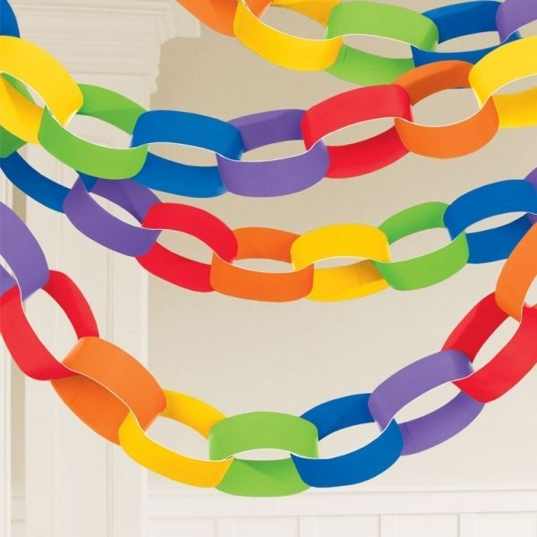

- Put up little tents, beach shelters etc, put colourful spreads and rugs on the ground for people to sit on
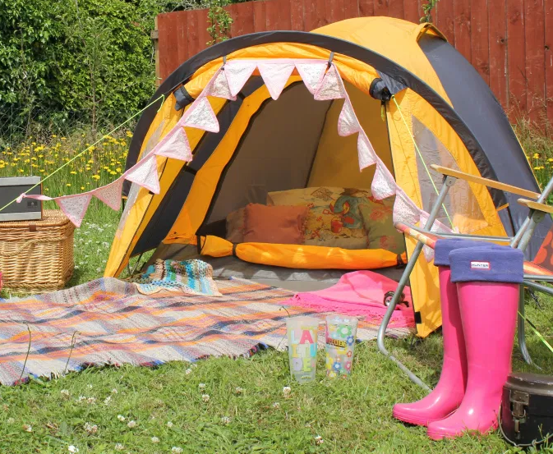
- Decorate with balloons, biodegradable confetti and streamers
4. Clothes
Now you can’t rock up to your festival dressed in the same leggings/tracksuit bottoms/t shirt that you have been living in since March can you! Let’s find your inner hippie, flower power, metal rocking self and dig out the flowery wellies because with our current climate you may well need them!!
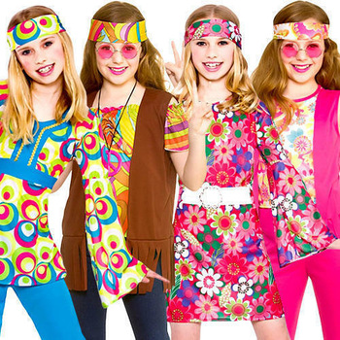 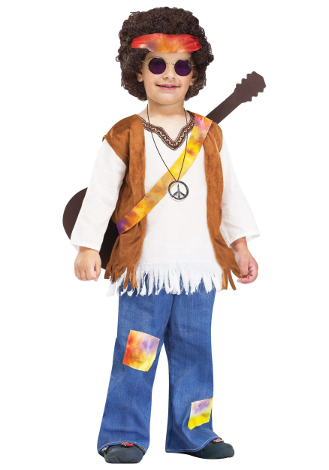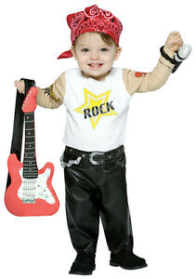
(and no, the last pitcure is not my Thom!)

5. Games
No festival would be complete without some silly games so here are some ideas.
Tin can alley
You will need 10 empty tins (please ensure these have been opened in a way where there are no sharp edges) and 3 balls or bean bags. For a more audio friendly version, use drinks cans, fill them with a small amount of pasta or rice and seal the top – they will rattle!). Cover the clean cans with paper and decorate as you chose (or just use them as they are). Stack the cans in a pyramid and see who can knock them all off with the balls or beanbags. Use audio cues or allow VI children to be as near as they need.
If you have other ‘bubbles’ visiting, you will need to spray and clean balls (don’t use bean bags) and cans between each group.)

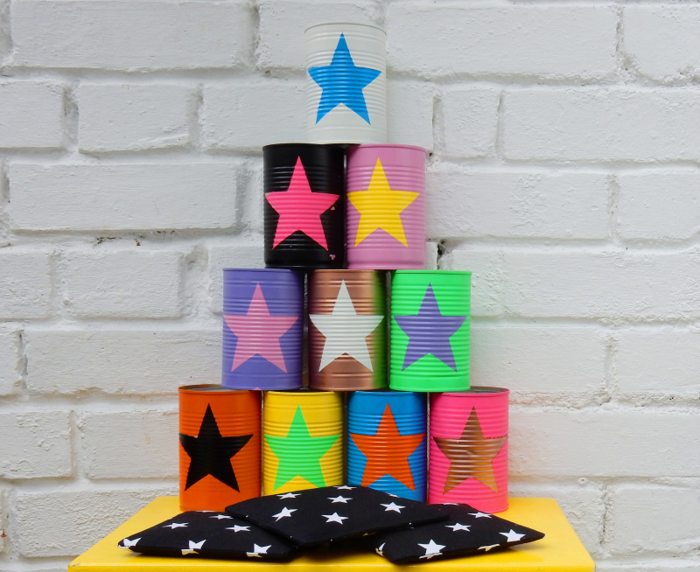

Lawn Twister
This is a great outdoor version of the classic game. Use spray paint to mark two or more areas of play and reserve each area for one family/bubble at a time – do not mix bubbles. Use a phone to generate random left/right, arm/leg and colour choices and off you go – which family will win!

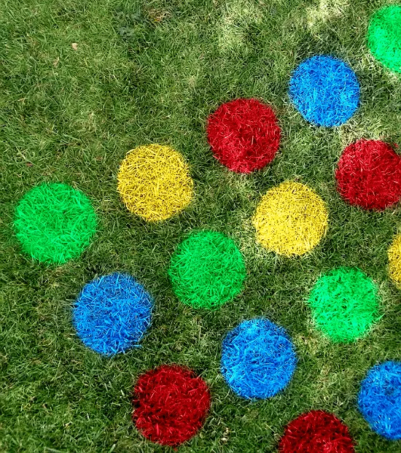

Ping pong water spray game
This is a great game for social distancing. Mount the ping pong balls on a straw with a flattened end and poked into a cardboard box and see who can shoot the most off the straws in a set time. VI children can get as close as they need to do this.
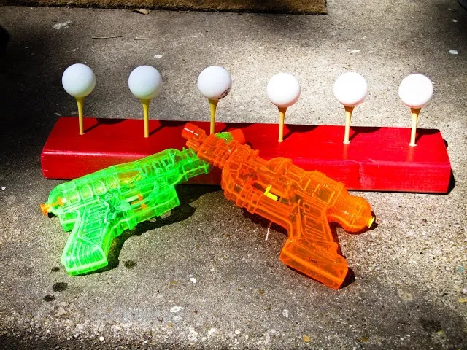

Cup Races
This is a simple and cheap way to have fun and so easy to set up. Simply thread a paper or plastic cup onto some string, tie the string across two objects (making sure no one is going to trip over it) and use a water gun to blast it across the string as quick as you can. Water gun can be cleaned between use and cups can be replaced.
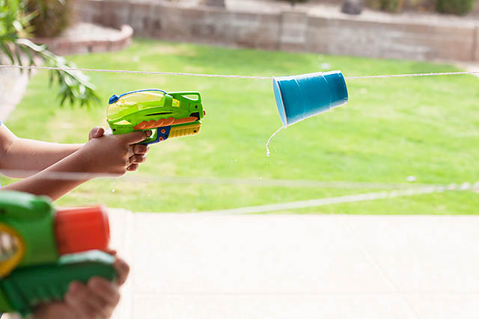

6. Food
Pick and choose from the festival food ideas below and adapt to your own dietary needs. Press Ctrl and click on the title of each item (below the picture) and this will take you to the recipe. Thanks to BBC Good Food.

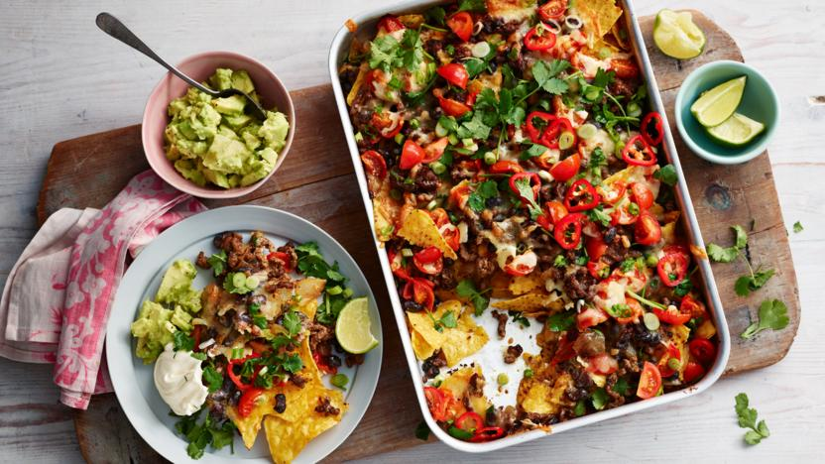

Nachos

by Ell
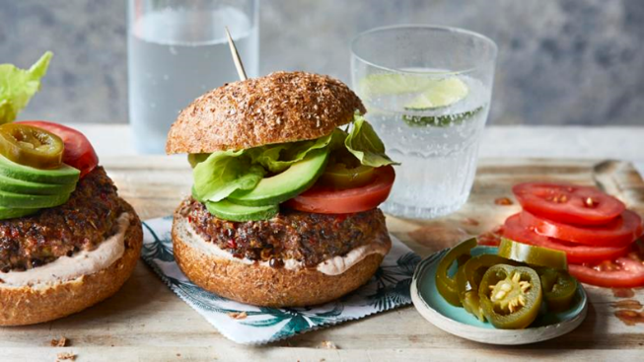

Spicy Mexican-style bean burger

b
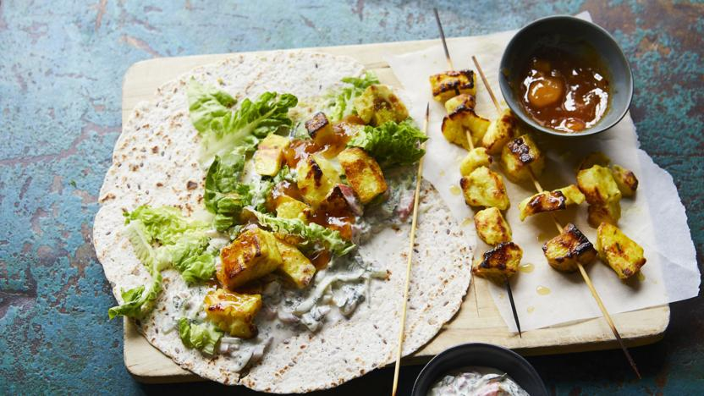

Halloumi wraps

by
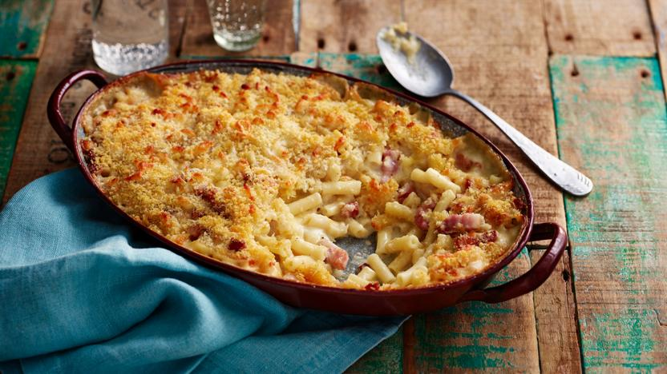Mac & cheese
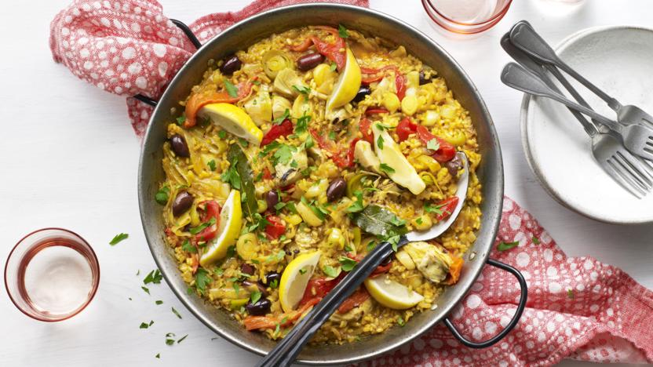

Vegetable paella

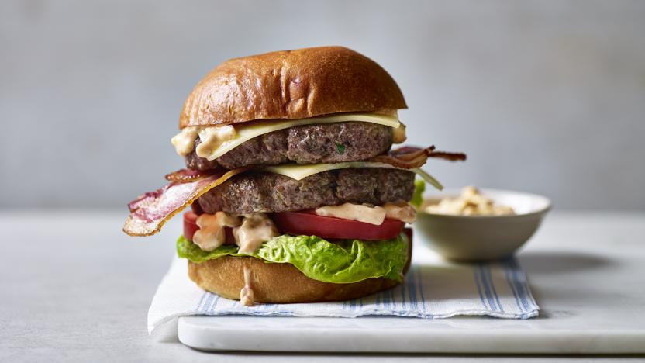

Homemade burger

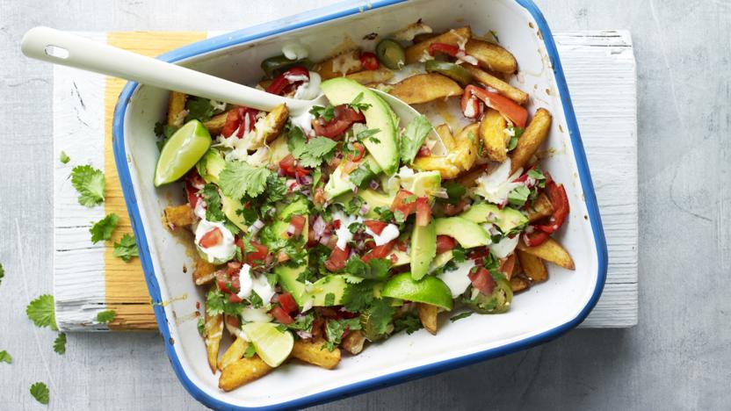

Loaded veggie fries

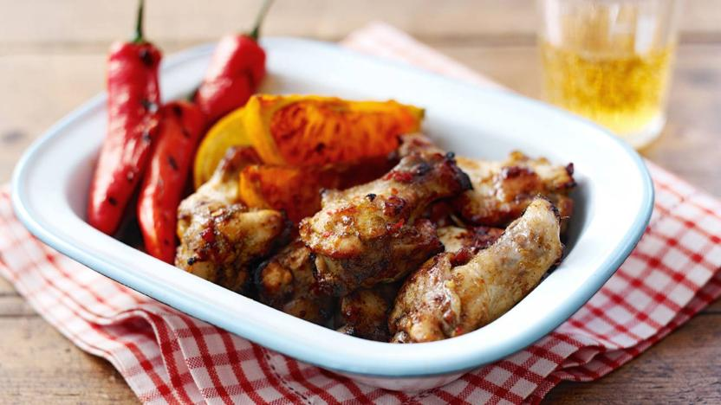

Sticky jerk chicken wings
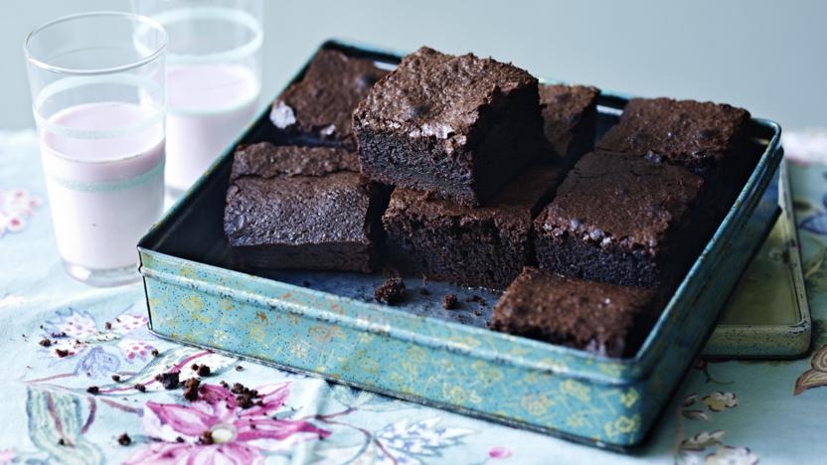

Chocolate brownies

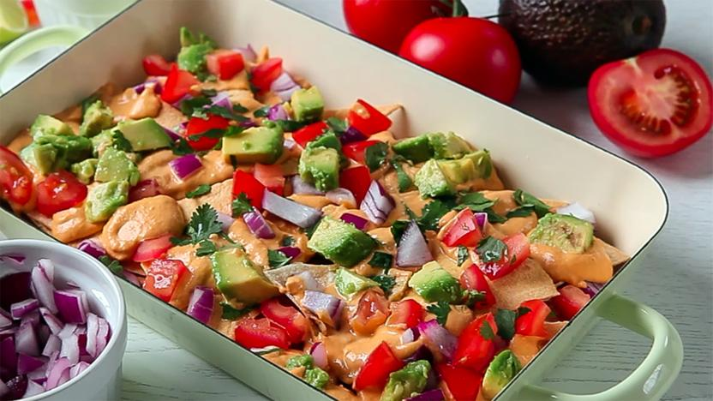

Vegan nachos

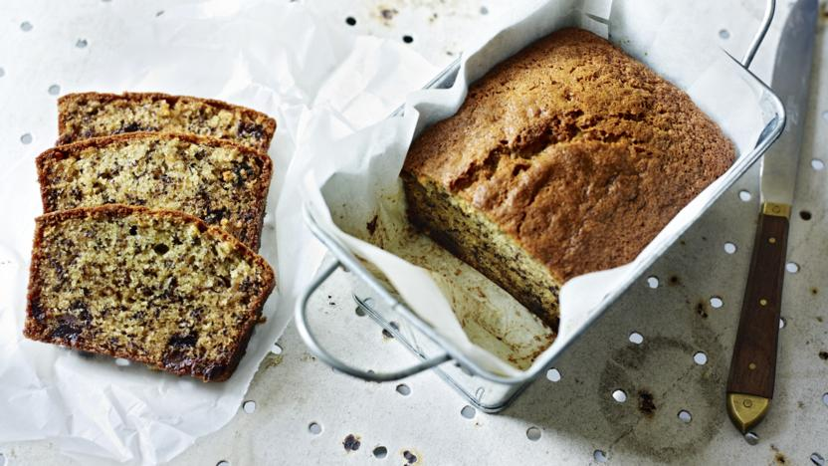

Chocolate chip banana bread

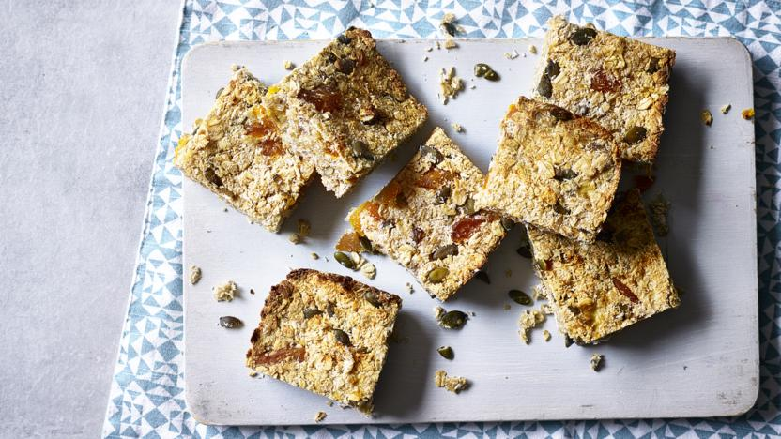

Vegan flapjacks

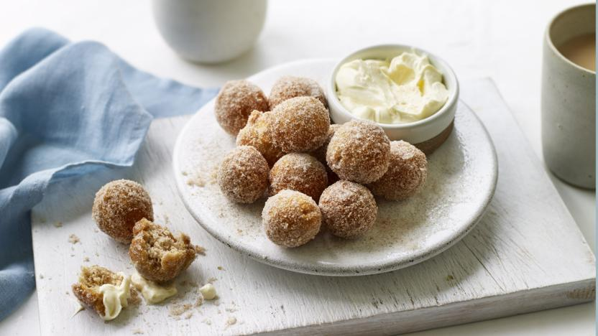

Cinnamon doughnuts with lemon cream

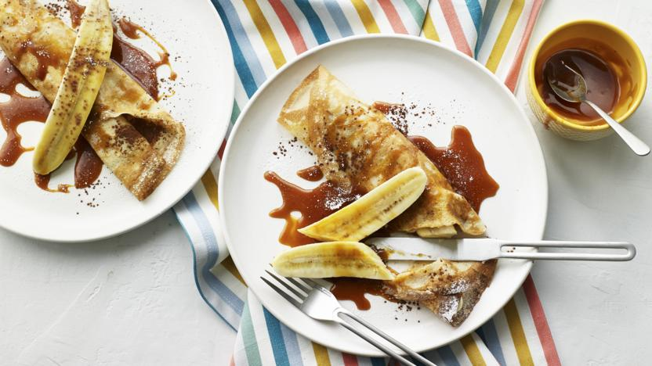

Caramelised banana pancakes
by Mike Reid

7. Drinks
Great selection of children and driver friendly mocktails here – not driving, over 18? Throw in some Pimms or alcohol of your choice (please keep all alcoholic drinks well out of the reach of children.) Again, press Ctrl and click on the link to find the full recipe. Thanks to BBC Good Food.

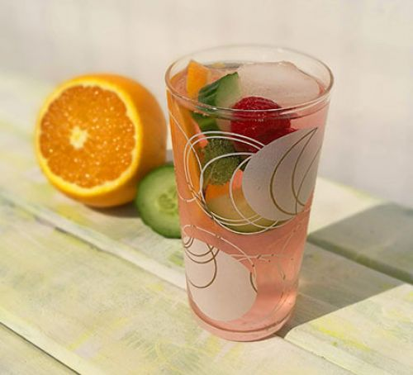

Summer cup mocktail
GGet into the summer vibe with this fruity mocktail featuring red berries, lemonade, mint, and cucumber. Cool and refreshing
0
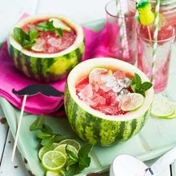

Watermelon lemonade

This watermelon lemonade looks amazing but is super-simple to make. It's perfect for a kids party or makes a refreshing summer drink for kids or adults...

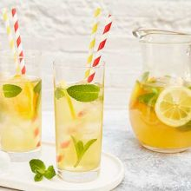

Easy iced tea
3
Make up a jug of refreshing iced tea to serve on summer days.
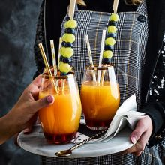

Fruity mocktail
5
Make this fruit-flavoured mocktail with grenadine and orange juice to serve as a non-alcoholic drink option at a family party.
5
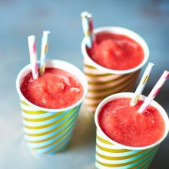

Watermelon & strawberry slushie
5What's more refreshing than eating a slice of cool watermelon on a hot summer's day? Drinking our iced fruit slushie!

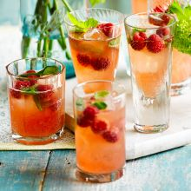

Raw raspberry shrub
A cordial-like drink made from fruit, vinegar and sugar with sweet and sharp notes - an elegant mocktail to share with friends
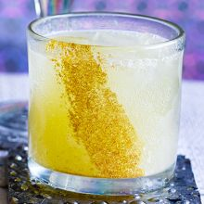

Pineapple & lime mocktail

Mix a sparkling mocktail that will bring sunshine to any party – and to make it slightly sweeter, use soda water instead of tonic water.

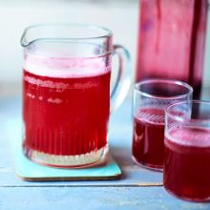

Blackcurrant cordial
4
This easy recipe is a great way to use up a pick-your-own glut of blackcurrants and makes a refreshing summer drink

Apple, elderflower & mint sparkle
4
A fruity and grown-up non-alcoholic punch perfect for the drivers at the picnic or party
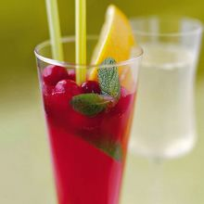

Punch
A refreshing and healthy punch that’s alcohol-free – perfect for the designated drivers...

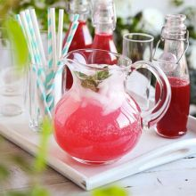

Raspberry cordial
4
Preserve the flavours of a batch of raspberries in this refreshing concentrated drink - delicious with soda on ice
5
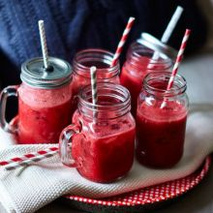

Raspberry lemonade slushies
4
An easy frozen drink to satisfy your cravings for something cool. Toss the ingredients in a blender and enjoy!

7. Craft area
For a bit of ‘down’ time you can’t beat a simple craft area with low tables and a few chairs. You could include
- a chalkboard (or allocated area of paving) and chalks
- messy paint area
- tactile stickers and wikki stiks with card area
- safe scissors, glue, Sellotape and some saved up packaging materials for junk modelling area
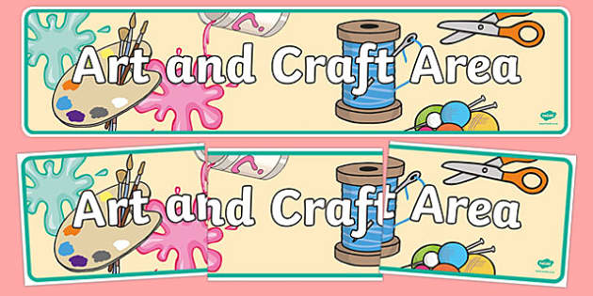

So – get prepared, get ready and have a great festival this year!!

