Moorvision Virtual Summer Creative Week
Fri 14th Aug Start – Fri 21st August Zoom

Time to get creative and make some summer artwork from our list of ideas!
This week we would like your children to choose three (or more) of the following six activities that should cover all ages and abilities. Take photos, make recordings, keep a diary of what they are doing and catch up with us on Fri 14th August at 10.30am on Zoom. Zoom link to be sent out to anyone who requests it. If you can’t make the Zoom session, email photos or post on Moorvision’s Facebook or Twitter pages (@MoorvisionDevon). Certificates will be sent to all children who take part.

1. Make a Cereal Box Aquarium
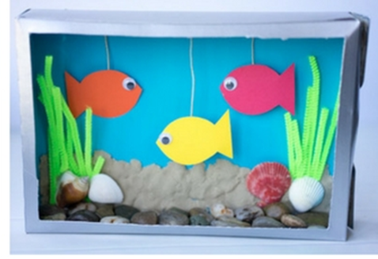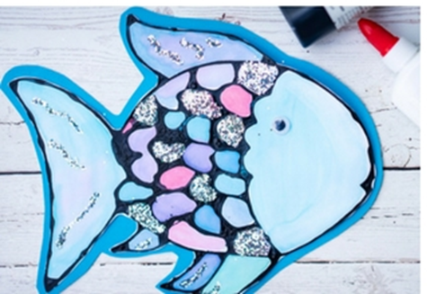

You will need:
- An old cereal box
- Paper or card
- String or cotton
- Scissors
- Pens, paint, glitter, tactile art and craft supplies, glue.
- Coloured paper
- Foil
- Stones, shells and/or sand
This is a simple and fun activity that can fill up quite some time and produce a great result.
1. Use the templates below or your own to cut out and colour in, fill with glitter, add shiny foil, add tactile craft material to make the fish.
2. Cut one of the larger sides off the cereal box and either cover it with coloured paper or paint it.
3. Punch a small hole and hang each fish from a piece of string or cotton from the top of the cereal box.
4. Fill the bottom of the cereal box with stones, shells or sand.
5. Hang strips of paper coloured green from the top for seaweed or use green pipe cleaners or straws if you have them.
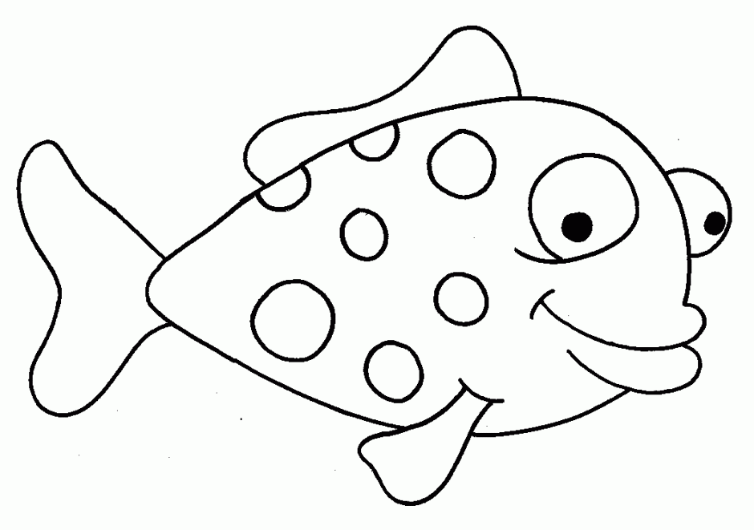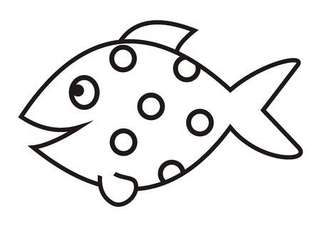
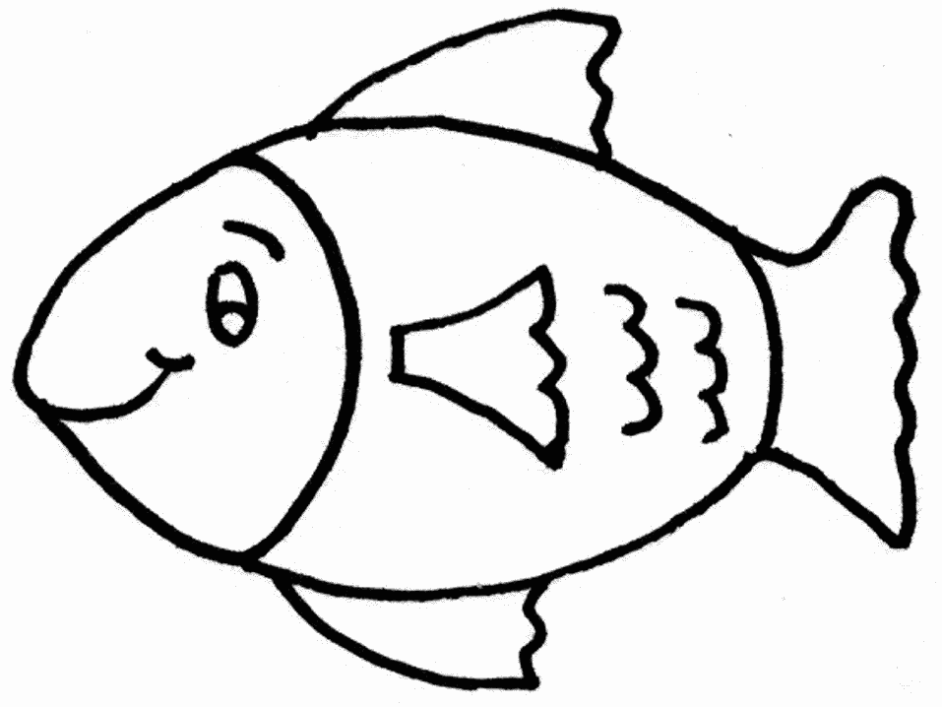
Activity 2. Sun Suncatcher and Beach Ball
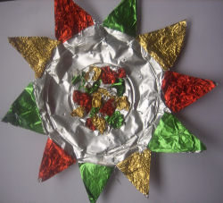
Even if you can’t get to the beach, celebrate the summer with these great ideas!
Suncatcher
You will need:
- Foil pie plate or paper plate covered in foil
- Sweet wrappers, coloured foil, any other craft material
- Glue
- Thread

1. Cut triangles around the sides of the plate making a set of points. Fold out the points to make your sun shape.
2. Glue sweet wrappers, coloured foil or craft material to each point of the sun. Don't worry about cutting them to shape: just trim when they have dried.
3. Decorate the centre of the sun by gluing on some scrunched up sweet wrappers or craft material.
4. Punch a small hole and thread a loop of thread through the top of the sun to hang.
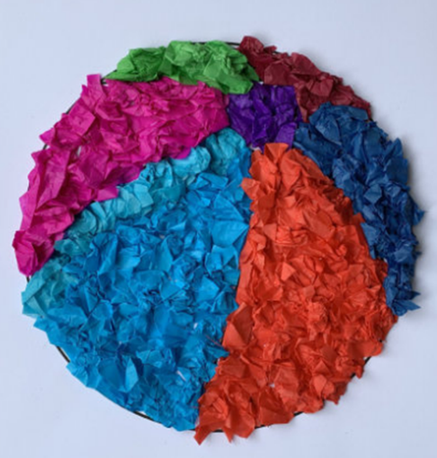
Beach ball
You will need:
- Beach ball picture (template below)
- Coloured tissue paper or other craft material
- PVA glue

1. Cut your tissue paper up into small squares and stack them by colour.
2. Scrunch up enough tissue paper to cover one segment of the beach ball. You can place them on the beach ball to measure when you have enough.
3. Paint that section of the beach ball thickly with white glue.
4. Press the tissue paper into position.
5. Move onto the next colour and segment.
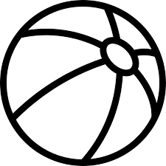

Activity 3. Balloon Bowls and String Bowls
These are lovely hands on activities with a great result at the end.
Balloon bowls
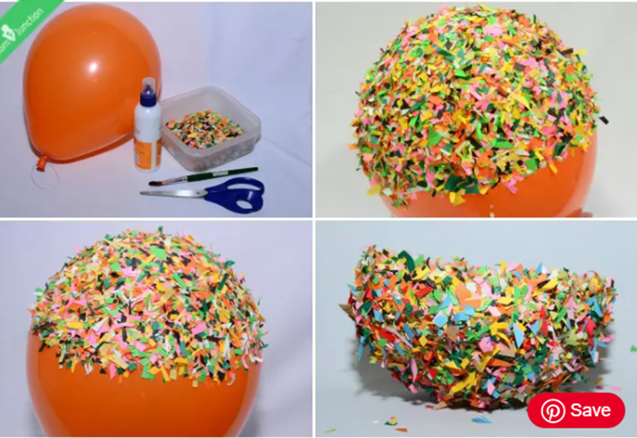
You will need:
- A large balloon
- Paper confetti or finely cut up paper
- PVA Glue
- Paintbrush
- A round container, like a pie or a cake tin

1. Blow up the balloon and tie it up. Put it in a bowl to keep it still.
2. Apply glue to the bottom of the balloon and spread it generously using a paintbrush.
3. Sprinkle confetti or shredded paper all over the glued portion of the balloon. You can take it out of the bowl and add confetti to the sides.
4. Put it back in the bowl and let it dry.
5. Add some more glue on top of the confetti/paper and add more confetti/paper. Repeat the steps three or four times more.
6. Make sure that there are no gaps between the confetti/paper or you’ll end up with a bowl with holes!
7. Once it is dry, pop the balloon and cut the edges to make it even.

String Bowl
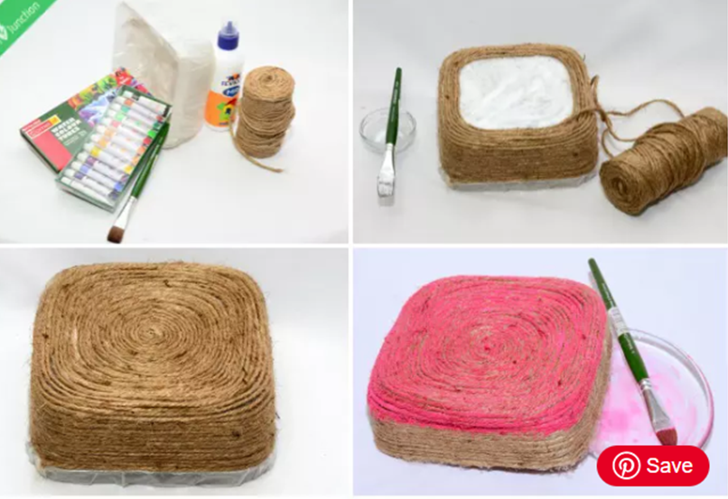
You will need:
- String
- PVA glue
- Clingfilm
- Scissors
- Bowl (as mould)
- Paintbrush

1. Take a bowl and wrap it up with the clingfilm tightly.
2. Use the paintbrush to coat the outer layer of the clingfilm with glue. Cover it completely.
3. Take one end of the string roll and wrap it around the open end of the bowl. Continue wrapping the string, creating a single layer below another.
4. Carefully wrap until the entire dish is covered. You can paint the base in any colour you want.
5. Let it dry and remove the bowl used as the mould.
Activity 4. Rainbow day
With the rainbow symbolising peace and hope appearing everywhere recently have a go at some of these rainbow themed activities.

Bead Rainbow
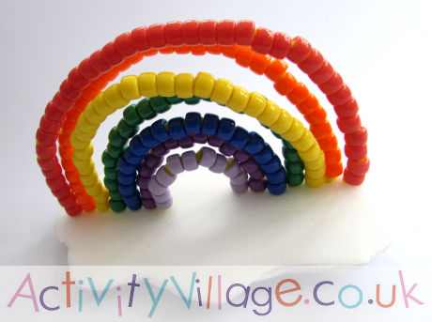
You will need:
- White foam board (such as a pizza tray)
- Pipe cleaners
- Ponytail beads in the colours of the rainbow

1. Cut a cloud shape from the foam.
2. Push one of the pipe cleaners through the foam near to the middle and twist the end so it stays in place.
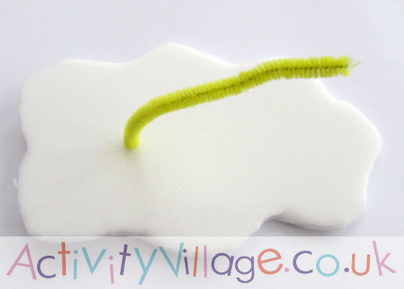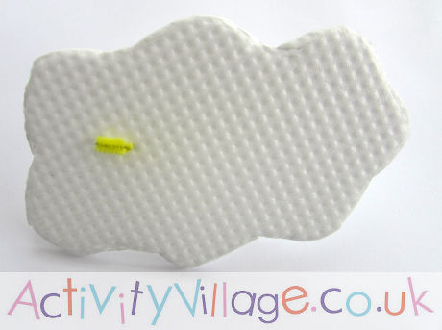
3. Thread violet beads onto the pipe cleaner. Now bend the pipe cleaner to make a small arch and poke the end of the pipe cleaner back through the foam. Cut off the excess pipe cleaner and twist the end to hold in place.

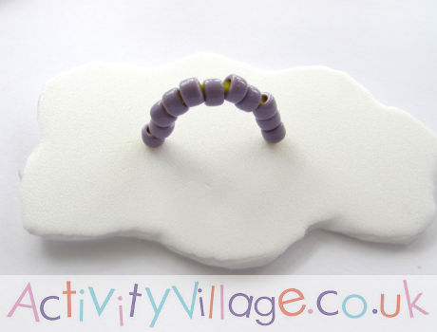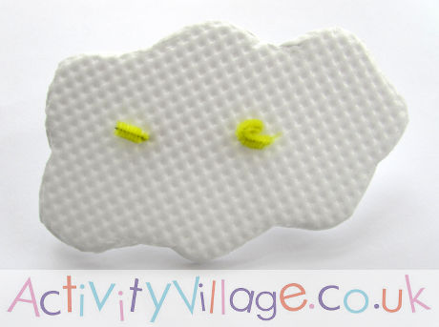
4. Poke a second pipe cleaner into the foam just outside the first arch. Thread it with purple beads. Bend the pipe cleaner to make an arch slightly bigger than your first arch and poke the end of the pipe cleaner back through the foam. Cut off the excess pipe cleaner and twist the end to hold in place.
5. Repeat with the next five colours, making the arches bigger each time.
6. Tape the ends of the pipe cleaners to the foam so they sit flat and hold securely.

Rainbow wool collage
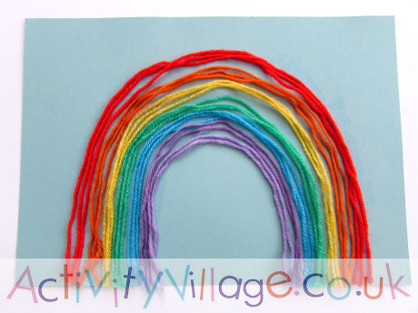
You will need:
- Card (pale blue or white)
- PVA Glue
- Wool (yarn) in the colours of the rainbow and/or different textured yarn or string depending on your child’s level of sight.

1. Use the rainbow template below to make your rainbow shape or simply paint or draw a rainbow shape onto the card.
2. Stick on strands of wool to make your rainbow.
3. Trim any loose ends of wool.

Paper Plate Rainbow

This is super easy to make with everyday things (you can substitute buttons for stickers, puffy stickers, painted or food dyed pasta bows etc if you need. It has a lovely tactile feel.

You will need
- Paper plate
- Card or thick paper
- Scissors
- Cotton wool balls
- Glue that works on plastic and PVA
- Buttons or other rainbow colour decorations

1. Cut the paper plate in half and the card into strips
2. Glue the paper strips to the half circle with PVA glue and allow to dry
3. Glue the cotton wall balls onto the half circle with PVA glue to make a cloud effect
4. Glue the coloured buttons, stickers or whatever you are using onto the strips to make a rainbow.

Activity 5. Nail Signs
Older children might be keen to create designs using this unique idea that works well as it is tactile as well as visual.
You will need:
- Wood – make sure the edges are sanded so as not to cause splinters
- Nails (regular or roofing nails)
- Hammer
- Paint & Paint brush – enamel paint or nail varnish

1. Draw or stencil your design lightly onto the wood with a pencil. Any design can be used, pictures and or letters/numbers

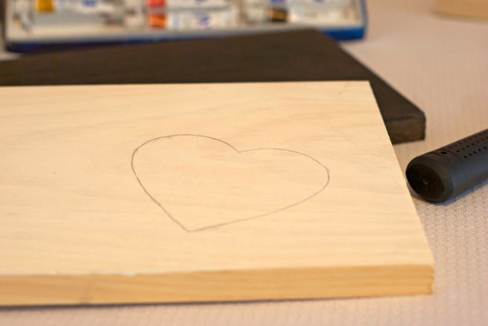
PHOTO SOURCE • MICHELLE CANGEMI, WEDLOFTPIN IT

2. Nails. You can do a single line of nails or double it up for a bold effect. When you’re finished nailing, go back in and erase your pencil lines if they are noticeable. Please supervise all use of hammer and nails at all times.

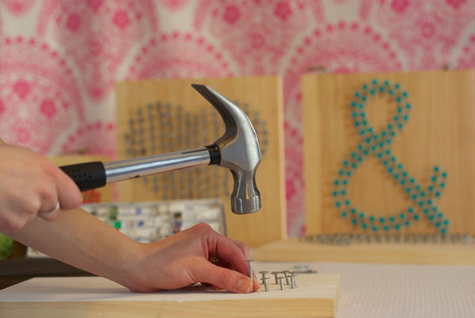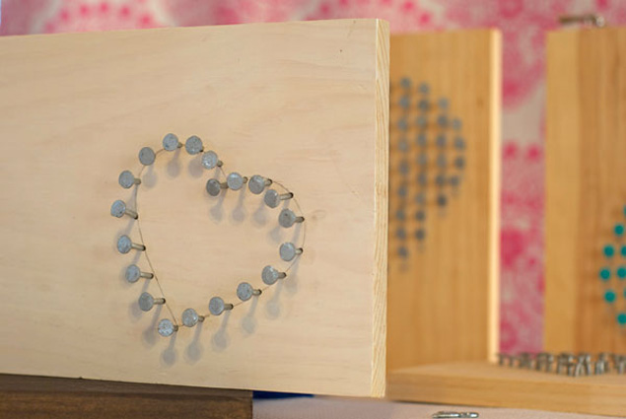
PHOTO SOURCE • MICHELLE CANGEMI, WEDLOFTPIN IT

3: Paint. Using the colour of your choice, paint the tops of the nails… and you’re done!

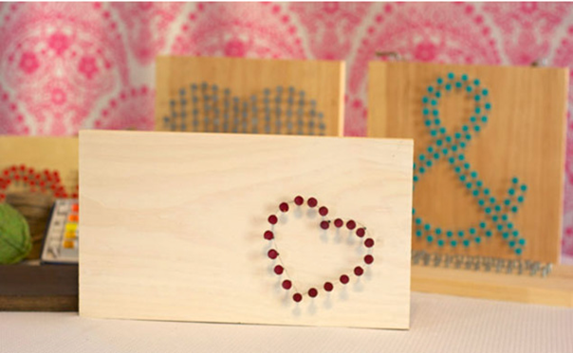
PHOTO SOURCE • MICHELLE CANGEMI, WEDLOFTPIN IT
Activity 6. CD Weaving
Finally a more complex activity for those who want to really spend some time on a project. I absolutely love these and might make one myself!

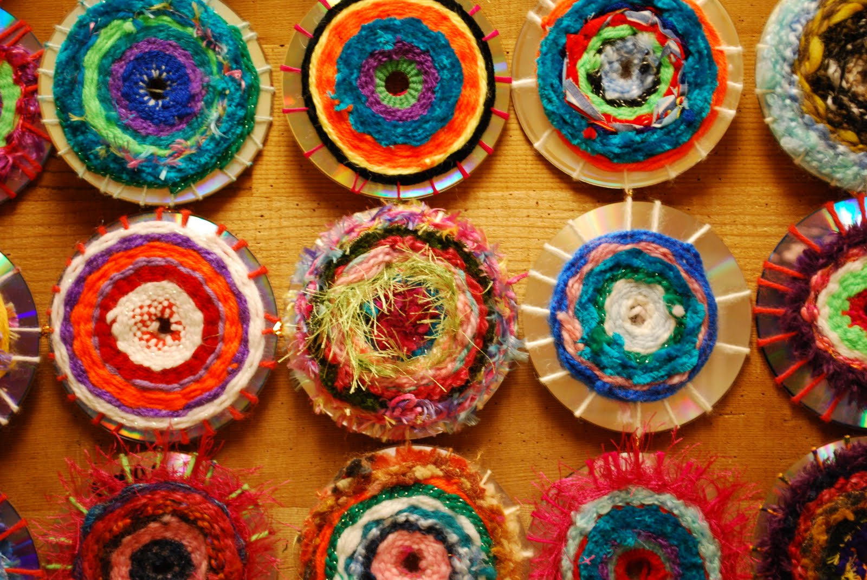

You will need:
- Old CDs – try a second hand shop if you don’t have any
- String
- Old scraps of yarn
- A wide eyed and blunt needle (you can make one from cutting out a needle shape from a plastic bottle and punching a hole in the non ‘sharp’ end to make an eye.
1. Use string or very strong yarn and thread it through the hole in the CD, to the edge and back to the middle until you have about 18-20 ‘spokes’ around the CD. Tie the string up at the back.
2. Using different colour shortish lengths of yarn and starting from the middle, thread the yarn over and under the spokes to make the circles. Tuck the end of each thread and the beginning of the new thread under the weaving you have just done.
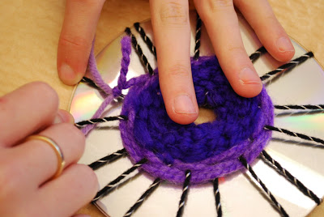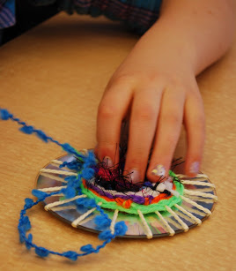
3. Try using different textures of yarn and wool for interesting tactile effects.

