Moorvision Virtual Summer Rainbow Cooking Week
Fri 7th Aug Start – Fri 14th August Zoom

Time to get creative in the kitchen and dish up some delicious treats!
In keeping with our rainbow theme, you will find some rainbow coloured food to make and enjoy this week. None of the recipes contain nuts, other information is given for each one.
This week we would like your children to choose three (or more) of the following six activities that should cover all ages and abilities. Take photos, make recordings, keep a diary of what they are doing and catch up with us on Fri 14th August at 10.30am on Zoom. Zoom link to be sent out to anyone who requests it. If you can’t make the Zoom session, email photos or post on Moorvision’s Facebook or Twitter pages (@MoorvisionDevon). Certificates will be sent to all children who take part.

Activity 1. Rainbow pizza
This is a super fun and healthy pizza with both visual and textural ingredients that should tempt even the fussiest eaters. Please be the judge of your own child’s ability to safely cut up vegetables and handle hot items. If you need any advice on this, please get in touch.
Vegetarian, contains gluten and dairy.
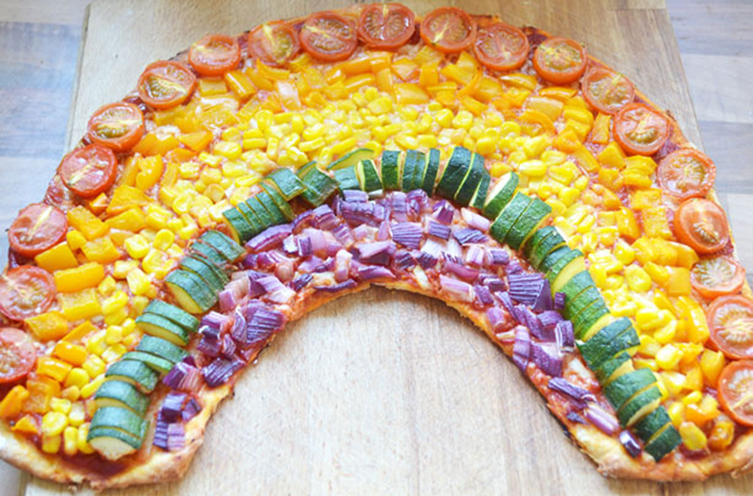
You will need:
- Ready-made pizza base x 2 or you can make your own pizza base.
- 3 heaped tbsp tomato puree
- 1tsp oregano
- A good drizzle of olive oil
- Salt and pepper
- 40g cheddar grated
- 100g Mozzarella, torn or grated
- A handful of cherry tomatoes, sliced in half
- ½ orange pepper, diced
- 198g tin of sweetcorn (you could use frozen sweetcorn if preferred)
- ½ courgette, diced (you can use cooked peas if preferred)
- 1 small red onion, diced

1. Preheat your oven to 200°C / Gas Mark 6
2. Cut or roll out your dough into rainbow shapes, one for each person eating. They can be any size. Use any left-over dough to make sun or moon shapes.
3. Grease two large baking trays and then carefully transfer the rainbow shaped dough to the trays.
4. Make the pizza topping – mix the tomato puree with salt, pepper and oregano and spread this over the bass. Sprinkle the grated cheddar and mozzarella on the top.
5. Add the vegetables in rows over the pizza base in the colours of a rainbow (fine to leave out any that they really won’t eat!)
6. Place pizza in preheated oven and cook for 20-25 minutes, keeping an eye on the toppings so they don’t burn.
7. Once the pizza is cooked through, carefully transfer to a wire rack to cool slightly.
8. Cut the colourful pizza into slices and enjoy your work of art.

Activity 2. Rainbow salad
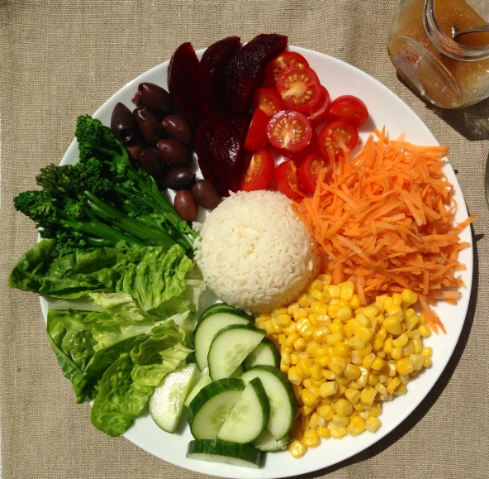
This is a great way to encourage children to eat fresh salad and vegetables and has interest in both colour and texture so should make a fun activity.
Vegan, gluten free unless pasta or cous cous is used, dairy free.
Ideas for salad:
- White centre – rice, couscous, boiled new potatoes, pasta
- Red – tomatoes, red pepper
- Orange – orange pepper, carrots, roasted squash
- Yellow – sweetcorn, yellow pepper
- Green – lettuce leaves, avocado, cucumber, green beans
- Blue – this one is a bit tricky! – purple sprouting broccoli, blueberries
- Indigo – red cabbage, olives
- Violet – beet root, dark red salad leaves
Simply arrange the different colour and texture ingredients to make a fun and healthy salad!

Activity 3. Rainbow jacket potatoes
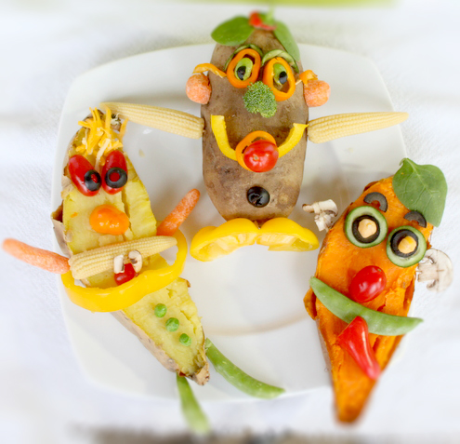
Another child friendly and healthy way to bring colour and texture to your child’s diet.
Vegan, gluten free, dairy free unless you use butter on the potatoes.
You will need:
- Baking potatoes – one per person – you can use ordinary or sweet potatoes
- A variety of different colour vegetables that can include:
- Red – tomatoes, red pepper
- Orange – orange pepper, carrots, roasted squash
- Yellow – sweetcorn, yellow pepper, pineapple
- Green –peas, green beans, broccoli, cabbage, asparagus
- Blue –purple sprouting broccoli
- Indigo and violet – red cabbage, olives
- Toothpicks if these are safe for your individual child
Wrap the potatoes individually with foil (for softer skin) or leave them unwrapped for slightly crisper skin.
Place the potatoes on a baking sheet and bake them at 200 deg C / gas mark 6 for approximately 1 hour or until they are fork tender. (You can also cook your potatoes in your microwave).
Remove them from the oven and let them cool slightly.
Once cool enough to handle but ideally still warm for eating, decorate the potatoes using the veggies (and toothpicks when necessary if these are safe for your child).
You can cut the potatoes in half and decorate either side of the potato or you can decorate whole potatoes and even use the top slice of a pepper with the stem (or another alternative) as the feet stand.

Activity 4. Rainbow fruit skewers
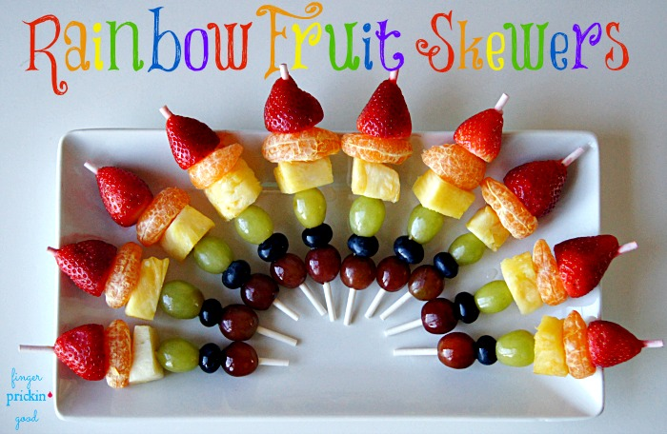

Vegan, gluten free, dairy free.
You will need:
- Strawberries
- Clementines/Satsumas/Oranges
- Pineapple
- Grapes (red & green)
- Blueberries
Using wooden barbecue skewers slide fruit onto stick in the following order; strawberry, clementine etc, pineapple, green grape, blueberry, red grape.
Make as many as desired and arrange on a plate to form a rainbow.
Activity 5. Rainbow double chocolate cookies!
These delicious biscuits are fun to make and the paler coloured smarties stand out well both visually and in a tactile way from the darker biscuit.
Vegetarian.
You will need:
- 50 g unsalted butter
- 300 g dark chocolate – Bourneville, Green and Blacks or supermarket brand dark chocolate
- 2 eggs
- 170 g soft light brown sugar
- ½ tsp vanilla extract
- 150 g plain flour
- ½ tsp salt
- ½ tsp baking powder
- 2 packs Smarties
1. Preheat your oven to 170 degree C / gas mark 3-4 and line 2 baking trays with baking paper
2. Melt the butter and chocolate. Break 200g of the chocolate into small pieces. Pop it into a heatproof bowl over a saucepan of simmering water. Make sure you don’t let the bottom of the bowl touch the water. Weigh out the butter and cut it into small pieces. Add it to your bowl. Allow it to melt slowly, stirring it occasionally.
3. Mix the eggs and sugar. Weigh the sugar into a small bowl. If you have a freestanding mixer, add your sugar or just put it in a large mixing bowl.
4. Break the eggs into a small bowl to check for shell, then add it to your sugar. Add the vanilla extract.
5. Using an electric mixer, a hand-held whisk or wooden spoons, mix everything together.
6. Add the melted chocolate and butter mixer. Continue mixing everything on a slow speed until it is thoroughly combined.
7. Add the dry ingredients. Measure the flour into your small bowl. Add baking powder and salt. Add to your chocolate mix a little at a time, mixing after each addition.
8. Roughly chop the remaining chocolate into small pieces and add to your mixture. Give it a final stir until it is evenly distributed.
9. Make the cookies. Dollop 6 equal(ish) amounts of cookie mixture onto your baking trays. Make sure the cookies are spaced apart as they’ll spread a little in the oven. Add some Smarties to the top of each cookie.
10. Bake the cookies. Pop your baking trays in the oven for 10-15 minutes. Keep an eye on them after they’ve been in for 10 minutes. They’re ready when the tops start to crack and they look glossy.
11. Remove from the oven and leave to cool on the trays for a few minutes before putting them on a wire rack to cool completely.
12. Enjoy!

Activity 6. Rainbow Meringues.
These are super easy to make and have a great texture and taste.
You will need:
- 3 large egg whites
- 175g white caster sugar
- ½ tsp vanilla extract
- Assorted Food colouring
- Multicoloured sprinkles, stars or other shapes.

1. Preheat the oven to 120°C/gas 1.
2. In a large, grease-free mixing bowl (you can wipe the bowl round with some vinegar or lemon juice and let it thoroughly dry to ensure it is completely grease-free), whisk the egg whites to soft peaks with a hand or electric mixer.
3. While continuously whisking, slowly add the caster sugar – 1 tbsp at a time – until you have a stiff, glossy meringue mixture. Whisk in the vanilla extract until combined.
4. Once mixed, carefully add a few drops of different colours of food colouring and very gently swirl.
5. Line a baking tray with baking paper, fixing it in place with a tiny blob of meringue in each corner. Using a metal spoon, place 6 craggy dollops of meringue on the baking paper, spaced well apart. Cover with sprinkles etc.
6. Bake for 1¼ hours for mallowy centres, or 1½ hours if you prefer crisper meringues. Peel off the baking paper, then transfer the mallowy meringues to a wire rack to cool, or leave the crisp ones in the turned-off oven for at least 2 hours to cool slowly, then transfer to a wire rack.

