Moorvision Virtual Halloween Week
Mon 26th Oct – Sat 31st Oct
Moorvision Halloween Party on Sat 31st October from 5 - 6.30pm on Zoom!

Half term, half lockdown, half the temperature it was at Easter … and time to keep busy with our VI friendly Halloween ideas for all! One for every day – you can do as few or as many as you like. The activities that should cover all ages and abilities.
Take photos, make recordings, keep a diary of what they are doing if you can.
Then join us for our Covid Safe Moorvision Halloween Party Sat 31st Oct 5.00 - 6.30pm on Zoom – Halloween music, Halloween songs, Halloween jokes, Halloween quiz and show and tell about your Halloween week!
Zoom link to be sent out to anyone who requests it. If you need help with Zoom, please ask. If you can’t make the Zoom session, email photos or post on Moorvision’s Facebook or Twitter pages (@MoorvisionDevon).
Halloween Certificates will be sent to all children who take part in standard, large print, braille or tactile as requested.

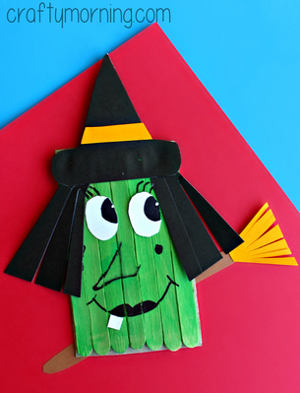
1. Make a Halloween Witch
A simple and fun project including cutting, gluing, painting, colouring, sticking etc and you will have this little witch (or make more than one) for Halloween.

You will need:
- Wooden Lolly Sticks
- Cardboard (i.e. cereal box)
- Scissors
- Paper
- Black sharpie
- Green paint
- Glue
Instructions
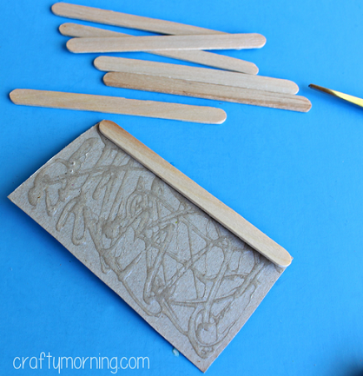
1. Cut a rectangle out of a piece of cardboard and glue on the 7 lolly sticks, pressing down hard.

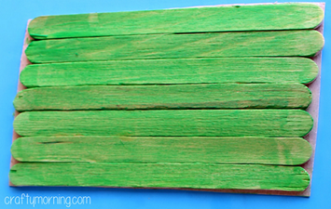
2. Paint all of the sticks with green paint and let dry.

Now the fun part – decorating your little witch! Add a hat, hair, and a broom stick, all drawn and cut out of paper or card to make her fabulous! Use the black sharpie, wikki stiks or tactile stickers to make her big nose, wart, mouth, and eyelashes. The broom is just glued to the back of the cardboard. Love her!
2. Tactile pasta skeleton
This is a fantastic tactile halloween craft to scare even the bravest parents!
You will need:
- A few different types of pasta and/or dried beans, like spaghetti, macaroni, small tube pasta, long tube pasta, wagon wheels, long spirals, tiny shells etc.
- A piece of black card
- White PVA type glue
- A white crayon, tipex (supervise, as it doesn’t come off clothes!) or a brailler to write your name
Instructions
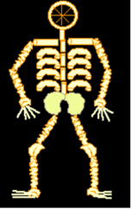
Glue the pasta to the black paper using the glue. Arrange the pasta on the paper before gluing (to make sure that they have room for the whole body on the piece of paper).
You can use just about any type of pasta (or dried beans) for the bones. A wagon wheel is nice for the head. Spaghetti makes good fingers and toes. Tiny tubes or dried lentils are good as vertebrae in the spine. Long tubes make collar bones. Longer tubes or long spirals make good arm and leg bones. Small shells or dried white beans are nice for the kneecaps, wrists and ankles. Two dried beans make good hips.
You can use the template at the end of this document for guidance – go over the shape with glitter glue to provide your child a tactile template if needed.
There is also a guide (picture and large print, screenreader or braillenote friendly text) to the names of the bones below that older children may be interested in.

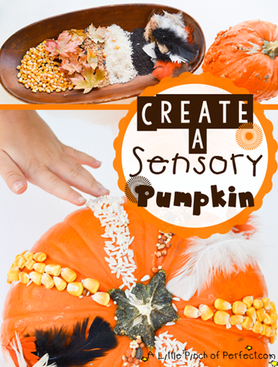
3. Tactile pumpkin decorating
This is a great activity that your child might find easier (and you less nerve wracking!) than pumpkin carving! The pumpkin will also last longer so you can do it before or on the day. This activity can be adapted to include different size decorations according to your child ability to use them.
You will need:
- Pumpkins
- Glue
- Small sponge or paint brush

Decorations – these are just suggestions, but you can include ideas of your own.
- Dried popcorn kernels
- Feathers
- Rice
- Sesame seeds
- Bird seed
- Leaves
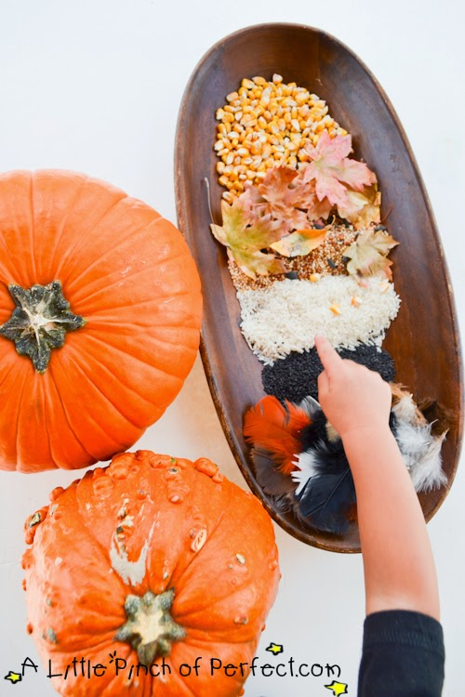
- Halloween themed tactile or large stickers – spiders, eyes, skulls, cats, pumpkins, ghosts etc.
- Pasta shapes
- Dried lentils

Instructions
1. Set supplies out and let your kids explore and touch what they want so it’s a fun sensory experience.

2. Use sponge to apply glue and decorate pumpkin – you may find using a spoon to sprinkle the smaller decorations on is helpful.
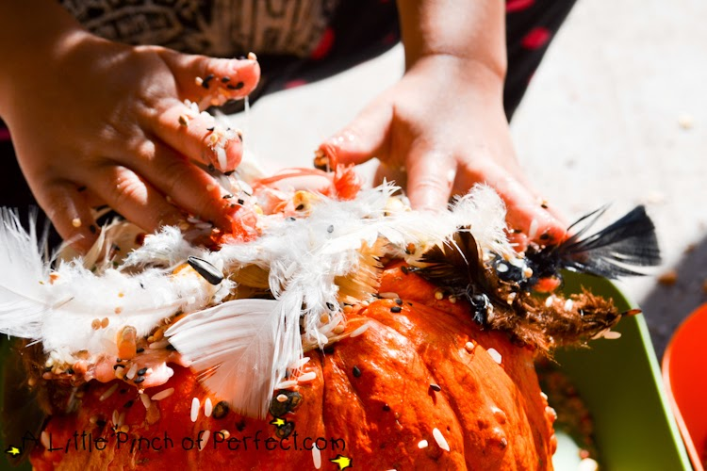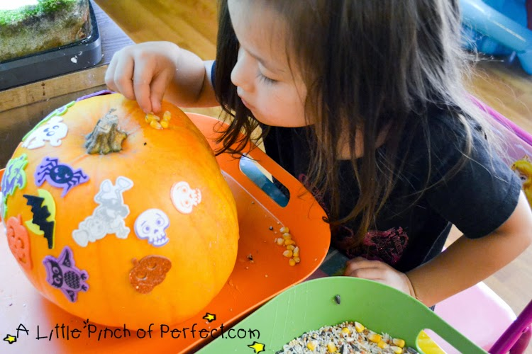

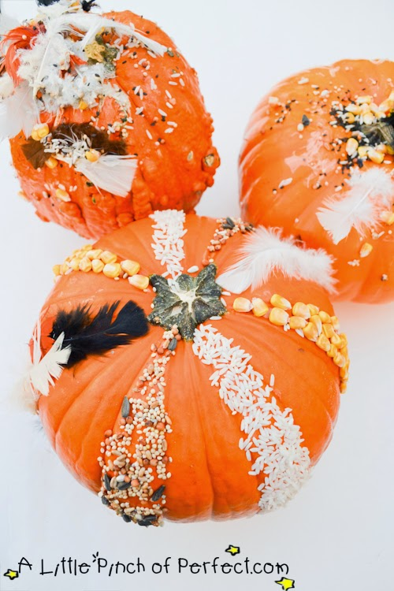
Once the glue dries, the pumpkins are a fun sensory experience to touch and pretty to look at.

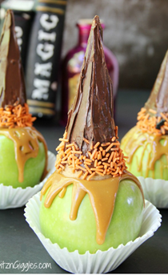
4. Witchy Caramel apples
Witchy Caramel Apples – Crisp and tart Granny Smith apples covered with melted caramel and topped with a chocolate covered cone decorated with some Halloween-themed sprinkles.
You will need:
- 4 large granny smith apples
- 4 ice cream cones
- 6 ounces chocolate chips
- 1 tablespoon butter
- 4 ounces caramel sweets
- 4 lolly sticks
- 4 jumbo cupcake or muffin liners
- Sprinkles for garnish

Instructions
1. Melt the chocolate chips and butter in the microwave, heating and stirring at about 30 second intervals until fully melted.
2. Cover the cones with the melted chocolate using the side of a knife to smooth the chocolate out. Position the sprinkles around the “top” of the cone to serve as the brim of the hat.
3. Set the finished cones aside on a piece of greaseproof paper until completely cooled.
4. Wash and dry the apples, put a lolly stick in the top of each one and place in a jumbo cupcake liner.
5. Combine the unwrapped caramels and water in a small saucepan and warm over low heat until completely melted.
6. Use a spoon to drizzle caramel over each of the apples.
7. Place the hats on top of the apples taking care to cover the lollipop straws completely.
8. Set aside to cool and enjoy.

5. Annabel Karmel’s Chocolate Spider Cupcakes
These are great fun to make for Halloween – especially the scary spider legs! You can do the whole recipe and make your own cupcakes or if you are short on time, buy chocolate cupcakes from your local shop or supermarket – we love cheating!
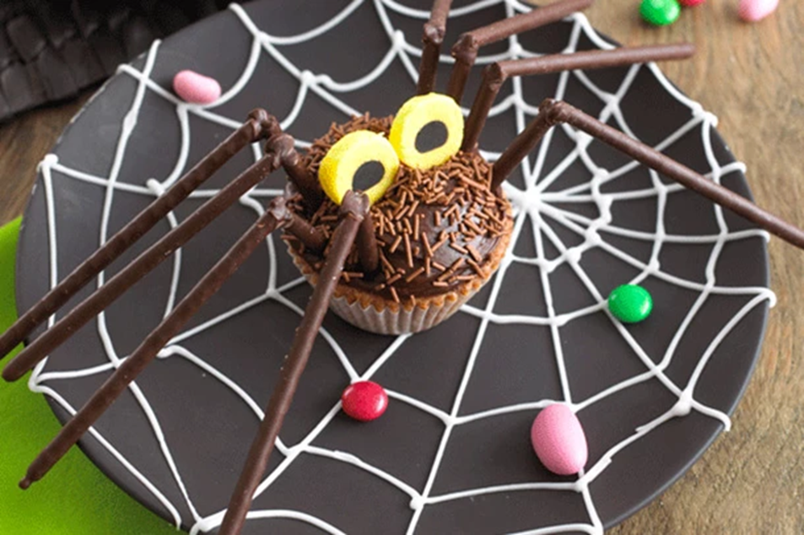
You will need:
- Butter 125g, room temperature
- Golden caster sugar 125g
- Self-raising flour 110g
- cocoa powder 1 1/2 tbsp
- eggs 2, lightly beaten
- Grated orange zest 1 tbsp
- Plain chocolate chips 50g
For the decorations
- Chocolate buttercream 3-4 tbsp
- Chocolate flavour strands
- Mikado chocolate sticks 4 boxes
- plain chocolate 50g
- Liquorice allsorts
Instructions
1. Preheat the oven to 180˚C.
2. Beat the butter and sugar together until fluffy. Sift the flour and cocoa powder together in a separate bowl. Add the eggs to the creamed butter mixture a little at a time, adding 1 tbsp of the flour mix halfway through. Add the orange zest, the remaining flour mix, then the chocolate chips.
3. Put 10 paper cases in a muffin tray and fill two-thirds full with the mix. Bake for 20–22 minutes. Allow to cool on a wire rack.
4. When cool (or back from the shops!), spread a little chocolate buttercream over each cupcake and sprinkle with chocolate-flavoured strands.
5. Cut off the ends of the Mikado sticks not covered with chocolate. Cut a quarter of the sticks in half. Melt the plain chocolate, dip one end of each of the longer Mikado sticks into the chocolate and attach these to the shorter lengths.
Arrange them on trays lined with greaseproof paper and allow the chocolate to set. Push one end of the legs into the body of the spider cake and then repeat until there are four legs either side. Stick round liquorice all sorts on to the top of each of the spider’s bodies to make eyes.
Then scare everyone!

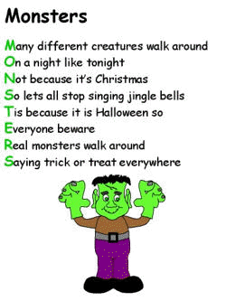
6. Write a Halloween Acrostic poem – make it as funny or as scary as you want!
You can make up your own acrostic poem on paper, on a computer or brailler, recorded onto audio or you can use one of the templates given at the end of the document.

SEE MORE

So here’s mine!

Halloween this year is weird
And I am missing you. Would
Love to see you all again with
Lots of things to do.

Only now we have to meet on Zoom
We might just mute someone!
Enjoying seeing all the things, that
Everyone has done.

Next year will be different!

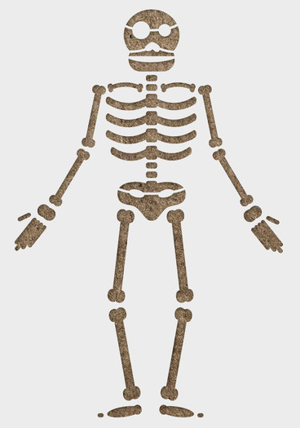
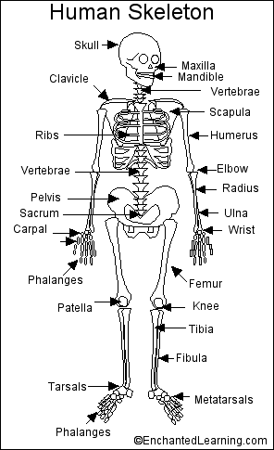
Bones
There are 206 bones in the human body. Over half of these bones are in the hands, which have 54 bones, and the feet, which have 52 bones. Here is the full list:

Bones in the Head (Cranial) (8)

Facial bones (14)

Ear bones (6)
malleus (2), incus (2), stapes (2)

Throat bones (1)
hyoid

Shoulder bones(4)
shoulder blade (2), collarbone (2) (also called the clavicle)

Thorax bones (25)
sternum (1), ribs (2 x 12)

Vertebral column bones (24)
cervical vertebrae (7), thoracic vertebrae (12), lumbar vertebrae (5)

Bones in the Arms:
humerus (2)
radius (2)
ulna (2)
Wrist bones (16)

Palm bones
metacarpals (5 x 2)

Finger bones
Phalanges (14 in each hand)

Pelvic bones (4)
sacrum, coccyx, hip bone (2)

Leg bones (6)
femur or thigh bone (2), patella (2), tibia (2), fibula (2)

Feet bones (52):

Ankle bones: (24)

Toe bones: (14 in each foot)

